2. Methods

2.1 Twin otter measurements
The NOAA Twin Otter aircraft carried a scientific instrument payload that was designed to characterize sources and chemistry related to ammonium nitrate aerosol formation. The flight plans were further designed to encompass all of the major air basins in northern Utah that experience high winter PM_{2.5} pollution and to provide horizontal and vertical distributions of the most important trace gases and aerosols. This section will first describe the scientific instruments and then the flight strategy.

Instrument Payload

Table 2.1 A shows the Twin Otter atmospheric chemistry instruments. Figure 2.1A shows the layout of the instrumentation in the aircraft, and Figure 2.1 B shows the instrumentation inside the aircraft and the positioning of inlets outside of the aircraft.

Aerosol was sampled using the perpendicular near-isokinetic inlet described and characterized in (Perring 2013) that was modified to accommodate a 3 liter per minute (LPM) total inlet flow and the lower cruise speed of the Twin Otter. The sample air was split between the AMS and the UHSAS.

The NOAA Aerosol Mass Spectrometer (AMS, Aerodyne Research) measured submicron aerosol composition and mass (PM₁). The AMS focuses ambient aerosols with an aerodynamic lens, evaporates the aerosol particles by heating them at 600 ºC and analyzes the evaporated molecules with an electron-impact ionization mass spectrometer. When the mass spectra are recorded as a function of time only the AMS is used in MS mode. Additionally, with any AMS it is also possible to measure mass spectra as a function of particle size (pTOF mode). The size information is retrieved by measuring the aerosol time of flight from a chopper, located after the aerodynamic lens, to the mass spectrometer (Jayne 2000, Drenwick 2005, Canagarana 2006). The NOAA AMS is also equipped with a light scattering (LS) module that provides a more accurate size information in the range 200-1000 nm and on the collection efficiency (Middlebrook 2012). The average limit of detections for NO₃⁻, NH₄⁺, Org, SO₄⁻², Cl⁻ and for the total aerosol mass were 0.04, 0.09, 0.33, 0.03, 0.07, 0.38 ug m-3 respectively. The uncertainty on the concentrations is estimated to be around 20%. The Twin Otter AMS was operated in MS mode (6 seconds, 4 open+2 closed) and pTOF mode (4 seconds) in 27 sub cycles of 10 seconds total. We measured in LS mode for 30 seconds every 4.5 minutes.

The Ultra High Sensitivity Aerosol Spectrometer (UHSAS) is an optical-scattering based aerosol spectrometer to measure aerosol size distributions. The aerosol particles enter the instrument and scatter the light produced by a solid-state laser (1054 nm, 1 kW cm⁻²). Mirrors capable of collecting light over a large solid angle (22°–158°) direct the scattered light to two different photodiodes. An avalanche photodiode (APD) for detecting the smallest particles and a low-gain PIN photodiode for detecting particles in the upper size range. The signals generated by the scattered light are used for particle sizing, since the amount of light scattered correlates strongly with particle size (Cai 2008). The data during the UWFPS were collected every 3 s and they were corrected for coincidence and for changes in the UHSAS inlet flow (Brock 2011).

The University of Washington high resolution time-of-flight chemical ionization mass spectrometer (HRToF-CIMS) is capable of online, fast-time response measurements of a suite of reactive inorganic gaseous halogen (Cl₂, Br₂, ClNO₂, etc.) and nitrogen oxide (N₂O₅, HNO₃, HONO, etc.) species. The spectral resolution and simultaneous acquisition across a wide mass-to-charge range provide molecular composition information of individual species and its isotopologue, all clustered with the iodide reagent ion. The major components of the HRToF-CIMS were as first described by Lee et al. (2014 ES&T) with upgrades implemented to improve in-flight calibration and sampling protocol Lee et al. (JGR 2017).

The NOAA custom-built, nitrogen oxide cavity ring down spectrometer (NOxCaRD) measured nitrogen oxides (NO, NO₂) total reactive nitrogen (NO_{y}) and ozone (O₃) with 1 second time resolution. The instrument measures NO₂ by optical absorption at 405 nm, and quantitatively converts NO and O₃ into NO₂ by reaction with excess O₃ or NO, respectively, in two separate channels (Fuchs 2009, Washenfelder 2011). A fourth channel converts NO_{y} to NO and NO₂ by thermal dissociation in a quartz inlet at 650 °C and subsequently converts NO to NO₂ in excess O₃ (Wild 2014). The measurement precision is 50 pptv or better, but zero uncertainty can be as large as 0.2 ppbv.

A continuous wave Quantum Cascade Tunable Infrared Laser Differential Absorption Spectrometer (QC-TLDAS, Aerodyne Research Inc.) measured ammonia (NH₃). Prior to installation the instrument was optimized for a lower total weight. Ambient air was aspirated at a flow rate of 4 LPM through a multi pass absorption cell (0.5 L, 76 effective path length) and NH₃ absorption was detected at 965.3 cm⁻¹ during the experiment. Particulate matter was filtered by a PFA (Teflon) impactor and an additional bypass flow rate of 16 LPM was introduced to purge the 0.5 m long inlet line. The precision of the instrument at 1 Hz sample frequency during the UWFPS campaign was significantly degraded from its usual performance due to difficulties with the laser source. Precision achieved during UWFPS was 150 ppt (1σ). The limit of detection (3σ) was 450 ppt at the 1 Hz sample frequency and 90 ppt for a 30 s averaging interval.

A commercial met probe (Avantech) measured meteorological parameters (T, P, RH, winds) GPS location and aircraft parameters (heading, pitch, roll, etc). Wind data were compromised for some flights, making only partial coverage available.

The total scientific instrument payload was approximately 1500 lbs., including support equipment (gas cylinders, pumps, etc.) and inlets, as Table 2.1 A shows. The allowable payload was defined by target aircraft endurance (see further below under flight planning) of 3 hours per flight, determined by the amount of fuel at takeoff, and the requirement for two pilots and two scientific operators.

Table 2.1 A NOAA Twin Otter instrumentation
Instrument | Species Measured | Institution | Power (kVA) | Weight (lbs.) | Precision | Accuracy | Reference
AMSª | Aerosol composition | NOAA | 1.1 | 560 | <0.4 µg m⁻³ | 20% | Middle brook (2012)
UHSAS^{b} | Aerosol size distributions | University of Toronto | 0.1 | 50 |  |  | Brock 2011
I⁻ ToF CIMS^{c} | HONO, HNO₃, N₂O₅, ClNO₂, Hhalogens | University of Washington | 1.7 | 380 | 1-15 pptv | 30% | Lee 2014
NO_{x}CaRD^{d} | NO, NO₂, NO_{y}, O₃ | NOAA | 0.5 | 280 | 50 pptv | NO, NO₂, O₃ 5%  NO_{y} 12% | Wild 2014
QC-TDLAS^{e} | NH₃ | University of Toronto | 1.0 | 230 | 300 pptv
Met Probe | T,P GPS, Winds | NOAA | 0.3 | 20
Total |  |  | 4.7 | 1520
Twin otter capacity |  |  | ~7 | 1500
ª Aerosol mass spectrometer
^{b} Ultra high sensitivity aerosol spectrometer
^{c} Iodide ion time of flight chemical ionization mass spectrometer
^{d} Nitrogen oxide cavity ring down spectrometer
^{e} Quantum cascade tunable diode laser absorption spectrometer

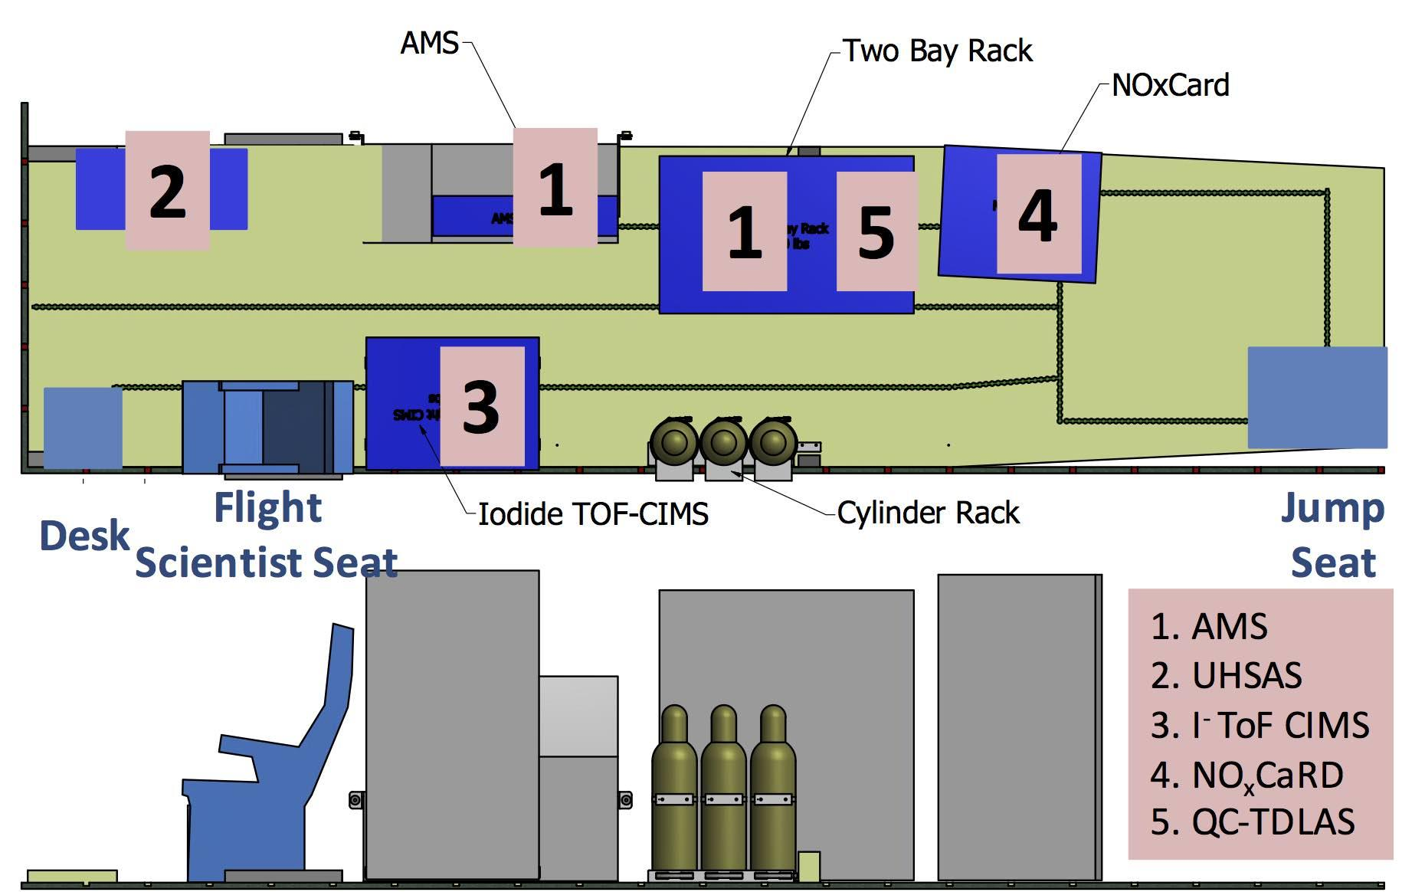

Figure 2.1 A Instrument layout inside the Twin Otter showing the location of the scientific instruments and the location of the seats for the flight scientist and a second scientist (jump seat).

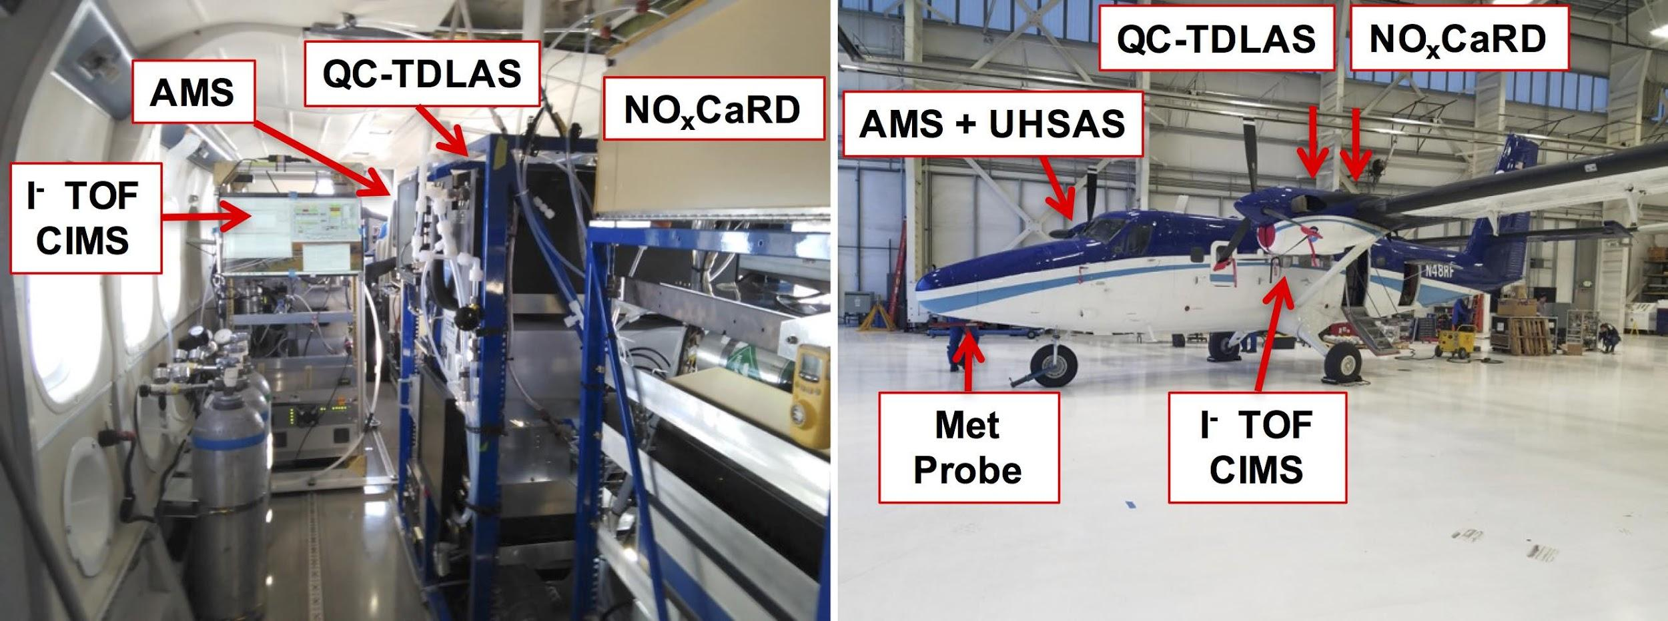
Figure 2.1 B Left: Photograph of the scientific instrument payload inside of the aircraft (photograph taken from the rear of the aircraft, facing forward). Right: Indication of the locations of sample inlets. The AMS + UHSAS shared a custom aerosol inlet on the right side of the aircraft, while the I⁻ ToF CIMS sampled from a custom gas phase inlet on the left side. Both NO_{x}CaRD and the QC-TDLAS instruments sampled through upward facing inlets mounted on the top of the aircraft.

Flight Strategy

The Twin Otter was based at TAC air at the Salt Lake City international airport (KSLC). The flight strategy consisted of two flight plans, generally executed sequentially, to achieve coverage of the major air basins in northern Utah, as Figure 2.1 C shows. The two flight plans were each 2.5 - 3 hours in duration. Landing, refueling and taking off typically required one hour in between the two flights. Thus, a flight day with full coverage of both flights was approximately 6 - 7 hours in total duration. The two plans were not always flown in the same order or at the same time of day, as Table 2.1 B shows. Variation in takeoff time was intended to characterize photochemistry, nighttime chemistry and the morning periods when both boundary layer structure and photochemistry are in transition. As the table shows, however, most of the flights during polluted periods took place in afternoon and evening. This was a logistical constraint imposed by fog that precluded flights during morning hours during severely polluted conditions (e.g., January 30), and due to the loss of flight hours at the conclusion of the second PCAP because of a bird strike on February 1. The bird strike required an approximately 1 week maintenance period for repairs, during which time conditions changed from polluted to clean. Weather conditions also required deviations from the nominal flight plans on some days, especially in the case where a low cloud ceiling prevented ascending to the maximum altitude (12,500 ft / 3.8 km for the unpressurized cabin without oxygen) for the Twin Otter. On flight days with lower ceilings, the Twin Otter sampled the same air space at low altitude but did not profile to higher altitude.

The Twin Otter executed 23 successful research flights across 13 flight days, capturing moderate to severe pollution events and one clean period. With the exception of one flight for which the ammonia instrument was unavailable due to an issue with its laser, all instruments reported data for all 23 flights.

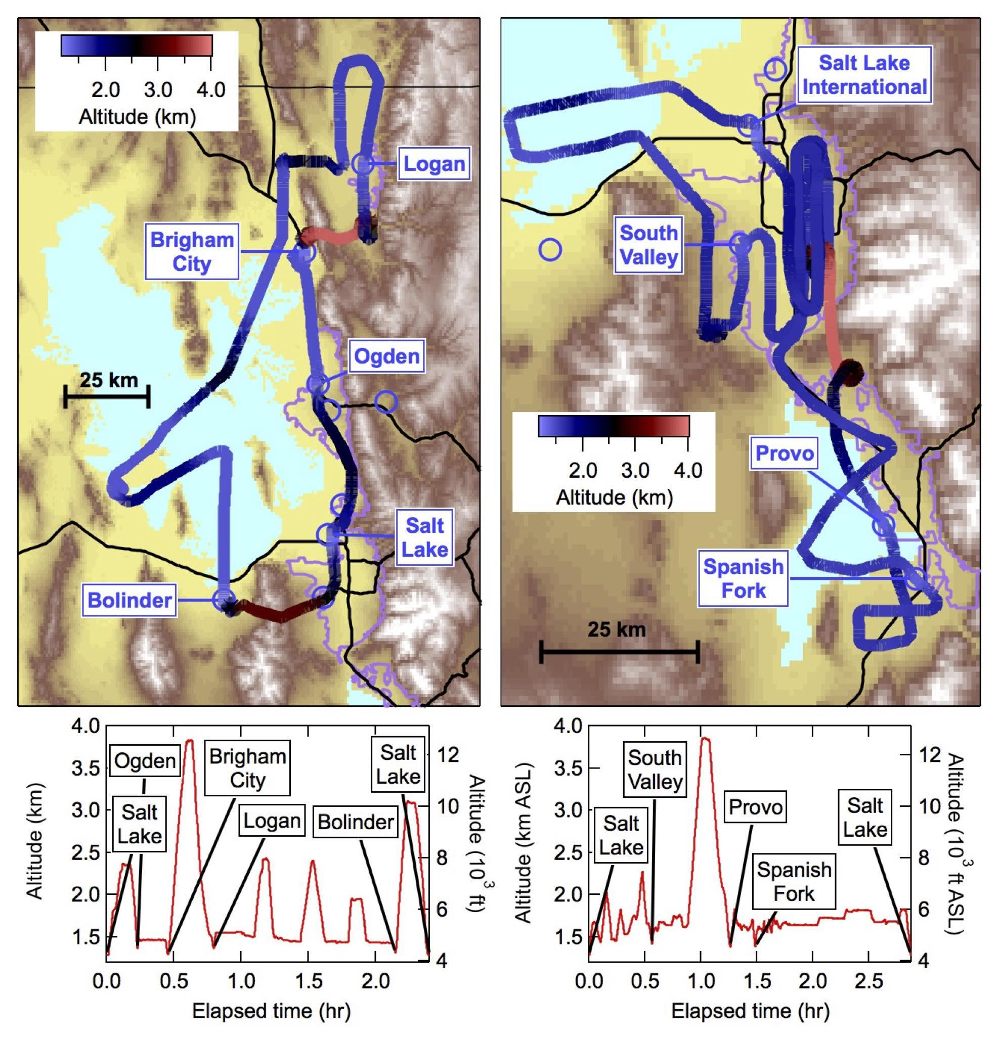
Figure 2.1 C Example Twin Otter flight patterns. Flight tracks are from January 18, 2017, and are color coded by altitude above sea level as the legend shows. Blue circles indicate locations of airfields throughout the region where the Twin Otter executed missed approaches. The left panel shows the north flight plan that covered the north metro areas along the east side of the Great Salt Lake, the Cache and Bear Valleys, Great Salt Lake and the Tooele Valley. The right panel shows the south flight plan that covered the southern end of Great Salt Lake, and the Salt Lake and Utah Valleys. Bottom panels show aircraft altitude (left axes = km, right axes = feet) against elapsed flight time, with locations of missed approaches corresponding to the airfields in the upper panels.

Table 2.1 B Twin otter flights during UWFPS
Date | Takeoff (MST) | Duration (hours) | Flight Plan | Time of Day | Conditions | Notes
Jan 16 | 14:34 | 2.6 | North | Afternoon | PCAP 5
Jan 17 | 14:15 | 2.6 | South | Afternoon | PCAP 5
 | 18:06 | 2.7 | North | Evening | PCAP 5
Jan 18 | 13:54 | 2.4 | North | Afternoon | PCAP 5
 | 17:39 | 2.9 | South | Evening | PCAP 5
Jan 26 | 14:34 | 2.7 | North | Afternoon | Moderately Polluted
 | 18:19 | 2.3 | South | Evening | Moderately Polluted | Low ceiling
Jan 27 | 11:00 | 3.1 | South | Midday | PCAP 6
 | 15:03 | 2.7 | North | Afternoon | PCAP 6
Jan 28 | 17:37 | 2.8 | North | Evening | PCAP 6
 | 21:17 | 3.3 | South | Night | PCAP 6
Jan 30 | 07:30 | 1.2 | South | Morning | PCAP 6 | Fog
 | 11:36 | 3.1 | North | Midday | PCAP 6
Jan 31 | 11:56 | 3.1 | South | Midday | PCAP 6
 | 15:57 | 1.6 | North | Afternoon | PCAP 6
Feb 1 | 11:19 | 0.9 | North | Midday | PCAP 6 | Bird strike
Feb 8 | 02:10 | 2.7 | North | Night | Clean | Low ceiling
 | 05:56 | 2.9 | South | Morning | Clean | Low ceiling
Feb 9 | 00:30 | 2.5 | South | Night | Clean | Low ceiling
Feb 11 | 16:56 | 2.6 | North | Evening | Moderately Polluted
 | 20:32 | 2.9 | South | Night | Moderately Polluted
Feb 12 | 19:15 | 2.2 | North | Evening | Moderately Polluted
 | 22:39 | 2.5 | South | Night | Moderately Polluted

2.2 Ground site network

Working Group: Munkh Baasandorj, Russell Long, Phil Silva, Sebastian Hoch, Erik Crosman, Logan Mitchell, Randy Martin, Ryan Bares, John Sohl, Jeff Page

As part UWFPS, a wide suite of trace gas, particulate and meteorological observations were made at five sites located in Cache, Salt Lake, and Utah Valley (Figure 2.2 A). Sections below describe the ground site network in detail and Table XX – XX provide a summary of measurements made in each valley.
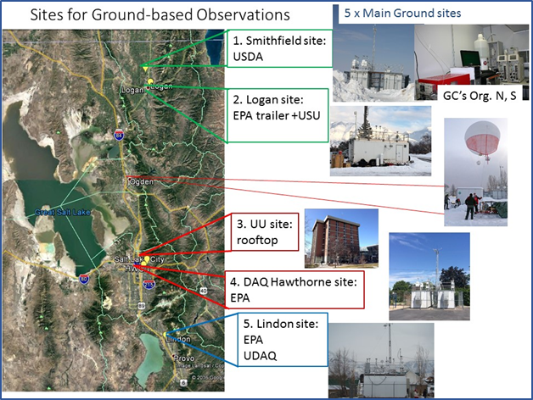
Figure 2.2 A: Map showing the locations of the ground-based observation sites and the tethered-balloon deployment.

2.2.1 Cache Valley measurements
Logan (L4) site. EPA and Utah State University (USU) measurements in the Cache Valley during UWFPS were conducted at a temporary sampling station located on the Utah State University campus in Logan, UT (41°45'31.95"N, 111°48'54.44"W). EPA analyzers and samplers operated during UWFPS are listed in Table 2.2.1-1 along with the analyzer/sampler operation principle.

Table 2.2.1-A. EPA/USU Analyzers/Samplers Operated during UWFPS at Logan, UT
Manufacturer and Model | Operation Principle | FRM/FEM Designation No.
Trace Gas
2B Technologies Model 211  (Ozone) | UV Photometric | EQOA-0514-215
Teledyne API T500U  (NO₂) | Cavity Attenuated Phase Shift (CAPS) Spectroscopy | EQNA-0514-212
Teledyne API T200U  (NO, NO₂, NO_{x}) | Chemiluminescence | RFNA-1194-099
Teledyne API T200U NO_{y}  (NO, NO_{y}) | Chemiluminescence | NA
Aerodyne CIMS | Chemical Ionization (I⁻) Mass Spectrometry (CIMS) | NA
Picarro G2508 CRDS  (NH₃, CH₄, CO₂) | Cavity Ringdown Spectroscopy | NA
Particulate Matter
Teledyne API T640  (continuous PM mass) | Broadband spectroscopy using 90° white-light scattering | EQPM–0516–236
Aerodyne TOF-AMS  (continuous NR-PM₁ composition) | Time-of-Flight Aerosol Mass Spectrometry (TOF-AMS) | NA
Tisch PM_{2.5} High Volume Air Sampler (PM_{2.5} composition) | 24-hr filter-based sample | NA
Remote Sensing/Meteorology
Vaisala WXT520 Weather Transmitter  (WS, WD, T, RH, BP, Prec.)¹ | Various | NA
Vaisala CL 51 Ceilometer  (MLH)² | Aerosol backscatter LIDAR | NA
Campbell Scientific CS135 Ceilometer (MLH)² | Aerosol backscatter LIDAR | NA
Pandora  (NO₂ and O₃ columns) | Sun photometer | NA
Volatile Organic Compounds
Summa Canisters | 12-hr samples (2 per day)  GC-FID analysis | NA
¹ WS-wind speed, WD-wind direction, T-temperature, RH-relative humidity, BP-barometric pressure, Prec.-precipitation)
² MLH-mixing layer height

designation information (EPA Federal Reference or Equivalent Method number). Most analyzers were housed within the temperature-controlled shelter during the sampling campaign except for the Tisch High Volume PM samplers which were located immediately adjacent to the shelter at ground level. Instruments were calibrated according to manufacturers’ operation manuals and in accordance with FRM requirements listed in 40 CFR part 50, Appendix F and D. During the UWFPS campaign, nightly automated zero and span checks were performed to monitor the validity of the calibration and control for drifts or variations in the span and/or zero response. Both the calibration gas concentrations and the nightly zero and span gas concentrations were delivered using a NIST-traceable and programmable dynamic dilution calibration system (Teledyne API Model T700U). Constituents were delivered to the system from EPA protocol (±2% accuracy) reference gas standards and/or the T700U enclosed ozone generator (with NIST traceable photometer). NO₂ was generated by the gas phase titration (GPT) of the NO span gas with ozone. Dilution air that had been scrubbed of all contaminants (zero air via a Teledyne T701H zero air generator) was delivered to the mixing system to meet test gas dilution needs. During UWFPS, a glass inlet with sampling height located approximately 5 m above ground level (agl) and a subsequent sampling manifold were shared by all instruments. Particulate filters were used on the inlets of all trace gas analyzers to prevent the sampling of particulates. Particle filters were changed weekly. The Teledyne API T200U NO_{y} analyzer was operated without a particle filter to allow sampling of particulate nitrate, a key component of NO_{y}. One-minute averaged data generated by the analyzers were collected and logged using a field deployable data acquisition system (Envidas Ultimate). All analyzers were operated according to their designation (FRM and FEM analyzers) and/or manufacturer provided operator's manual. Calibration data and nightly zero and span data were excluded from the final data set.

Oxidized gas-phase chemical species were monitored using an iodide-adduct high-resolution time-of-flight chemical ionization mass spectrometer (CIMS, Aerodyne Research Inc.) run in negative ion mode. The CIMS was housed within a temperature-controlled enclosure and sampled ambient air directly at ~2 L/min from the same glass sampling manifold as the criteria pollutant instruments. Reported mixing ratios of the analyte gases were averaged up to 1-minute from 6-second data which is available if higher time-resolution is needed. Signals for unreported gas-phase compounds of potential interest can also be evaluated upon request to confirm the presence of such compounds in ambient air.

Ambient ammonia (NH₃), methane (CH₄), and carbon dioxide (CO₂) were monitored at the Logan EPA trailer location using a Picarro Model G2508 cavity ringdown spectrometer. Data were collected on a nominal 5-second sampling rate, and averaged up to one-minute sample periods. The system collected concentration data from Jan. 17 to Feb. 14, 2017. Ambient air was pulled through the same glass manifold as the trace gas species and was transferred to the instrument via an insulated, heated-traced (40°C), ¼” TFE tube. The instrument was calibrated/verified pre- and post-deployment using commercially-purchased standard gases and zero air. Additionally, for the NH₃ calibrations, and prior to introduction to the sample inlet, the zero air was passed through a citric acid coated column to assure an effective NH₃ zero.

Continuous PM mass measurements were made using the Teledyne T640 mass analyzer. The T640 employs broadband spectroscopy using 90° white-light scattering to obtain 1-min average PM_{2.5}, PM₁₀, and PM_{10-2.5} mass measurements. The Unit was housed within the environmentally controlled shelter with the inlet extending through the shelter roof to a height of 5 m agl. The T640 analyzer was operated as designated (FEM) and according to the manufacturer provided operator manual.

The composition of non-refractory submicron (NR-PM₁) particles was continuously monitored by an Aerodyne high resolution time-of-flight mass spectrometer (TOF-AMS) that was housed in a temperature-controlled, mobile sampling trailer. Ambient air was sampled through a PM₁₀ inlet extending through the trailer roof to a height of ~6 m above ground level. Coarse particles were removed from sampled air by a BGI PM₁ sharp cut cyclone (SSC 2.229) operating at a rate of 16.65 l min⁻¹. PM1 exiting the cyclone was split among several instruments including the AMS using a TSI 4-way flow splitter (mod. no. 370800). A 1.1 l min⁻¹ bypass flow was used to decrease the total residence time (~10 s) of PM1 in the sampling line between the splitter and AMS inlet. Sampling lines downstream of the splitter were periodically verified to be free from particle intrusion using a HEPA-filter bypass at the exit of the bypass. Additionally, contributions of gas-phase species to AMS mass spectra were corrected using several sampling periods during which all particles were removed from the air entering the AMS using an in-line HEPA filter. TOF-AMS data were averaged to 5-minute time resolution during UWFPS.

24-hr filter-based PM_{2.5} samples were collected daily using Tisch PM_{2.5} High Volume Air Samplers over the midnight to midnight (MST) period. Collected filters were sent back to the EPA RTP laboratory to be archived and analyzed in the near future.

Mixing layer height (MLH) measurements in the Cache Valley were obtained with the Vaisala CL51 and the Campbell Scientific CS135 ceilometers. Ceilometers are eye-safe, single laser aerosol backscatter LIDAR’s that apply the gradient method to aerosol backscatter signals to obtain MLH measurements. The CL51 was coupled with the Vaisala BLView software package and the CS135 was coupled with the CSL CS135 MLH Software to provide continuous mixing layer height measurements during UWFPS. Operational conditions and procedures are based on recommendations provided in the manufacturer-provided user manuals for both the CL51 and CS135 ceilometers.

Remote sensing for trace gas column amounts was performed using the Pandora Sun Photometer (SciGlob Instruments and Services) during UWFPS. The Pandora system measures total columns of trace gases such as nitrogen dioxide, ozone, and others. Mounted on a microprocessor controlled azimuth, elevation tracker, the system can point anywhere in the sky to perform direct sun observations. Pandora operating conditions and procedures are based on recommendations provided in the manufacturer-provided user manual and protocols developed during the DISCOVER-AQ mission.

12-hr volatile organic compound (VOC) samples were collected twice daily using 6-liter Summa canisters during the 0600-1800 and 1800-0600 periods (MST). Collected samples were sent back to the EPA RTP laboratory for analysis using a gas chromatography - flame ionization (GC-FID) procedure. Compound identification were determined by comparing observed compound peak retention time to those provided in a developed CALTABLE containing more than 400 compounds. VOC samples were collected from the same glass manifold/inlet system as the trace gas analyzers.

Smithfield site (SM). SM, Utah DAQ’s main monitoring station in the Cache valley, is located at 675 W. 220 N., Smithfield, UT (41.842778, -111.851944). As part of the Utah air monitoring network, UDAQ routinely monitors PM_{2.5}, PM₁₀, NO_{x} (NO, NO2), O₃ and met parameters according to EPA guidelines at this site and operates 24-h Federal Reference Method (FRM) samplers for PM_{2.5} for NAAQS compliance. As part of UWFPS, USDA deployed a suite of analyzers to capture emissions from the agricultural sector. The analyzers and samples operated during UWFPS are listed in Table 2.2.1-2 along with the analyzer/sampler operation principle.

Table 2.2.1 B. UDAQ/USDA Analyzers/Samplers Operated during UWFPS at Smithfield
Manufacturer and Model | Operation Principle | Institute
Trace Gas
Teledyne API T400  (Ozone) | UV Photometric | UDAQ
Teledyne API T200U  (NO, NO₂, NO_{x}) | Chemiluminescence | UDAQ
TrsMedor gas chromatograph  (Chromatotec) for reduced sulfur compounds | Gas chromatography with electrochemical detection, 10-min | USDA
Auto-GC (SRI) for VOCs and N-VOCs | Tenax trap, gas chromatography with FID/NPD detection, 30-min | USDA
Electrochemical sensors  (Cairpol) for H₂S, NH₃ | sensors, 1-min | USDA
Particulate Matter
Thermo Scientific 1405-DF (continuous mass) | Two TEOM + two FDMS | UDAQ
FRM PM_{2.5} sampler | 24-hr filter-based sample | UDAQ
Ambient ion monitor (AIM) (URG) (gas and PM ions) | Gas and particle denuder; Ion chromatography | USDA
TSI Scanning mobility particle sizer (SMPS)  (Particle size 10-500 nm) | Particle growth and light scattering, 5-min | USDA
TSI Aerodynamic particle sizer (APS)  (Particle size 0.5-20 mm) | Light scattering and aerodynamic sizing, 5-min | USDA
Meteorology Observations
Weather Station  (WS, WD, T, RH, BP, Prec.)  (WS, WD, T, RH, BP, Prec.) | Various | UDAQ

Hourly continuous PM_{2.5}, PM₁₀ and coarse PM measurements are made using Thermo Scientific 1405-DF Dichotomous Ambient Air Monitor. This monitor utilizes two tapered element oscillating microbalances (TEOM) and two Filter Dynamics Measurement Systems (FDMS), which can account for volatile and nonvolatile PM fractions. NOx (NO and NO₂) and O₃ are measured using Teledyne API T200U and T400 UV absorption analyzer, respectively. Daily automated precision, zero and span (PZS) checks are performed automatically to monitor any drifts.

Gas and particulate ions were detected and quantified using an ambient ion monitor. (AIM) The instrument collects gases using a parallel plate denuder and particulates using steam distillation. Water-soluble ions are detected using cation (Na⁺, K⁺, NH₄⁺, amines) and anion (Cl⁻, NO₂⁻, NO₃⁻, SO₄²⁻, carboxylic acids) chromatography. The instrument sampled gases and particulates hourly.

Reduced sulfur gases (e.g. hydrogen sulfide, dimethylsulfide, methanethiol, dimethyldisulfide) and sulfur dioxide were sampled using a TrsMedor gas chromatograph. The TrsMedor takes a sample every 10 minutes. Gases are separated on a gas chromatography column and detected in an electrochemical flow cell using a redox reaction with chromic acid on platinum electrodes. The TrsMedor has a built in internal standard of permeation tubes to detect changes in instrumental response over time. An internal standards was run every three hours.

Volatile organic compounds were analyzed on an autosampling gas chromatograph. Samples were collected and analyzed hourly. VOC samples were collected on a Tenax-GR trap at 30 C and desorbed at 200 C. Gases were separated and detected using a split flow detection by FID and NPD detectors. The FID detected conventional hydrocarbons while the NPD detector detected nitrogen-containing VOCs.

Particle sizing and number concentrations from 10 nm – 20 mm were acquired using a scanning mobility particle sizer and an aerodynamic particle sizer. These instruments detect particles using light scattering (the SMPS uses butanol to grow small sized particles into the light detection region). Particle size distributions were acquired every five minutes.

Cairpol sensors for hydrogen sulfide and ammonia were deployed to the field site and recorded a sample every minute. These are electrochemical based sensors that have a selective thin film on them allowing only the analyte of interest to pass through and provide a response to the electrochemical cell. While the sensors are quoted for hydrogen sulfide and ammonia, they more likely can be thought of as total reduced sulfur and total reduced nitrogen. The Cairpol sensors have relatively high detection limits (1 ppb for H₂S and 100 ppb for NH₃) and are more suited for near-source detection than ambient detection.

2.2.2 Salt Lake Valley Sites

2.2.2.a Salt Lake Valley Chemistry Observations
University of Utah (UU). The UU site is located on the top floor of William Browning Building (WBB) on the University of Utah campus, which is situated on the northeastern bench of the Salt Lake Valley, ~150 meters above the valley floor. Most of the analyzers were housed in the Utah Atmospheric Trace Gas and Air Quality (ATAQ) lab except the analyzers for size distribution and HCHO, which were housed within the temperature-controlled penthouse located on the roof of WBB. Table 2.2.2 A gives a list of the measurements made during UWFPS at UU.

Table 2.2.2 A1 Samplers operated during UWFPS at UU
Manufacturer and Model | Operation Principle | Institute
Trace Gas
Teledyne API T400  (Ozone) | UV Photometric | Dr. Lin’s group  University of Utah
Teledyne API T200U  (NO, NO₂, NO_{x}) | Chemiluminescence | UDAQ
Los Gatos Research  (CO₂, CH₄, H₂O) | Cavity Ring-Down Spectroscopy (CRDS) | Dr. Lin’s group  University of Utah
Thermo 48i CO analyzer | IR absorption spectroscopy | UDAQ
PTR-MS (a suite of VOCs) | Mass Spectrometry | Dr. Baasandorj  University of Utah
Aerodyne Mini-TILDAS Formaldehyde Monitor | A multi-pass broad-band absorption spectroscopy | EPA
Particulate Matter
1400ab ambient particulate monitor (continuous mass) | FDMS TEOM | UDAQ
Ambient ion monitor (AIM) (URG) (gas and PM ions) | Gas and particle denuder; Ion chromatography | Dr. Murphy’s group, University of Toronto
TSI Scanning mobility particle sizer (SMPS)  (Particle size 10-500 nm) | Particle growth and light scattering, 5-min | Dr. Haller’s group  University of Utah
TSI Aerodynamic particle sizer (APS)  (Particle size 0.5-20 mm) | Light scattering and aerodynamic sizing, 5-min | Dr. Haller’s group  University of Utah
Weather Station  (WS, WD, T, RH, BP, Prec.)  (WS, WD, T, RH, BP, Prec.) | Various | Dr. Hoch  University of Utah

The inlet for most trace gas instrumentation in the lab is located on top of a 7 m meteorological tower located on the roof of WBB, approximately 40 meters above ground level. Air is drawn in at ~13 L/min to a central manifold located in the lab, then distributed out to trace gas instruments for O₃, NO_{x}, CO, CO₂, H₂O and CH₄. Atmospheric CO₂, CH₄ and H₂O measurements were performed using a Los Gatos Research Off-Axis Integrated Cavity Output Spectroscopy (Model 907-0011). The instrument is calibrated automatically every three hours using three whole-air, dry, high-pressure reference gas cylinders with known CO₂ and CH₄ concentrations. O₃, CO, and NO_{x} (NO, NO₂) measurements were performed using a Teledyne API T400, T200U and Thermo 48i CO analyzer respectively. The instruments were calibrated weekly and PZS tests were performed routinely.

A suite of volatile organic compounds (VOCs) including aromatics and OVOCs were measured by University of Minnesota’s high sensitivity standard Proton Transfer Reaction- Mass Spectrometer (PTR-MS). The ambient air was drawn in through ~ 8 m long ½” O.D. heated inlet at ~ 10 LPM and the inlet system sub-sampled 700 sccm of the total flow. Automated backgrounds were performed every two hours and calibrations were made every ~ 6 hours.

High-time-resolution measurements of formaldehyde and formic acid were made at the University of Utah site using the Aerodyne Mini-TILDAS Formaldehyde Monitor. A multi-pass broad-band absorption cell that provides optical path lengths up to 76 m allows enhanced sensitivity. The Mini-TILDAS using direct absorption spectroscopy allows for fast (<1 sec) absolute formaldehyde and formic acid concentrations. The Aerodyne Mini-TILDAS was coupled with TDLWintel software to provides instrument control and real-time data analysis. During UWFPS, formaldehyde and formic acid concentrations were averaged to 1-minute time resolution. Automated backgrounds were performed every ten minutes and are excluded from the final data set. The Mini-TILDAS was operated with the Aerodyne inertial inlet to provides particle separation from the sample gas stream with <1 s time response.

Continuous PM_{2.5} mass concentrations were determined using 8500 Filter Dynamics Measurement System (FDMS) coupled with TEOM 1400ab ambient particulate monitor. Aerosol size distributions at the UoU site were measured with a TSI SMPS 3938 (scanning mobility particle sizer with a TSI 3077 CPC) for particles with diameters between 13 and 615 nm and an Aerodynamic Particle Sizer (APS; TSI Inc, Model 3321) for particles with an aerodynamic diameter between 0.54 and 19.81 microns. The SMPS and APS were installed within a small structure on the roof of the William Browning Building on the campus of the University of Utah. For the SMPS, sheath and sample flow rates were 4 and 0.3 LPM, respectively. All SMPS distributions were corrected for multiple-charge and diffusional losses. Five-minute scans were collected from the SMPS. With the APS, the aerodynamic particle size was measured from the time of flight of the particle between two (633 nm) He-Ne lasers.
Online measurements of PM2.5 composition and gas phase precursors were done using University of Toronto’s modified Ambient Ion Monitoring System (AIM 9000D, URG Corp, Chapel Hill, NC) coupled with two Ion Chromatographs (Dionex ICS-2000, Thermo Fisher Scientific, Mississauga, ON). A detailed description of the AIM-IC sampling system can be found in Markovic et al., 2012. In brief, ambient air was drawn through a PM2.5 impactor allowing only gases and particles below 2.5 μm to pass through a parallel plate denuder equipped with nylon membranes with 2 mM H2O2 to capture water soluble gasses. Particles are hygroscopically grown as they pass through a particle condensation chamber and the dissolved solutes are subsequently collected in sample reservoirs. The inlet system was mounted on the roof to allow for collection of the gas and particle phase compounds with minimal impact to the sample flow, and connected via 20 m sampling lines to the IC systems, which were housed indoors. The AIM-IC system collects continuously and reports measurements every hour at ambient T and pressure.
Hawthorne (HW). HW is UDAQ’s main air monitoring station for Salt Lake City, situated on the valley floor (at ~ 1306 m asl). This site is also part of EPA’s Chemical Speciation Network (CSN) and a NCore multi-component monitoring site, where PM (PM_{2.5}, PM₁₀, PM_{10-2.5}), PM_{2.5} speciation, trace gases (O₃, NO_{x}, NO_{y}), and meteorological parameters are monitored according to EPA guidelines [NCore]. US EPA deployed Vaisala CL51 ceilometer and the Pandora Sun Photometer (SciGlob Instruments and Services) during UWFPS to obtain the aerosol backscatter profiles and monitor the total columns of O₃, NO₂ and others. See Table 2.2.2 B and Section 2.2.1 for instrumentation and measurement details.

Table 2.2.2 B. EPA and UDAQ Analyzers/Samplers Operated during UWFPS at HW
Manufacturer and Model | Operation Principle
Measurements by EPA
Vaisala CL 51 Ceilometer  (MLH)¹ | Aerosol backscatter LIDAR
Pandora  (NO₂ and O₃ columns) | Sun photometer
Monitoring by Utah DAQ
PM (PM_{2.5}, PM₁₀, PM₁₀-PM_{2.5}), PM_{2.5} speciation, trace gases (O₃, NO_{x}, NO_{y}, SO₂, CO) | Various
Weather Station  (WS, WD, T, RH, BP, Prec.) | Various
¹ MLH-mixing layer height

2.2.2.b. Overview/method of the met observations to study transport
Sebastian Hoch & Erik Crosman

The observational sites of the Cold-Air Pool Exchange Process Study are shown on a map (Fig. 2.2.2.b.1) of the northeastern part of the Salt Lake Valley. The site names, abbreviations, elevations, type of measurements, and site coordinates are shown in Table 2.2.2.b.1. The key locations for meteorological observations were Hawthorne Elementary (HW), the University of Utah William Browning Building (UU), the University of Utah Mountain Meteorology Laboratory at the mouth of Red Butte Canyon (RB), the Salt Lake City Landfill (LFL), a site near 800 S and 800 E in Salt Lake City (8th&8th), and two sites at the mouth of Parleys Canyon (PAR). Radiosondes were launched twice a day by the National Weather Service (NWS) from the Salt Lake International Airport (KSLC) and additional soundings were flows during PCAP conditions from the 8th&8th site. Small and inexpensive temperature data loggers were distributed along an elevation transect running up the northeastern sidewall of the Salt Lake Valley. Additional mobile observation platforms were two instrumented TRAX trains and the KSL news helicopter.
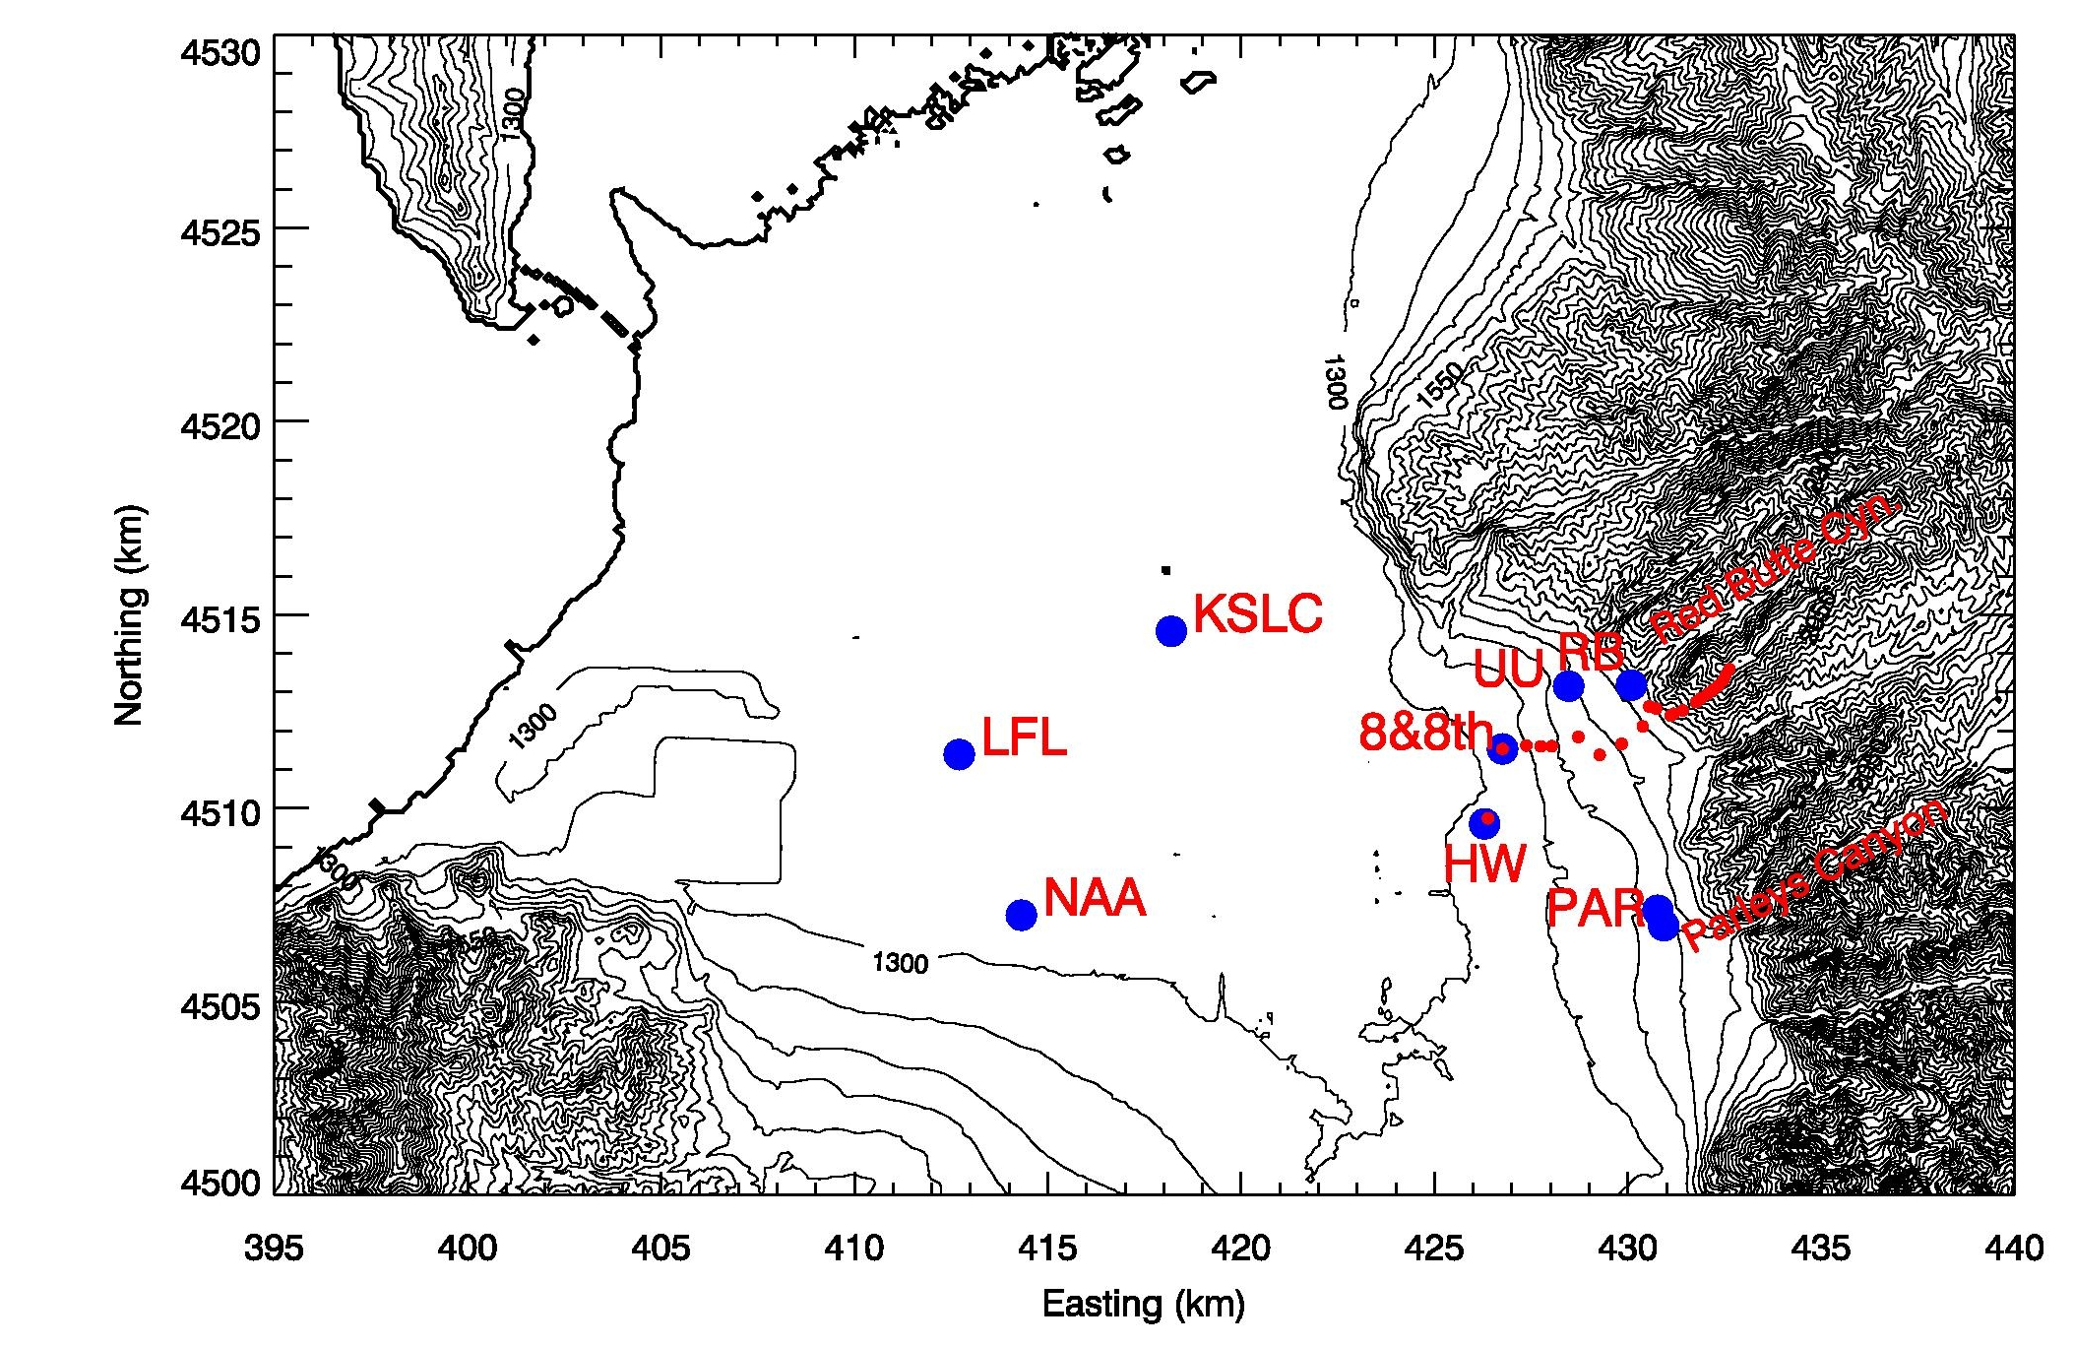

Figure 2.2 B: Map (UTM grid, 100 m elevation contours) of the northern part of the Salt Lake Valley showing the locations of meteorological observation sites. Blue dots mark sites with multiple meteorological sensors and/or profilers, as described in Table 2.2.b.1. Red dots mark automatic temperature data loggers deployed along an elevation transect between ~1300 m and 2150 m ASL. The thick elevation contour approximately shows the coastline of the Great Salt Lake.

Table 2.2.2.b.1: The main meteorological observational sites in the Salt Lake Valley during UWFPS.

Site Name | Site Abbreviation | Instrumentation | Elevation (m ASL) | Surrounding elevation (m ASL) | Elevation above ground (m) | Latitude (°N) | Longitude (°E)
University of Utah; William Browning Building | UU  (base) and (top) | Temp/RH,  Wind,  Solar and infrared radiation,  turbulence | 1442 m  1465 m | 1435 m | 2 m and  30 m | 40.766082°  40.766187° | -111.846752°  -111.847718°
Hawthorne Elementary; UDAQ site | HW-LIDAR | Temp,  Lidar wind profile,  Ceilometer | 1310 m | 1307 m | 2 m | 40.735269° | -111.871889°
Salt Lake City International Airport | KSLC | Temp/RH,  Wind,  Radiosonde | 1289 m | 1289 m | 122 m | 40.772436° | -111.954703°
Mountain Meteorology Laboratory; mouth of Red Butte Canyon | RB | Temp/RH,  Wind,  Ceilometer,  O3, PM | 1522 m | 1520 m | 2 m | 40.7666° | -111.8284°
Salt Lake Landfill | LFL | Sodar Wind Profile,  Ceilometer  O3, PM | 1292 | - | - | 40.74879 | -112.03398
Neil Armstrong Academy | NAA | Temp/RH,  Wind, O3 | 1301 m | 1298 m | 3 m | 40.71152° | -112.01448°
Parleys Canyon Exit  Site 1 | PAR | Sodar Wind Profiler | 1388 | - | - | 40.71423 | -111.81957
Parleys Canyon Exit  Site 2 | PAR | Ceilometer  O3, PM | 1433 | - | - | 40.7107 | -111.81778
800 S &  800 E | 8th&8th | Radiosonde during PCAP events | 1311 | - | - | 40.75146 | -111.86762

Temperature Profiles and Valley Heat Deficit

Vertical profiles of the atmospheric temperature are necessary to evaluate static stability of the atmosphere and to help to define the strength of diurnal and persistent cold air pools. A good measure of the stability of a valley atmosphere is the Valley Heat Deficit (VHD, see below and Section 1.1 for season overview). Two independent observations of the temperature structure in the Salt Lake Valley were made to calculate the VHD. The first observation is readily available from the twice-daily radiosonde ascents from KSLC. Radiosondes are launched daily, at approximately 0500 and 1700 MST. Additional soundings were flown during PCAP conditions from the 8th&8th site. The second observation is based on a pseudo-vertical assumption (Whiteman and Hoch 2014), where temperature observations along an elevation transect are interpreted as a proxy for the vertical variation of temperatures within the valley or basin atmosphere. A set of 23 inexpensive temperature data loggers (Hobo© Pro v2, Onset Computers, MA) was deployed housed in 6-plate radiation shields (R. M. Young, MI) along an elevation transect. With the exception of the topmost sensor, they were deployed at a height of approximately 130 to 180 cm above the surface. Sensors in the upper basin were installed on available dead branches of the vegetation, to avoid any disturbance of the environment. The topmost sensor on the summit of Mt. Wire was installed on the top of a freely accessible tower, approximately 10 m AGL. Tempe­rature data was recorded every 5 minutes and stored on local memory. Location of sensors are given in Table 2.2.2.b.2.

The valley heat deficit (VHD) is a measurement of the amount of energy that would be needed to bring a valley or basin atmosphere to a neutral stratification. Following Whiteman et al. (1999, 2014) it is calculated for the Salt Lake Valley as
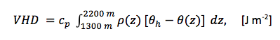
where “theta_h” is the potential temperature at height h, “rho” and “theta” are the air density and potential temperature from the twice-daily rawinsonde sounding, respectively. The specific heat of air at constant pressure is denoted as “c_p”, and dz is 10 m. The VHD is the heat required to warm an atmospheric column with a 1-m² base to the potential temperature observed at the top of the basin at height h=2200 m, bringing the underlying atmosphere to a dry adiabatic lapse rate. Calculations were performed using the twice-daily radiosondes launched by the National Weather Service (NWS) at the KSLC site, additional radiosondes launched during intensive observational periods, and based on the pseudo-vertical temperature soundings recorded along the northeastern valley sidewall. For the Salt Lake Valley, the elevation range between 1300 m ASL (valley floor) and the height of 2200 m, corresponding the mean ridge height surrounding the valley, are used. Calculations of VHD reveal the episodes of high atmospheric stability during the passage of high-pressure centers across Northern Utah.

Wind Profiles

Wind profiles, while available from the radiosondes from the KSLC and 8th&8th launch sites, were also continuously recorded using the University of Utah Halo Photonics (UK) Doppler wind lidar and from two Atmospheric Systems Corporation (Santa Clarita, CA) mini-SoDARs. The lidar was installed in a backyard of a local volunteer who lives in the direct vicinity of Hawthorne Elementary (HW) site. The installation required a fixed power source and an unobstructed view of sky. The lidar was programmed to scan a Plan Position Indicator (PPI) scan pattern every 10 minutes. The Vertical Azimuth Display (VAD) analysis was used to retrieve the vertical profile of the three-dimensional wind field. This wind field can be overlaid with the aerosol backscatter coefficient of the lidar retrieval or of the co-located ceilometer. Daily quicklooks were produced during the experiment and shared via a web page with the collaborators and interested public.

The two SoDARs were installed at the LFL and PAR sites, recording 10-min average wind profiles up to 200 m AGL with a vertical resolution of 10 m. Regular maintenance was necessary to keep the PAR site sodar running, as it was powered by solar power and snow had to be removed from the antenna housing.

Aerosol backscatter

Aerosol backscatter profiles were recorded with three ceilometers at three locations in the Salt Lake Valley to resolve spatial differences in the atmospheric aerosol loading and to resolve temporal changes in the aerosol optical properties at these three sites. Ceilometers (Vaisala CL31), were deployed at the Salt Lake Landfill (LFL), at the mouth of Parleys Canyon (PAR), and the Red Butte Canyon Exit (RB) sites. These observations complement the observations at Hawthorne (HW) and in the Utah and Cache basins made with the EPA deployed Vaisala CL51 ceilometer. The instruments recorded a vertical profile (10-m resolution) of the atmospheric aerosol backscatter coefficient β every 16 seconds. The raw data was averaged to 10-min means for further processing. Daily quicklooks are available for the experiment at the following web site: http://www.inscc.utah.edu/~hoch/AIRQUAL_2016-2017/CEILOMETER/. Time-height cross sections of aerosol backscatter illustrate changes in the polluted PCAP atmosphere, and visualize mixing processes, layering, and injection of clean air along basin sidewalls or through tributary canyons. Further, phases of quickly intensifying backscatter retrievals may indicate periods of PM_{2.5} formation.
Table 2.2.2.b.2: Locations and elevation of Hobo® automatic temperature dataloggers deployed along an elevation transect in the northeastern Salt Lake City Basin during UWFPS.

Identifier | Latitude (deg N) | Longitude (deg E) | Elevation (m ASL) | Serial number
HOBO_01 | 40.73528 | -111.87189 | 1307 | 10538180
HOBO_02 | 40.75146 | -111.86762 | 1311 | 9889090
HOBO_03 | 40.75146 | -111.86762 | 1311 | 9810707
HOBO_04 | 40.75231 | -111.86035 | 1338 | 9806339
HOBO_05 | 40.75216 | -111.85593 | 1372 | 9806338
HOBO_06 | 40.75225 | -111.85254 | 1388 | 9806340
HOBO_07 | 40.75443 | -111.84443 | 1427 | 9806358
HOBO_08 | 40.75032 | -111.83782 | 1429 | 9784026
HOBO_09 | 40.75292 | -111.83113 | 1457 | 9826455
HOBO_10 | 40.75702 | -111.82473 | 1493 | 978403
HOBO_11 | 40.7617 | -111.82282 | 1527 | 980633
HOBO_12 | 40.76124 | -111.82067 | 1542 | 980633
HOBO_13 | 40.7596 | -111.81619 | 1607 | 9806342
HOBO_14 | 40.76007 | -111.81534 | 1662 | 9784035
HOBO_15 | 40.76085 | -111.81250 | 1716 | 9784034
HOBO_16 | 40.7628 | -111.80849 | 1804 | 9806354
HOBO_17 | 40.76373 | -111.80695 | 1888 | 9806344
HOBO_18 | 40.76477 | -111.80495 | 1953 | 9784028
HOBO_19 | 40.76572 | -111.80326 | 2000 | 9784029
HOBO_20 | 40.76664 | -111.80176 | 2048 | 9784027
HOBO_21 | 40.76799 | -111.80014 | 2105 | 9806345
HOBO_22 | 40.76915 | -111.79947 | 2137 | 9784030
HOBO_23 | 40.77055 | -111.79835 | 2181 | 9806343

Chemical observations co-located with meteorological equipment
Observations at the LFL, PAR and RB sites were co-located with ozone and particulate concentration measurements. The PM_{2.5} measurements were recorded by two types of research-grade laser nephelometers manufactured by Met One Instruments: The E-Sampler 9800 or the ES-642 monitors [precision: 3 μg/m³, uncertainty: 8%] with sharp cut cyclones at the inlet to restrict particle size sampled to PM_{2.5} or smaller. The E-Samplers and ES-642 monitors are calibrated by the manufacturer and have been shown to compare well in match-ups between Utah Division of Air Quality measurements.

The ozone measurements were recorded by a Model 205 Dual Beam Ozone Monitor (O3) from 2B Technologies, CO, [precision: 2% uncertainty: 2%]. The 2B Ozone Monitor utilizes UV absorption at 254 nm and is approved by EPA as a Federal Equivalent Method (FEM). The 2B Ozone Monitors were calibrated against Utah Division of Air Quality standards as well as a 2B Technologies Model 306 Calibration Source.

Turbulence Intensity and Vertical Mixing. Turbulence kinetic energy (TKE) is a measure of turbulence intensity. To evaluate the strength of atmospheric mixing at the valley sidewall (UU) site, turbulence observations were made using a Campbell Scientific CSAT3 ultrasonic anemometers to measure the three-dimensional wind field at 20 Hz. This dataset was processed using the Utah Turbulence in Environmental Studies processing and analysis code (UTESpac).
A second measure of atmospheric mixing and turbulence is the vertical velocity variance (σ_{w}) that was derived from vertical stare data collected with the University of Utah Doppler wind lidar.

Solar and Infrared Radiation. Solar incoming and reflected radiation was measured at the University of Utah (UU) site, using pyranometers (CMP21, Kipp and Zonen, Delft, the Netherlands) and in- and outgoing thermal (longwave) radiation were monitored with pyrgeometers (CGR4, Kipp and Zonen, Delft, the Netherlands). Observations of solar radiation can indicate the degree of cloudiness and the amount of radiative energy available to drive photochemical reactions. The surface albedo - the ratio between reflected solar and incoming solar radiation - indicates the surface conditions such as the degree snow cover or bare grass surface.
Changes in infrared incoming radiation indicate the degree of cloud cover and cloud height, while the outgoing longwave radiation is a function of surface temperature and emissivity.

2.2.2.c. Overview of the TRAX observations
The University of Utah research group has partnered with the Utah Transit Authority (UTA) and installed suites of instruments on two light-rail “TRAX” trains (numbered 1136 and 1104, hereafter TRAX 1 and 2). This measurement project began in December 2014 and is ongoing. Electrified trains are an ideal platform for air sampling because they have zero direct emissions and often run continuously throughout the day. The trains have electric circuitry on their roofs in steel weatherproof boxes, and the instruments were installed in one of the spare boxes (dimensions 1.5 m x 0.5 m x 0.5 m). The sample inlets were 4 m above ground level and 0.5 m above the top of the train. On TRAX 1, PM_{2.5} was measured with an E-Sampler aerosol monitor from Met One Instruments, Inc. Carbon dioxide (CO₂), methane (CH₄), and water (H₂O) measurements were made with an Ultra-portable Greenhouse Gas Analyzer from Los Gatos Research (LGR) Inc. The Campbell Scientific CS215-L Temperature and Relative Humidity probe and CS106 Barometer were used for the meteorological parameters. A Raspberry Pi based data logger collected trace gas data and controlled valve systems for hourly automated calibrations and a Campbell Scientific data logger (CR1000) collected meteorological and PM_{2.5} data. TRAX 2 was equipped with a Model 205 Dual Beam Ozone Monitor from 2B Technologies, a NO₂ analyzer from LGR Inc., and an ES-642 Remote Dust Monitor from Met One Instruments, Inc. Data were collected on a Raspberry Pi computer. The PM_{2.5} instruments on both TRAX trains are equipped with a sharp cut cyclone and maintain a sample relative humidity of 30% with an internal heater. The observations were collected at frequencies ranging from 1 s to 1 min and transmitted to University of Utah servers every 5 minutes with cell modems.

The TRAX light-rail network has three train lines: Red, Green, and Blue (Figure 2.2.2.C 1). TRAX 1 and 2 operate primarily on the Red and Green train lines, and all of the observations during the UWFPS come from these two train lines. The TRAX trains had a limited deployment schedule during the UWFPS study period due to maintenance requirements for the train cars, however there are mobile transects on several days that coincide with UWFPS flights. On days when the train cars were not deployed on the train lines they were stationed outside at the light-rail maintenance facility and acted as an additional ground observation site.

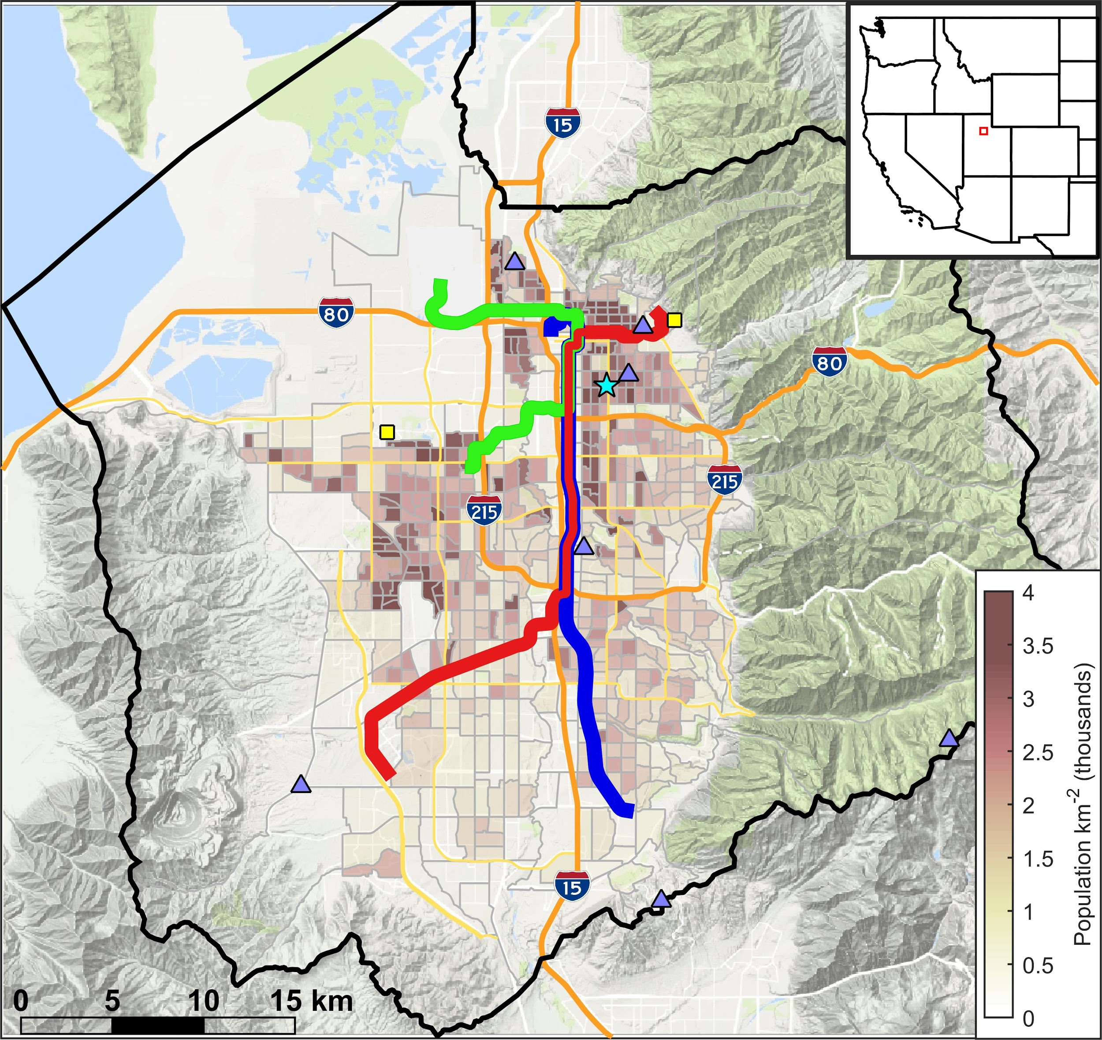
Figure 2.2.2.C 1 The TRAX Red, Green, and Blue train lines in the Salt Lake Valley (SLV). The University of Utah greenhouse gas monitoring network (blue triangles), University of Utah air quality research sites (yellow squares), and the Utah Department of Air Quality’s Hawthorne site (cyan star) are also shown. The population density is superimposed in brown shading, and the inset shows the location of the SLV as a red box in the western U.S.

2.2.2.d. Overview of the balloon-based observations
Weber State University’s tethered balloon system was used to measure an air column from ground level to 500 feet (150 m) above ground. Balloon flight operations were located approximately halfway between Logan and Salt Lake City near Utah DAQ’s Ogden station (See Figure 2.2 A) and 1.25 miles (2.02 km) from the end of the runway used by the NOAA Twin Otter when making missed approaches at the Ogden airport. Each flight lasted approximately six minutes including a two minute pause at the high point. A total of 114 flights were completed during 14 operational periods. The operational periods were selected to sample the air at sunrise, mid-afternoon, and sunset. Because the afternoon data showed no strong altitude dependence and the sunset data had no obvious patterns, resources were concentrated mostly on the sunrise operational periods.

The primary target was ozone, as such the balloon hoisted an electrochemical cell (ECC) ozonesonde, EN-SCI model 2ZV7-ECC, attached to an iMet model 1-RSB radiosonde on every flight. Ozone concentrations were calculated from the raw data using the NOAA SkySonde client software. Each flight carried a second payload that was either a Met One GT-526 particle counter, a prototype of a custom-made device we call the AtmoSniffer, or a set of cameras.

The GT-526 is a six-channel nephelometer measuring from 0.3μm to 10μm particles. The channel counts are cumulative, thus the first channel contains counts of all particles from 0.3μm through 10μm, the second channel is 0.5μm through 10μm, the third channel is 0.7μm - 10μm, etc. The remaining channels do the same starting at 1.0μm, 2.0μm, and 5.0μm, respectively. Two identical GT-526 units were used. One unit was only for flight and one unit was gently handled to insure that it maintained calibration. Each day the two units were operated next to each other for a few minutes to verify that they were in reasonable agreement. As a further check on the data the particle counts were compared to the UDAQ O2 PM_{2.5} data. Exact comparisons are not possible as the particle size ranges are different and the units and method of measurement are different. However, the trends were consistent between the GT-526 counts (near ground level) and the reported mass densities from the UDAQ O2 instrumentation. The evidence indicates that the flight unit (whose data are reported here) maintained its calibration during the UWFPS study period.

The AtmoSniffer is a prototype instrument that we are developing as a lightweight device that can be flown under balloons or drones. It includes multiple measurements including PM, O₃, NH₃, NO₂, CO, and SO₂. Due to the prototype status of the AtmoSniffer, these values are considered uncalibrated. There was also an issue with sensor warm-up time that was being investigated. The result is that the AtmoSniffer data will only be provisional and can only be used for general trends at this point.

The cameras varied between flights both in model and orientation. The goal was to measure transparency of the atmosphere by looking at high-contrast targets. No data will be reported from this effort as a method of calibration has yet to be developed.
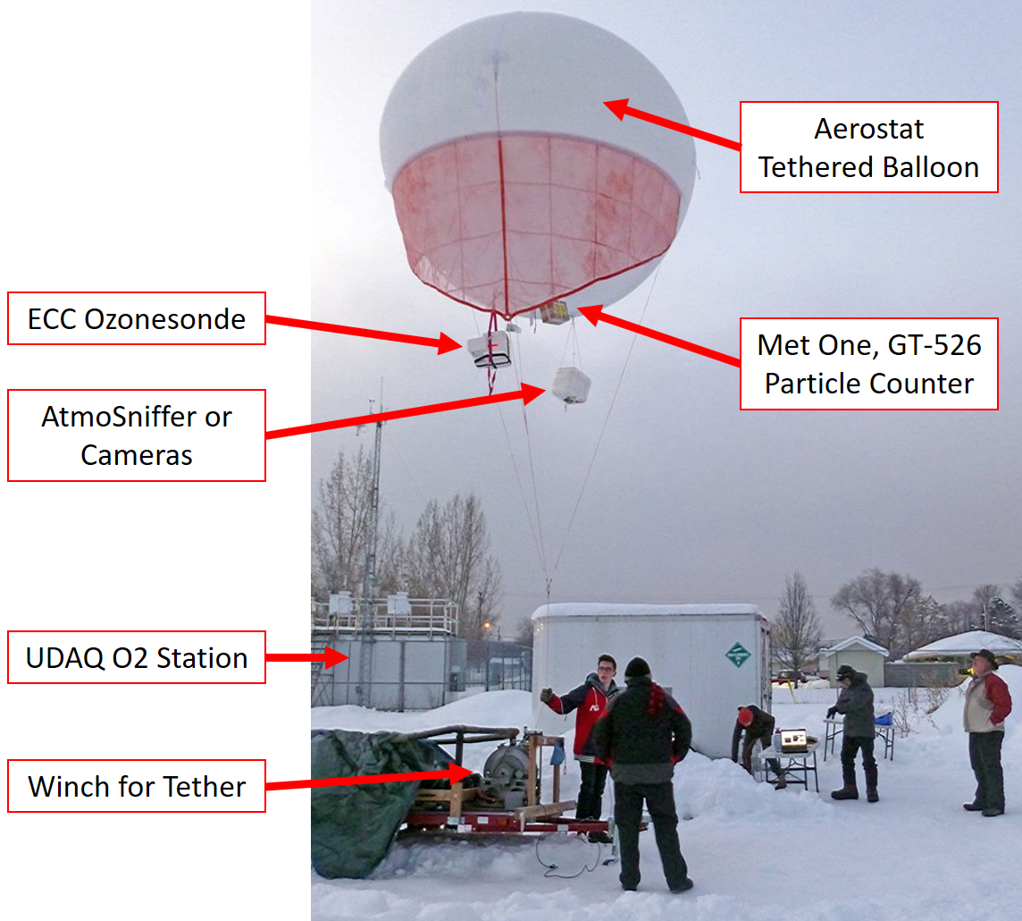
Figure 2.2.2 D 1: The tethered balloon platform carried an ozonesonde on every flight with other payloads alternating between flights. The launch point was collocated with the Utah Division of Air Quality Ogden O2 ground station to provide a calibration reference. The winch raised and lowered the balloon from ground to 500 feet (150 m) high, then back down. Each flight lasted approximately 6 minutes.

2.2.2.e. Overview of the news helicopter based observations
The University of Utah research group has partnered with KSL-TV and installed particulate and ozone pollution monitoring instruments on the KSL Chopper (Crosman et al. 2017). This measurement project began in June 2015 and is ongoing. The helicopter was outfitted with air quality instruments beginning in June 2015 (Figure 2.2.2.E 1). The goal of the helicopter air quality monitoring is to provide near real-time mapping of large horizontal and vertical gradients in pollution for government forecasters and the public. The following instruments were installed on the helicopter:

PM_{2.5}: ES-642 dust monitor with PM_{2.5} cyclone from Met One Instruments Inc. Measures particulate concentration using laser nephelometer. [precision: 3 μg/m³, uncertainty: 8% of NIOSH 0600].
O₃: Model 205 Dual Beam Ozone Monitor (O₃) from 2B Technologies [precision: 2% uncertainty: 2%] Uses UV absorption at 254 nm. Approved by EPA as a Federal Equivalent Method (FEM).
Atmospheric pressure: Campbell Scientific 106 Barometer (pressure) [precision: 0.03 hPa, uncertainty: 0.3–1.5 hPa].
Data logging: Campbell Scientific CR1000 data logger.
GPS: Garmin GPS18X-5HZ 010-00321-37 GPS Receiver.

The CR1000 datalogger collects samples from the ES-642 (PM_{2.5}), 2B 205 (O₃), CS 106 barometer, and the Garmin GPS18X-5HZ every 2 s, and then averages and logs observations every 10 s. A Sierra Wireless Airlink Raven XT cellular modem is used to transmit 10-s data observations to the University of Utah Center for High Performance Computing every 5 min. The on-board pressure sensor is also utilized to restrict cellular communications when the helicopter flies at higher altitudes. The transmitted data is then processed for near-real time display at the following website: http://meso2.chpc.utah.edu/aq/
Data download page at:
•http://meso2.chpc.utah.edu/gslso3s/cgi-bin/mobile_data.cgi
•Plot archive at http://meso2.chpc.utah.edu/aq/cgi-bin/map.cgi
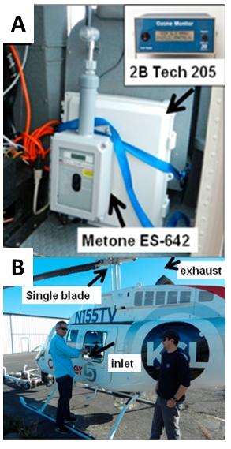
Figure 2.2.2.E 1 The KSL-TV helicopter with inlet location shown (top, A) and instrument box (bottom, B).

2.2.3 Utah Valley Site
Lindon, UT. UDAQ’s Lindon air monitoring station, is located at 50 North Main Street, Lindon, UT (40.3396,-111.7133675). UDAQ routinely monitors 24-h PM_{2.5}, PM_{2.5}, PM₁₀, and met parameters according to EPA guidelines at this site (See table 2.2.3 A or section 2.2.1 for details). 24-h filter based PM_{2.5} samples were collected using two low vol samplers for PM_{2.5} organic and inorganic speciation. Additional measurements of O₃, NO_{x}, aerosol backscatter, and O₃, NO₂ column are conducted by EPA at this station during UWFPS as listed in Table 2.2.3-A. See Section 2.2.1 for instrument and measurement details.

Table 2.2.3 A. UDAQ/EPA Analyzers/Samplers Operated during UWFPS at LN
Manufacturer and Model | Operation Principle
Measurements by EPA
2B Technologies Model POM (O₃) | UV photometric
Teledyne API T200UP  (NO, NO₂, NO_{x}) | Chemiluminescence with photolytic converter
Vaisala CL 51 Ceilometer  (MLH)¹ | Aerosol backscatter LIDAR
Pandora  (NO₂ and O₃ columns) | Sun photometer
Monitoring by Utah DAQ
PM (PM_{2.5}, PM₁₀, PM₁₀-PM_{2.5}), PM_{2.5} speciation | Various
Weather Station  (WS, WD, T, RH, BP, Prec.) | Various
¹ MLH-mixing layer height

2.2.4 Passive ammonia network
Time-averaged, ambient gas-phase NH₃ concentrations were measured in the Cache Valley and along the Wasatch Front using a network of Ogawa Model 3300 passive samplers (Ogawa USA, Inc.). A complete description of the passive sampling systems and ultimate quantifications can be found in Roadman et al. (2003). Briefly, these portable systems consist of a multi-component sampler, a mounting base, and a rain cover. Commercially-purchased, pre-treated (citric acid-coated) sample pads are loaded into one end of the sampler and held in place by metal screens and a porous cap. Collection of gaseous NH₃ onto the pads is based on the diffusion of air through a porous end cap and a metal screen to the pad surface and subsequent reaction with the citric acid. Collected NH₃ is subsequently determined via ion chromatography. A schematic drawing of a component-separated sampler can be found in Figure 2.2.4 A. A picture of a sampler as deployed the rural Lewiston (Cache Valley) site is shown in Figure 2.2.4 B.

As can be seen in Figure 2.2.4 C, 25 and 11 sites were arrayed around Cache Valley and along the Wasatch Front, respectively. Table 2.2.4 a gives the latitude and longitude of each site as well. While the primary goal of the various locations was to adequately characterize the representative airsheds, select locations within the Cache Valley were purposely located near suspected large NH₃ emissions sources (Franklin East and Lewiston Rural – large poultry facilities; Hyrum 6600 – a commercial fur production facility). The samplers were deployed over three, consecutive 7-day periods beginning on Jan. 26, 2017.

Blank pads were collected during each weekly deployment period at each of the lab sites (USU and U of U/UDAQ) while loading the samplers and processing the pads to quantify potential NH₃ contamination during handling. After exposure, all pads were transferred to individual, label opaque 8 ml HDPE sample bottles and refrigerated (<4°C)) until shipment and final quantification via ion chromatography (IC) as performed at the USDA’s Agricultural Research Services Food Animal Environmental Research Unit (Bowling Green, KY).

Samples were extracted with 8 mL DDI water. Ammonium cation was determined by ion chromatography (ICS 3000, Dionex Corporation, San Francisco, CA). Samples were injected into IC via an autosampler (Model AS-1, Dionex Corporation). Initial samples were run with a 100 mL injection; subsequent to that, samples with no detection were run with a 500 mL injection volume. Methanesulfonic Acid (20mM, Sigma-Aldrich, St Louis MO) was used as mobile phase for an isocratic run. The mobile phase was pumped at 1.2 mL/min through a 50 mm x 4.00 mm IonPac CG12A Guard and 250 mm X 4.00 mm IonPac CS12A Analytical columns (Dionex Corp, Sunnyvale, CA) held at a temperature of 25 ºC. Detection was performed with a conductivity detector (Model # 061830, Dionex Corporation) and a Cation Self-Regenerating Suppressor (CSRS 300 4-mm Dionex Corp, Sunnyvale, CA). Samples were analyzed in triplicate. The method was calibrated for ammonium from 0.05 to 10 mg/L. The lower detection limit (LDL) for the IC quantification was determined to be 0.05 mg/L (ppm). On the cases wherein the analyzed samples were below the specified LDL, the samples were assigned one-half of the LDL (0.025 mg/L). This IC value is approximately equivalent to an associated ambient value of 1.9 ppb, which can be taken as the minimum measurable ambient concentration using the above passive sampling protocol.

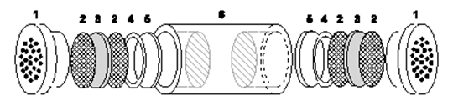
Figure 2.2.4 A. Display of the components of the Ogawa Model 3300 passive sampler. Sampler components are: 1) a porous end cap, 2) a stainless steel screen, 3) a sampling pad, 4) a retainer ring, and 5) a base with hollowed ends (Roadman et al., 2003).
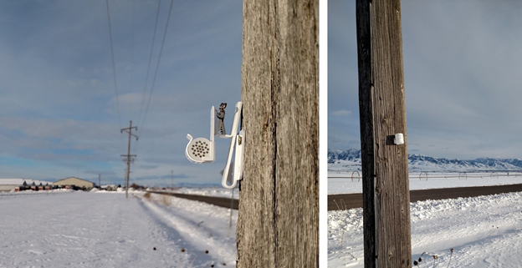
Figure 2.2.4 B. Passive ammonia sampler as deployed at the rural Lewiston (Cache Valley) sample location – without (left) and with the wind/precipitation cap (right).
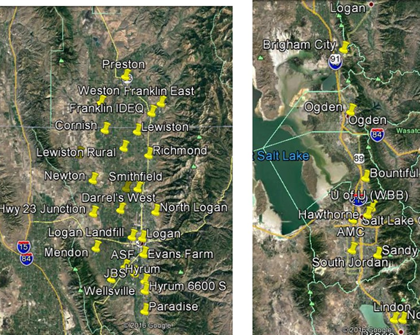
Figure 2.2.4 C. Passive ammonia sampler locations in the Cache Valley (right) and along the Wasatch Front (left).

Table 2.2.4 a. Latitude and longitude of passive sampling network sites.
 | Site | Latitude | Longitude
Cache Valley | Amalga pole 177 | 41.8433 | -111.8873
 | Animal Science Center | 41.6661 | -111.8912
 | Clarkston | 41.9200 | -112.0317
 | Cornish | 41.9754 | -111.9525
 | Daryl West | 41.7947 | -111.9047
 | Evans Farm | 41.6950 | -111.8345
 | Franklin East | 42.0355 | -111.7818
 | Franklin (IDEQ) | 42.0137 | -111.8102
 | HWY 23 JXN | 41.7864 | -111.9873
 | Hyrum Center | 41.6344 | -111.8310
 | Hyrum 6600 S | 41.6125 | -111.8306
 | Lewiston Town | 41.9718 | -111.8541
 | Lewiston Rural | 41.9347 | -111.8949
 | North Logan | 41.7903 | -111.7981
 | JBS | 41.6516 | -111.8613
 | Logan | 41.7309 | -111.8383
 | Logan Landfill | 41.7338 | -111.8696
 | Mendon | 41.7081 | -111.9791
 | Newton Park | 41.8617 | -111.9886
 | Paradise | 41.5665 | -111.8312
 | Preston | 42.0963 | -111.8901
 | Richmond | 41.9184 | -111.8193
 | Smithfield | 41.8426 | -111.8522
 | Weston | 42.0370 | -111.9654
 | Wellsville Park | 41.6380 | -111.9316
Wasatch Front | AMC | 40.7118 | -111.9608
 | Brigham City | 41.4929 | -112.0178
 | Bountiful | 40.9029 | -111.8845
 | Hawthorne | 40.7344 | -111.8722
 | Lindon | 40.3395 | -111.7135
 | North Provo | 40.2528 | -111.6627
 | Ogden | 41.2069 | -111.9751
 | Sandy | 40.5503 | -111.8118
 | South Jordan | 40.5720 | -111.9663
 | Spanish Fork | 40.1384 | -111.6655
 | University of Utah | 40.7665 | -111.8477

References

Crosman, E. T., Jacques, A. A., & Horel, J. D. (2017). A novel approach for monitoring vertical profiles of boundary-layer pollutants: Utilizing routine news helicopter flights. Atmospheric Pollution Research. 8, 828-835.

Roadman, M.J., J.R. Scudlark, J.J. Meisinger, and W.J. Ullman, 2003, Validation of Ogawa passive samplers for the determination of gaseous ammonia concentrations in agricultural settings, Atmos. Environ., 37, 2317-2325.

