3.3 Exchange processes
Working Group: Sebastian Hoch, Erik Crosman and John Lin (?)

Science Question 3b: What are the relevant meteorological exchange processes within a PCAP in the Salt Lake Valley, between a PCAP and the free atmosphere, between different basins, and between the atmosphere over the Great Salt Lake and the Salt Lake Valley? What is the role of thermally-driven circulations along valley sidewalls and through tributary canyons?
How do these exchange processes influence air quality and the availability of precursor gases and reactants?

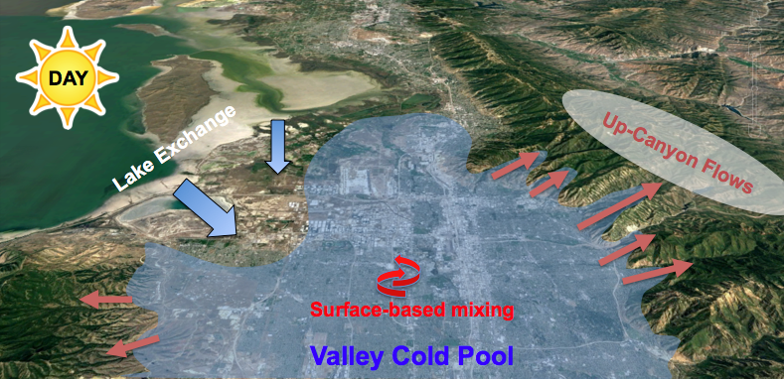
Figure 3.3.1: Schematic Illustration of diurnal exchange processes affecting the evolution of a PCAP in the Salt Lake Valley.

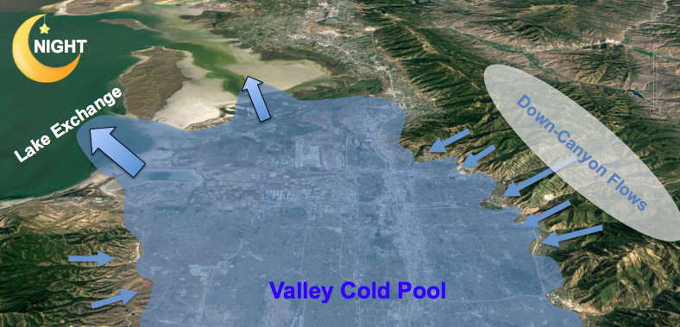

The NSF-funded meteorological component of UWFPS allowed the installation of equipment at the interfaces between the Salt Lake Valley and two tributary canyons (Red Butte Canyon and Parleys Canyon) and between the Salt Lake Valley and the Great Salt Lake. Further, LiDAR and radiosonde observations monitored the evolution of the thermal and dynamic structure of the PCAP at the center of the basin.

The Red Butte Canyon site (RB) was equipped with surface wind sensors, a ceilometer, and PM_{2.5} and ozone observations, the Parleys Canyon (PAR) and Landfill (LFL) sites were augmented with additional SoDAR wind profilers. Goal was to investigate the link between up-canyon or down-canyon thermally driven flows at RB and PAR, particulate pollution, and ozone concentrations. Further, the role of air mass exchange with the boundary layer over the Great Salt Lake - both through thermally-driven lake breezes and synoptically forced flows - was targeted with the observations at LFL and NAA. Insufficient funding was obtained to target meteorological interbasin-exchange processes but careful analysis of existing data sets such as Mesowest (Horel et al. 2002) allows for a limited characterization of these flows.

In the following, examples of these various exchange processes are highlighted through selected case studies.

3.3.1 Down-Canyon flows

Thermally-driven down-canyon flows are strongest during clear nights and synoptically quiescent conditions, when radiative surface cooling is strong and synoptic pressure gradients are weak. The onset of the 25 January to 4 February 2017 pollution episode was characterized by increasing influence of cloudiness from 27 January (clear) to 30 January (strong influence of cloud cover), reducing the effectiveness of night-time radiative cooling (not shown) in these initial days. Thermally-driven flows were observed during the three nights at both the Parleys and Red Butte Canyon exits, as illustrated in Fig. 3.3.2 (winds in down-canyon directions, 110 and 70 degrees, respectively) However, the strength of the flows decreased with increasing cloud effects (see wind speeds).

Winds at HW and UU also show signatures of diurnal thermal wind forcing, with nocturnal northeasterly downslope and daytime west-southwesterly upslope flows at UU and nighttime southeasterly and daytime northwesterly down- and up-valley flows. The near-surface wind speeds, however, are highest during the day and suggest a downward transport of momentum from aloft, while wind speeds are highest during the night at the canyon exits.

The time series of PM_{2.5} and ozone are shown in the bottom panels of Fig. 3.3.2, and indicate a reduction in particulate concentrations and an increase in ozone concentrations during the night when the down-canyon flows transport aerosol scarce and ozone-rich air into the PCAP.

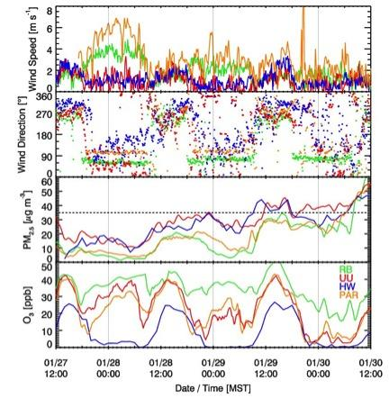
Figure 3.3.2: Time series of wind speeds, wind direction, PM2.5 and ozone concentrations collected at four selected sites near the mouths of tributary canyons (PAR, RB), the valley sidewall (UU) and the basin floor (HW) during the onset of a particulate pollution episode.

Thermally-driven down-canyon flows are expected to occur on clear nights within all tributary canyons leading into the Salt Lake, Utah and Cache Valleys. These include the Bells Canyon, Little Cottonwood, Big Cottonwood, Parley Canyon, Mill Creek, Red Butte, and City Creek drainages in the Salt Lake Valley, Weber and Ogden Canyons to the north of Salt Lake City, and the Provo and American Fork Canyons in Utah Valley. Strong influences of drainage flows are expected through Logan and Blacksmith Canyons in Cache Valley The relative strength of the canyon flows and how far and at what height above the Valley floors they extend into the PCAP atmosphere is largely unknown but likely a complex function of basin depth, slope, land cover, and other meteorological factors such as thermal stratification and the strength of synoptic flow. Signatures of possible injections of aerosol-scarce air reaching the HW site in the Salt Lake Basin, and the Lindon site in Utah Valley can be found in the ceilometer backscatter profiles collected at these sites (not shown).

3.3.2 Daytime sidewall ventilation - 29 January 2017

Even under PCAP conditions, a convective boundary layer (CBL) develops at the basin floor and along the basin sidewall during daytime. The depth of the convective mixing strongly depends on the surface net radiation, and thus on surface snow cover and cloud conditions. The development of the CBL can be seen in the vertical and pseudo-vertical temperature profiles (2.2.2.b.x), ceilometer backscatter profiles (2.2.2.b.x), and lidar-retrieved σ_{w} (2.2.2.b.x).

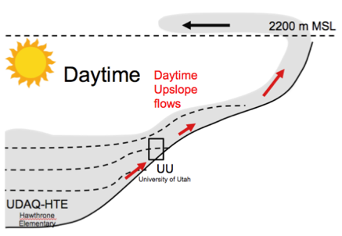 | 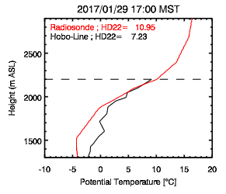
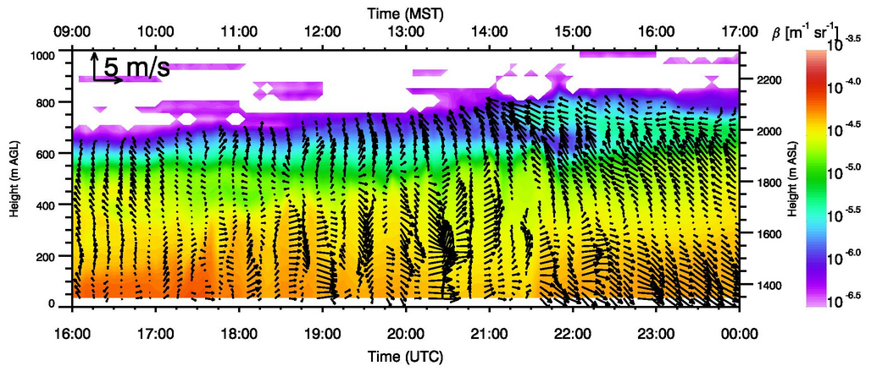

Figure 3.3.3: Illustration of basin sidewall ventilation on 29 January 2017. A schematic of the process is shown in the top left panel. Vertical (red) and pseudo-vertical temperature profiles (black) are shown for 1700 MST in the tep right. The evolution of the convective boundary layer is shown in the lidar backscatter (bottom). The recirculation of sidewall-ejected aerosols at ~2050 m ASL reaches HW shortly after 1400 MST.
Surface heating on the sun-exposed northeastern basin sidewalls is expected to drive upslope and up-canyon flows. While these flows were not directly targeted in the meteorological observations, they can be seen in time series of wind speed and direction at the canyon exit sites (PAR, RB, see Fig. 3.3.2). The thermal forcing, however, can be inferred from the difference between the balloon-based temperature soundings and the pseudo-vertical temperature profiles collected along the northeastern basin transect, as shown for the afternoon of 29 January 2017 (Fig 3.3.3). LiDAR backscatter collected at HW during this day shows the growth of the CBL. Aerosols ventilated along the basin sidewall are recirculated with the easterly flow above 2000 m ASL and are picked up in the backscatter profile at HW after 1400 MST.

3.3.3 Lake breeze circulation - 30 January 2017

A lake-breeze event is illustrated in Fig 3.3.4 using the case study of 30 January 2017 as a pollution episode evolved in the Salt Lake Valley. In the afternoon, the thermal contrast between a warmer valley boundary layer and the cold air over the lake forced a lake breeze front to penetrate into the northern part of the Salt lake Valley. The lake atmosphere brought aerosol-scarce air into the basin, leading to a decreasing PM2.5 concentrations as the breeze advanced.

The flight of the instrumented KSL news helicopter (Crosman et al. 2017) flown in the northern part of the valley revealed the depth of the lake breeze. The last panel of Fig 3.3.4 shows a smoothed profile of the averaged PM_{2.5} observations as the helicopter ascended within and descended back into the PCAP. It reveals how shallow the lake breeze is as it undercuts the more heavily polluted valley airmass.

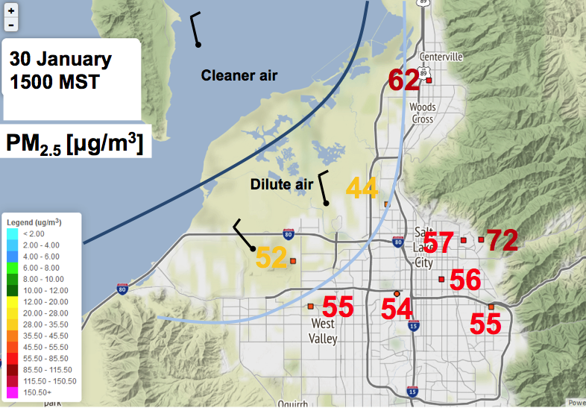 | 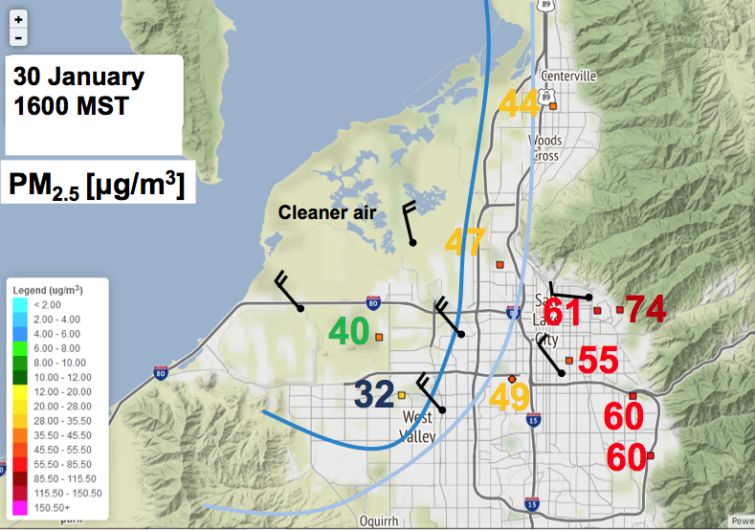
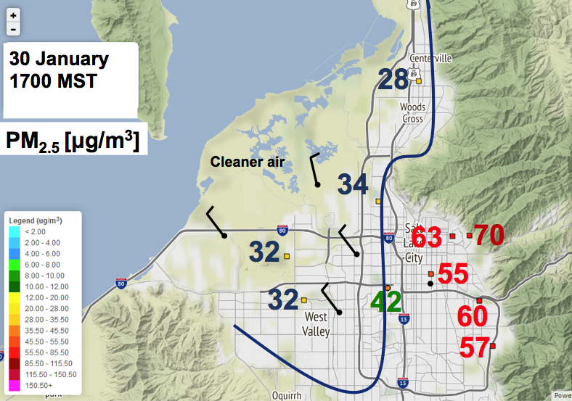 | 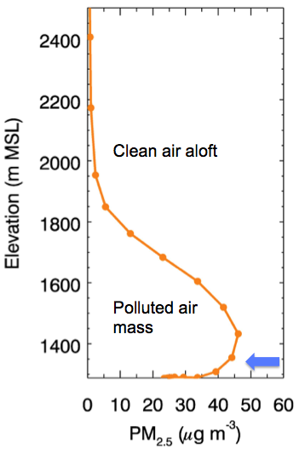
Fig 3.3.4: Analysis of the surface wind field and surface PM2.5 concentrations during the 30 January 2017 lake breeze event. The last panel shows a smoothed vertical profile of PM2.5 concentrations from observations on a local news helicopter taken in the northern part of the basin.

3.3.4 Synoptically-forced lake exchange

A schematic of the wind field and particulate concentrations during a synoptically-forced lake exchange event is shown in Fig. 3.3.5. In the morning of 3 February 2017, strong southerly flow scoured out the pollution from the Salt Lake basin, starting at the benches (0500 MST), and eventually eroding the entire PCAP in the basin (0730 MST). Polluted air was pushed north over the Great Salt Lake.

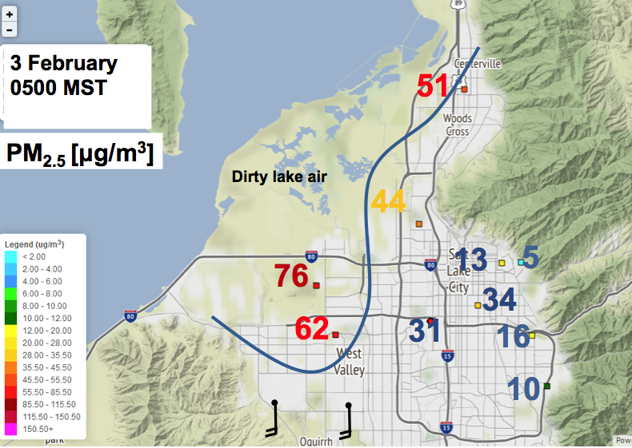 | 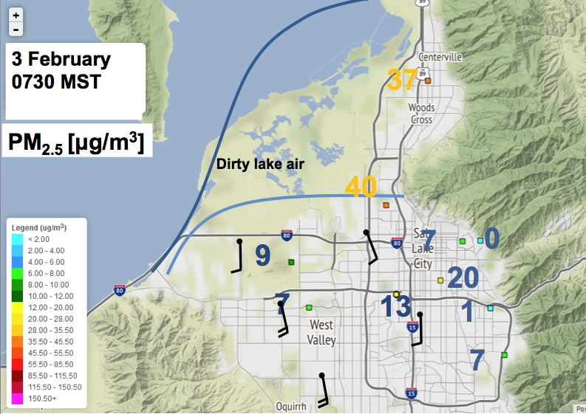
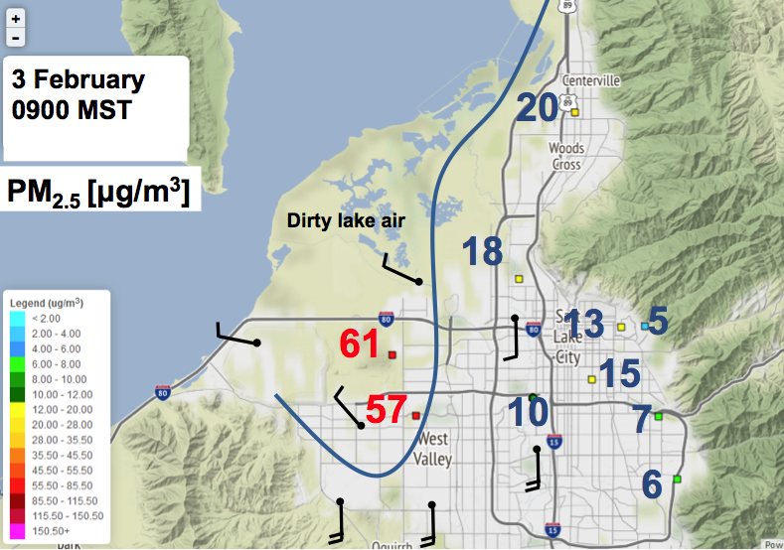 | 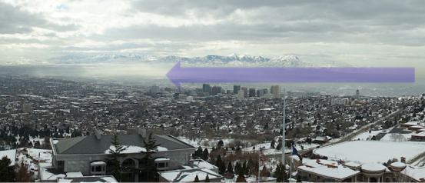
Fig 3.3.5: Analysis of the surface wind field and surface PM2.5 concentrations during the 3 February 2017 lake “recharge” event. The last panel shows a photograph of the shallow tongue of polluted air “recharging” the basin.

By 0900 MST, however, the flows weakened and colder and aerosol-rich air penetrated back into the lowest areas of the Salt Lake basin, leading to a “recharge” of the pollution are those locations. The last panel shows a photograph of the pollution tongue penetrating back into the basin.

3.3.5 Inter-Basin Exchange

Interbasin exchange through synoptically forced and or thermally driven circulations may play an important role in the import and export of pollutants, pollutant precursors, and oxidants. Initial plans to place additional equipment at the Jordan Narrows could not be realized due to limited funding. Nevertheless, data from MesoWest stations, TRAX-based measurements, and large gradients in pollutants between the Salt Lake and Utah Basins can indicate the role of such interbasin exchange processes.

Initial analysis shows that ammonia concentrations at HW are associated with periods of interbasin exchange. During most nights during the UWFPS study, a period of southerly flow was observed by a Utah Department of Transportation Weather station in the Jordan Narrows gap (Fig 3.3.6). However, periods when that exchange persisted for longer time periods were also observed. The following periods were identified as having both a PCAP and significant prolonged south-to-north (from Utah Valley into Salt Lake Valley) from Mesowest observations (Fig 3.3.6): January 17-20, 28-31 and Feb 1-2 2017.

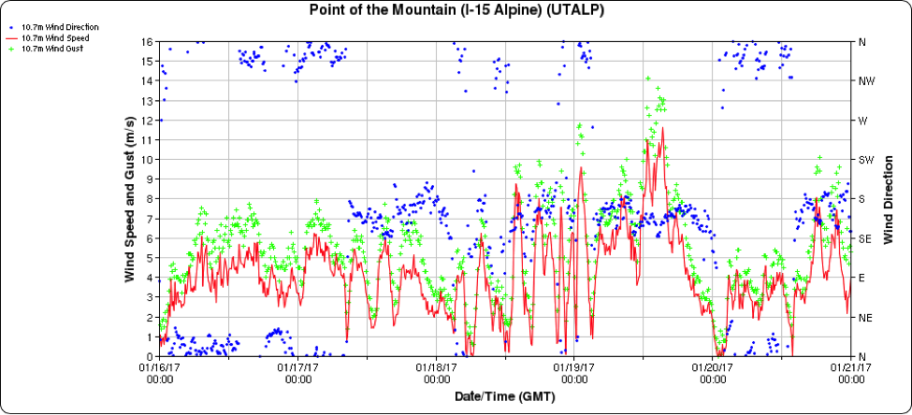
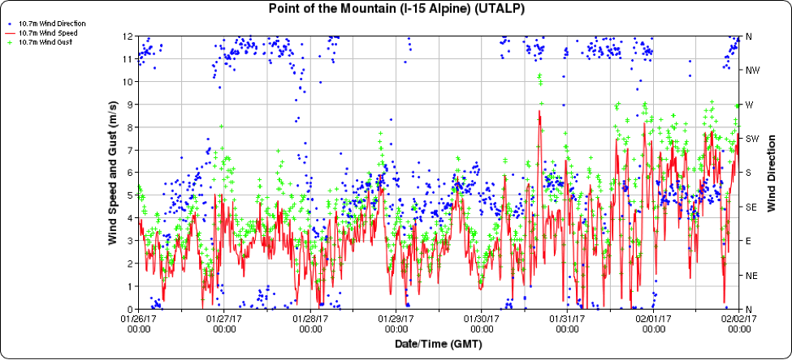
Fig 3.3.6: Wind speed (m s⁻¹) and wind direction at the Point of the Mountain Utah Department of Transportation weather station between 16-21 January 2017 (top) and 26 January- 2 February 2017 (bottom).
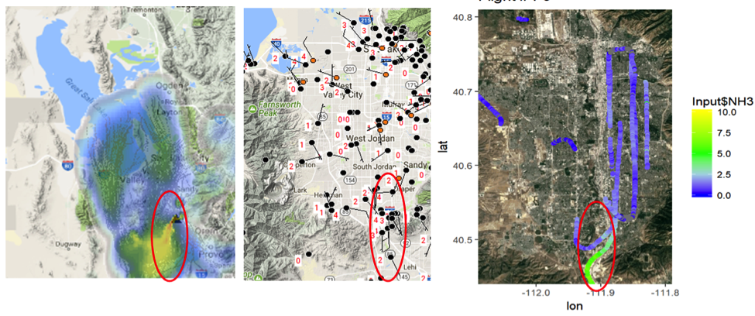
Fig 3.3.7: Analysis of HRRR-STILT backward trajectories (left panel), Mesowest surface wind speeds (middle panel, barb and red value, in ms⁻¹) and ammonia concentrations from the NOAA Twin Otter during the afternoon of 17 January 2017. The red circled region indicates the region of southerly inter-basin from the Utah Valley into the Salt Lake Valley and the associated high ammonia concentrations (ammonia figure courtesy Ann Middlebrook).

Another valuable resource for determining the southerly flow are particulate and ozone sensors onboard the TRAX light-rail train (Mitchell et al. 2017). On 31 January 2017, the TRAX sensors intersected a plume of air with higher particulate concentrations flowing into the Salt Lake Valley from the Utah Valley. Mesowest observations and HRRR-Stilt analyses verify that the source of the polluted air observed by TRAX was from the Utah Valley (Fig 3.3.8)

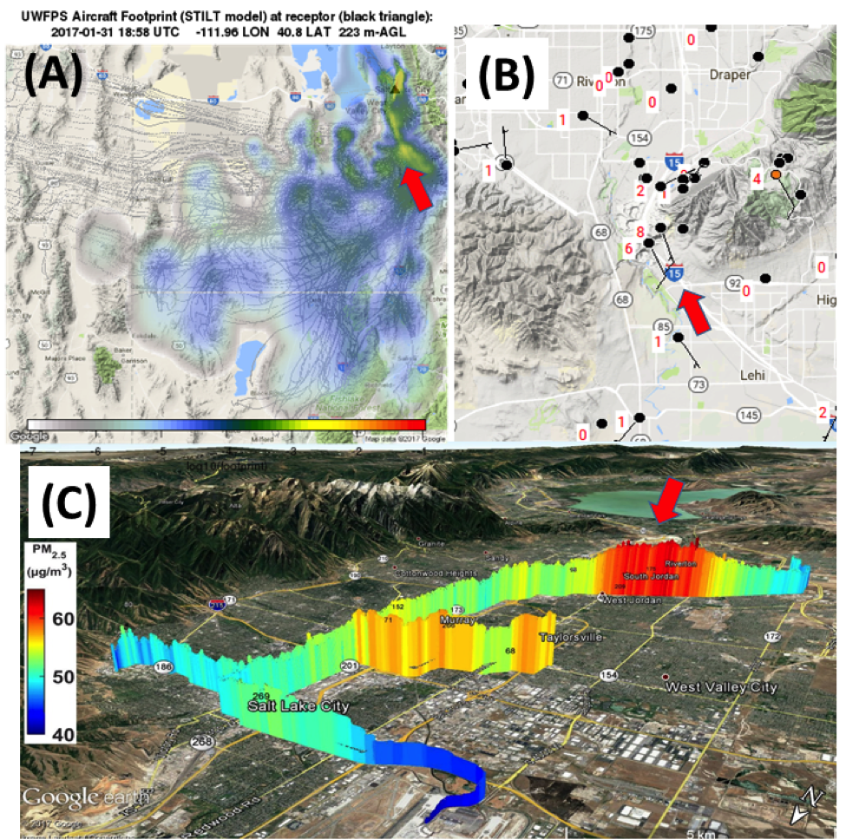
Fig 3.3.8: (a) analysis of HRRR-STILT backward trajectories, (b) Mesowest surface wind speeds (barb and red value, in ms⁻¹), and (c) TRAX PM_{2.5} concentrations during mid-morning hours on 31 January 2017.

Figures
Sebastian/Erik, slides on transport/exchange processes and discussion (as needed)
John Lin: slide 5 the averaged footprint; slide 13-15 discussion
Alex Moravek, Erik Crosman, Logan Mitchell, Amy: Choose a flight from Alex’s slides 11, 12, 14, or 15 and pair it with MESOWEST, trax and/or UU AIM observations and STILT footprints

Needs:

Logan, Erik, John, Jen’s group, Munkh.:select a date e.g. Jan 30 or Jan 31 with transport of NH3 from Utah valley
Munkh: cite NAA work (slide 15-17) for the potential importance of transport from Utah valley
Erik’s comment on the frequency of this transport.

