Online Supplement for: The MatterHEX Experiment – Investigating Atmospheric Flow Patterns in Highly Complex Terrain Related to Banner Cloud Formation

Sebastian W. Hoch,^{a,b} Marius L. Thomas,^{c} Hendrik Huwald ^{d,e}, Michael Lehning ^{d,e}, Brandon J. A. van Schaik ^{d}, Paul Imbert ^{d}, Dominique S. Rentel ^{c}, and Volkmar Wirth,^{c}
ª Earth Observing Laboratory, National Center for Atmospheric Research, Boulder, CO
^{b} Atmospheric Sciences Department, University of Utah, Salt Lake City, UT
^{c} Johannes Gutenberg University Mainz, Mainz, Germany
^{d} Laboratory of Cryospheric Sciences, Ecole Polytechnique Fédérale de Lausanne (EPFL), Sion, Switzerland
^{e} WSL Institute for Snow and Avalanche Research, SLF Davos, Switzerland

Corresponding author: Sebastian Hoch, hoch@ucar.edu

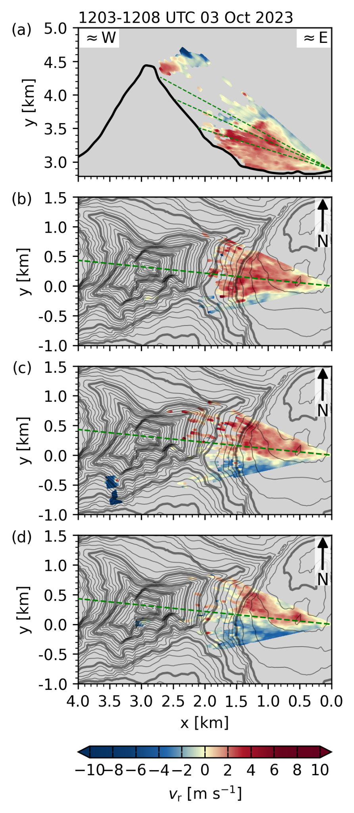  Fig. S1: Lee-side radial velocities resolved by (a) the range-height indicator scan (RHI) through the summit pyramid, and plan-position indicator scans (PPI) at (b) 16.5°, (c) 23°, and (d) 27° elevation for the scan cycle between 1203 and 1207 UTC, 3 October 2023. | 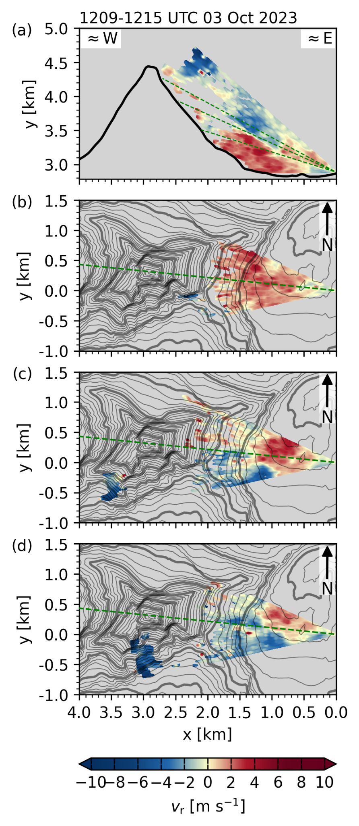  Fig. S2: As Fig 1, but for scan cycle between 1209 and 1215 UTC, 3 October 2023. | 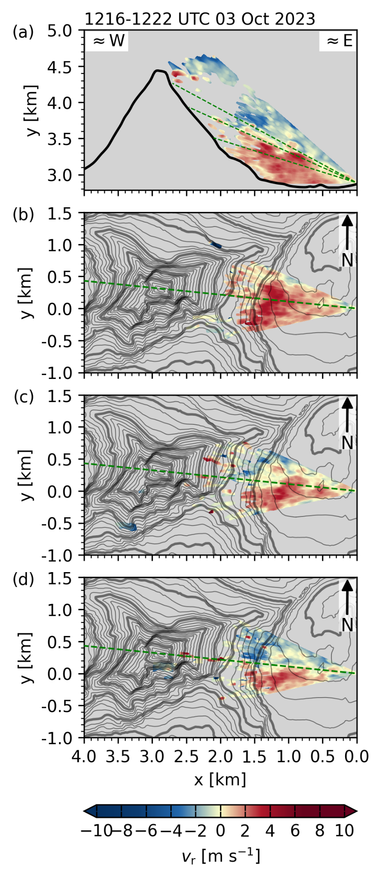  Fig. S3: As Fig 1, but for scan cycle between 1216 and 1222 UTC, 3 October 2023.
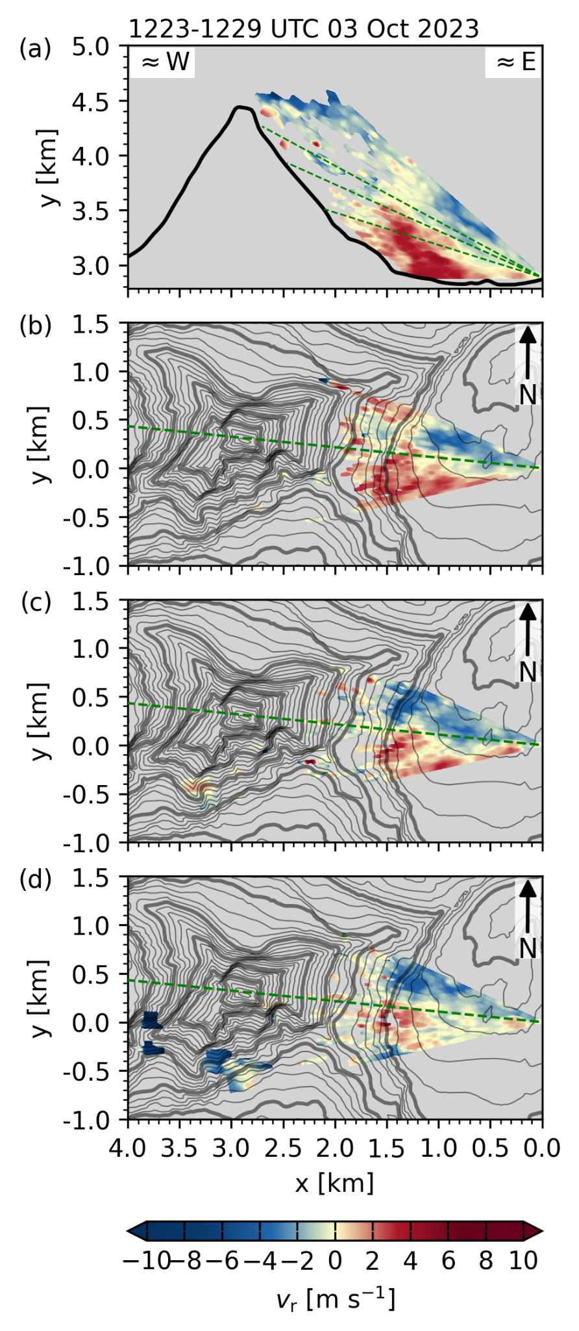  Fig. S4: As Fig 1, but for scan cycle between 1223 and 1229 UTC, 3 October 2023. | 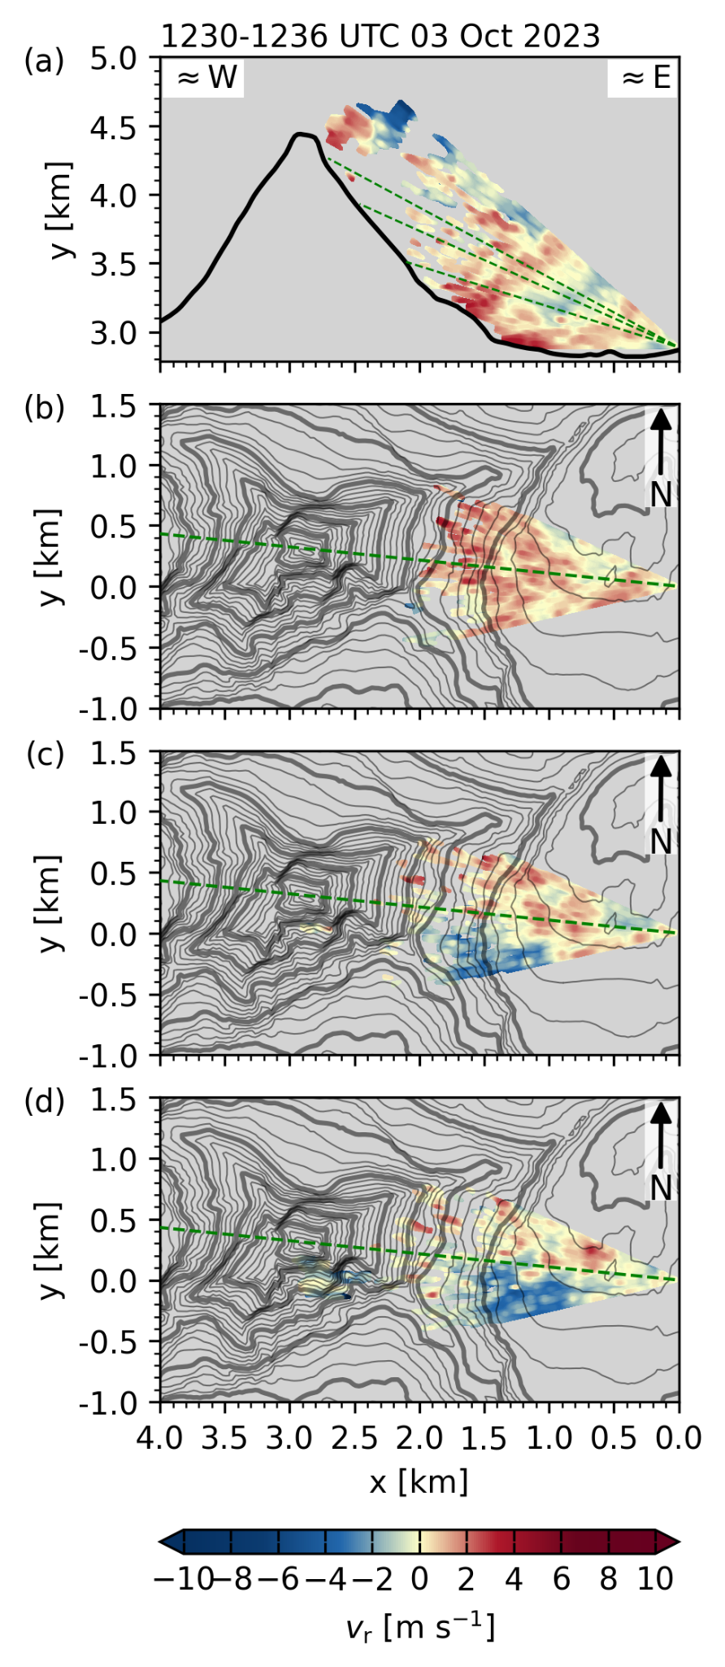  Fig. S5: As Fig 1, but for scan cycle between 1230 and 1236 UTC, 3 October 2023. | 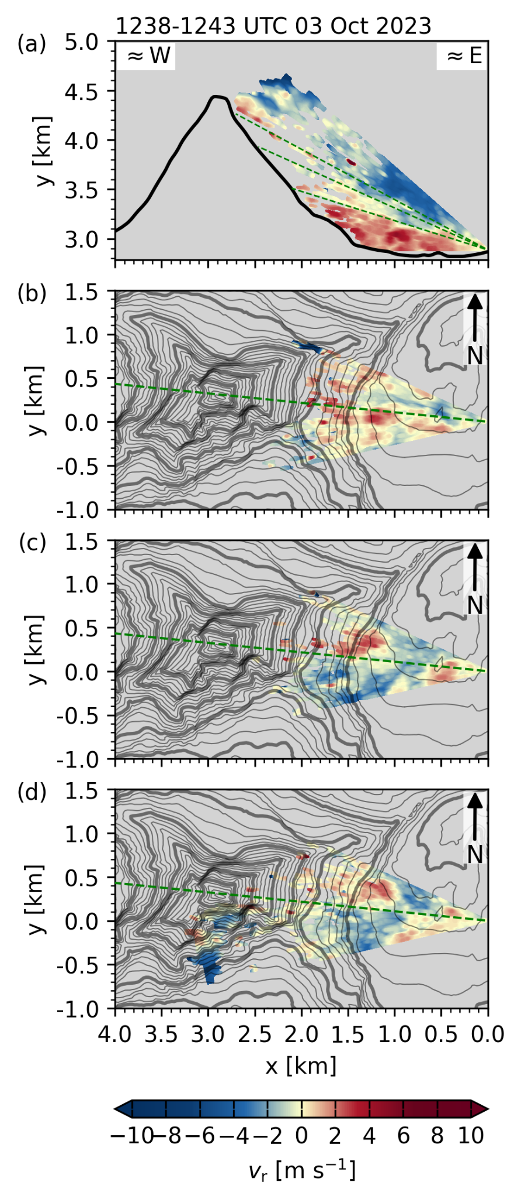  Fig. S6: As Fig 1, but for scan cycle between 1238 and 1243 UTC, 3 October 2023.
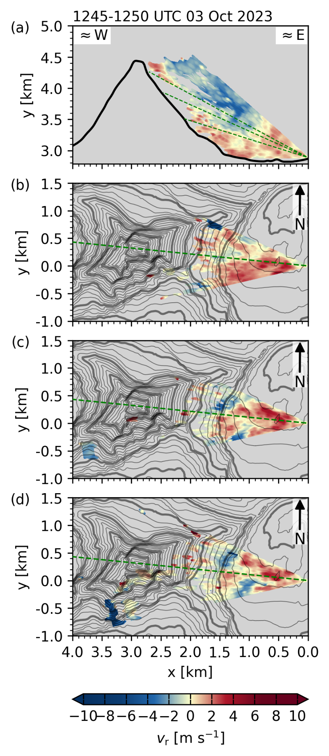  Fig. S7: As Fig 1, but for scan cycle between 1245 and 1250 UTC, 3 October 2023. | 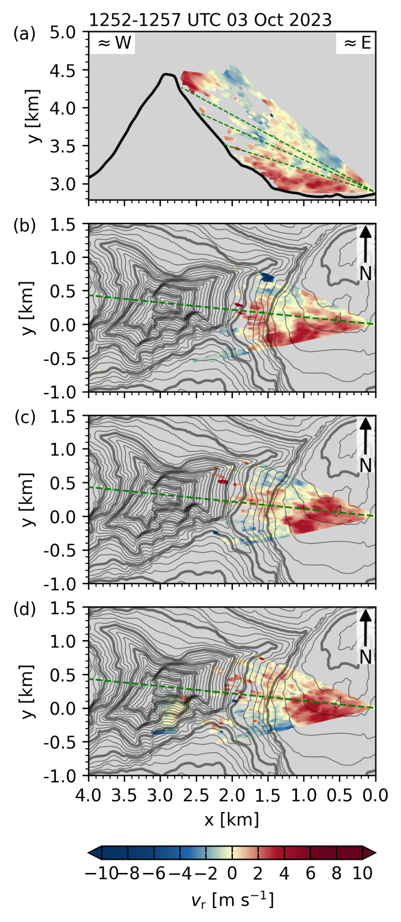  Fig. S8: As Fig 1, but for scan cycle between 1252 and 1257 UTC, 3 October 2023. | 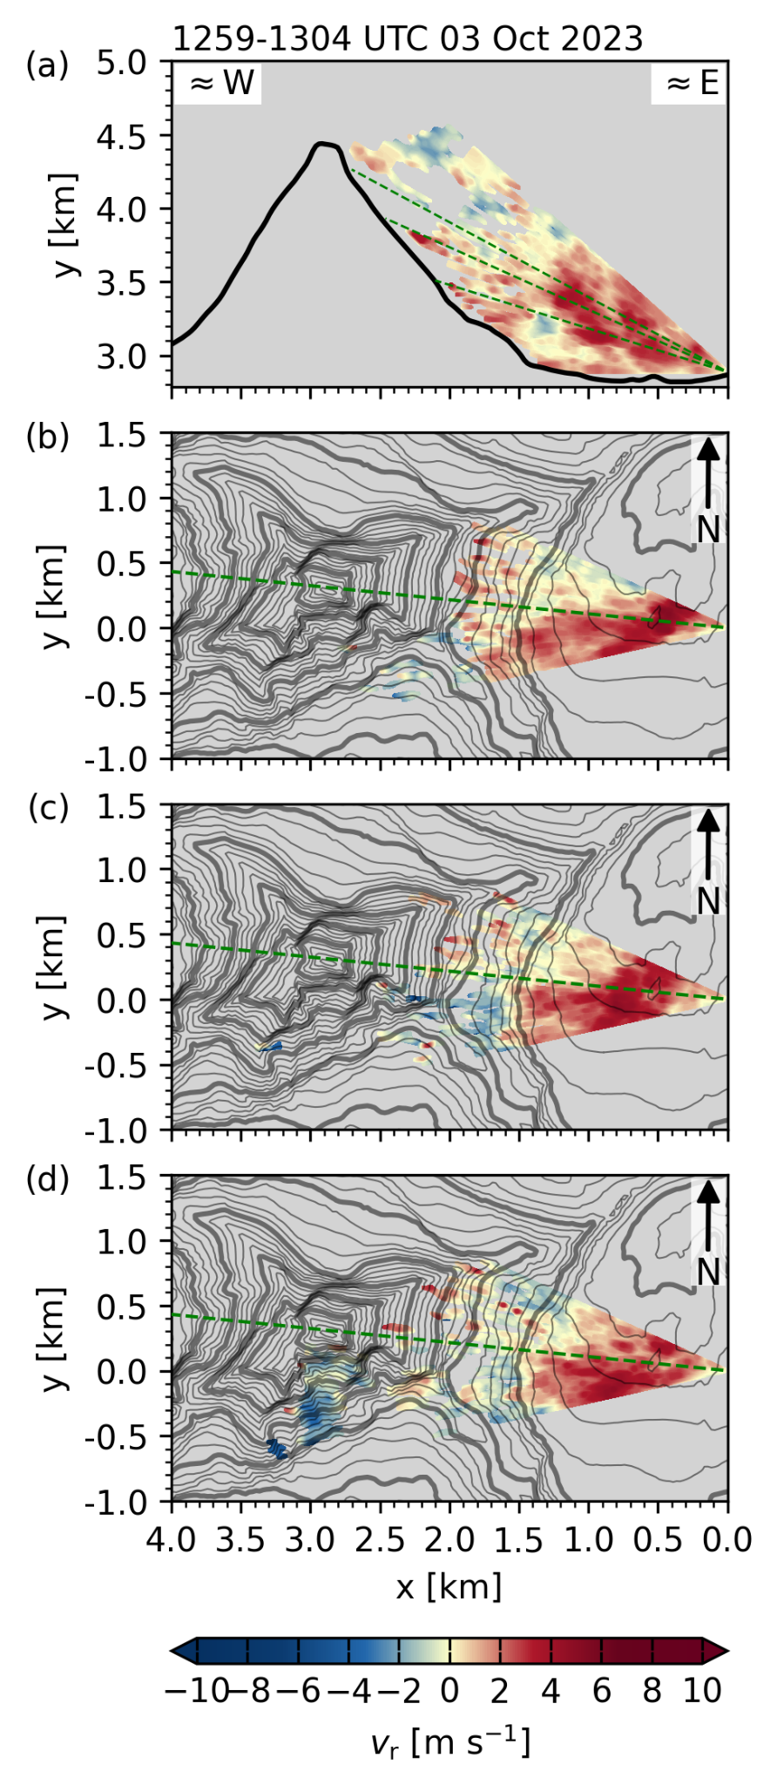  Fig. S9: As Fig 1, but for scan cycle between 1259 and 1304 UTC, 3 October 2023.
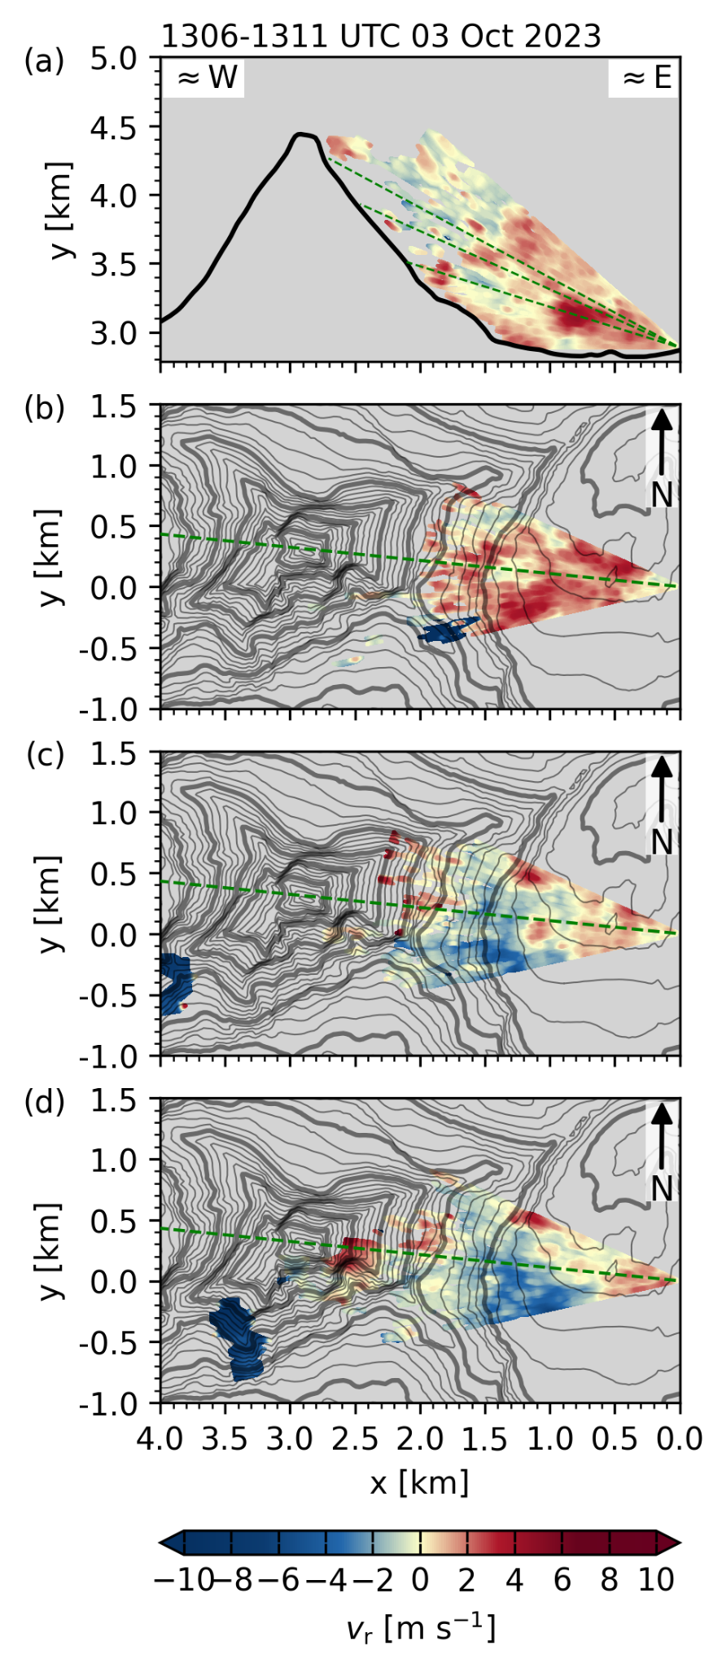  Fig. S10: As Fig 1, but for scan cycle between 1306 and 1311 UTC, 3 October 2023. | 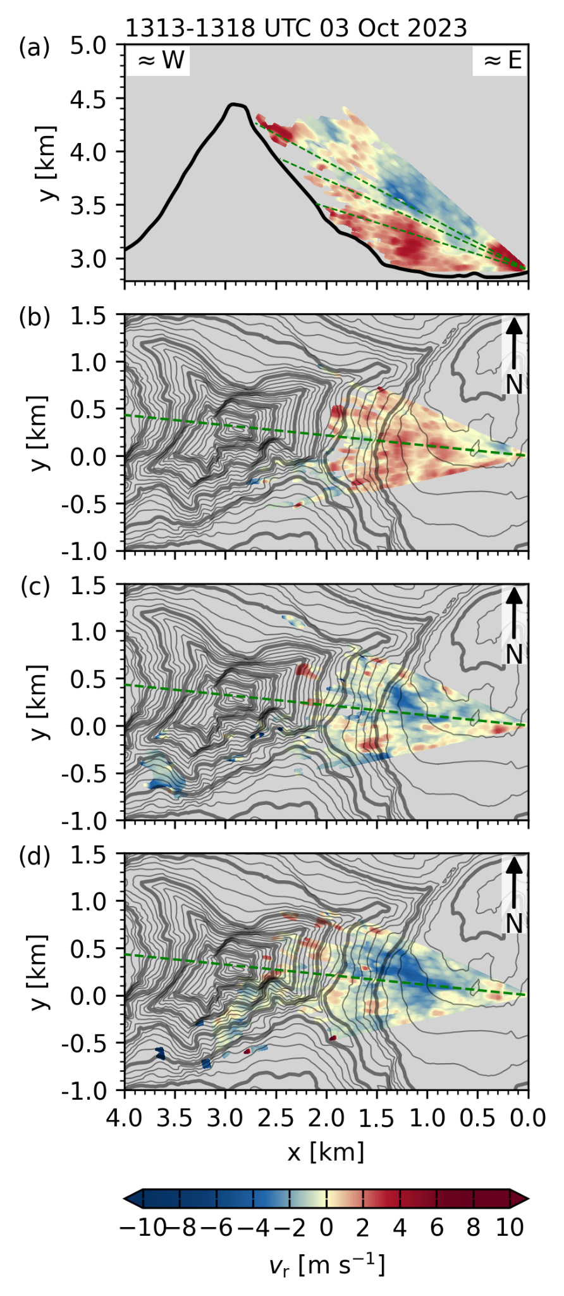  Fig. S11: As Fig 1, but for scan cycle between 1313 and 1318 UTC, 3 October 2023. | 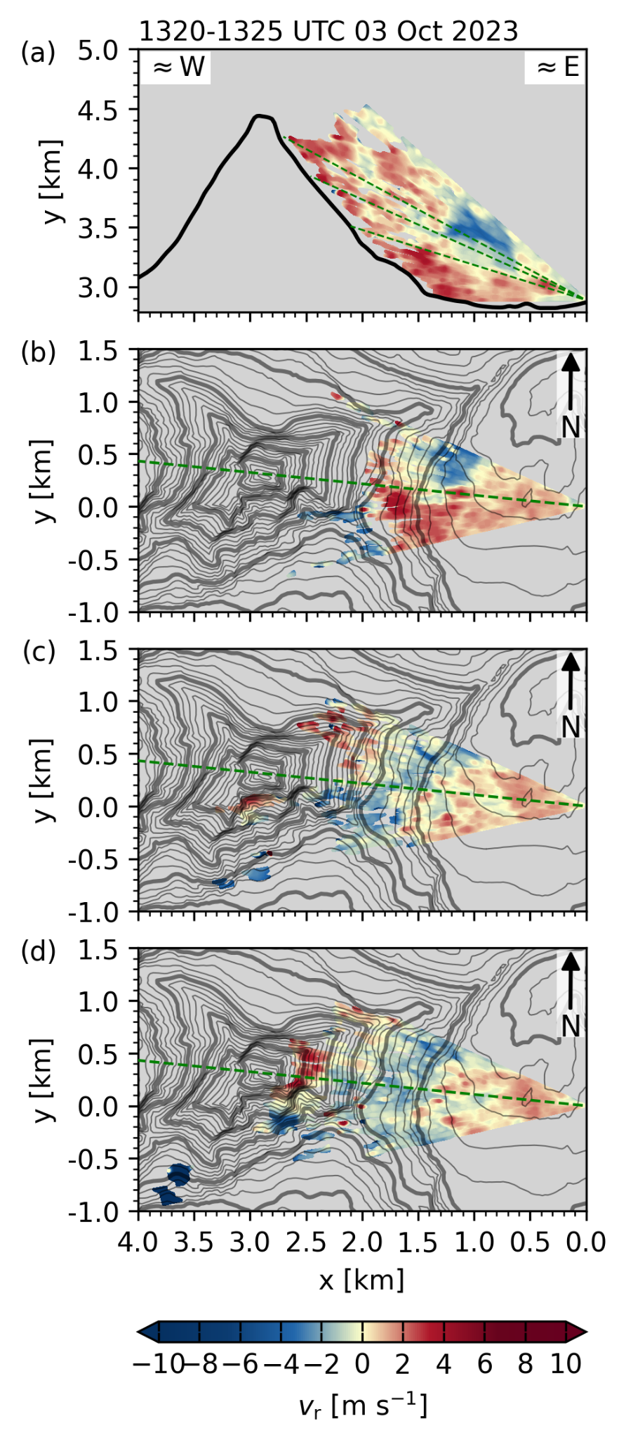  Fig. S12: As Fig 1, but for scan cycle between 1320 and 1325 UTC, 3 October 2023.
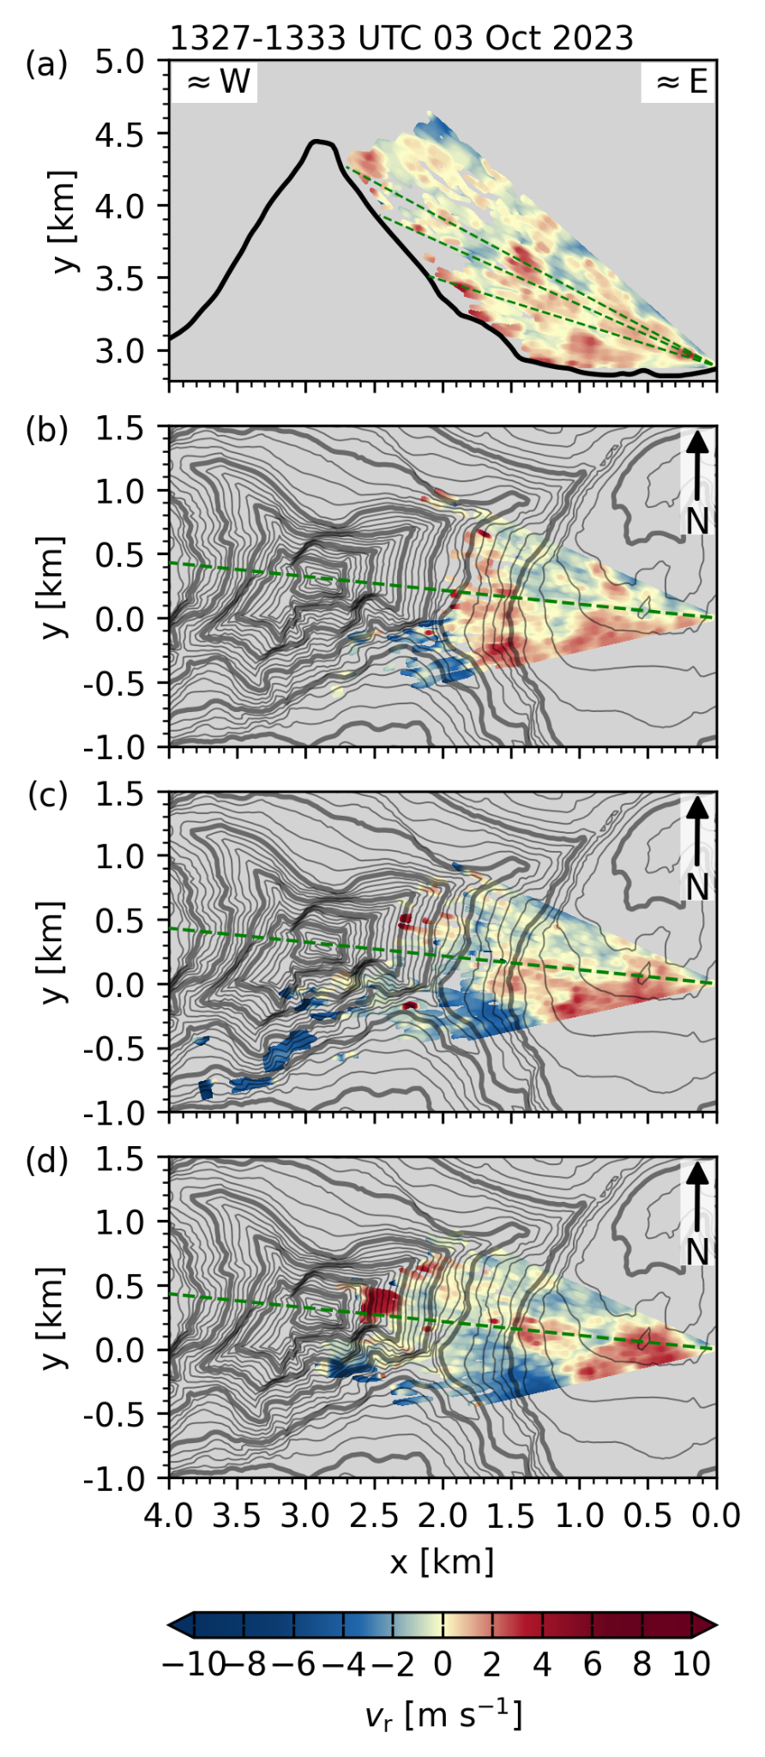  Fig. S13: As Fig 1, but for scan cycle between 1327 and 1333 UTC, 3 October 2023. | 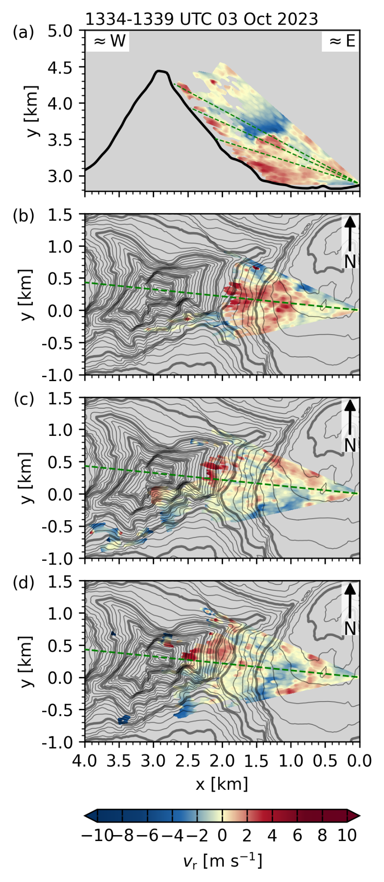  Fig. S14: As Fig 1, but for scan cycle between 1334 and 1339 UTC, 3 October 2023. | 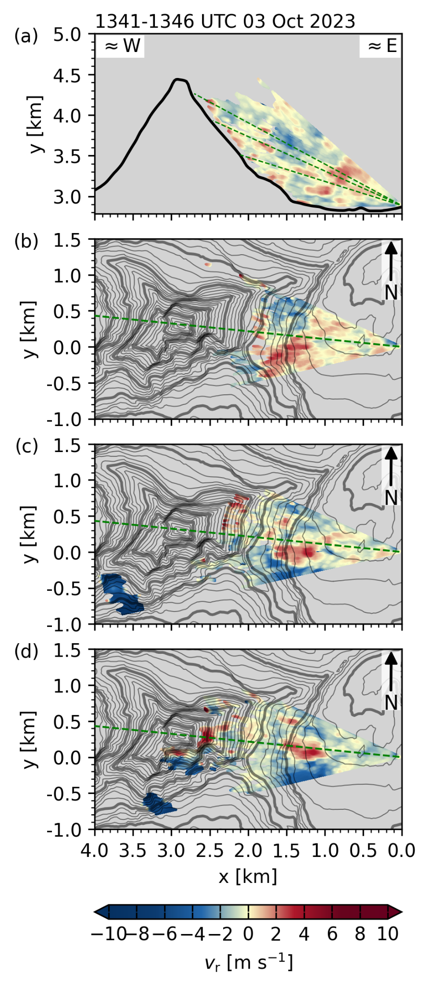  Fig. S15: As Fig 1, but for scan cycle between 1341 and 1346 UTC, 3 October 2023.
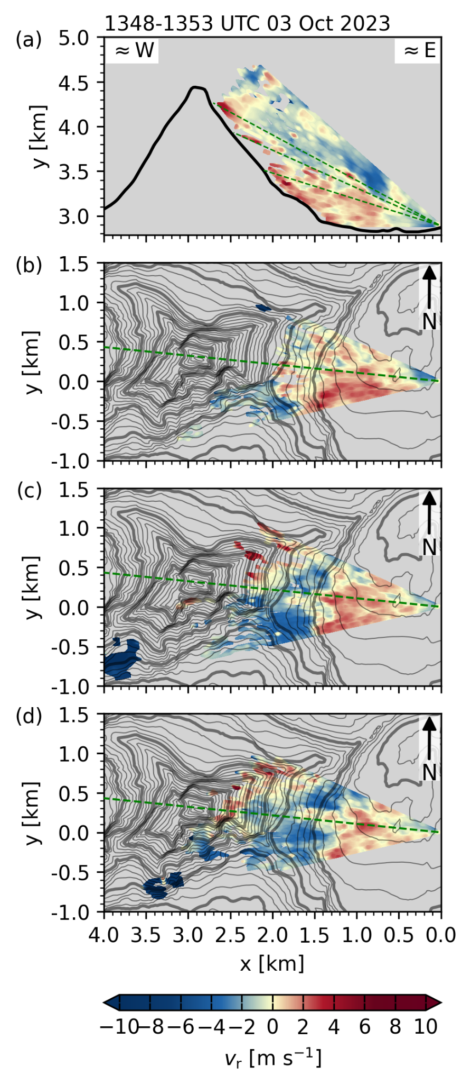  Fig. S16: As Fig 1, but for scan cycle between 1348 and 1353 UTC, 3 October 2023. | 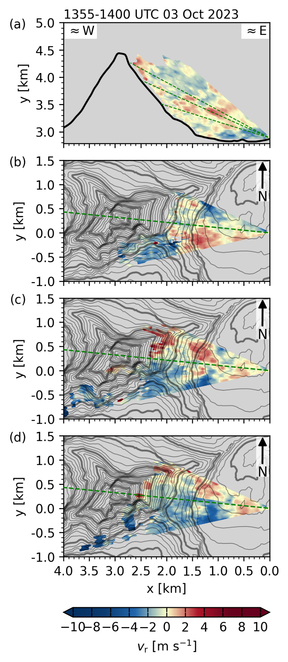  Fig. S17: As Fig 1, but for scan cycle between 1355 and 1400 UTC, 3 October 2023. | 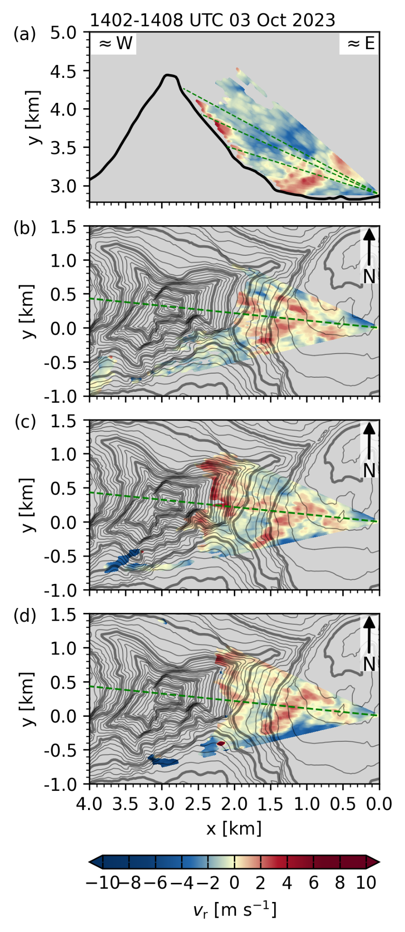  Fig. S18: As Fig 1, but for scan cycle between 1402 and 1408 UTC, 3 October 2023.
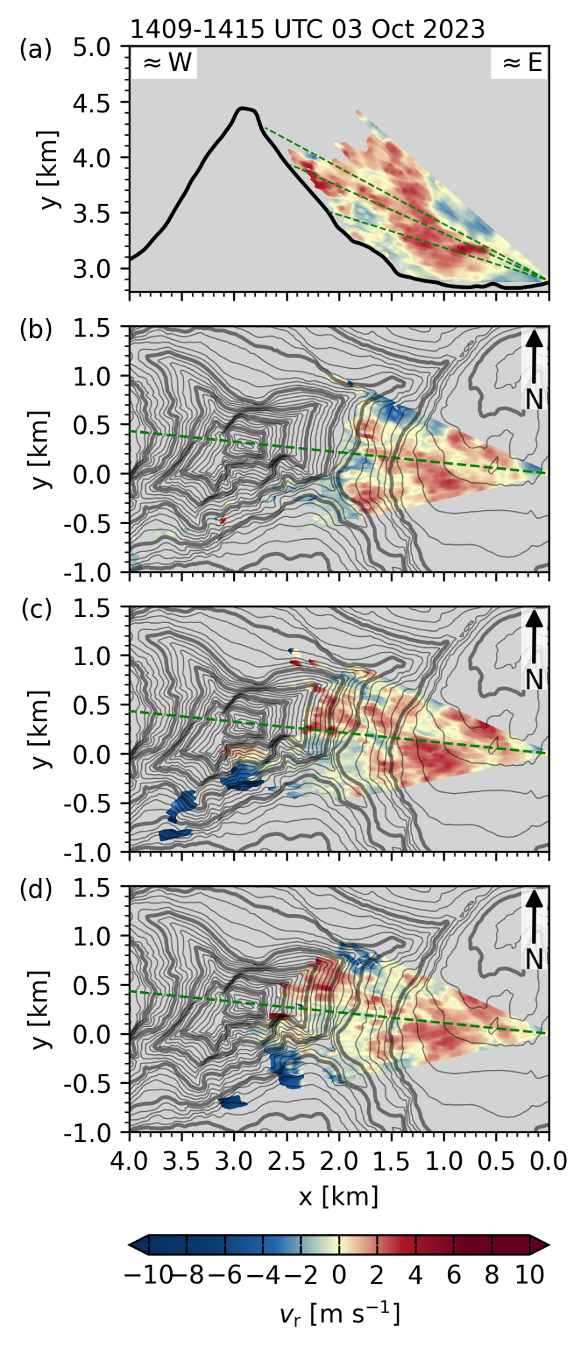  Fig. S19: As Fig 1, but for scan cycle between 1409 and 1415 UTC, 3 October 2023. | 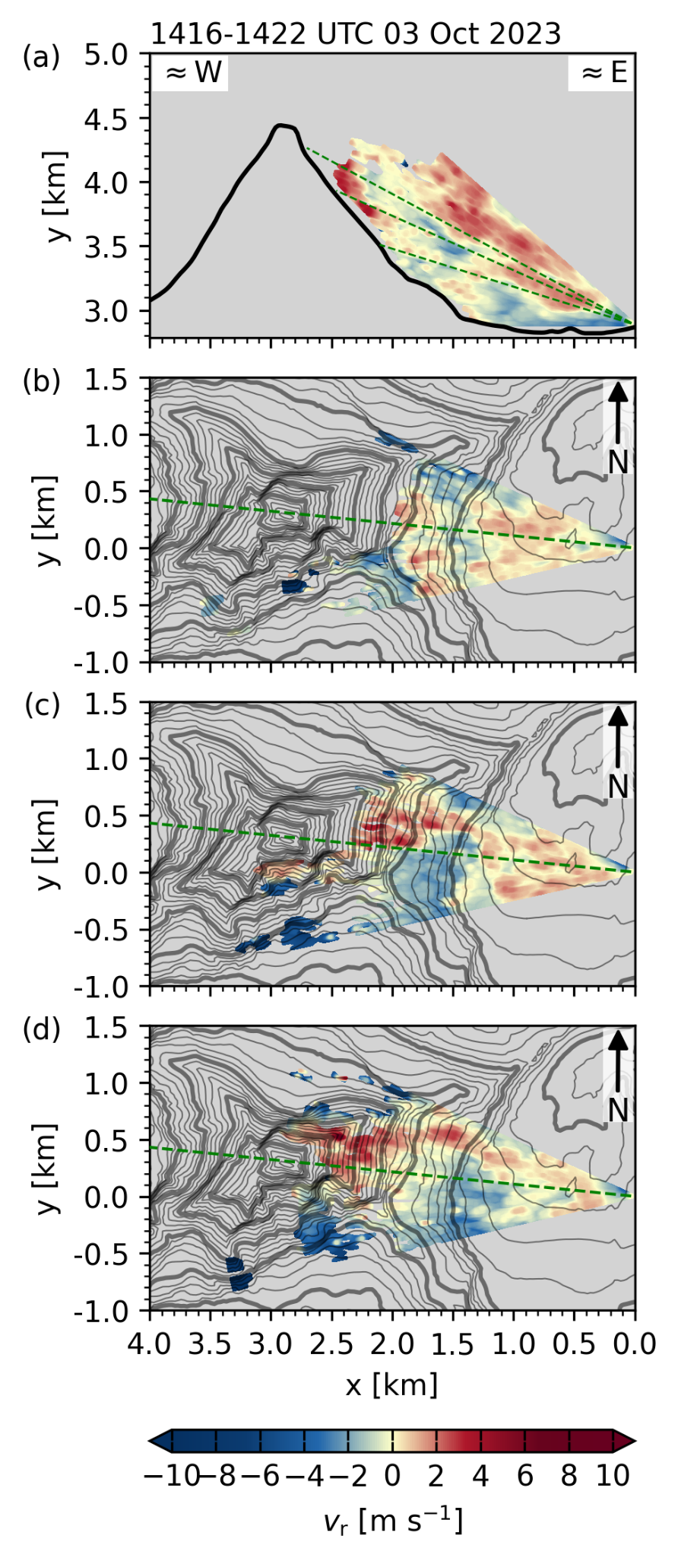  Fig. S20: As Fig 1, but for scan cycle between 1416 and 1422 UTC, 3 October 2023. | 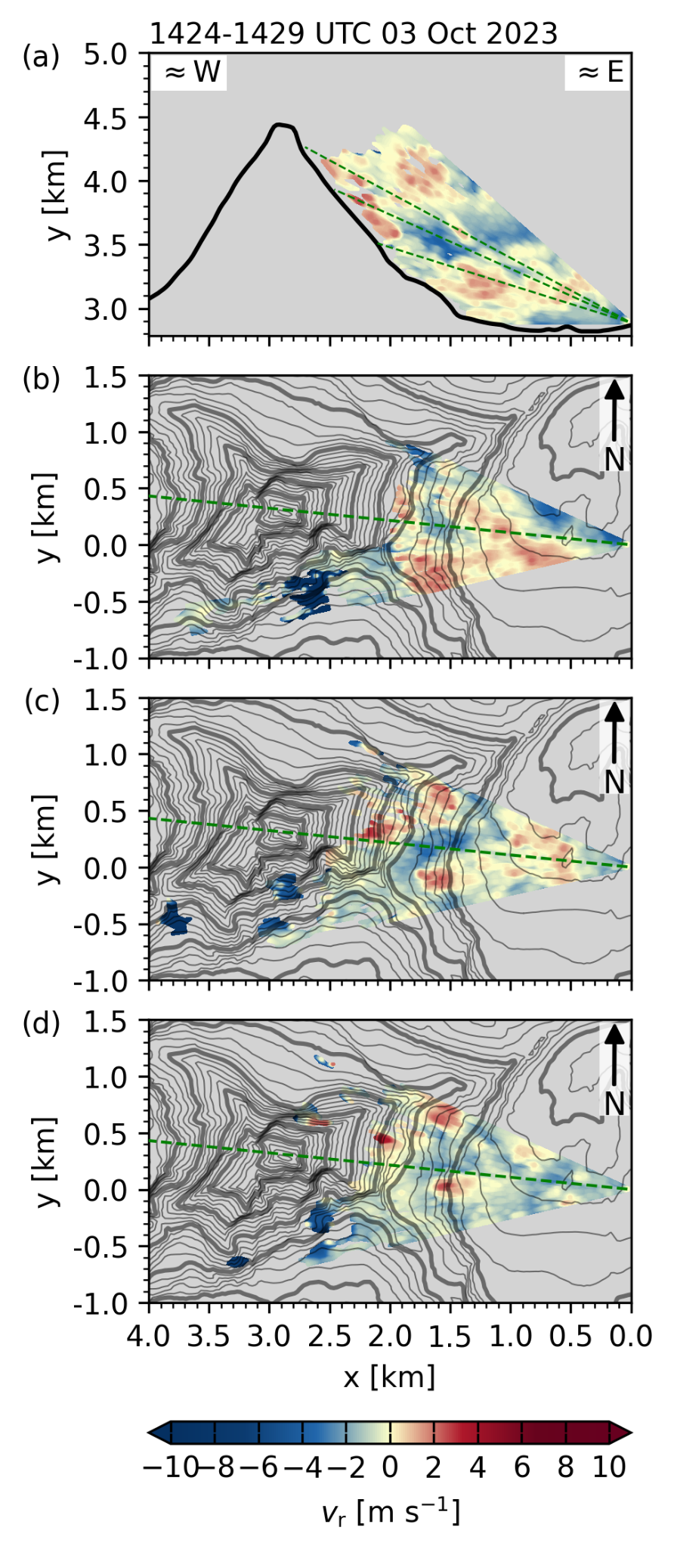  Fig. S21: As Fig 1, but for scan cycle between 1424 and 1429 UTC, 3 October 2023.
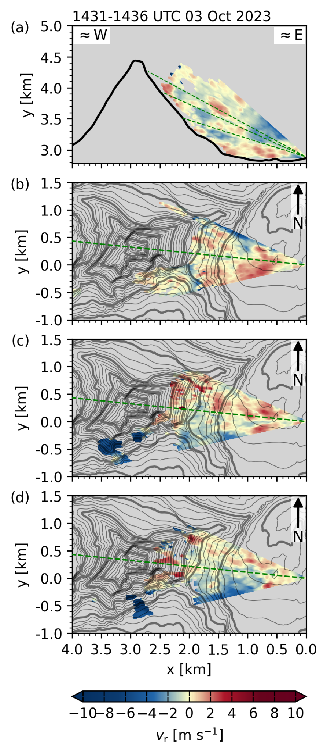  Fig. S22: As Fig 1, but for scan cycle between 1431 and 1436 UTC, 3 October 2023. | 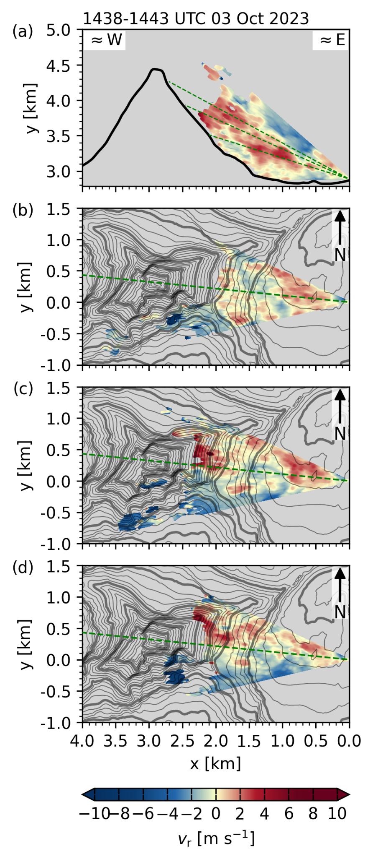  Fig. S23: As Fig 1, but for scan cycle between 1438 and 1443 UTC, 3 October 2023. | 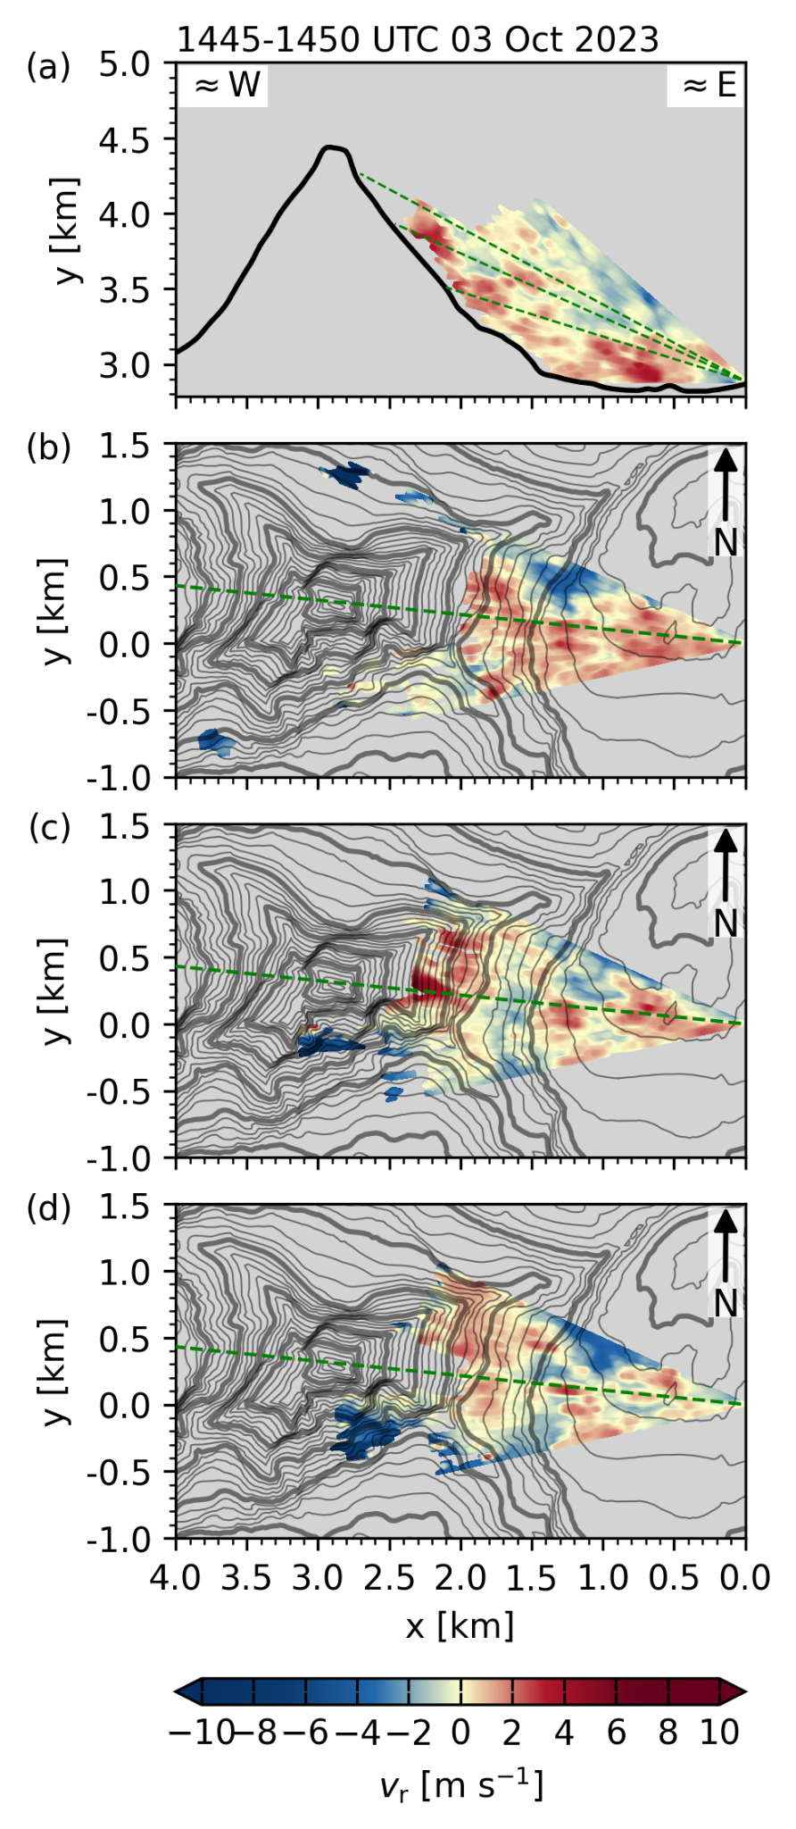  Fig. S24: As Fig 1, but for scan cycle between 1445 and 1450 UTC, 3 October 2023.
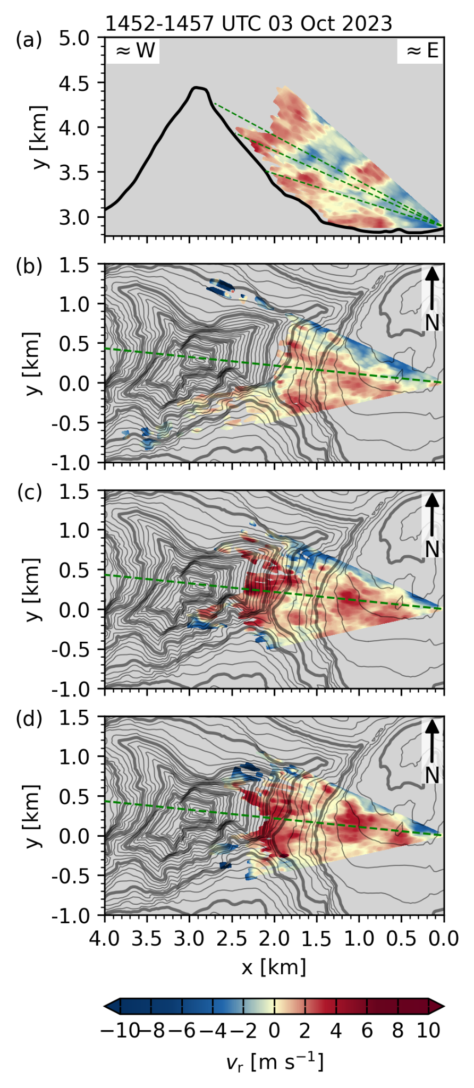  Fig. S25: As Fig 1, but for scan cycle between 1452 and 1457 UTC, 3 October 2023. | 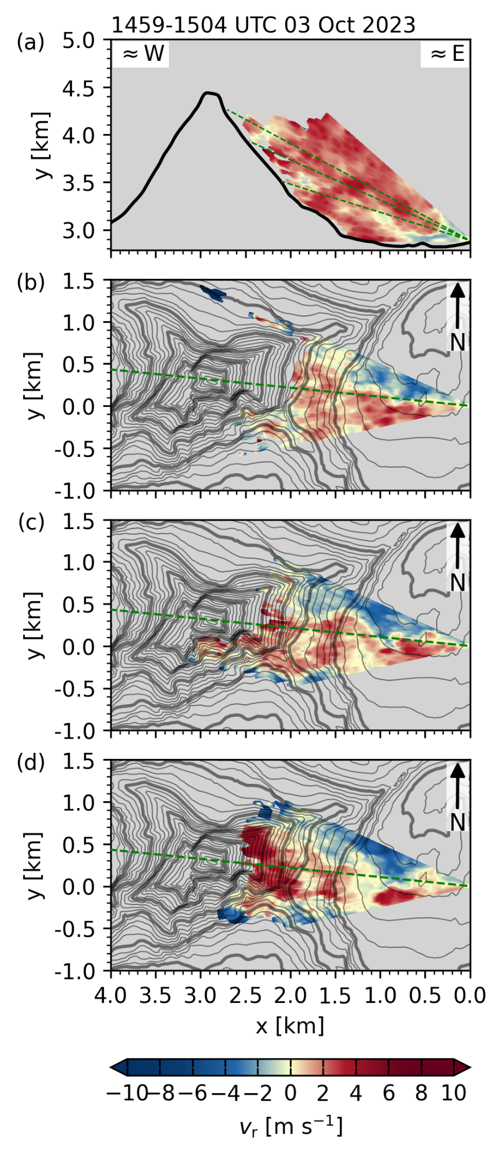  Fig. S26: As Fig 1, but for scan cycle between 1459 and 1504 UTC, 3 October 2023. | 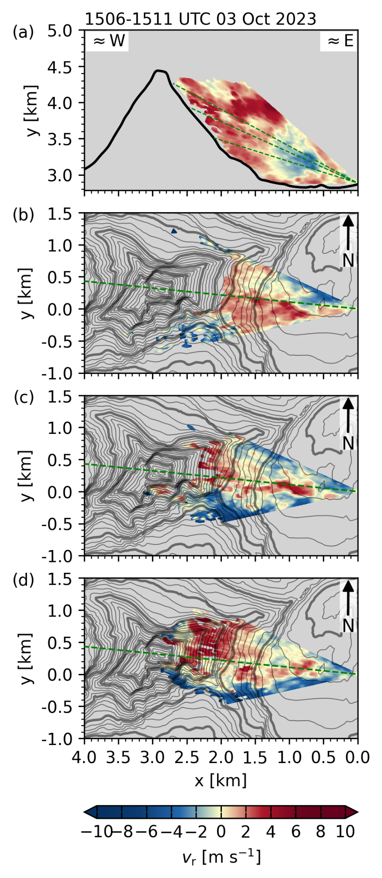  Fig. S27: As Fig 1, but for scan cycle between 1506 and 1511 UTC, 3 October 2023.
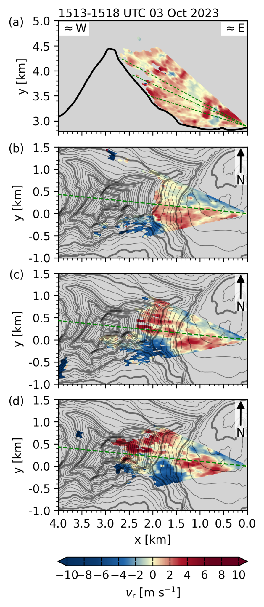  Fig. S28: As Fig 1, but for scan cycle between 1513 and 1518 UTC, 3 October 2023. | 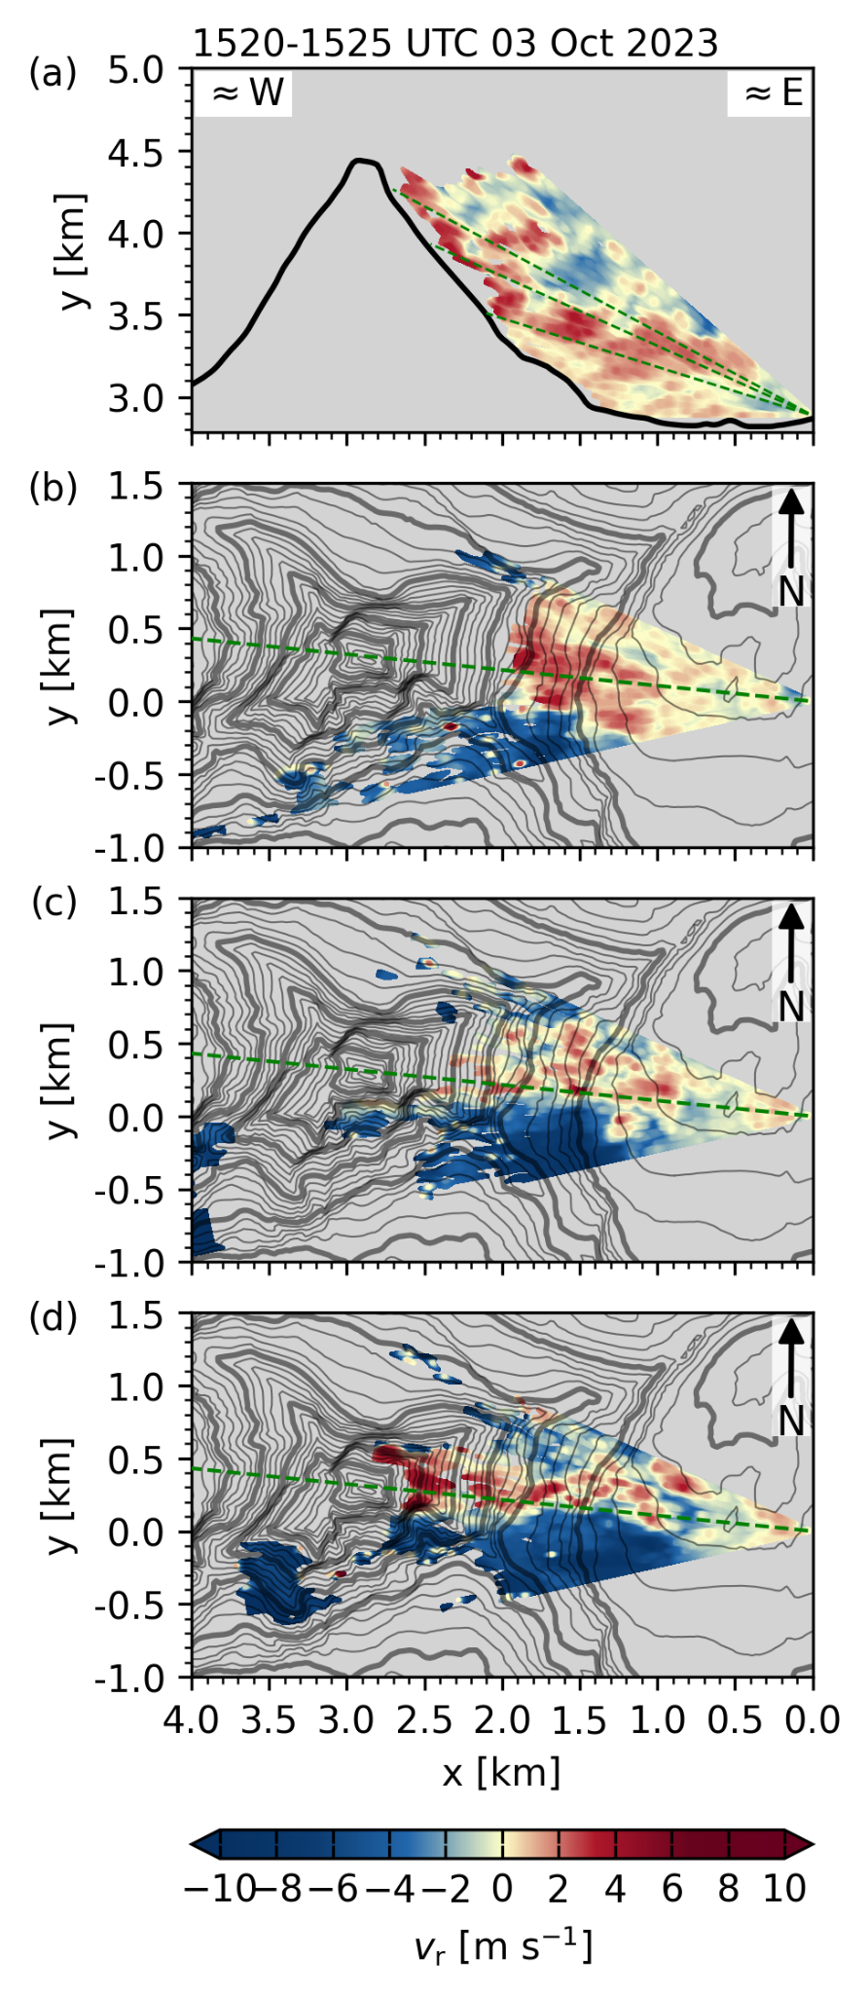  Fig. S29: As Fig 1, but for scan cycle between 1520 and 1525 UTC, 3 October 2023. | 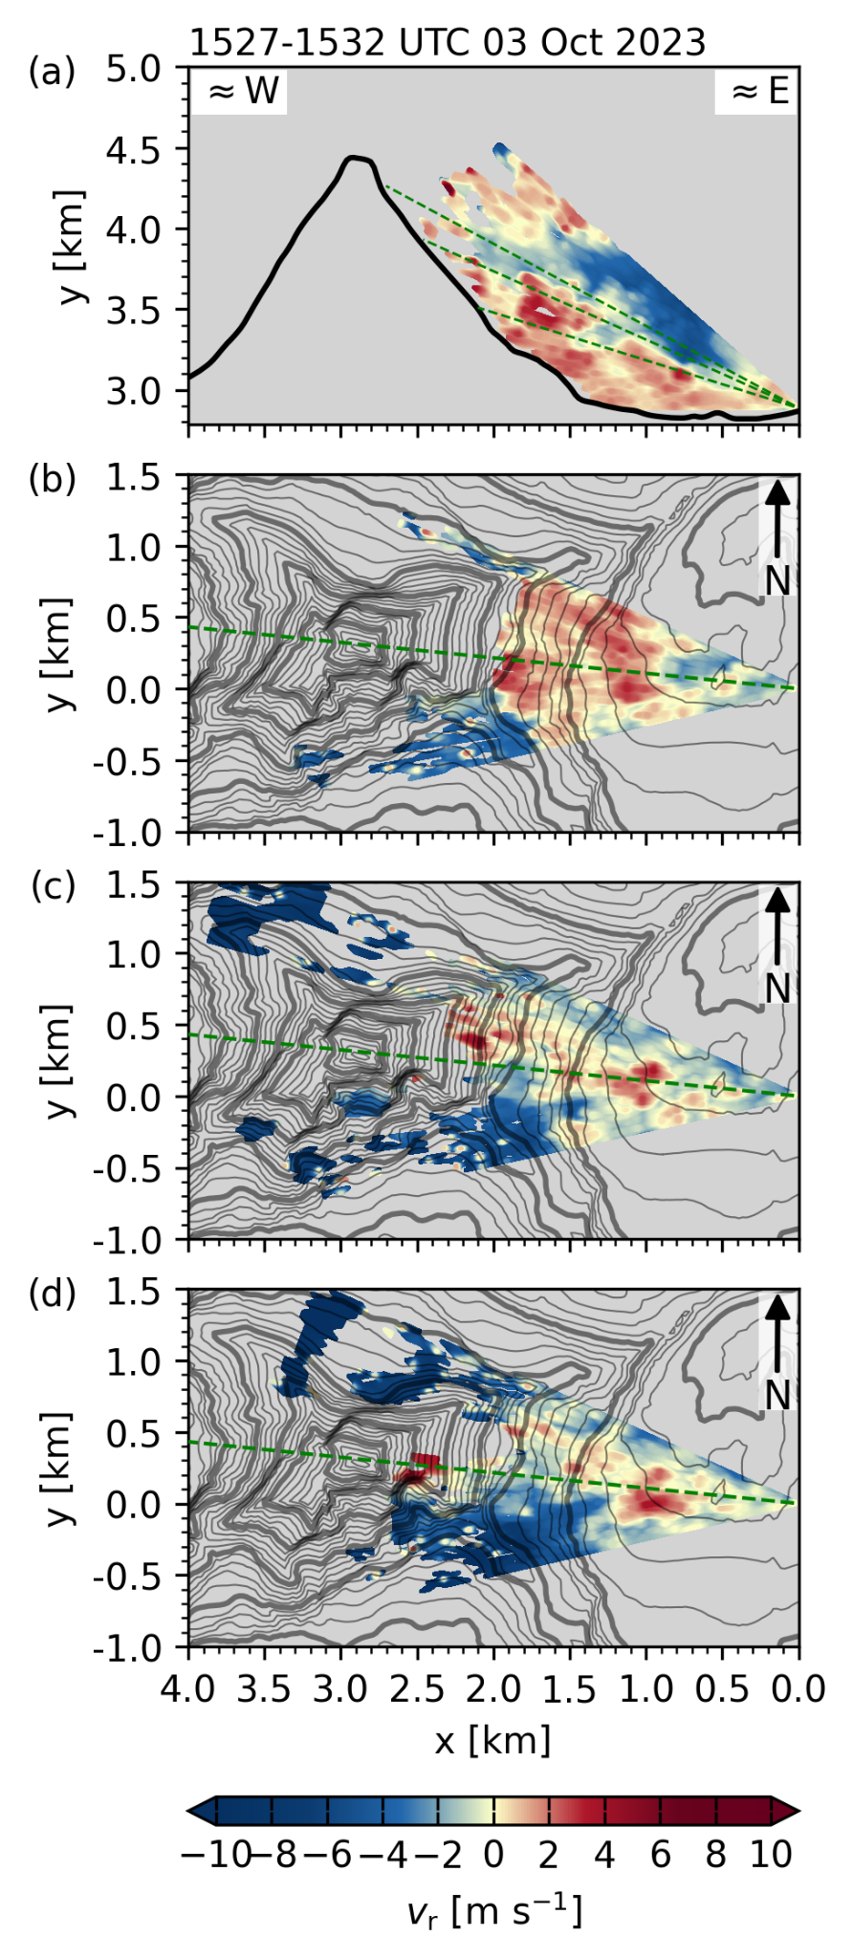  Fig. S30: As Fig 1, but for scan cycle between 1527 and 1532 UTC, 3 October 2023.
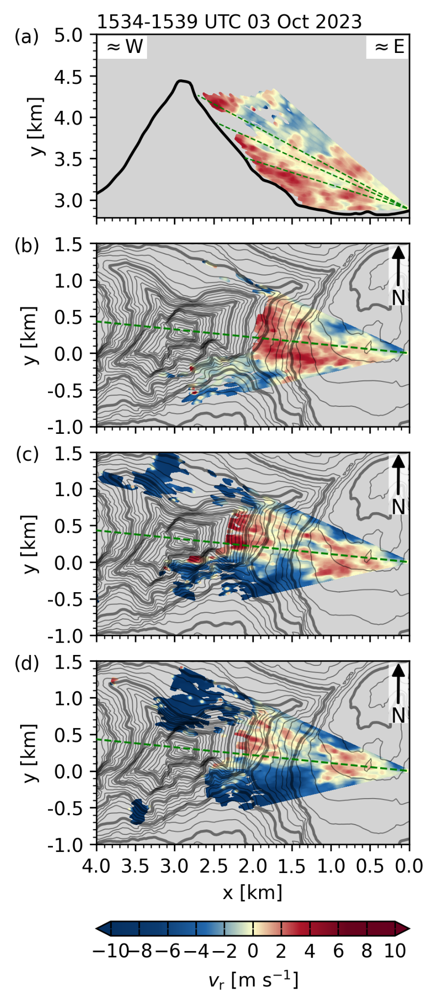  Fig. S31: As Fig 1, but for scan cycle between 1534 and 1539 UTC, 3 October 2023. | 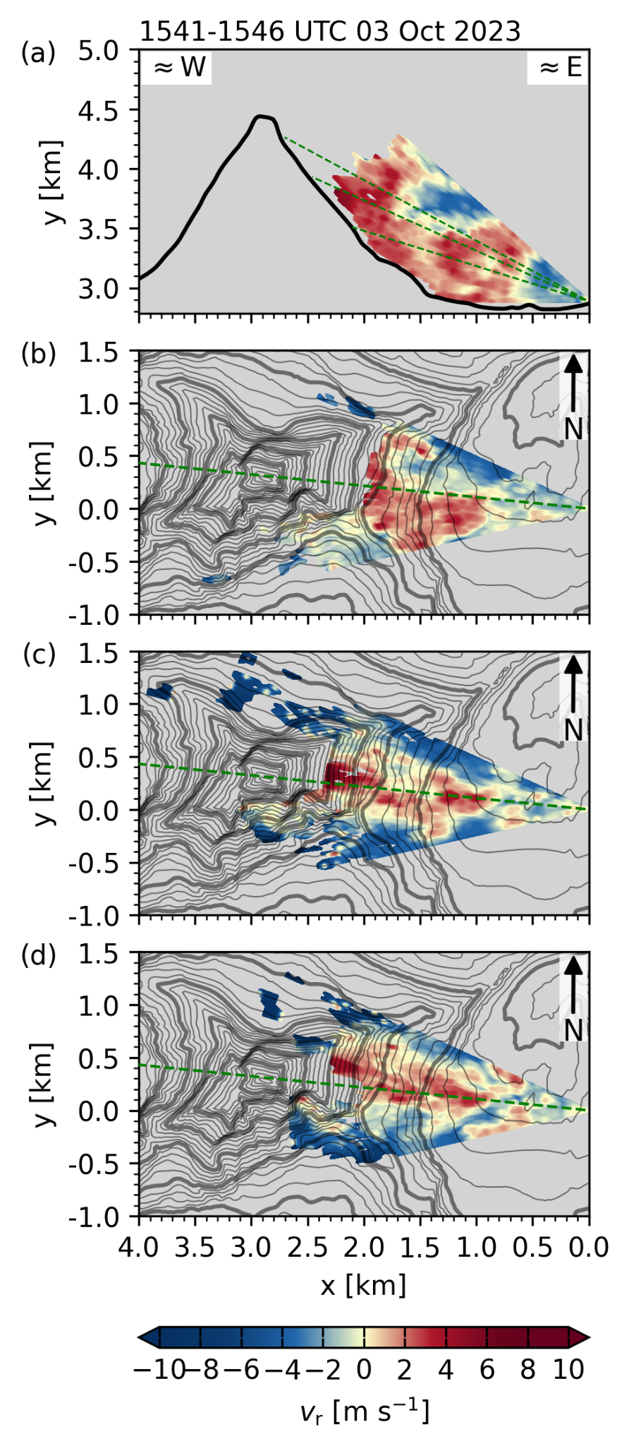  Fig. S32: As Fig 1, but for scan cycle between 1541 and 1546 UTC, 3 October 2023. | 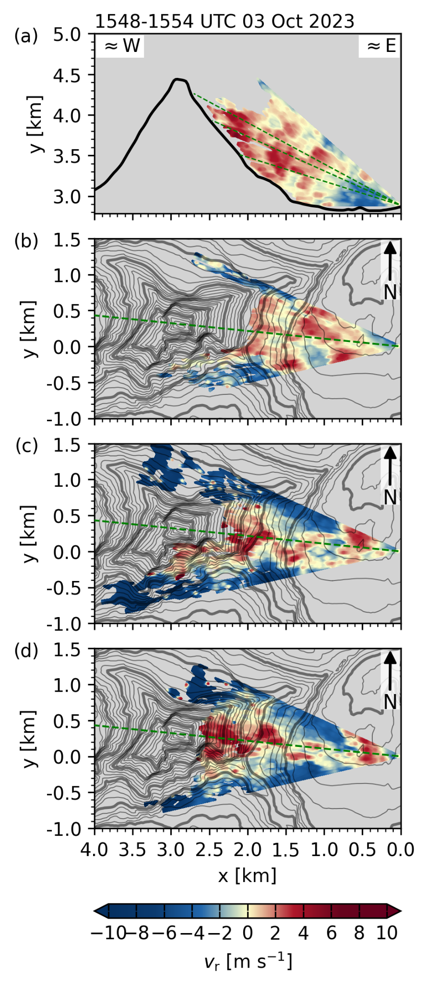  Fig. S33: As Fig 1, but for scan cycle between 1548 and 1554 UTC, 3 October 2023.
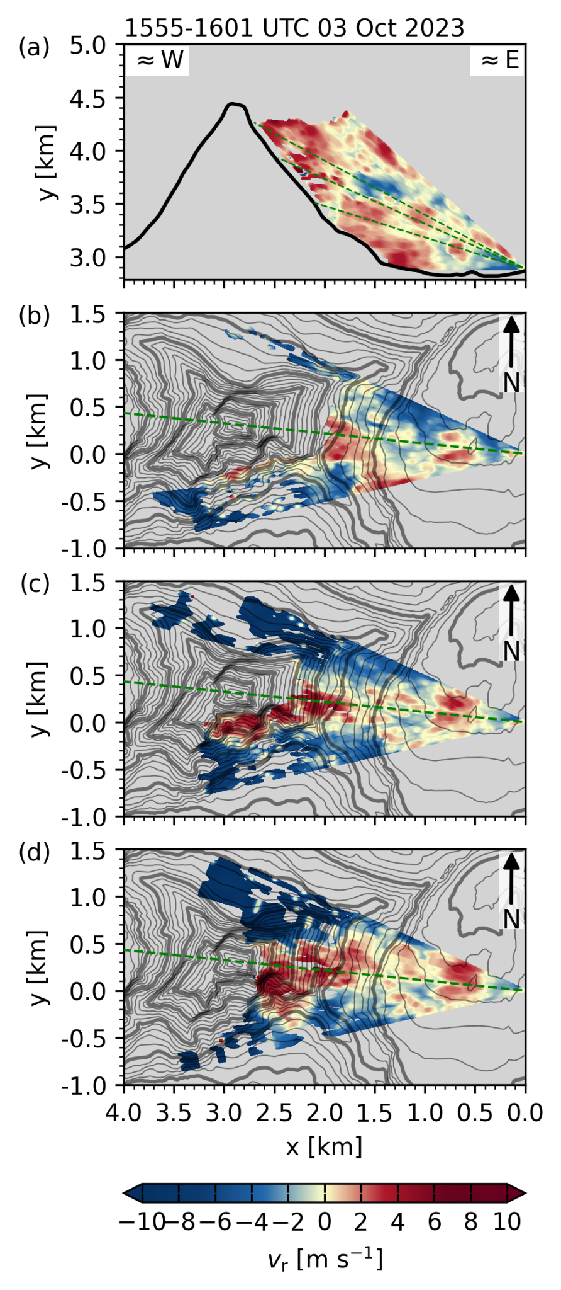  Fig. S34: As Fig 1, but for scan cycle between 1555 and 1601 UTC, 3 October 2023. | 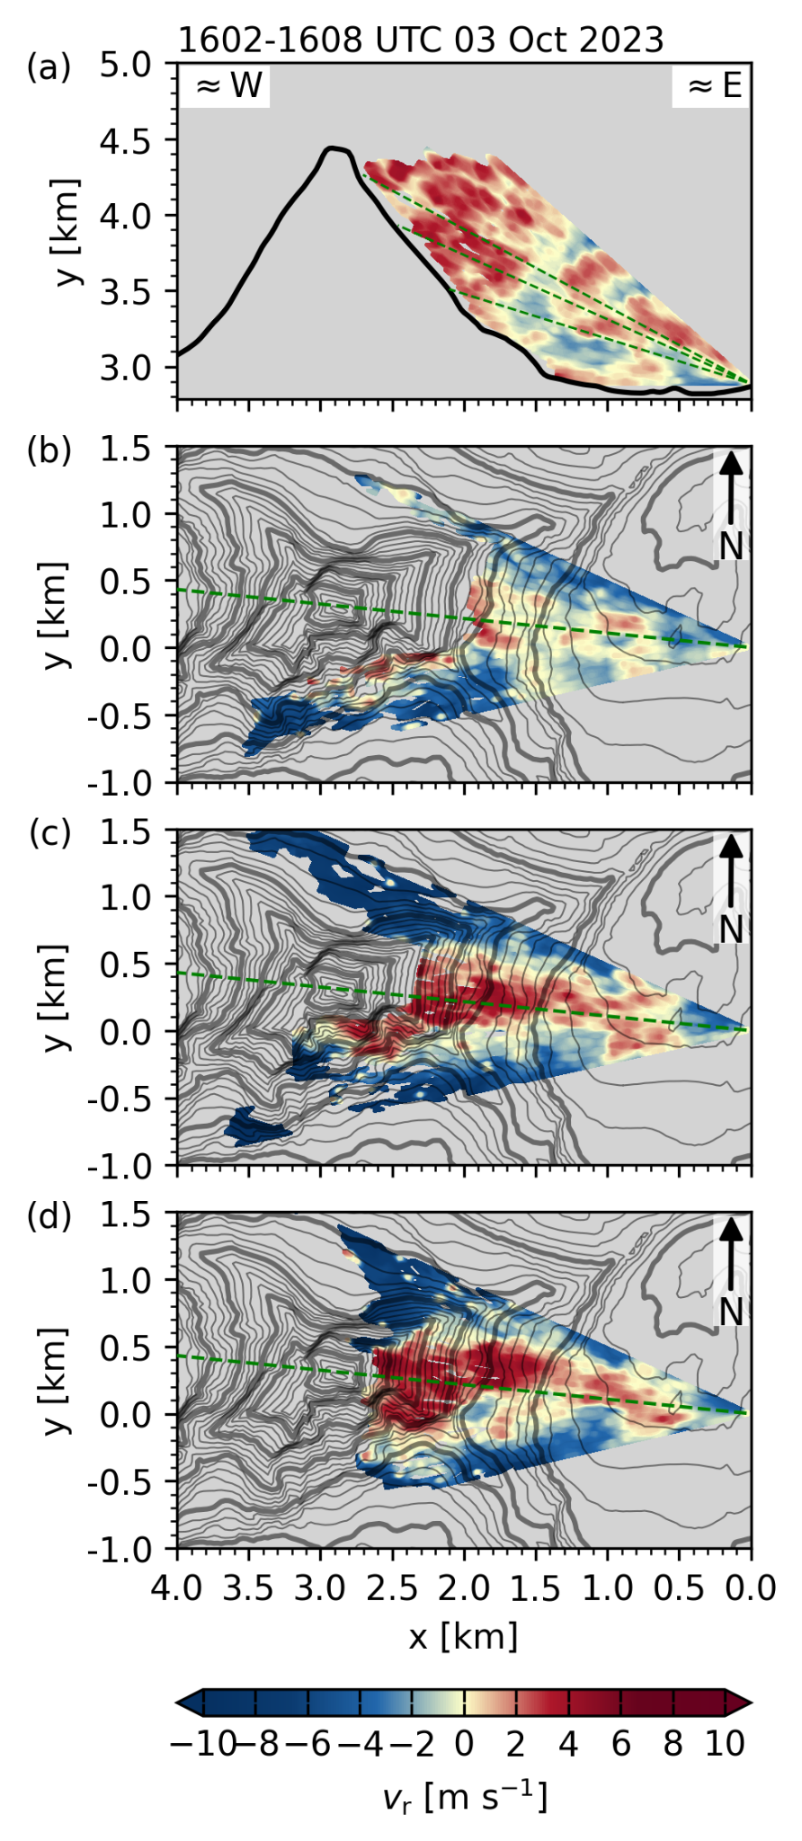  Fig. S35: As Fig 1, but for scan cycle between 1602 and 1608 UTC, 3 October 2023. | 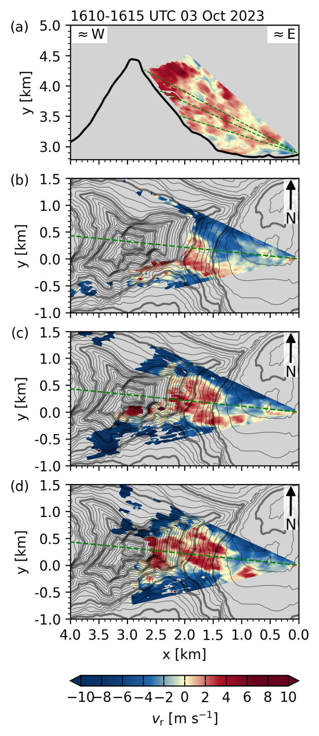  Fig. S36: As Fig 1, but for scan cycle between 1610 and 1615 UTC, 3 October 2023.
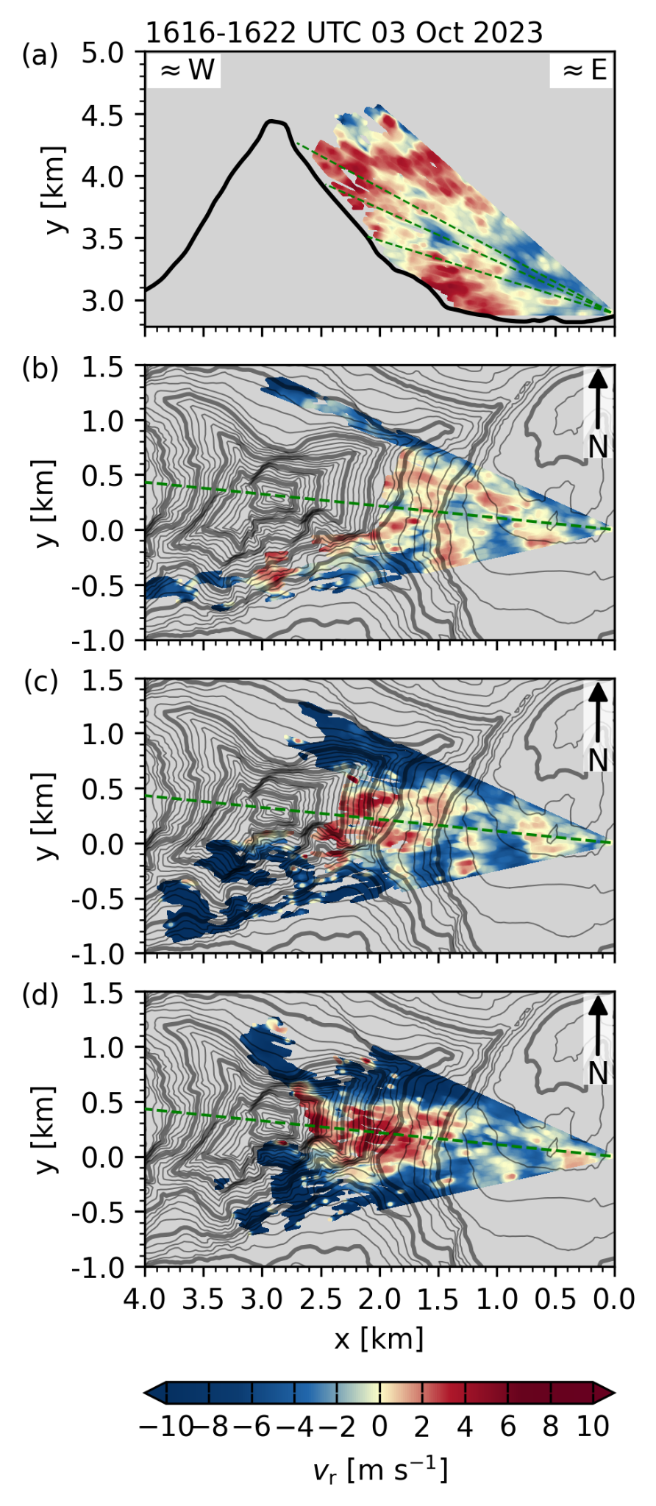  Fig. S37: As Fig 1, but for scan cycle between 1616 and 1622 UTC, 3 October 2023. | 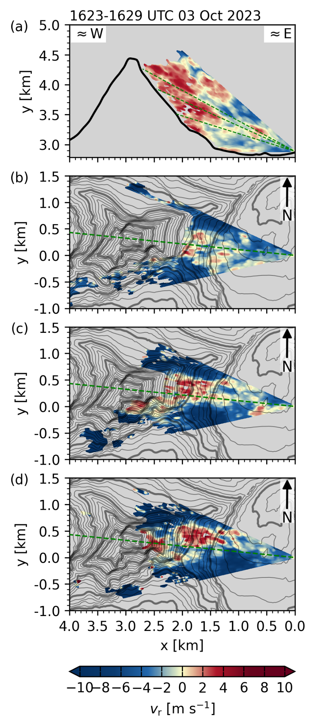  Fig. S38: As Fig 1, but for scan cycle between 1623 and 1629 UTC, 3 October 2023. | 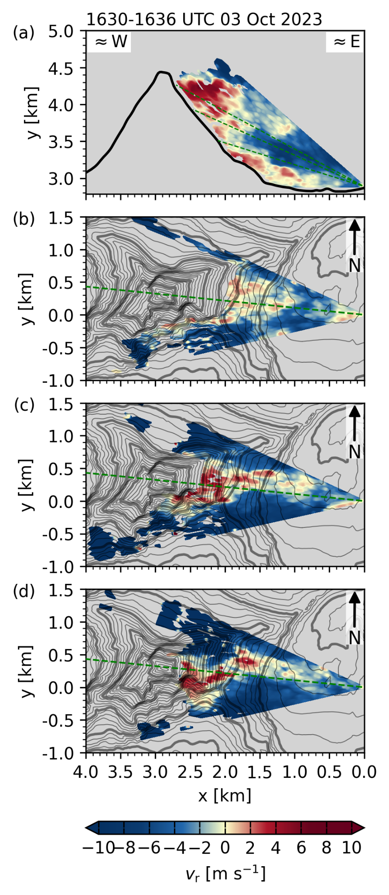  Fig. S39: As Fig 1, but for scan cycle between 1630 and 1636 UTC, 3 October 2023.
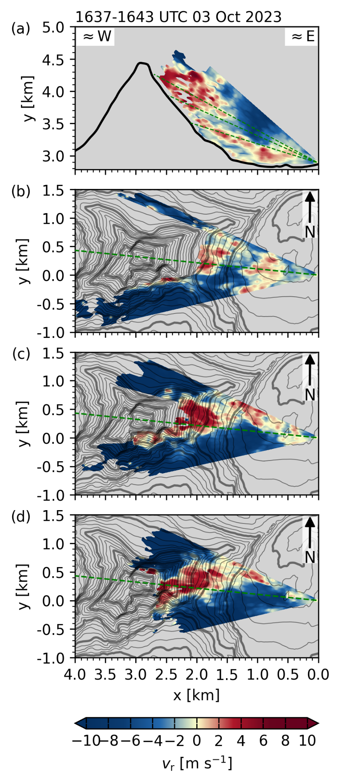  Fig. S40: As Fig 1, but for scan cycle between 1637 and 1643 UTC, 3 October 2023. | 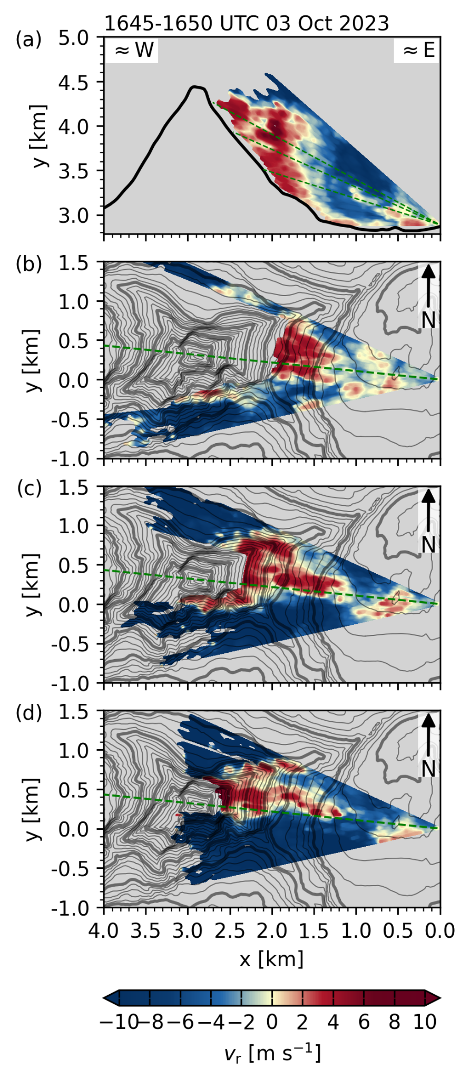  Fig. S41: As Fig 1, but for scan cycle between 1645 and 1650 UTC, 3 October 2023. | 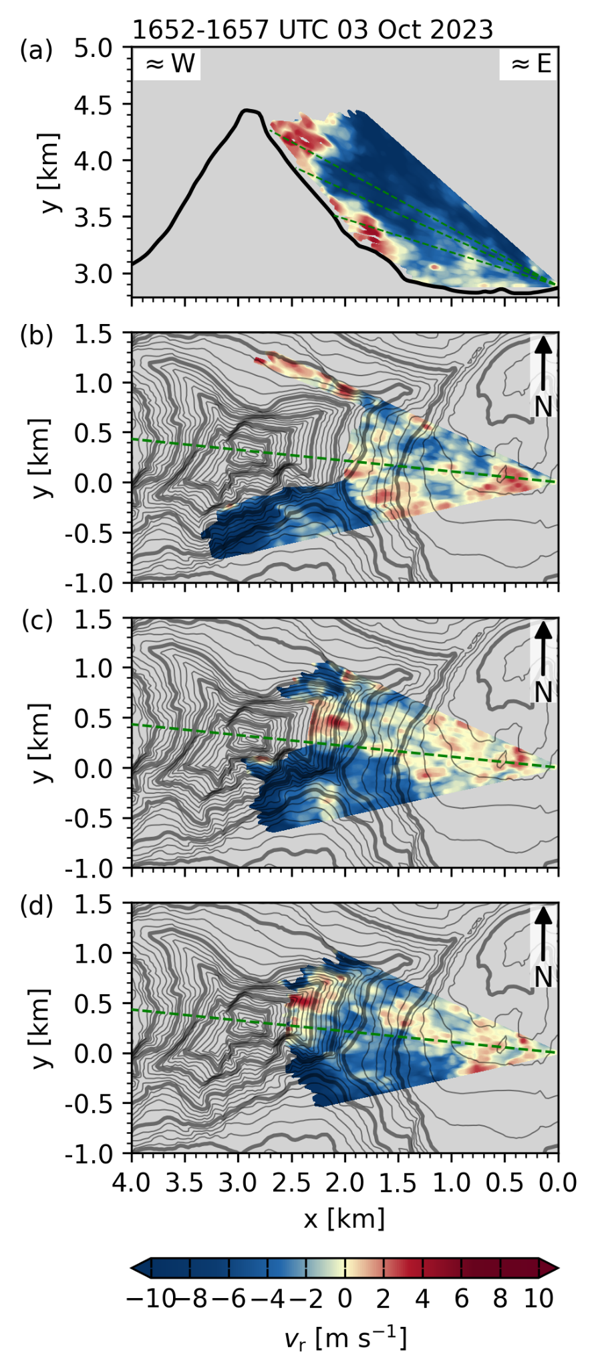  Fig. S42: As Fig 1, but for scan cycle between 1652 and 1657 UTC, 3 October 2023.
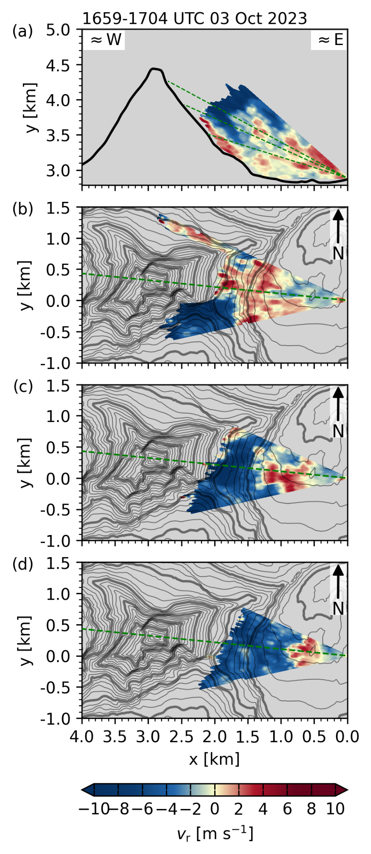  Fig. S43: As Fig 1, but for scan cycle between 1659 and 1704 UTC, 3 October 2023. | 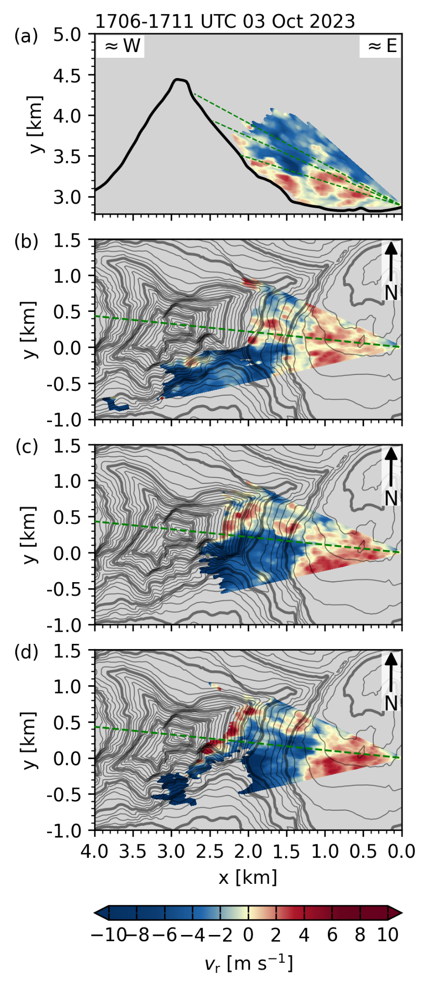  Fig. S44: As Fig 1, but for scan cycle between 1706 and 1711 UTC, 3 October 2023. | 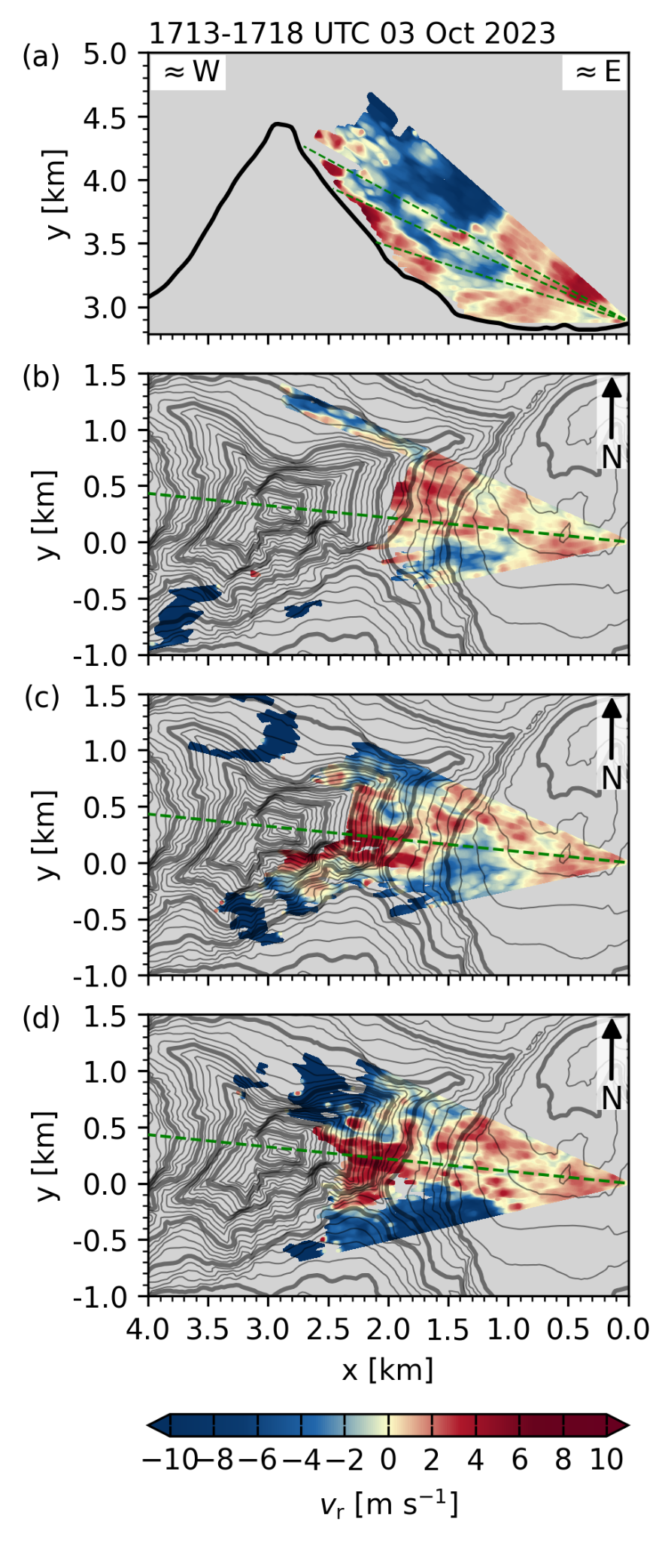  Fig. S45: As Fig 1, but for scan cycle between 1713 and 1718 UTC, 3 October 2023.
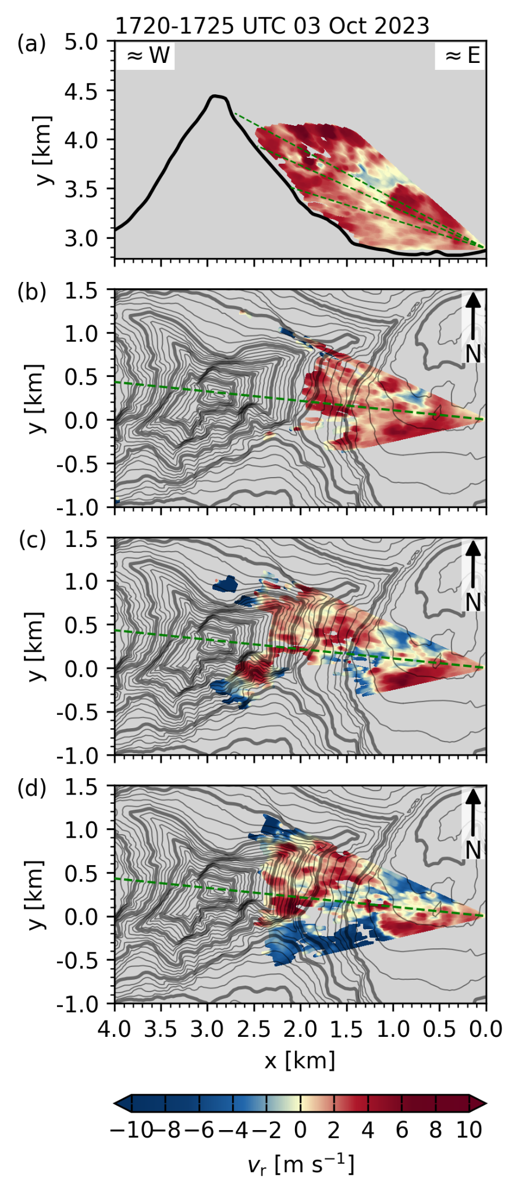  Fig. S46: As Fig 1, but for scan cycle between 1720 and 1725 UTC, 3 October 2023. | 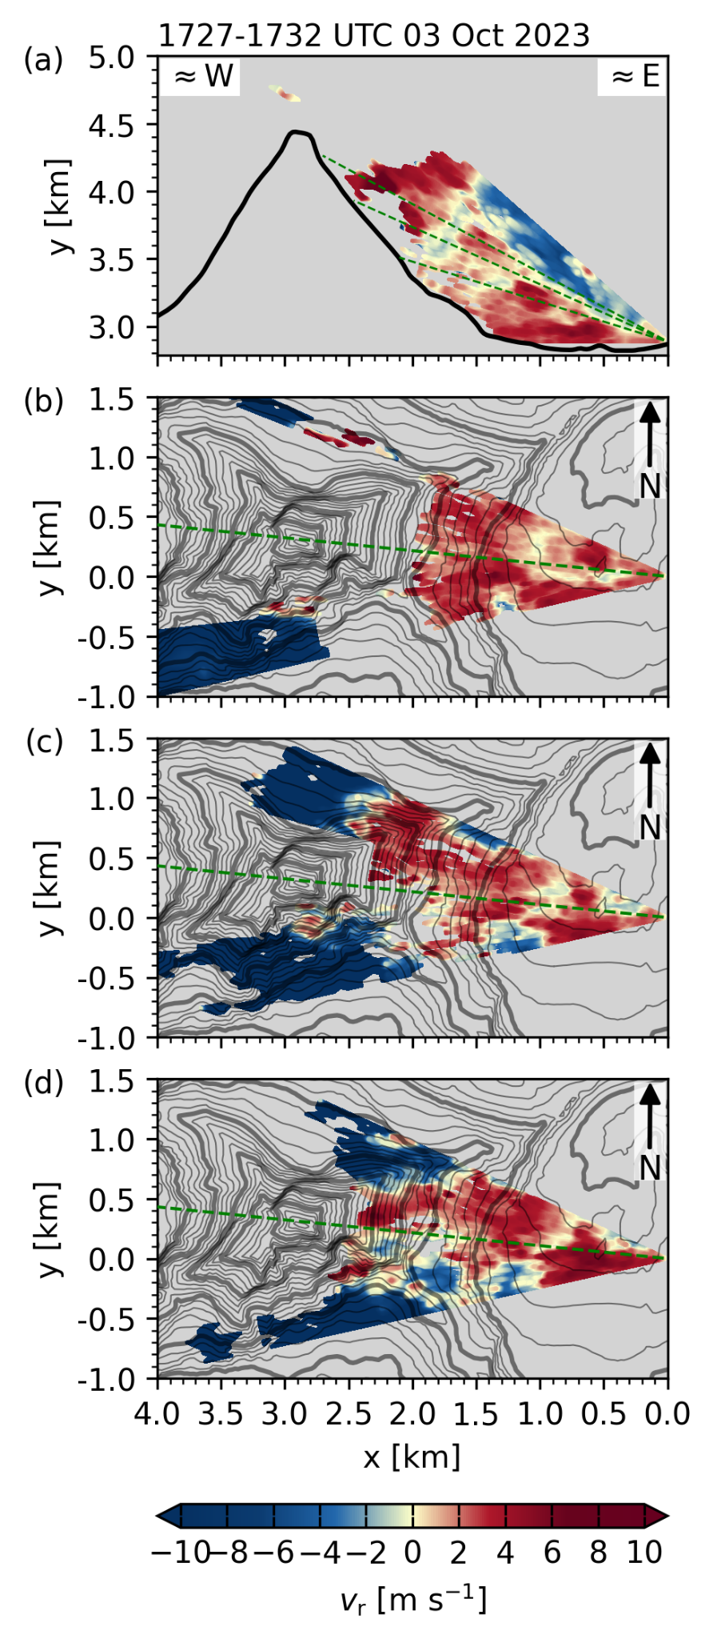  Fig. S47: As Fig 1, but for scan cycle between 1727 and 1732 UTC, 3 October 2023. | 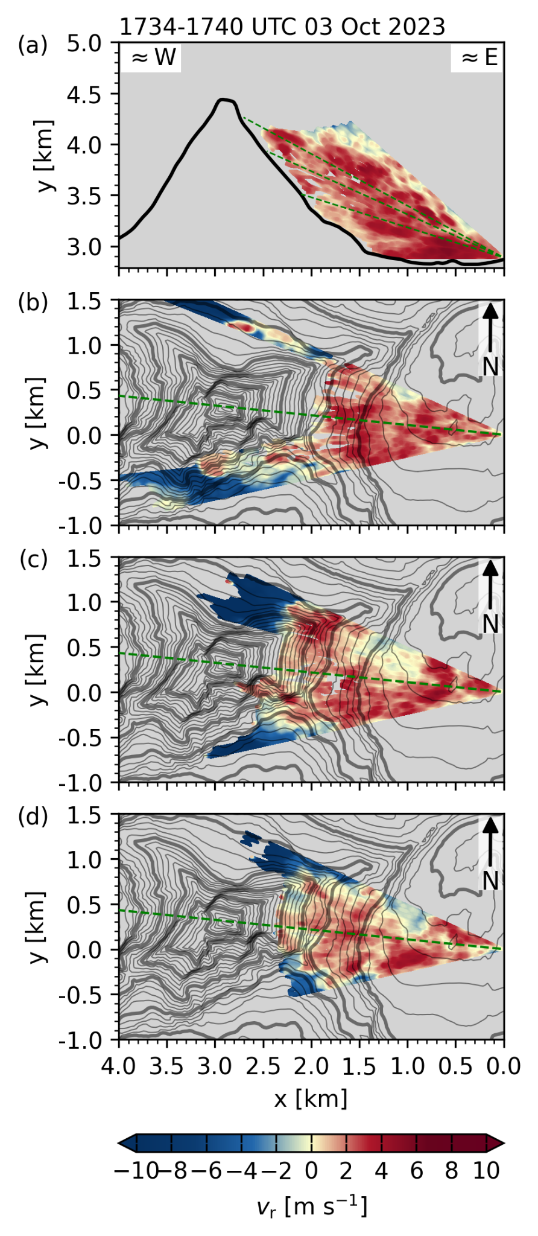  Fig. S48: As Fig 1, but for scan cycle between 1734 and 1740 UTC, 3 October 2023.
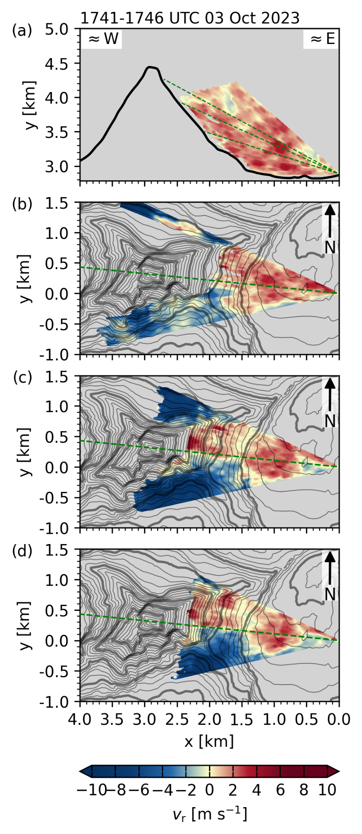  Fig. S49: As Fig 1, but for scan cycle between 1741 and 1746 UTC, 3 October 2023. | 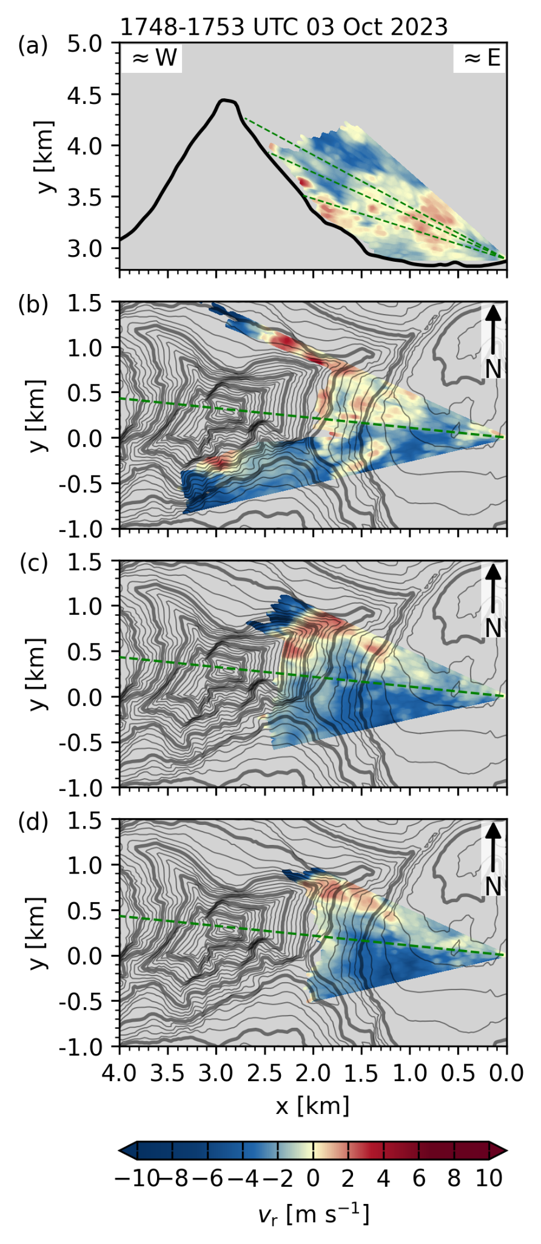  Fig. S50: As Fig 1, but for scan cycle between 1748 and 1753 UTC, 3 October 2023. | 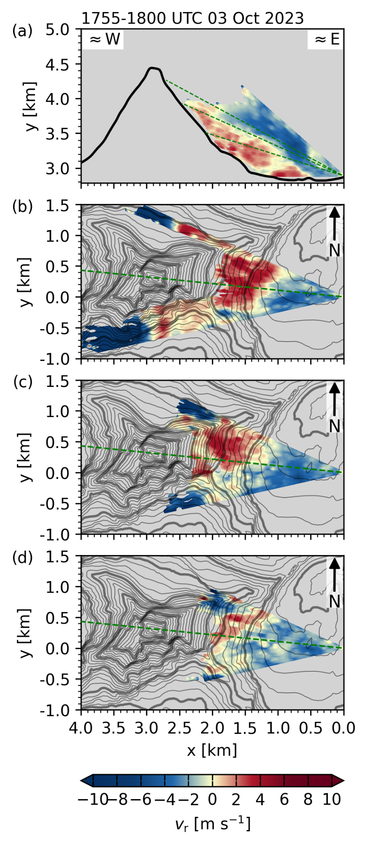  Fig. S51: As Fig 1, but for scan cycle between 1755 and 1800 UTC, 3 October 2023.

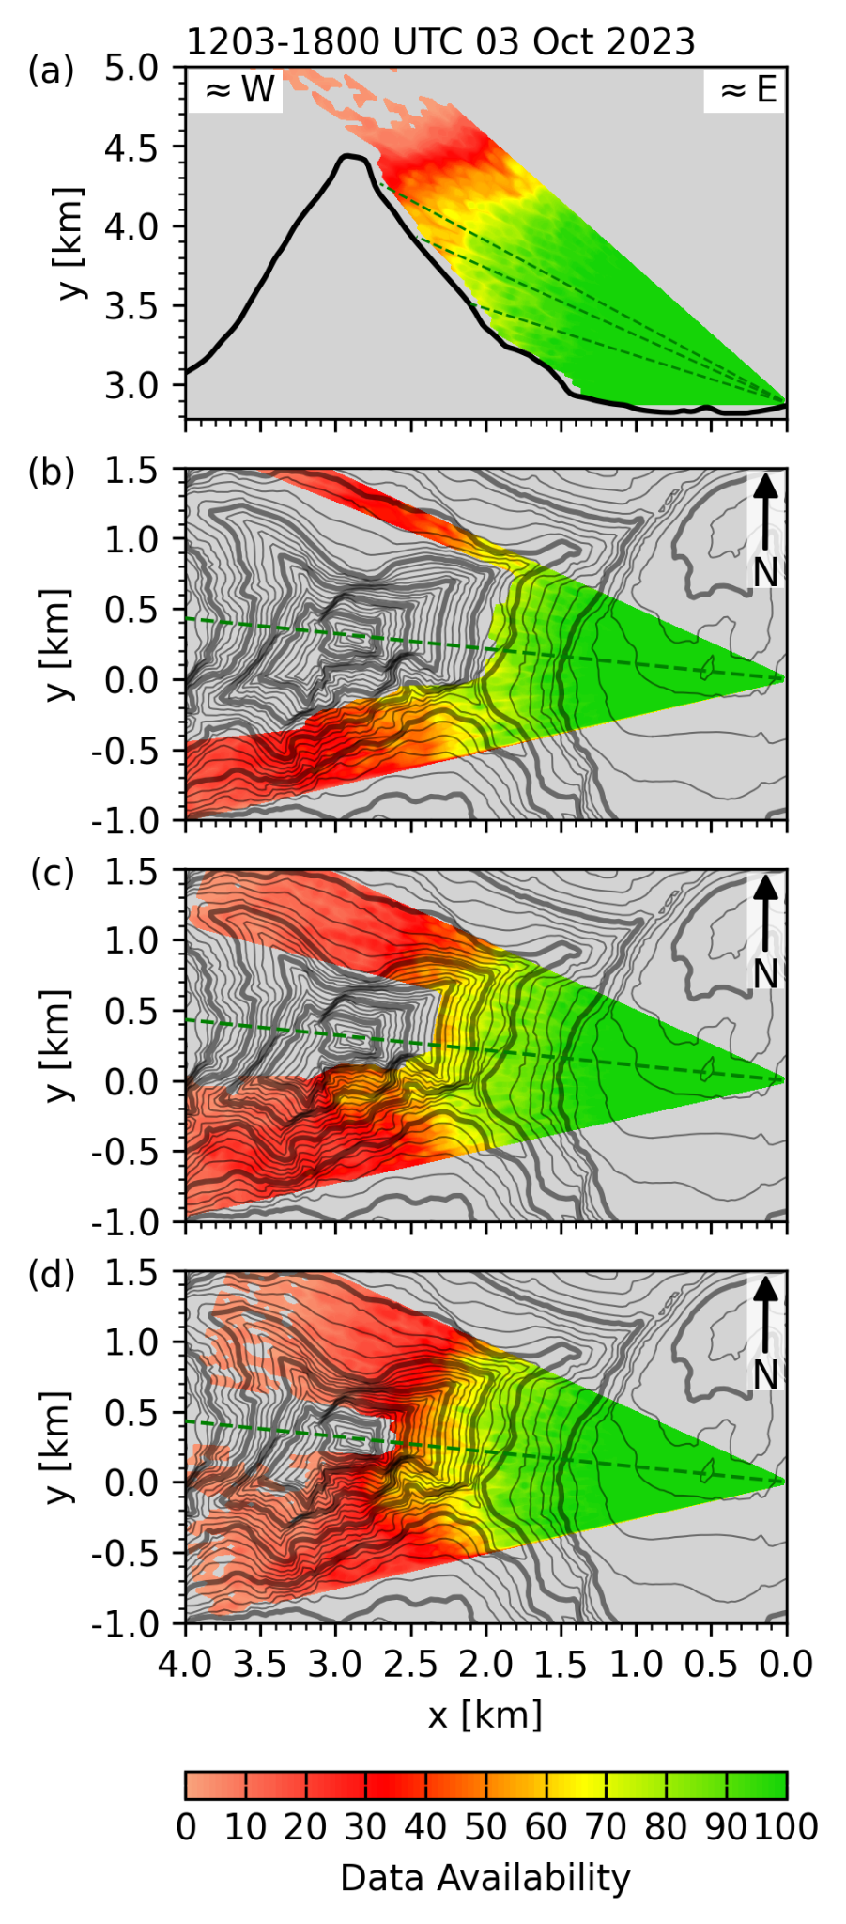
Fig. S52: Percentage in data coverage available for composing the average radial velocities shown in Fig 6, for (a) the range-height indicator scan (RHI) through the summit pyramid, and plan-position indicator scans (PPI) at (b) 16.5°, (c) 23°, and (d) 27° elevation for all cycles between 1200 and 1800 UTC, 3 October 2023.

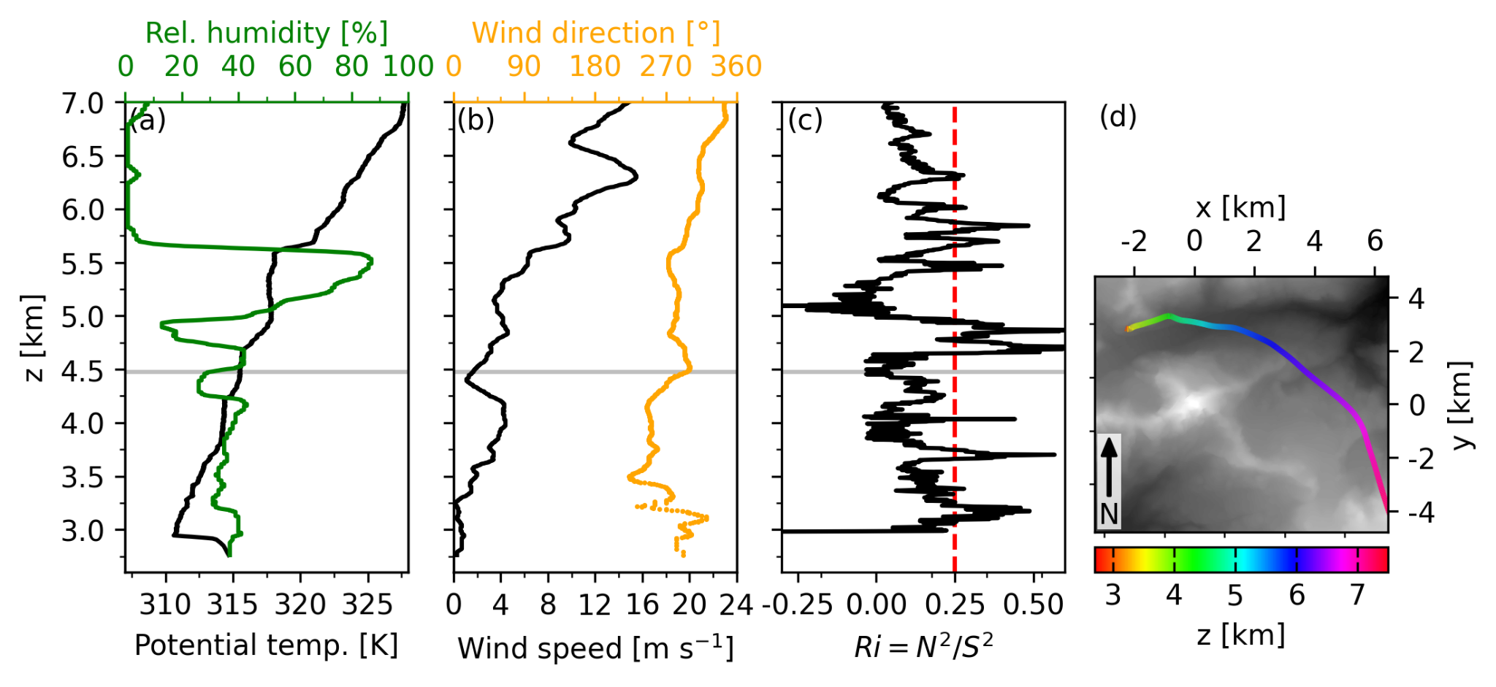
Fig. S53. Upwind vertical profiles at 1050 UTC 28 September 2023 of (a) potential temperature and relative humidity, (b) wind speed and direction, and (c) gradient Richardson number, calculated using a 20-point rolling mean ($≈$100 m). Horizontal gray lines indicate the summit height of the Matterhorn, and the red dashed line in (c) depicts the critical Richardson number Ri_{c} of 0.25. Panel (d) shows the ascent path of the radiosonde, with coordinates centered at the Matterhorn summit and grey shading indicating topography.

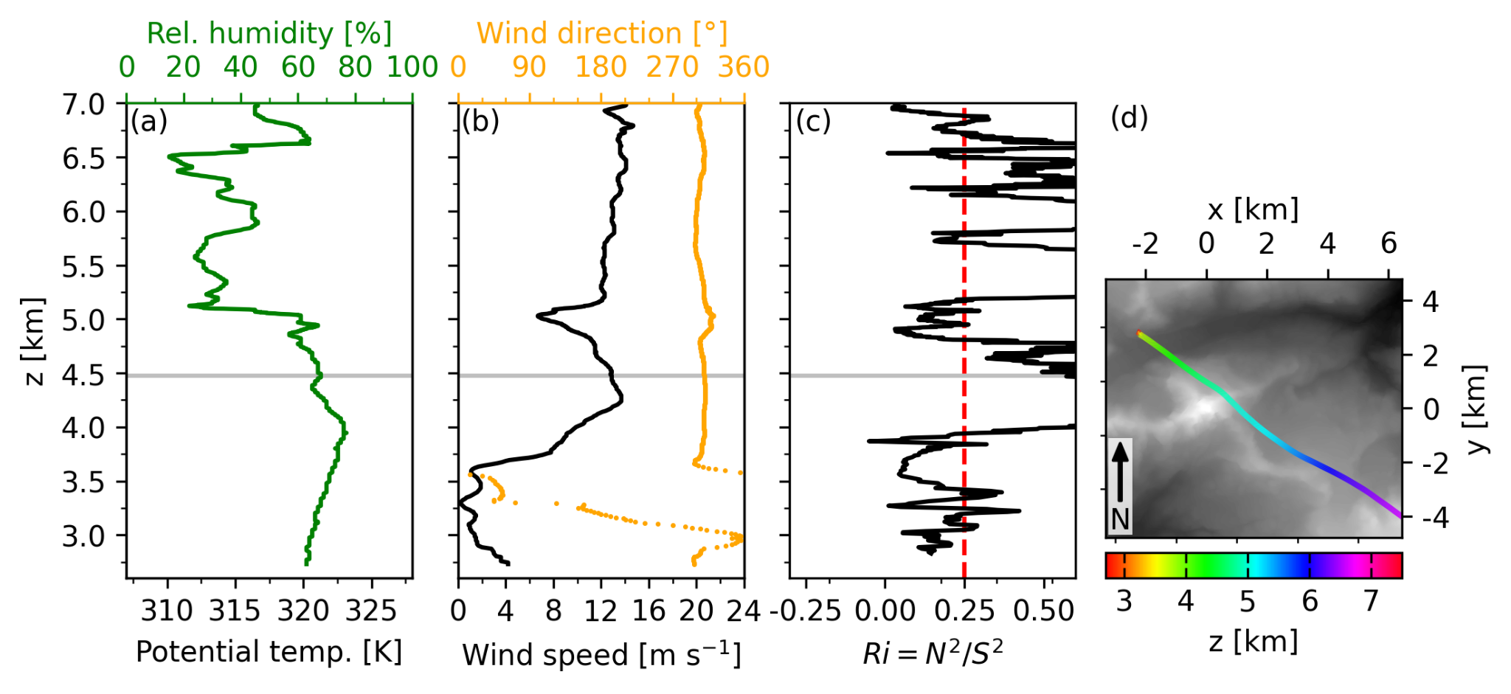
Fig. S54. As Fig. S53, but for radiosonde data from 1740 UTC 29 October 2023.

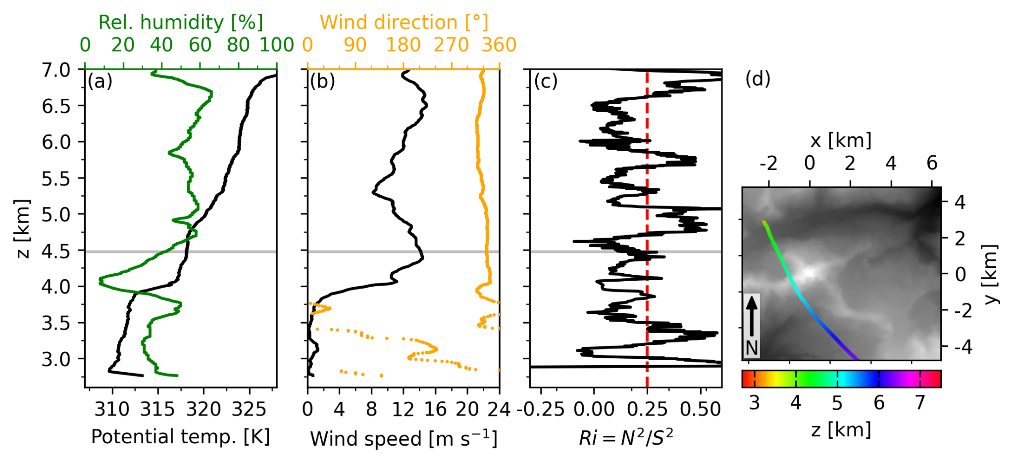
Fig. S55. As Fig. S53, but for radiosonde data from 1200 UTC 30 September 2023.

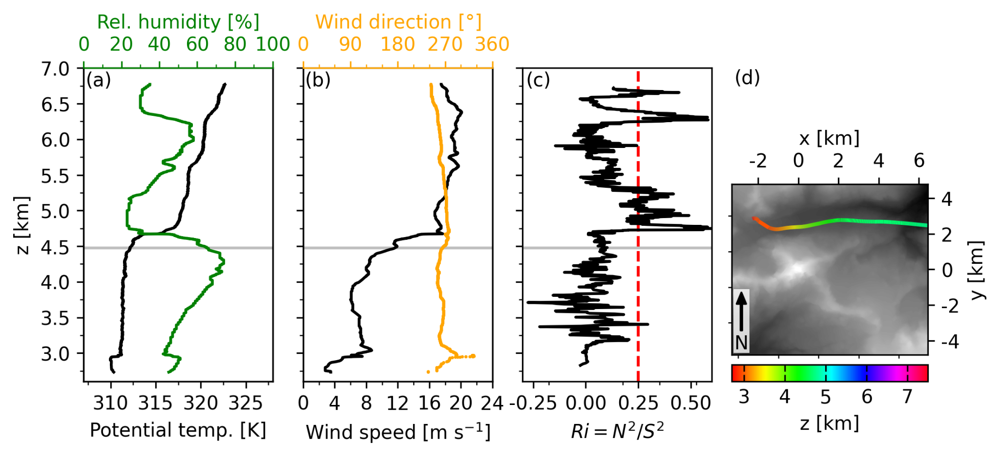
Fig. S56. As Fig. S53, but for radiosonde data from 1400 UTC 3 October 2023.

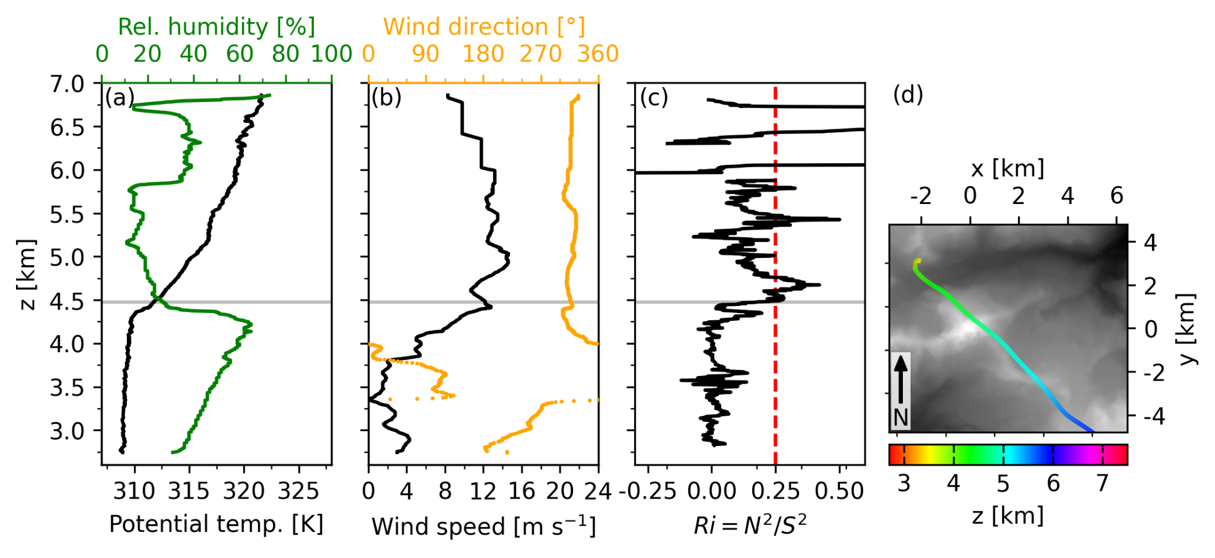
Fig. S57. As Fig. S53, but for radiosonde data from 1220 UTC 9 October 2023.

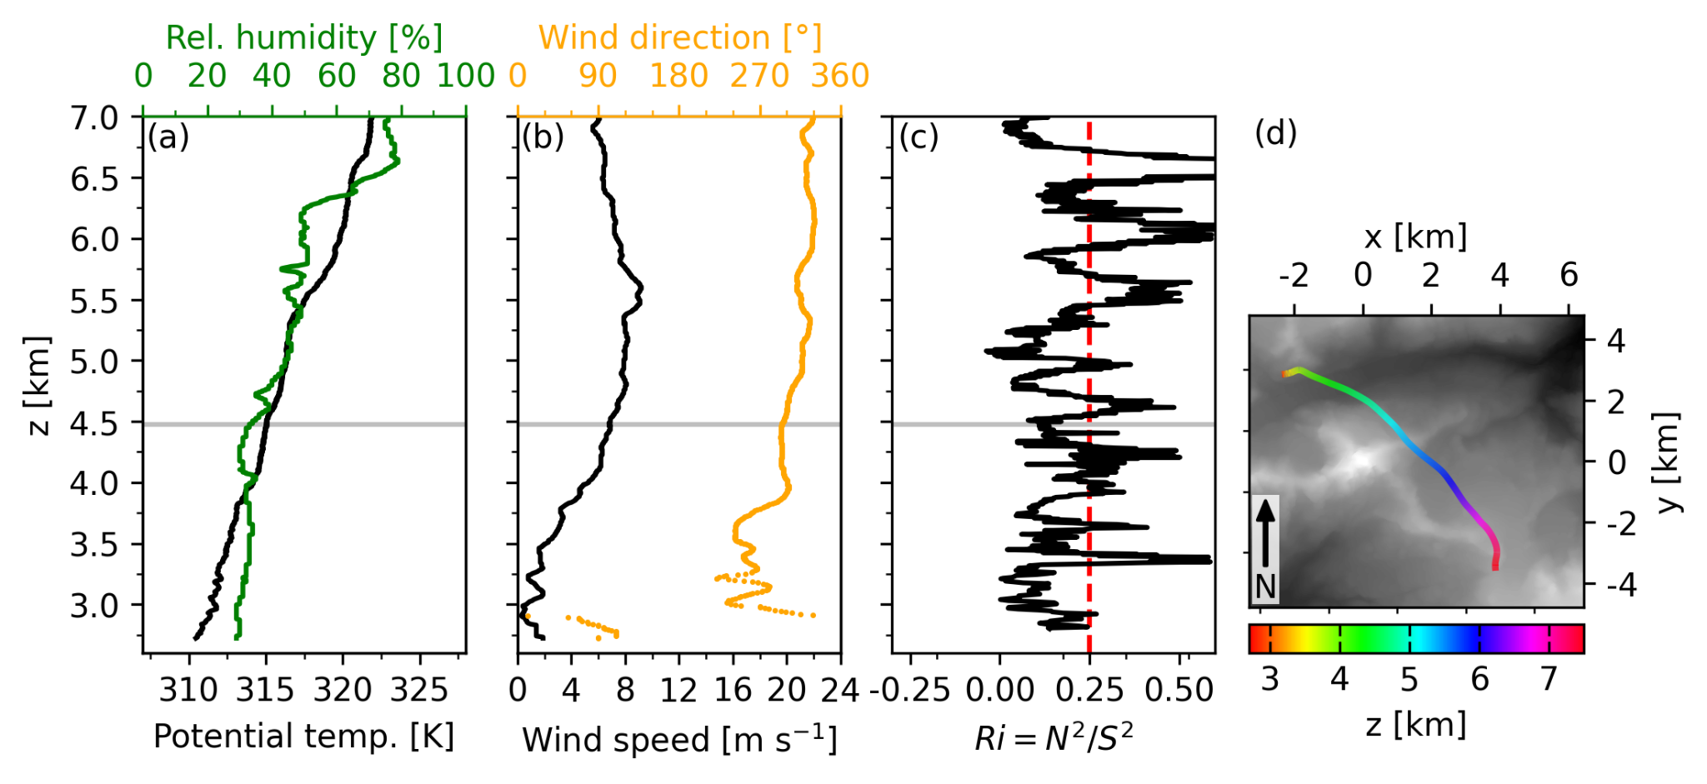
Fig. S58. As Fig. S53, but for radiosonde data from 1600 UTC 10 October 2023.

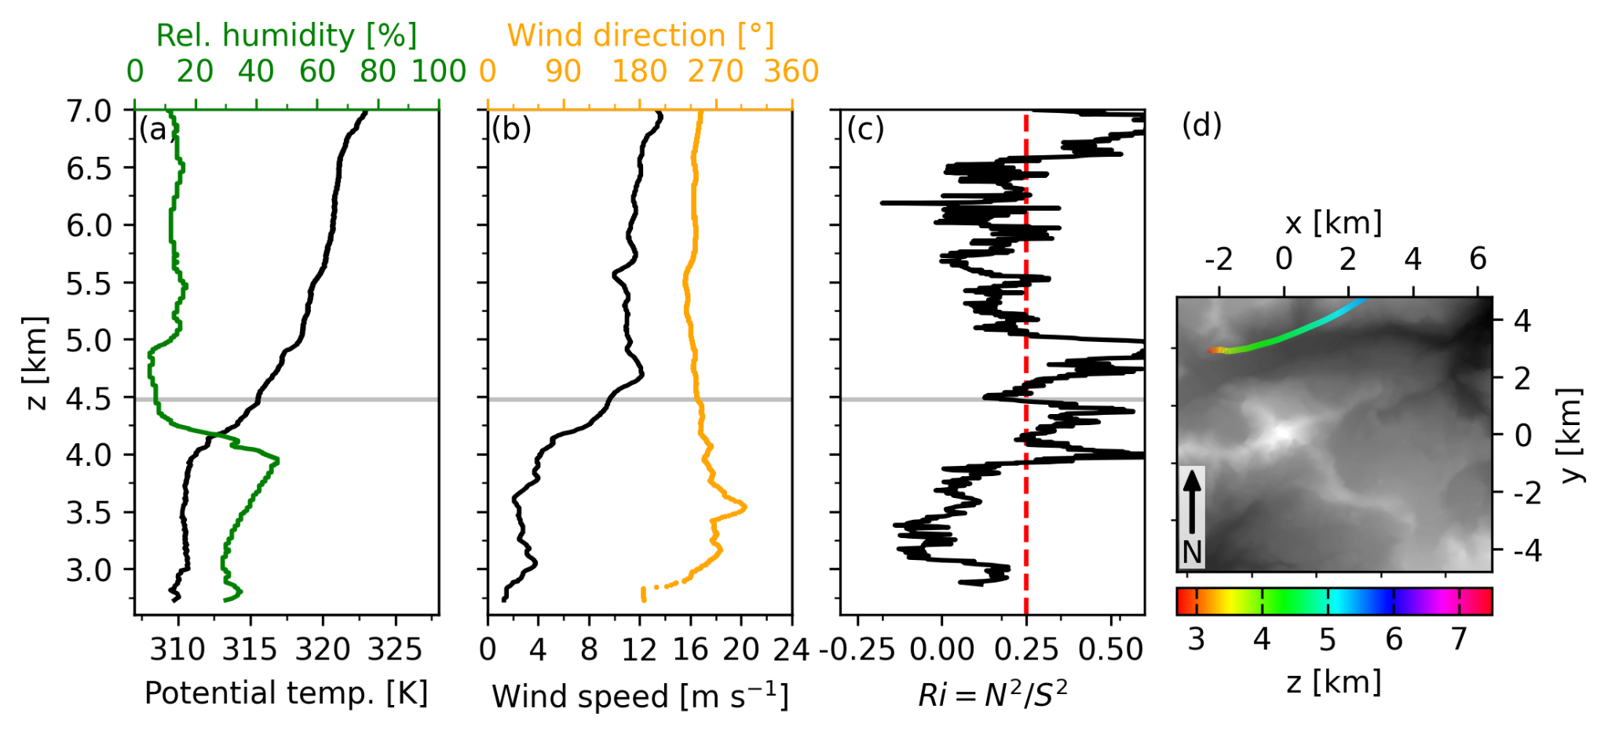
Fig. S59. As Fig. S53, but for radiosonde data from 1320 UTC 11 October 2023.

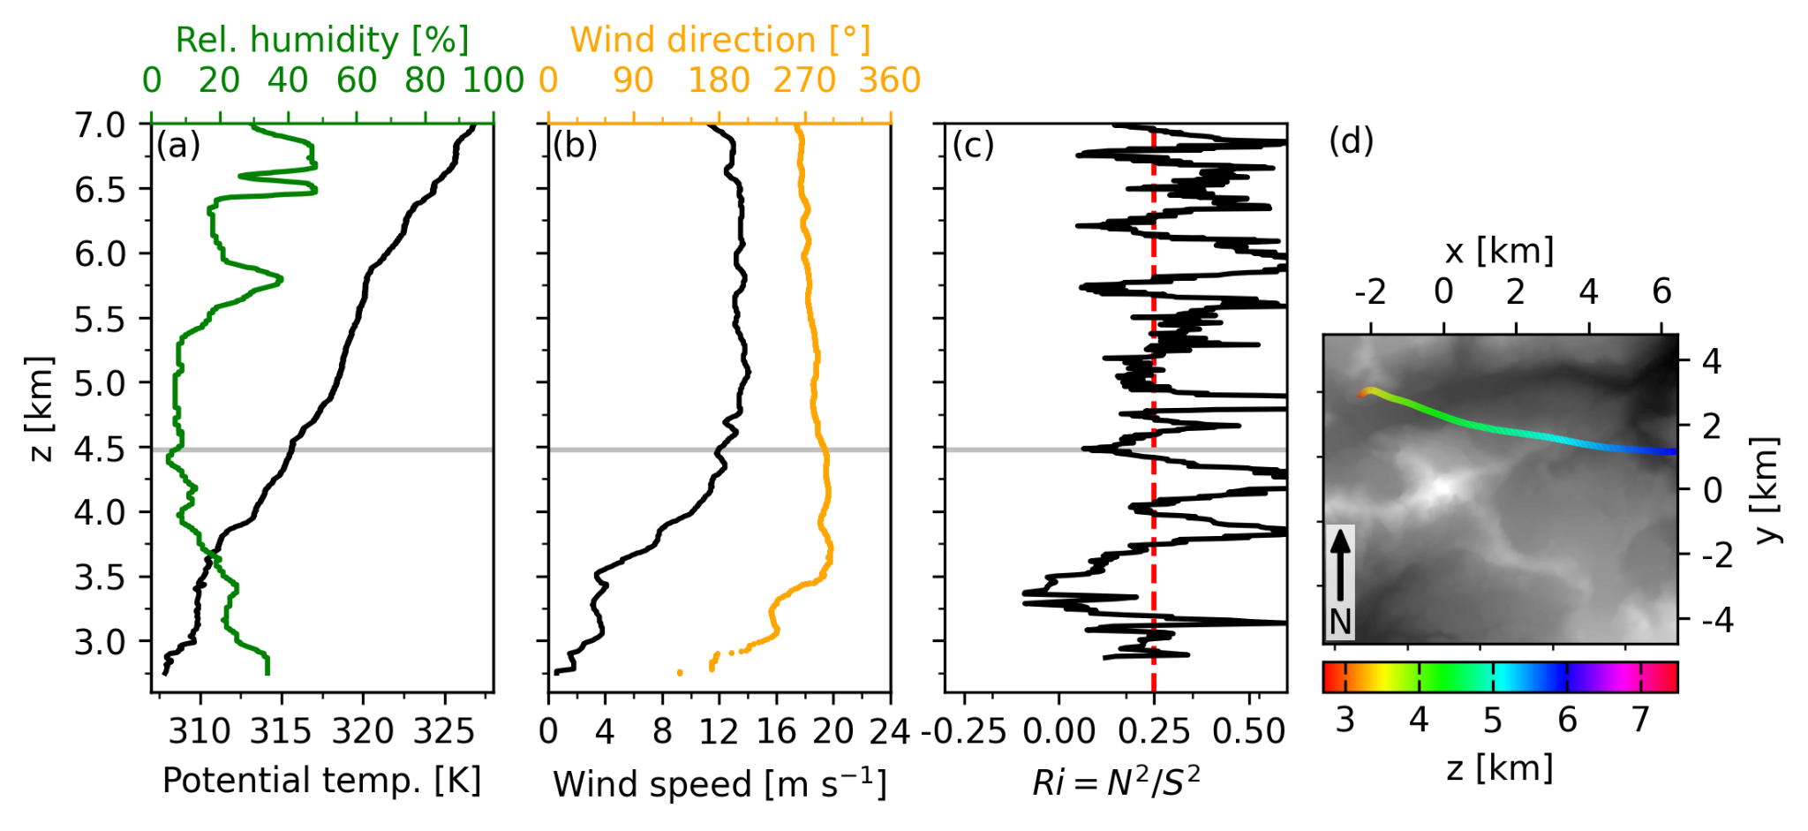
Fig. S60. As Fig. S53, but for radiosonde data from 1630 UTC 12 October 2023.

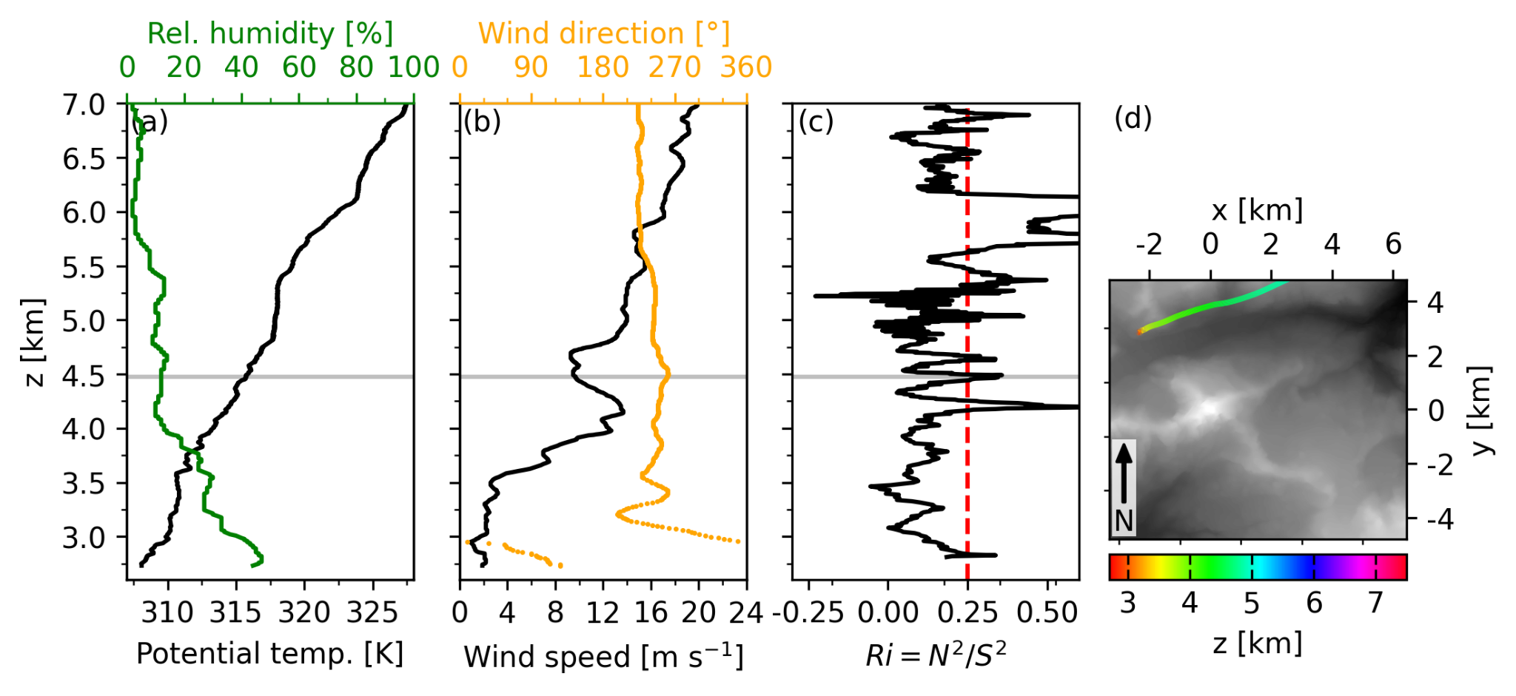
Fig. S61. As Fig. S53, but for radiosonde data from 1530 UTC 13 October 2023.

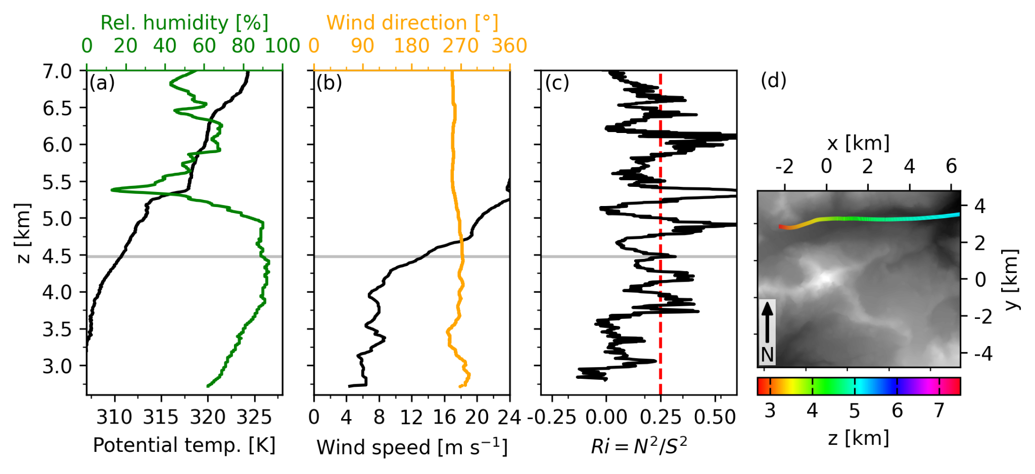
Fig. S62. As Fig. S53, but for radiosonde data from 1210 UTC 14 October 2023.

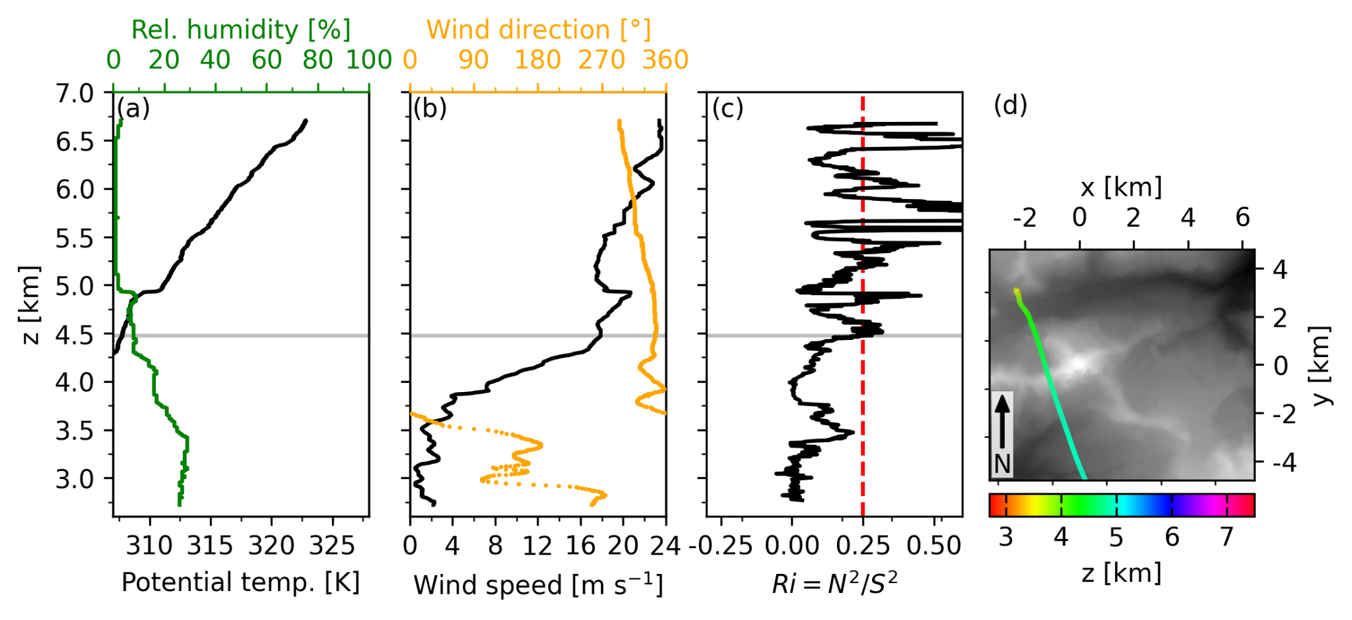
Fig. S63. As Fig. S53, but for radiosonde data from 1540 UTC 15 October 2023.

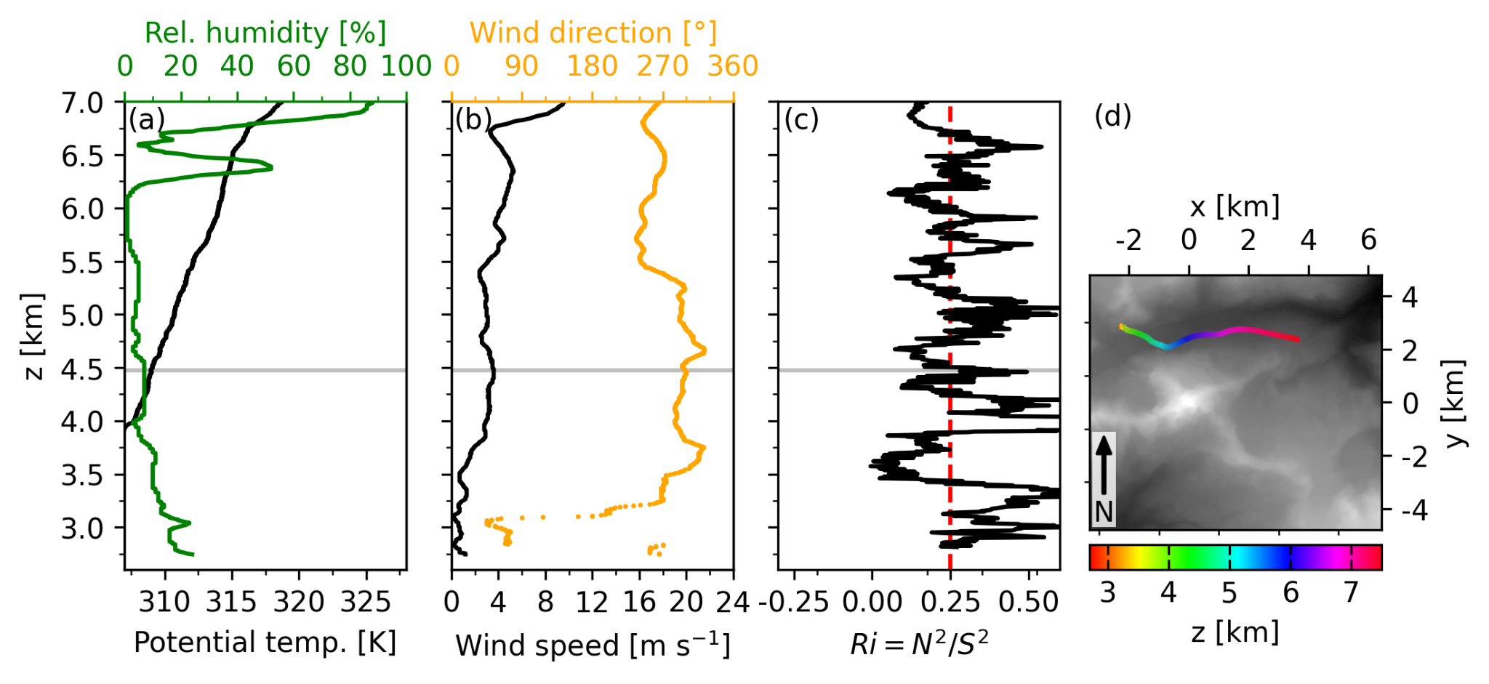
Fig. S64. As Fig. S53, but for radiosonde data from 0910 UTC 16 October 2023.

