The MatterHEX Experiment – Investigating Atmospheric Flow Patterns in Highly Complex Terrain Related to Banner Cloud Formation

Sebastian W. Hoch,^{a,b} Marius L. Thomas,^{c} Hendrik Huwald,^{d,e} Michael Lehning,^{d,e} Brandon J. A. van Schaik,^{d} Paul Imbert,^{d} Dominique S. Rentel,^{c} and Volkmar Wirth,^{c}

ª Earth Observing Laboratory, National Center for Atmospheric Research, Boulder, CO
^{b} Atmospheric Sciences Department, University of Utah, Salt Lake City, UT
^{c} Institute for Atmospheric Physics, Johannes Gutenberg University Mainz, Mainz, Germany
^{d} Laboratory of Cryospheric Sciences, Ecole Polytechnique Fédérale de Lausanne (EPFL), Sion, Switzerland
^{e} WSL Institute for Snow and Avalanche Research, SLF Davos, Switzerland

Corresponding author: Sebastian W. Hoch, hoch@ucar.edu
ABSTRACT
Orographic clouds typically form on the windward side of a topographic barrier when approaching air is cooled as it is lifted, and moisture condenses into cloud droplets. Under special conditions, however, clouds can appear on the leeward side of a mountain. Attached to leeside mountain slopes below the summit like a banner to a mast, these cloud formations are known as “banner clouds”. They are often seen on steep singular mountains such as the Matterhorn (Cervino) of the European Alps. Their formation indicates that vertical displacement in the lee dominates over the lifting occurring upwind. Past investigations of the flow conditions associated with banner clouds have mostly relied on numerical simulations, as observations are difficult in the often extremely complex or inaccessible mountainous terrain.
This article summarizes the main findings of the MatterHorn EXperiment, MatterHEX, that was conducted at the Matterhorn near Zermatt, Switzerland, in fall 2023. The experiment was designed to overcome observational challenges due to topography and to collect the minimum data necessary to assess the flow conditions conducive to banner cloud formation. Upwind flow and stability conditions were observed with radiosondes; cloud conditions were monitored with webcams; and leeward flow patterns were remotely sensed with Doppler lidar from the best possible location still accessible by foot. Time-averaged lidar scans reveal strong leeside ascent associated with banner cloud formation, while individual scans resolve the turbulent features associated with leeside flow separation. Our analysis shows that flow conditions around the Matterhorn are frequently conducive to banner cloud occurrence, but that a lack of moisture can prevent their formation.

SIGNIFICANCE STATEMENT
Understanding weather in mountainous terrain is of high relevance owing to its sometimes-extreme character. Yet, observations are often very challenging due to the complexity of the terrain. The field campaign described in this paper addresses this challenge with the combination of careful campaign design and state-of-the-art instrumentation. Our focus lies on the leeside flow structures of an isolated steep mountain, the Matterhorn of the European Alps. Analysis of the data indicates leeside flow reversal and upwelling, consistent with theory. Our observations allow us to be the first to test existing theories on the formation of leeside banner clouds. The data is well-suited for the evaluation of corresponding Large-Eddy Simulations that resolve similar spatiotemporal scales in highly complex terrain.
CAPSULE
Meteorological observations in the highly complex terrain around the Matterhorn test existing theories of banner cloud formation.

1. Introduction
Flow past orography is a classic topic in mountain meteorology (Whiteman 2000). In recent decades, associated processes such as gravity waves (Smith 1979, Durran 2003), orographic drag (Fritts et al. 2016), and orographic precipitation (Roe 2005) have been specific foci of research and field campaigns. Most of these studies have dealt with the meso- or larger-scale flow over large mountains or mountain ranges rather than a single mountain. One reason may be the challenges in obtaining field observations in highly complex and steep terrain, but there are also challenges in performing highly resolved model simulations of flow past steep orography as they require techniques such as immersed boundary conditions to avoid numerical problems arising from steep topography (e.g. Lundquist et al. 2012, Connolly et al. 2021). At scales smaller than a mountain, flow separation and the associated influence on particle dynamics and snow deposition have been investigated over idealized and real complex terrain (Lehning et al. 2008; Comola et al. 2019; Reynolds et al. 2024a; Gerber et al. 2017; Lehner et al. 2019; Reynolds et al. 2024b; Berg et al. 2024). These studies focus on near surface boundary layer flow features such as speed-up and flow separation.
One phenomenon on the scale of a typical mountain has received some attention recently: orographic banner clouds. These clouds form, somewhat counter-intuitively, in the lee of steep mountains, often under otherwise cloud-free conditions (Glickman 2000). They are closely attached to the lee slopes, and the combination of strong flow past the mountain's summit and the associated wind shear let them appear like a banner flying in the wind (Fig. 1). Schween et al. (2007) used time-lapse movies for a first systematic study of these clouds forming on Mount Zugspitze, Germany, which were then combined with complementary meteorological observations to reveal some of their properties such as their diurnal cycle, wind direction dependence, and sensitivity to wind speed (Wirth et al. 2012). The first Large-Eddy Simulations (LES) of banner clouds were conducted by Reinert and Wirth (2009) and Voigt and Wirth (2013). Their simulations were based on idealized topography; they resolved a bow-shaped vortex in the lee of the obstacle (their Fig. 4) and highlighted the role of the extensive leeside vertical uplift for banner cloud formation. Subsequently, trajectory calculations by Schappert and Wirth (2015) illustrated that most air parcels that reach the banner cloud have previously traveled around the mountain before ascending on the lee side. Prestel and Wirth (2016) systematically examined the conditions that are conducive to banner cloud formation, stressing the importance of a weakly stratified ambient atmosphere as well as the steepness of the mountain. More recently, Thomas and Wirth (2023) investigated the transition from idealized to realistic orography of the Matterhorn region in LES. They confirmed that banner cloud formation remains primarily driven by dynamically induced upwelling in the lee-side recirculation region, though the detailed flow structure is strongly shaped by terrain complexity.
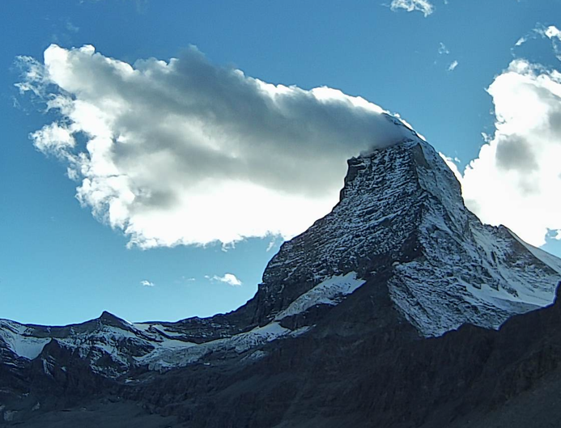
Fig. 1. Banner cloud on the Matterhorn (Cervino), 1540 UTC 29 September 2023.
Substantial theoretical guidance exists on terrain-flow interactions. Generally, the flow response to a topographic obstacle depends on the wind speed, the ambient static stability (resistance to lift), as well as the height and the width of the obstacle (Whiteman 2000). Baines (1995) used laboratory experiments of two-dimensional flow over an isolated obstacle to define regimes of flow responses to two-dimensional terrain as a function of two non-dimensional parameters characterizing the upwind flow and the geometry of the obstacle. Based on whether and where the flow starts to deviate (“separate”) from the shape of the underlying terrain, these regimes are called “Lee-side separation”, “Post-wave separation”, and “No separation”. As shown in Figure 2, the occurrence of these regimes depends on the obstacle’s aspect ratio 𝒜=h₀ /A_{d} and on the inverse Froude number 𝒩=Nh₀/U. Here, h₀ is the obstacle height, A_{d} the leeside mountain half-width, N the Brunt-Väisälä frequency, and U the wind speed. Note that a large 𝒜 represents a steep and tall mountain, and that the inverse Froude number 𝒩 represents the ratio of the flow’s resistance to lift to its momentum to surmount the barrier. A small 𝒩 means that the flow can easily pass over the obstacle while a large 𝒩 results in blocking or flow around the barrier. The same regime classification was shown to be valid for flow past a three-dimensional mountain (Hunt and Snyder 1980; Baines 1995; Prestel and Wirth 2016). Out of the three regimes, banner clouds only occur in the “Lee-side separation” regime, since their formation requires extended leeside uplift all the way to the mountain summit (Voigt and Wirth 2013).

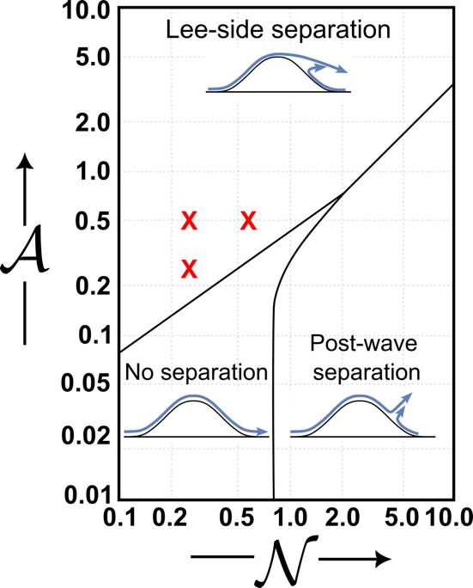
Fig. 2. Diagram of flow separation properties as a function of the inverse Froude number 𝒩 and mountain aspect ratio $A$, adapted from Fig. 5.8 of Baines (1995). The red crosses indicate conditions which are conducive to banner cloud formation in idealized simulations using a three-dimensional obstacle (Prestel and Wirth 2016).
While theoretical concepts and numerical simulations are consistent with each other, there has been - so far - a lack of detailed observations of the banner cloud phenomenon including the associated flow field. Fortunately, the development of smaller and more mobile Doppler wind lidars in the past decade has facilitated the deployment of such equipment in complex terrain and allowed advances in applications such as wind energy, fire weather, mountain hydrology, and urban meteorology (Gerber et al. 2017; Lareau et al. 2017; Whiteman et al. 2018; Menke et al. 2019; Kristianti et al. 2023; Kristianti et al. 2024; Davis and Lamer 2025; van Schaik et al. 2025).
Given these more recent developments, we explored the possibility of an observational campaign to study banner clouds. Our focus was on the Matterhorn near Zermatt, Switzerland, one of the most iconic peaks in Europe and worldwide. As is well known, the Matterhorn features frequent occurrences of banner clouds. Despite being one of the highest peaks in the Swiss Alps (4478 m ASL), the Matterhorn is rather well accessible due to the infrastructure catering to skiers, hikers, and mountaineers visiting Zermatt. In 2018 we conducted exploratory measurements proving the fundamental feasibility of direct observation of the flow in the vicinity of a banner cloud at the Matterhorn. Based on these preliminary investigations, we received funding from the German Research Council (Deutsche Forschungsgemeinschaft, DFG) to conduct a low-cost and focused field campaign called the MatterHorn EXperiment (MatterHEX). The key objective of this campaign was to observe the mean leeside flow features resulting from the interaction of a well-characterized background flow with the topography of the Matterhorn. A further motivation was to collect a dataset that would be suited to evaluate Large-Eddy Simulations in extreme complex topography.
The global COVID-19 pandemic delayed our campaign, and we had to wait until fall 2023 to conduct the experiment. We were further constrained by having to avoid the main tourist season while minimizing the risk of being shut down due to an early onset of winter. An additional challenge was the need to coordinate upper-air soundings with the busy helicopter traffic related to tourism, mountain rescues, and infrastructure maintenance.
It is the goal of this paper to provide an overview over the MatterHEX campaign and to present the key findings. A more detailed comparison of the observations with LES model simulations can be found in Thomas et al. (2025). Of the many banner cloud cases during MatterHEX, we highlight the 3 October 2023 case to describe the observed mean leeside flow structure as well as selected turbulent characteristics of the flow. Finally, we relate our observations to theory.
2. Experimental Design and Observations
We received permission for the three-week MatterHEX field campaign between 25 September and 15 October 2023, as well as for one-week setup and take-down phases. Logistical issues delayed the helicopter lifts to the field sites, and routine observations did not start until 29 September.
Based on the wind climatology for September and October (Fig. 3) and the available infrastructure on the eastern side of the Matterhorn, we designed the experiment for a westerly flow regime. The challenge was to find suitable but accessible locations for the key instrumentation needed to meet our objectives. These were (1) a location for an upwind radiosonde operation, (2) locations for webcams with good view of the east face of the Matterhorn, and (3) accessible and stable terrain as close as possible to the east face of the mountain to place remote wind sensing equipment with a limited range. The selection of these observation sites is discussed in the following section, and site and instrument details are given in Tables 1 and 2.
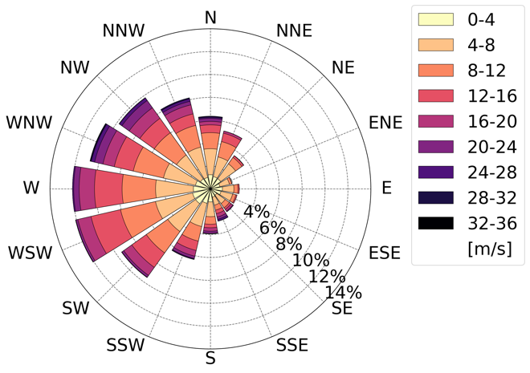
Fig. 3. Wind climatology from ERA5 reanalysis (Hersbach et al. 2023) at 600 hPa for 45.9°N and 7.55°E for 15 September though 15 October covering the period 1993-2023.

Table 1. MatterHEX sites, their coordinates, and elevations.
Observation Site | Latitude | Longitude | Elevation (ASL)
Schönbielhütte | 46.002°N | 7.629°E | 2694 m
Furggsee | 45.974°N | 7.695°E | 2877 m
Trockener Steg | 45.971°N | 7.722°E | 2939 m
Hirli | 45.989°N | 7.699°E | 2765 m

Table 2. Observational components, targeted processes, instrumentation, and measured variables.
Observational component | Targeted Process | Instrument | Location | Variables | Manufacturer and Model
Upwind flow conditions | Wind profile,  stratification | Radiosonde | Schönbielhütte | P, T, RH, u, v | Graw DFM-09
Leeside flow response | Leeside flow field, wind profile | Doppler wind lidar | Furggsee, Trockener Steg (7-14 Oct) | Radial velocity, aerosol backscatter, VAD wind retrieval | Halo Photonics Streamline XR
 | Leeside wind profile | Doppler wind lidar | Furggsee | VAD wind retrieval | Vaisala Windcube V2.1
 | Banner cloud formation | Webcam | Furggsee, Hirli | Pictures | Microseven M7B5MP-PSAA
 | Near-surface turbulence | Sonic Anemometer | Furggsee | u, v, w, T | Campbell Scientific CSAT3
a. Upwind Observations
Identifying the best-suited site to collect representative flow conditions upwind of the Matterhorn was challenging, as every location in complex terrain suffers from the influence of upstream topography and from local effects (exposure, valley circulations, etc.). We considered sites slightly north of the Matterhorn and slightly to the south, in the Italian Aosta Valley. We deemed the southern candidates less ideal, mainly due to their proximity to the Dent d’Herens, a mountain just 300 m lower than the Matterhorn, and the depth and southerly exposure of the upper Aosta Valley. Additional logistical disadvantages included operating from two different countries, and extended travel times between upwind and downwind locations. Locations to the north of the Matterhorn seemed better suited, as the westerly flow would enter over the relatively flat Plateau d’Herens. We therefore decided to observe the relevant upwind conditions by launching radiosondes from the Schönbielhütte (Fig. 4), a mountain hut of the Swiss Alpine Club, which can be reached in a 4.5-hour hike from Zermatt. The Schönbielhütte is located at 2694 m ASL on the northern slope of the east-west oriented Zmutt valley northwest of the Matterhorn. By the start date of the campaign the hut was already closed for the season, but we were allowed to use its winter room. Provisions as well as cooking fuel were flown in by helicopter, together with the scientific equipment, a small generator, and the helium cylinders needed for the radiosonde operation. Water was available from a natural well near the hut. Two group members stayed at the hut to perform the upper-air soundings.
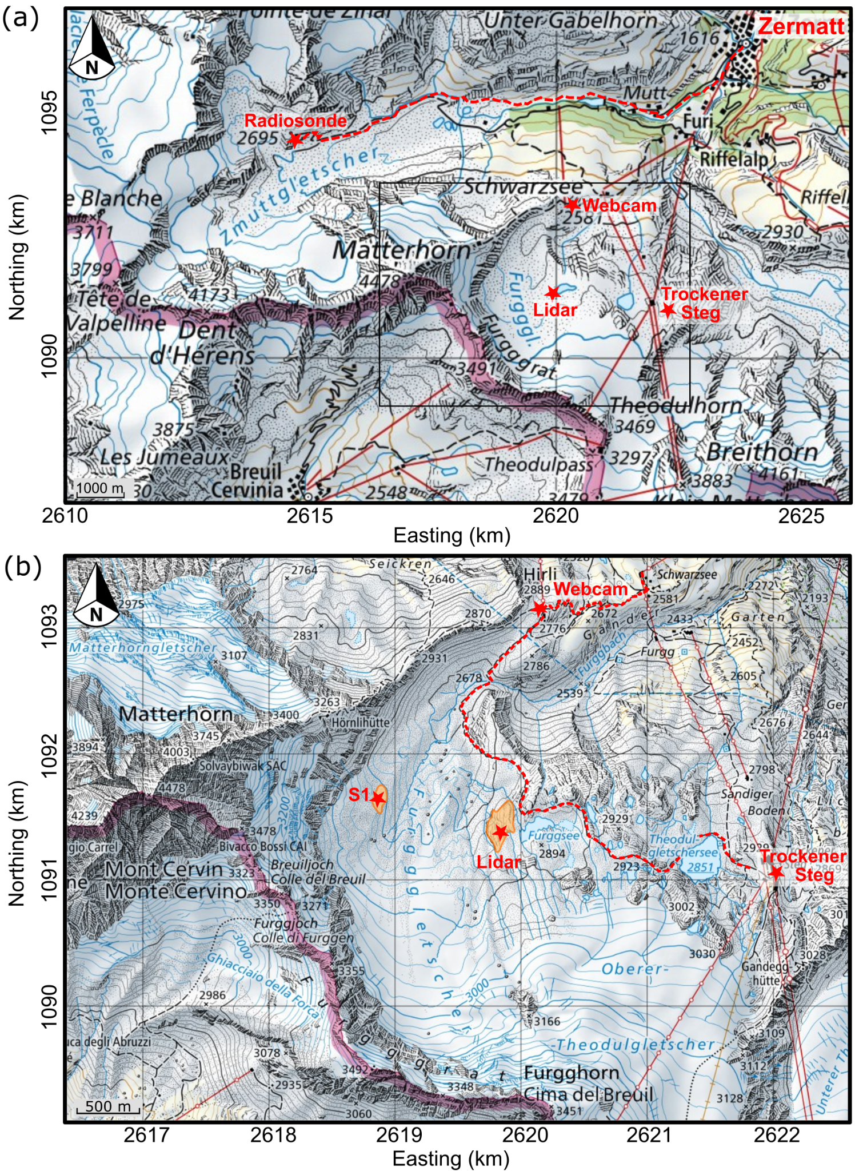
Fig. 4. Maps showing (a) the Matterhorn region with the distribution of both up- and downwind observational sites, and (b) a zoom into the terrain on the lee of the Matterhorn with the location of the instrumentation used to monitor the leeside circulation. Based on CH1903+ / LV95 maps from the Swiss Federal Office of Topography, swisstopo.
Upwind conditions were observed with radiosondes (GRAW DFM-09) that measured air temperature, relative humidity, wind speed and direction as a function of height. Stability parameters such as N and the gradient Richardson number R_{i} were derived from these profiles. The timing of the launches was based on the forecast of westerly flow as well as the occurrence of banner clouds under various flow conditions.
b. Downwind Observations
The flow response in the lee of the Matterhorn was remotely sensed using Doppler wind lidar techniques. The principal instrument in use was the University of Utah’s Halo Photonics Streamline XR scanning Doppler wind lidar. There were several constraints that limited the choice of an observational site. While smaller lidar units such as ours can be powered using portable generators which offers significant flexibility, we were limited to stable terrain safe from rockfall, with easy access, and well-hidden from hikers. During a scouting visit in summer 2023 we noticed that vast areas of the Furgg glacier on the eastern slopes of the Matterhorn had melted, exposing very loose and unstable debris unsuitable for instrument deployment. However, we identified two potential locations on solid bedrock. While the site closest to the summit pyramid (S1 in Fig. 4) offered the best vantage point for observing the underside of a banner cloud, access required crossing meltwater streams with large diurnal variations in runoff and travel over debris-covered ice. We therefore opted for the second-best location. This location, on the western side of Lake Furggsee (Lidar in Fig. 4), is easily accessible from a popular hiking trail which connects the Trockener Steg and Schwarzsee cable car stations. This trail offered safe access even under adverse weather conditions, and no major stream crossings were necessary. The local topography, with sharp drop-offs to the west, allowed for a deployment well hidden from the trail despite its proximity. At a highpoint near this site, near-surface wind and turbulence were measured with an 3D ultra-sonic anemometer (Campbell Scientific CSAT3). The near-surface wind profile was monitored using a 5-beam prism-based lidar retrieval with a Vaisala Windcube V2.1. All instruments, hardware, generators, fuel, provisions, and camping gear were flown in by helicopter.
A second scanning Doppler wind lidar (Lumibird Streamline XR) was deployed during part of the experiment at the roof of the Trockener Steg cable car station — the same location where the exploratory measurements were taken in 2018. This site, while at the edge of the lidar range for flow detection around the summit pyramid of the Matterhorn, offered hard power and easy access under almost any weather conditions. Observations from this location were seen as a backup, in case of a failure of the system installed at the Furggsee location.

1) Lidar Scanning Strategy
The wind lidar at the Furggsee site was programmed with a repeating scan pattern consisting of three range-height indicator (RHI) and four plan-position indicator (PPI) scans, and a short period of vertical stares. This scan pattern was repeated approximately every 7 minutes. In addition, a 6-point PPI scan every 15 minutes was used for a velocity azimuth display (VAD) wind retrieval.
The coverage of the RHI and PPI scans is illustrated in Figure 5. These scans were designed to capture the key features of the flow field around the Matterhorn’s summit pyramid. One RHI scan was centered on the summit, the other two to the north and south of the summit. The PPI scans were positioned to capture potential flow asymmetries at different elevations and to detect the anticipated flow reversal in the lee of the mountain.
The lidar’s range gate length was set to 60 m. While the Streamline XR instrument allows range gates as small as 18 m, we chose 60 m to enhance the returns in the ambient high-altitude and low-aerosol environment. Lidar data was collected using the continuous scanning mode, and scan speeds and acquisition time were chosen to resolve the radial wind velocities at the distance of the Matterhorn summit with a spatial resolution of approximately 30 m. Noise was filtered using a threshold filter, but limited by applying the Density-Based Spatial Clustering of Applications with Noise (DBSCAN) algorithm (Ester et al. 1996; Alcayaga 2020; Duscha et al. 2023). More details on the data processing can be found in Thomas et al. (2025).
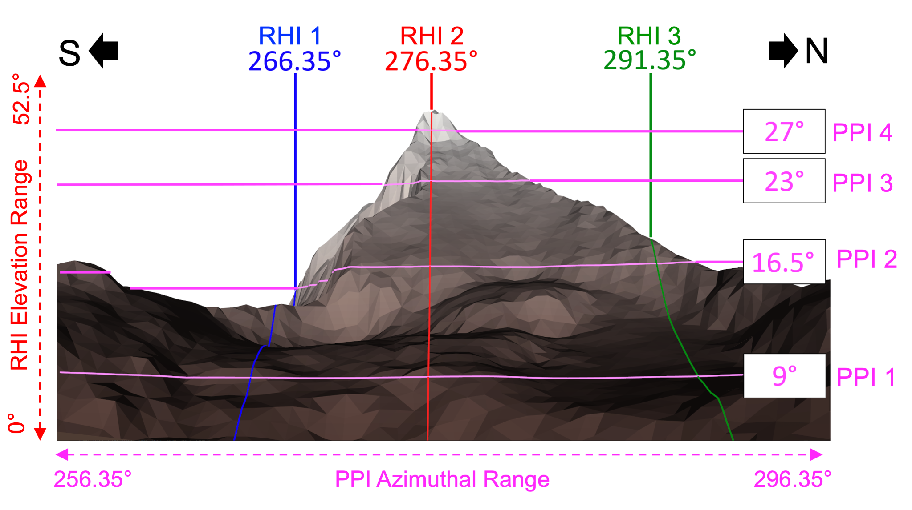
Fig. 5. Illustration of the lidar scan pattern. RHI (blue, red, green) and PPI (pink) scans, their ranges, and simulated terrain intersections. All scans were repeated every 7 minutes and had an angular resolution of 0.55°.
The additional profiling wind lidar (WindCube V2.1) recorded the wind profile above the Furggsee site up to a height of 300 m above ground at 20 levels. The back-up lidar at Trockener Steg scanned a repeating grid pattern across the summit pyramid using a 60 m gate length, as well as a 6-point PPI for a VAD retrieval of the vertical wind profile.

1) Webcams
Time-lapse photography from webcams was used to monitor and document the banner cloud formation and evolution during the field campaign. One camera was co-located with the lidar at the Furggsee site, and a second one was deployed at the upper Hirli cable car station (Fig. 4), where hard power was available. The combined perspectives from these two vantage points helped to distinguish banner clouds from other low- or mid-level clouds. Both cameras captured time-stamped images every minute, which were transmitted in real time. This allowed us to remotely assess conditions, whether in Zermatt or at Schönbielhütte. The images were later animated into time lapse videos to better visualize the temporal and spatial evolution of the banner clouds. An example video is available as an online supplement.
3. Campaign Highlights
In the following we provide highlights from the campaign based on the wind lidar retrievals during the occurrence of banner clouds. Additional analysis and a comparison of the lidar observations with large eddy simulations can be found in Thomas et al. (2025).
a. Banner Cloud Occurrence
Banner clouds were observed on eight days of the 17 days of the MatterHEX field campaign, and banner clouds can be identified during 45 hours of webcam imagery. Not all banner clouds were as well defined as the one pictured in Fig. 1. There were cases when the banner clouds were very faint, almost sub-visible, and other cases when lower clouds partially concealed a banner-shaped cloud. We even encountered situations reminiscent of a transition from a cap cloud to a banner cloud. Furthermore, banner clouds developed under different prevailing upstream wind directions. Table 3 summarizes the banner cloud observations, listing the prevailing wind direction and the launch times of the upwind radiosondes during the event.
Table 3. Overview of banner cloud episodes observed during MatterHEX.
Date | Banner cloud characteristics | Duration (hours) | Prevailing wind direction | Radiosonde launch time (UTC)
29-Sep | Well defined | 3 (1500-1800 UTC) | NNW / NW | 1200, 1740, 2000
30-Sep | Faint | 4 (1100-1500 UTC) | N / NNW | 1200, 1810
3-Oct | Well defined | 6 (1200-1800 UTC) | W | 1200, 1400
4-Oct | Faint | 5 (1200-1700 UTC) | NW / NNW | 1815
7-Oct | Cap cloud to banner cloud transition | 1 (1130-1230 UTC) | NW / NNW | -
8-Oct | Good | 5 (1300-1800 UTC) | NNW/N | -
11-Oct | Very Faint | 10 (0500-1500 UTC) | SW | 1000, 1320
14-Oct | Good / Obscured | 11 (0500-1600 UTC) | W / WSW | 0530, 0900, 1210

To give a campaign overview, a time-height cross sections of the vertical profile of wind direction above the Furggsee site is shown in Figure 6. Note that the vertical extent of the VAD retrieval was constrained by aerosol availability in this high-altitude environment. However, as cloud droplets greatly enhance lidar reflectivity, the leeside radial flow field within and near a banner cloud edge could frequently be observed, even at times when the lack of aerosols limited the range of the vertical wind profile retrievals further downstream.
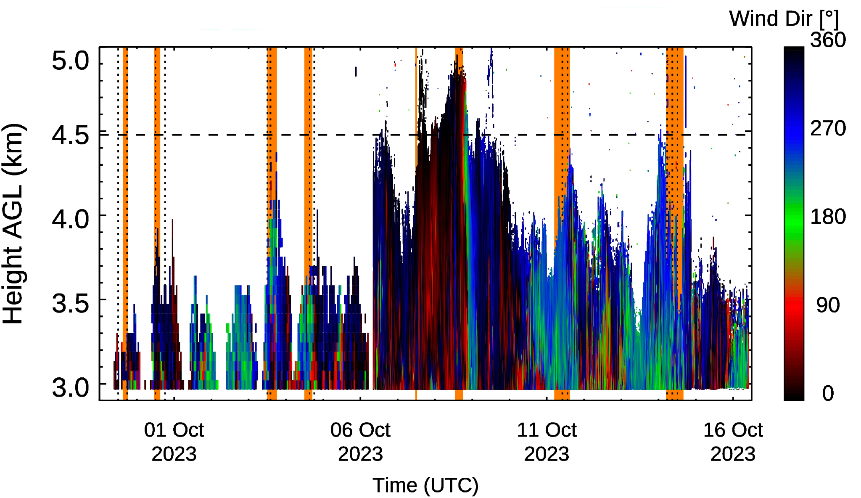
Fig. 6. Time-height cross section of wind direction east of the Matterhorn from Doppler wind lidar at the Furggsee site. Episodes with banner cloud occurrence are highlighted in orange, and radiosonde ascents are indicated as vertical dotted lines. The horizontal dashed line indicates the elevation of the Matterhorn summit.
In this paper we focus on the 3 October 2023 case, when lee-side flow separation and sufficient moisture levels led to banner cloud formation. This case is well-suited to describe both the observed mean leeside flow structure and selected turbulent characteristics of the flow.
b. Leeside Mean Flow Structure
Our lidar scans were successful in resolving the key flow features associated with banner cloud formation as predicted by previous model studies. These are, firstly, the flow reversal in the lee of the mountain, and secondly, the rising motion in the vicinity of the leeside mountain face. Both features are necessary consequences of boundary layer separation at the summit and at the ridgelines as illustrated in the regime diagram (Fig. 2).
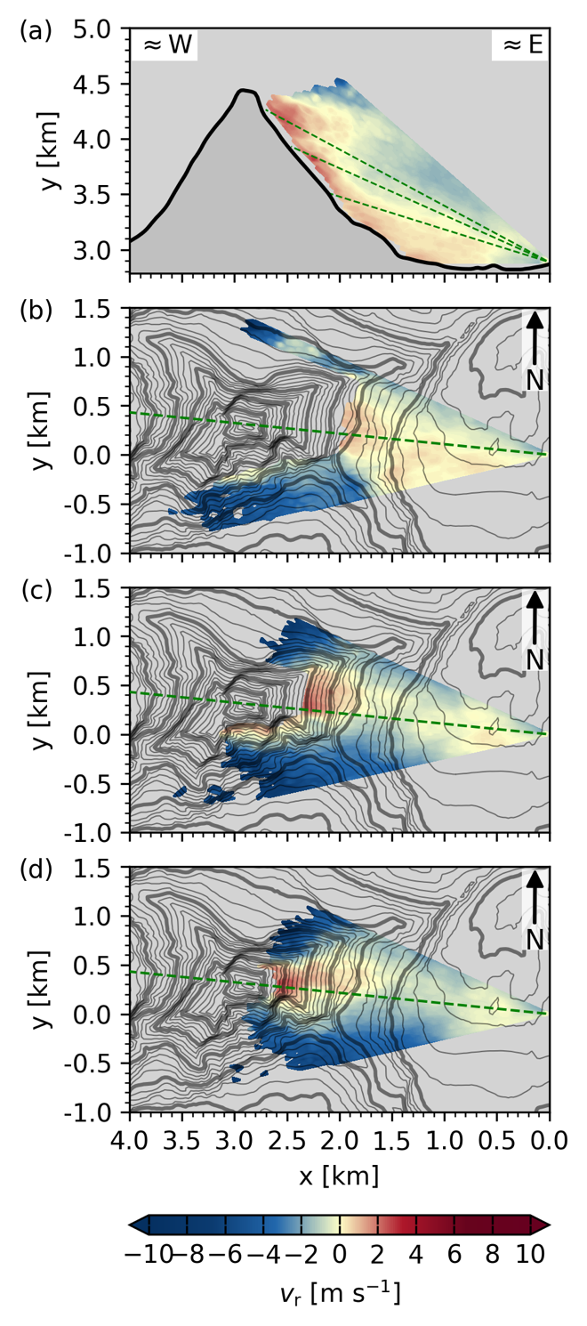
Fig. 7. Mean leeside radial velocities resolved by (a) the range-height indicator scan (RHI) through the summit pyramid, and plan-position indicator scans (PPI) at (b) 16.5°, (c) 23°, and (d) 27° elevation for the period between 1200 and 1800 UTC. Only those grid points are included where data are available for at least 25% of the scans. The x-coordinate in (a) gives the E-W distance, in (b)-(d) the line-of-sight distance from the lidar. Negative values (blue) correspond to flows towards the lidar, positive values (red) indicate flow away the lidar.
The mean flow structure is visualized by combining multiple individual lidar retrievals. This has been done for the scans between 1200 and 1800 UTC 3 October 2023, and the composite scans are shown in Figure 7. Details on the averaging procedure can be found in Thomas et al. (2025). The individual retrievals are provided in Figures S1-S51 of the supplementary information. Figure S52 further illustrates the data coverage and visualizes the fraction of time the radial velocity is directed toward the lee of the mountain.
Since the wind lidar is limited to resolving radial velocities, a unique interpretation may prove difficult. For example, the radial velocities away from the lidar (towards the mountain’s lee side) could be explained by either one of the following two extremes: a strong upward motion and no horizontal flow component, or strong horizontal motion towards the mountain and no vertical flow component. However, as the radial velocities remain significant in the direct vicinity of the mountain’s east face, and radial velocities in the PPI scans change signs very quickly at the mountain ridgelines, we conclude that these radial retrievals reflect a combination of flow towards the lee slope and upward flow along the lee slope.
The considerable spatial extent of the mean flow towards and upwards along the lee slope apparently allows the air parcels to ascend over a larger vertical distance than at the windward side. This ultimately results in the strongest adiabatic cooling of leeside air parcels, leading to saturation and the formation of the banner cloud. As seen from the underlying individual scans (Fig. S1-S51), the spatial extent as well as the shape of the uplift zone varies greatly with time. Despite the strongly turbulent character of the leeside flow, the time average is consistent with the existence of a banner cloud as observed.
The mean flow patterns shown in Figure 7b-d illustrate the flow separation on the ridgelines as the main flow passes the mountain. A flow separation eddy forms in the lee, generating drastic changes in flow direction. Shear surfaces can be identified where the flow quickly changes direction over short distances. These surfaces define the basic structure or outline of the banner cloud. Lee-side, easterly and rising air reaches saturation and forms the cloud banner. Entrainment of relatively drier air from the westerly flow at the cloud’s edges subsequently leads to the evaporation of cloud droplets and the downwind thinning of the banner cloud.
The upwind atmospheric profile from the radiosonde launched during the early part of the episode shows a near neutral boundary layer, capped by a strong increase in potential temperature and wind speed above the Matterhorn summit (Fig. 8). As shown in model simulations by Prestel and Wirth (2016), low atmospheric stability below the mountain summit favors lee-side flow separation and is conducive to banner cloud formation. Hence, the occurrence of a banner cloud in this specific episode is consistent with these earlier predictions based on theory and numerical simulation.
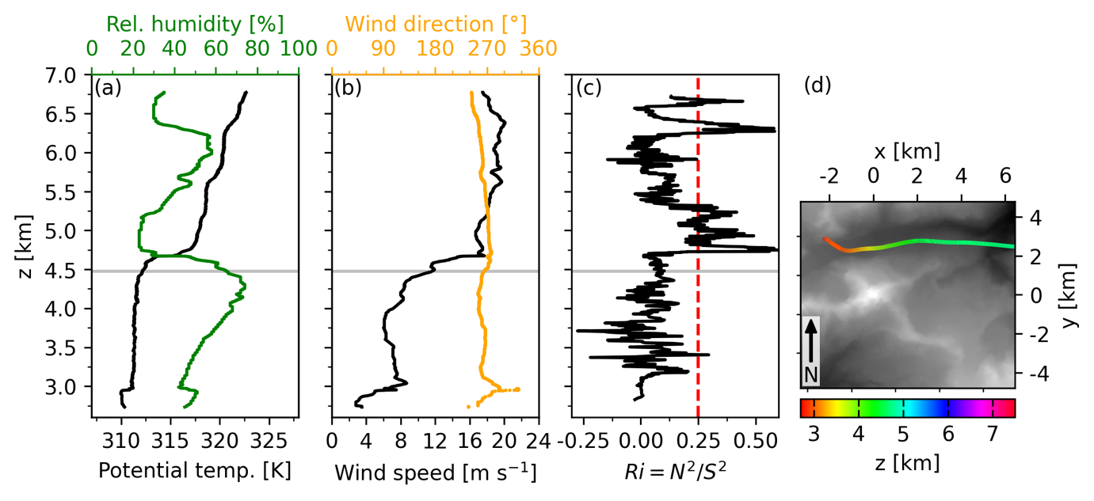
Fig. 8. Upwind vertical profiles at 1358 UTC 3 October 2023 of (a) potential temperature and relative humidity, (b) wind speed and direction, and (c) gradient Richardson number, calculated using a 20-point rolling mean ($≈$100 m). Horizontal gray lines indicate the summit height of the Matterhorn, and the red dashed line in (c) depicts the critical Richardson number Ri_{c} of 0.25. Panel (d) shows the ascent path of the radiosonde, with coordinates centered at the Matterhorn summit and grey shading indicating topography.
c. Leeside Turbulent Features
While the primary goal of the observations was to evaluate the mean circulation patterns in the lee of the mountain, we also aimed to capture key turbulent patterns.
On 3 October, we took the photo shown in Figure 9a during the hike from Schönbielhütte to Zermatt. It shows how parts of the banner cloud are sheared off, and it suggests that strong overturning leads to a cloud train resembling Kelvin-Helmholtz billows. Indeed, the atmospheric conditions on this day were conducive to Kelvin-Helmholtz Instability (KHI), as indicated by the gradient Richardson number which dropped below the critical threshold of Ri_{c}=0.25 (Fig. 8c). The RHI scan from the time of these observations, shown in Figure 9b, reveals a substantial area of upwelling reaching the summit, likely amplifying directional wind shear. This created favorable conditions for this particular banner cloud display, resembling Kelvin-Helmholtz billows. The RHI scan also shows the characteristic ascending and descending portions of the overturning motion at the cloud base.
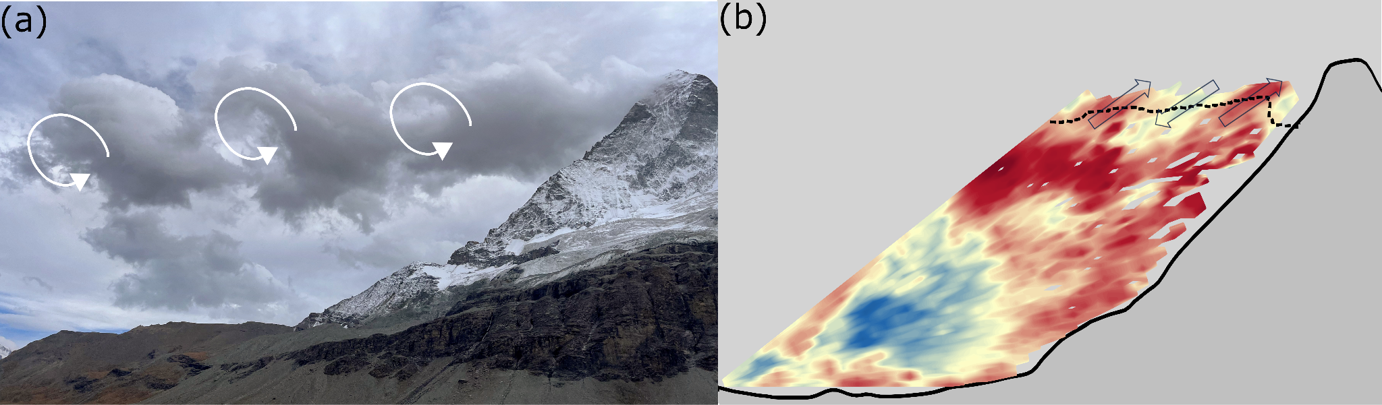
Figure 9. Analysis of turbulent cloud features at 1506 UTC 3 October 2023: (a) Photograph of a banner cloud pattern resembling Kelvin-Helmholtz billows, and (b) RHI scan through the Matterhorn summit. The dashed line indicates the base of the cloud, and the arrows highlight the fluctuations in radial velocities consistent with the cloud billows.

Strong overturning motion can also be detected directly above the Furggsee lidar site. Vertical velocities from stare scans, shown in Fig. 10, highlight strong vertical speed oscillations consistent with the passing of overturning eddies. Vertical velocities exceed 5 m/s, indicating vigorous mixing.
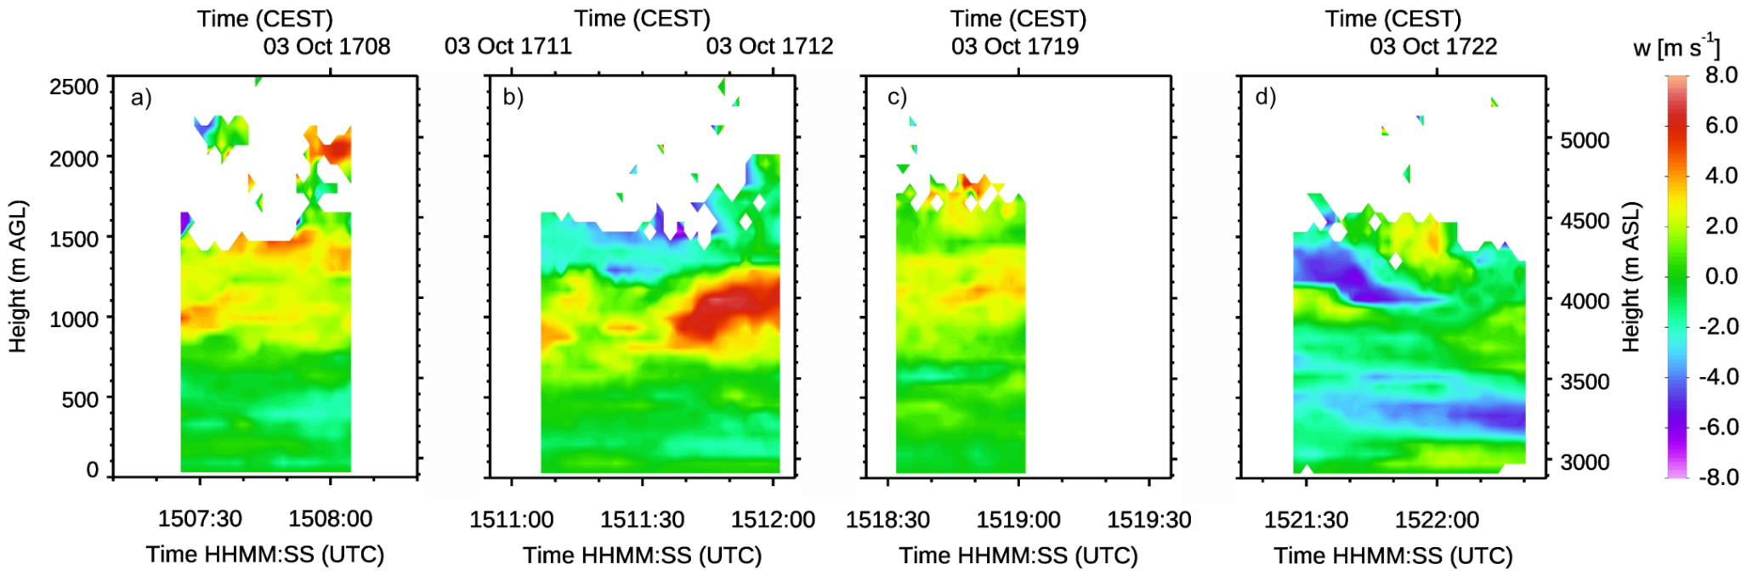
Figure 10. Vertical velocities from stares above the Furggsee lidar site between 1507 and 1525 UTC 3 October 2023.
As the lidar scans only resolve radial velocities, inferring the full three-dimensional flow pattern can be challenging, especially as turbulent structures evolve within and between individual scans. Additional lidar observations implementing dual-, or triple-Doppler approaches (Hill et al. 2010; Cherukuru et al. 2015; Wang et al. 2016) would be very helpful. Similarly, the combination of lidar observations with numerical Large-Eddy Simulations adds to the understanding of the complex flow patterns (Thomas et al. 2025).

4. Synthesis
Let us come back to the regime diagram in Fig. 2, which illustrates why steep mountains like the Matterhorn (i.e. large $A$), are more likely to exhibit a banner cloud in their lee than mountains with a lower aspect ratio: Leeside flow separation occurs under a much wider range of stratification for any given wind speed $U$ (i.e. allowing larger $N$). As Baines (1995) points out, the regime boundaries are approximate and depend on the obstacle’s exact shape. In real complex topography, the relevant aspect ratio of a mountain will vary with the direction of the flow. With this in mind, we can now go a step further and explore the dependence of banner cloud formation on wind direction at the Matterhorn. Figure 11a illustrates how the specific topography of the Matterhorn controls the height and width scales ($h_{0 }$and $A_{d }$), and thus 𝒜 as a function of wind direction and distance from the summit. Following Baines (1995), leeside separation occurs when 2πU/N is smaller than the leeside mountain half-width, $A_{d }$. This sets the upper threshold value for 𝒩, namely $N_{lim}=πA$, which may not be exceeded for the flow to remain within the “lee-side separation” regime and, thus, for banner cloud occurrence. As $N_{lim}$ is proportional to 𝒜, Figure 11a also shows the variation of the threshold value $N_{lim}$ for different flow directions on the Matterhorn. This allows us to calculate a directionally smoothed mean of $N_{lim}$ , $〈N_{lim}〉$, for a 2-km radius to encompass the entire Matterhorn. Analyzing this $〈N_{lim}〉$ we conclude that banner clouds can form under a widest range of $N$ for northerly flows as $〈N_{lim}〉$ is largest (Fig. 11b) due to the steepest lee-side (i.e. southern) terrain; for westerly and easterly flows, $〈N_{lim}〉$ is smaller by comparison, suggesting that for these wind directions banner cloud formation is less likely, and more sensitive to the balance between the wind speed $U$ and the Brunt-Väisälä frequency $N$.
We can now use our upwind observations to evaluate whether the flow conditions fall into the leeside separation regime, and thus, if conditions are conducive to banner cloud formation. Figure 11b shows that only two of our upwind profiles result in $N$ values exceeding the threshold level $〈N_{lim}〉$, and thus preventing banner cloud formation. All the other profiles fall into the banner cloud-permitting leeside separation regime, including four cases during which no banner clouds were visually observed. On these four days, upwind relative humidity levels tended to be lower (not exceeding 40% relative humidity in the 750 m below the summit) than on days when banner clouds were observed (Fig. S53-S65). On 11 October, the banner cloud was very faint, and humidity levels peaked at just 45%. These observations indicate that the circulation patterns responsible for banner cloud formation are likely to occur more frequently than their actual occurrence would suggest.
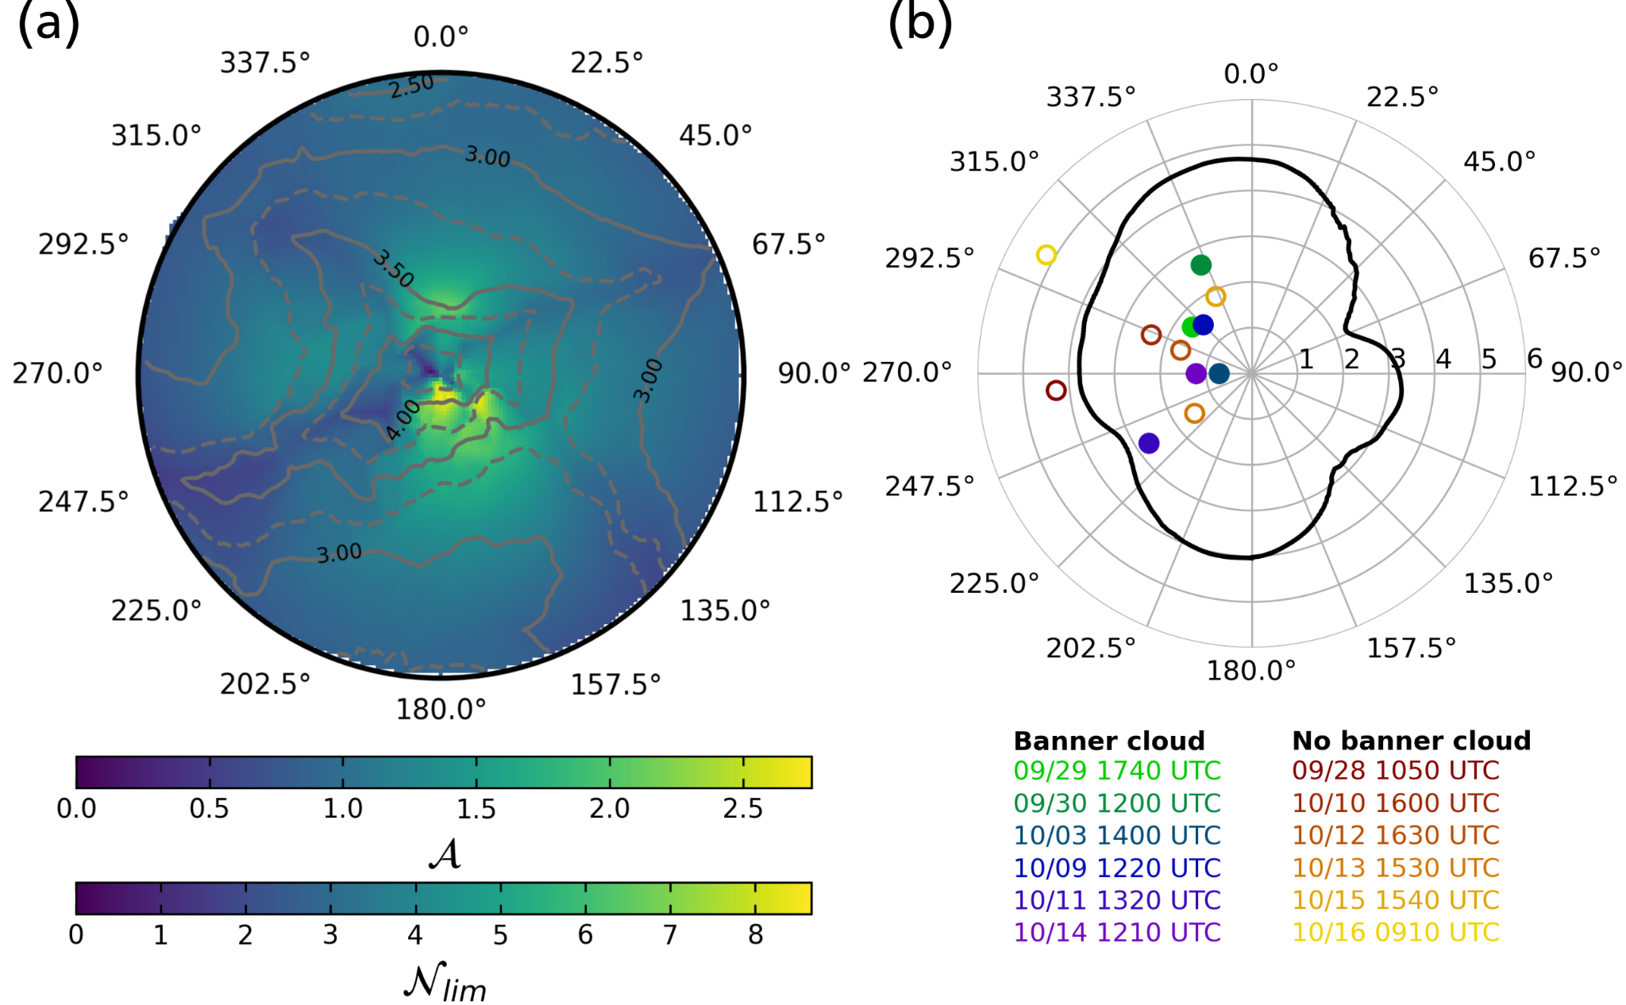
Figure 11. Analysis of regime conditions and banner cloud occurrence during the MatterHEX campaign. Panel (a) shows the directional dependence of the leeside mountain aspect ratio 𝒜 and of the upper threshold value of 𝒩, $N_{lim }$, for leeside flow separation within a 2-km radius around the summit. Note that 𝒜 and $N_{lim}$ are proportional to each other. Panel (b) shows the variation of the spatially averaged $N_{lim }$, $〈N_{lim }〉$ (2-km distance average with 5° directional smoothing) as a function of wind direction. Circles in (b) indicate 𝒩 from upwind observations with (filled) and without (empty) visual banner cloud occurrence. Upstream 𝒩 was calculated using the mean U and the mean N between 3000 m ASL and the Matterhorn summit (4478 m ASL). Alternative methods for determining U and N led to very similar results (not shown).
5. Summary and Conclusions
This paper summarizes the design and execution of a high-risk, high-reward field experiment addressing the flow-terrain interactions responsible for the frequent formation of banner clouds on steep mountains such as the iconic Matterhorn of the European Alps. A key instrument in this endeavor was a Doppler wind lidar system. Such systems, which have become commercially available in the last decades, allow remote sensing of circulation patterns in highly complex terrain, even at elevations with reduced aerosol loading. Our lidar was used to retrieve radial wind components of the flow around the Matterhorn. Temporal averages of these retrievals were used to resolve the mean flow structures during banner cloud episodes. The observed mean structures suggest strong flow reversal and extensive upward motion in the lee of the Matterhorn, consistent with previous numerical simulations. Individual lidar retrievals resolved the highly turbulent character of the leeside circulation and indicated turbulent structures resembling Kelvin-Helmholtz billows.
We further categorized our observed upwind flow conditions in terms of the regimes of Baines (1995) while taking the effects of the varying obstacle aspect ratio with wind direction into account. As it turns out, all banner cloud cases fit well within the regime of “leeside flow separation” which is conducive to banner cloud formation. At the same time, our observations suggest that the flow regime promoting the generation of banner clouds is more prevalent than the actual occurrence of banner clouds may indicate. This is because the availability of moisture can be insufficient for condensation to occur despite the large leeside vertical displacement. These findings emphasize the prevalence of extensive leeside rising motion even in the absence of banner clouds. Our observations show that this mean lift in the lee may easily be obscured by strong turbulent eddies and overturning, involving strong changes of vertical velocity over short distances. This emphasizes the danger to leeside air travel, even when clouds may not be visible. Furthermore, the lee ascent and turbulent flow are likely also present under conditions of deep clouds and precipitation. This could possibly enhance leeside snowfall which could be investigated through a future field campaign deploying a ground-based or airborne Doppler radar.
The data collected during MatterHEX resolves the relevant spatiotemporal scales associated with the flow interactions in extremely complex terrain. It is therefore well suited for the evaluation of Large-Eddy Simulations, which in turn may offer a more refined and complete picture of the flow in the complex terrain of the Matterhorn. Such a study is presented in a follow-up paper by Thomas et al. (2025).
We hope to have demonstrated that meaningful observations of flow in highly complex terrain can be made by combining modern equipment with careful campaign design. Given the continuous advances and miniaturization of observational platforms, this bodes well for a bright future in observational mountain meteorology.

Acknowledgments.
MatterHEX was funded by grant 432130757 from the Deutsche Forschungsgemeinschaft (DFG, German Research Foundation). SWH was partially supported by the NSF National Center for Atmospheric Research, which is a major facility sponsored by the U.S. National Science Foundation under Cooperative Agreement No. 1852977. We thank the Copernicus Climate Change Service for granting free access to the ERA5 data, and three reviewers for their comments that helped to improve the manuscript. We thank Bernhard Arnold and Romy Biner-Hauser (Gemeinde Zermatt), Air Zermatt, Fredy and Yolanda Biner-Perren (Schönbielhütte SAC), and Reinhard Lauber (Zermatt Bergbahnen AG) for invaluable logistical support. We could not have realized these observations without their support.

Data Availability Statement.
All data is available at https://doi.org/10.5281/zenodo.14644747.

APPENDIX
Appendix Title
(Optional)

REFERENCES
Alcayaga, L., 2020: Filtering of pulsed lidar data using spatial information and a clustering algorithm. Atmospheric Measurement Techniques, 13 (11), 6237–6254, https://doi.org/10.5194/50amt-13-6237-2020.
Baines, P., 1995: Topographic Effects in Stratified Flows. Cambridge University Press.
Berg, J., D. Reynolds, L. Quéno, T. Jonas, M. Lehning, and R. Mott, 2024: A seasonal snowpack model forced with dynamically downscaled forcing data resolves hydrologically relevant accumulation patterns. Frontiers in Earth Science, 12, 1393260.
Cherukuru, N. W., R. Calhoun, M. Lehner, S. W. Hoch, and C. D. Whiteman, 2015: Instrument configuration for dual-Doppler lidar coplanar scans: METCRAX II. Journal of Applied Remote Sensing 9(1), https://doi.org/10.1117/1.JRS.9.096090
Comola, F., M. Giometto, S. Salesky, M. Parlange, and M. Lehning, 2019: Preferential Deposition of Snow and Dust Over Hills: Governing Processes and Relevant Scales. Journal of Geophysical Research: Atmospheres, 124(14), 7951–7974.
Connolly, A., F. K. Chow, and S. W. Hoch, 2021: Nested large-eddy simulations of the displacement of a cold-air pool by lee vortices. Boundary-Layer Meteorology, 178 (1), 91–118, https://doi.org/10.1007/s10546-020-00561-6.
Davis, E. V., and K. Lamer, 2024: Observations of airflow around a supertall curved building and its impact on temperature and humidity in Houston's urban center. Building and Environment, 260, https://doi.org/10.1016/j.buildenv.2024.111693.
Durran, D., 2003: Lee waves and mountain waves. Encyclopedia of Atmospheric Sciences, J. R. Holton, Ed., Academic Press, Oxford, 1161–1169, https://doi.org/https://doi.org/10.1016/B0-12-227090-8/00202-5.
Duscha, C., J. Pálenik, T. Spengler, and J. Reuder, 2023: Observing atmospheric convection with dual-scanning lidars. Atmospheric Measurement Techniques, 16 (21), 5103–5123, https://doi.org/10.5194/amt-16-5103-2023.
Ester, M., H.-P. Kriegel, J. Sander, and X. Xu, 1996: A density-based algorithm for discovering clusters in large spatial databases with noise. Proceedings of the Second International Conference on Knowledge Discovery and Data Mining, AAAI Press, 226–231, KDD’96.
Fritts, D. C., and Coauthors, 2016: The Deep Propagating Gravity Wave Experiment (DEEPWAVE): An Airborne and Ground-Based Exploration of Gravity Wave Propagation and Effects from Their Sources throughout the Lower and Middle Atmosphere. Bull. Amer. Meteor. Soc., 97, 425–453, https://doi.org/10.1175/BAMS-D-14-00269.1.
Gerber, F., M. Lehning, S. W. Hoch, and R. Mott, 2017: A close-ridge small-scale atmospheric flow field and its influence on snow accumulation. Journal of Geophysical Research: Atmospheres, 122 (15), 7737–7754, https://doi.org/https://doi.org/10.1002/2016JD026258.
Glickman, T. S., Ed., 2000: Glossary of Meteorology. 2nd ed., American Meteorological Society, 855 pp., Boston, Massachusetts, U.S.A.
Hersbach, H., B. Bell, P. Berrisford, G. Biavati, A. Horányi, J. Muñoz Sabater, J. Nicolas, C. Peubey, R. Radu, I. Rozum, D. Schepers, A. Simmons, C. Soci, D. Dee, J-N. Thépaut, 2023: ERA5 hourly data on pressure levels from 1940 to present. Copernicus Climate Change Service (C3S) Climate Data Store (CDS), DOI: 10.24381/cds.bd0915c6 (Accessed on 17-09-2024)
Hill, M., R. Calhoun, H. J. S. Fernando, A. Wieser, A. Dörnbrack, M. Weissmann, G. Mayr, and R. Newsom, 2010: Coplanar Doppler Lidar Retrieval of Rotors from T-REX. J. Atmos. Sci., 67, 713–729, https://doi.org/10.1175/2009JAS3016.1.
Hunt, J. C. R., and W. H. Snyder, 1980: Experiments on stably and neutrally stratified flow over a model three-dimensional hill. Journal of Fluid Mechanics, 96, 671 – 704.
Kristianti, F., J. Dujardin, F. Gerber, H. Huwald, S. W. Hoch, and M. Lehning, 2023: Combining weather station data and short-term lidar deployment to estimate wind energy potential with machine learning: A case study from the Swiss alps. Boundary-Layer Meteorology, 188 (1), 185–208, https://doi.org/10.1007/s10546-023-00808-y.
Kristianti, F., F. Gerber, S. Gonzàlez-Herrero, J. Dujardin, J., H. Huwald, S. W. Hoch, M. Lehning, 2024: Influence of air flow features on alpine wind energy potential. Frontiers in Energy Research, 12, 1379863.
Lareau, N. P., and C. B. Clements, 2017: The Mean and Turbulent Properties of a Wildfire Convective Plume. J. Appl. Meteor. Climatol., 56, 2289–2299, https://doi.org/10.1175/JAMC-D-16-0384.1.
Lehner, M., C. D. Whiteman, S. W. Hoch, B. Adler, N. Kalthoff, 2019: Flow Separation in the Lee of a Crater Rim. Boundary-Layer Meteorol. 173, 263–287, https://doi.org/10.1007/s10546-019-00466-z
Lehning, M., H. Lowe, M. Ryser, and N. Raderschall, 2008: Inhomogeneous precipitation distribution and snow transport in steep terrain. Water Resources Research, 44(7). https://doi.org/10.1029/2007wr006545.
Lundquist, K. A., F. K. Chow, and J. K. Lundquist, 2012: An immersed boundary method enabling large-eddy simulations of flow over complex terrain in the wrf model. Monthly Weather Review, 140 (12), 3936 – 3955, https://doi.org/10.1175/MWR-D-11-00311.1.
Menke, R., N. Vasiljević, J. Mann, and J. K. Lundquist, 2019: Characterization of flow recirculation zones at the Perdigão site using multi-lidar measurements. Atmos. Chem. Phys., 19, 2713–2723, https://doi.org/10.5194/acp-19-2713-2019
Prestel, I., and V. Wirth, 2016: What flow conditions are conducive to banner cloud formation? Journal of the Atmospheric Sciences, 73 (6), 2385 – 2402, https://doi.org/10.1175/JAS-D-15-0319.1.
Reynolds, D., M. Haugeneder, M. Lehning, and R. Mott, 2024: Intermediate complexity atmospheric modeling in complex terrain: is it right? Frontiers in Earth Science, 12, 1388416.
Reynolds, D., L. Quéno, M. Lehning, M. Jafari, J. Berg, T. Jonas, M. Haugeneder, and R. Mott, 2024: Seasonal snow–atmosphere modeling: let’s do it. The Cryosphere, 18(9), 4315–4333. https://doi.org/10.5194/tc-18-4315-2024
Reinert, D., and V. Wirth, 2009: A new large-eddy simulation model for simulating air flow and warm clouds above highly complex terrain. part ii: The moist model and its application to banner clouds. Boundary-Layer Meteorology, 133 (1), 113–136, https://doi.org/10.1007/s10546-009-9419-x.
Roe, G. H., 2005: Orographic precipitation. Annual Review of Earth and Planetary Sciences, 33, 645–671, https://doi.org/10.1146/annurev.earth.33.092203.122541.
van Schaik B, Huwald H and Lehning M. Resolving three-dimensional wind velocity fields with sequential wind-Doppler LiDAR for wind energy in the complex terrain - Gotthard Pass, Switzerland [version 1; peer review: 1 approved with reservations, 2 not approved]. Open Res Europe 2025, 5:9 (https://doi.org/10.12688/openreseurope.19095.1)
Schappert, S., and V. Wirth, 2015: Origin and flow history of air parcels in orographic banner clouds. Journal of the Atmospheric Sciences, 72 (9), 3389 – 3403, https://doi.org/10.1175/JAS-D-14-0300.1.
Schween, J. H., J. Kuettner, D. Reinert, J. Reuder, and V. Wirth, 2007: Definition of “banner clouds” based on time lapse movies. Atmospheric Chemistry and Physics, 7 (8), 2047–2055, https://doi.org/10.5194/acp-7-2047-2007.
Smith, R. B., 1979: The influence of mountains on the atmosphere. Advances in Geophysics, Vol. 21, Elsevier, 87–230, https://doi.org/10.1016/S0065-2687(08)60262-9.
Thomas, M. L., and V. Wirth, 2023: Sensitivity of banner cloud formation to orography and the ambient atmosphere: Transition from idealized to more realistic scenarios. Journal of the Atmospheric Sciences, 80 (11), 2653 – 2668, https://doi.org/10.1175/JAS-D-23-0106.1.
Voigt, M., and V. Wirth, 2013: Mechanisms of banner cloud formation. Journal of the Atmospheric Sciences, 70 (11), 3631 – 3640, https://doi.org/10.1175/JAS-D-12-0353.1.
Whiteman, C. D., 2000: Mountain Meteorology: Fundamentals and Applications. Oxford University Press, https://doi.org/10.1093/oso/9780195132717.001.0001.
Whiteman, C. D., M. Lehner, S. W. Hoch, B. Adler, N. Kalthoff, and T. Haiden, 2018: Katabatically Driven Cold Air Intrusions into a Basin Atmosphere. J. Appl. Meteor. Climatol., 57, 435–455, https://doi.org/10.1175/JAMC-D-17-0131.1.
Wirth, V., P. Bubel, J. Eichhorn, E. Schömer, T. Kremer, R. Erbes, S. Schappert, and I. Prestel, 2020: The role of wind speed and wind shear for banner cloud formation. Journal of the Atmospheric Sciences, 77 (4), 1199 – 1212, https://doi.org/10.1175/JAS-D-18-0354.1.
Wang, Y., C. M. Hocut, S. W. Hoch, E. Creegan, H. J. S. Fernando, C. D. Whiteman, M. Felton, G. Huynh, 2016: Triple Doppler wind lidar observations during the mountain terrain atmospheric modeling and observations field campaign. J. Appl. Rem. Sens. 10 (2) https://doi.org/10.1117/1.JRS.10.026015
Wirth, V., M. Kristen, M. Leschner, J. Reuder, and J. H. Schween, 2012: Banner clouds observed at Mount Zugspitze. Atmospheric Chemistry and Physics, 12 (8), 3611–3625, https://doi.org/ 10.5194/acp-12-3611-2012.

