Reply to Reviewer Comments

We thank the reviewers for their effort and time to review our manuscript. We were pleased that the overall reception was very positive. The valuable input given by the reviewers led to many improvements, as reflected in the replies to the individual reviewer comments below, as well as the revised manuscript. In the following, the color coding is the following: Black are the original comments by the reviewers, but we numbered the comments. Blue are our replies, and red are excerpts from the revised manuscript to show how the comments were addressed without having to locate the changes in the revised document.

Reviewer #1:
-----------------------------------
Reviewer #1: The paper discusses the MatterHorn Experiment (MatterHEX), conducted in 2023 near Zermatt, Switzerland. The experiment aimed to observe airflow conditions upwind and downwind of an isolated mountain, particularly those conducive to the formation of banner clouds. Most of our understanding of this phenomenon comes from theoretical and numerical studies, making this experiment especially valuable since very few, if any, direct observations of banner clouds exist. Overall, the paper is well-written, easy to follow, and enjoyable to read. It is suitable for publication with minimal revisions. Below, I have listed a few minor comments that came to mind while reading. I would accept this manuscript with minor revision and I don't need to see the revisions.

We thank the reviewer for the careful and kind review of our manuscript.

R1.1: Lines 75-80 & Fig. 1: Can you schematically highlight the flow pattern that you describe in the text in Figure 1?

The flow pattern described is visualized in the hand-drawn Figure 4 of Voigt and Wirth (2013), and we include it here as reference. Based on your comment, we refer the reader to this figure, but we think that including a schematic into Figure 1 of this article would be distracting from the main message of the figure, which is to show a more or less typical banner cloud.
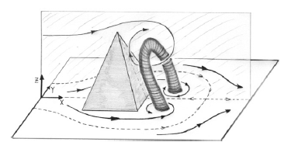
Fig RR1: Illustration of lee-side vortex, Fig. 4 of Voigt and Wirth (2013)

R1.2: Lines 91-99: Considering that BAMS has a readership with diverse backgrounds maybe this section can be a little bit more streamlined. For instance, the upwind flow property is described by the non-dimensional mountain height (flow = height might be confusing), so why not call it the inverse Froude number and explain that Fr is the ratio between atmospheric stability (N) and wind speed U, basically is there enough lift or wind speed to lift air up and over a mountain of the height h and if not, the air cannot be lifted and will move around the obstacle.

We appreciate this comment and have streamlined this section, including the specific suggestions (starting line 94): “Baines (1995) used laboratory experiments of two-dimensional flow over an isolated obstacle to define regimes of flow responses to two-dimensional terrain as a function of two non-dimensional parameters characterizing the upwind flow and the geometry of the obstacle. Based on whether and where the flow starts to deviate (“separate”) from the shape of the underlying terrain, these regimes are called “Lee-side separation”, “Post-wave separation”, and “No separation”. As shown in Figure 2, the occurrence of these regimes depends on the obstacle’s aspect ratio 𝒜=h₀ /A_{d} and on the inverse Froude number 𝒩=Nh₀/U. Here, h₀ is the obstacle height, A_{d} the leeside mountain half-width, N the Brunt-Väisälä frequency, and U the wind speed. Note that a large 𝒜 represents a steep and tall mountain, and that the inverse Froude number 𝒩 represents the ratio of the flow’s resistance to lift to its momentum to surmount the barrier. A small 𝒩 means that the flow can easily pass over the obstacle while a large 𝒩 results in blocking or flow around the barrier. The same regime classification was shown to be valid for flow past a three-dimensional mountain (Hunt and Snyder 1980; Baines 1995; Prestel and Wirth 2016). Out of the three regimes, banner clouds only occur in the “Lee-side separation” regime, since their formation requires extended leeside uplift all the way to the mountain summit (Voigt and Wirth 2013).”

R1.3: Fig. 4 & Tables 1-2: The terrain map in Figure 4 is busy with stuff that is interesting but not necessarily relevant to the paper. I would suggest using a simple terrain map showing altitude, indicating the locations (with full names) and list of instruments and variables. Upwind flow conditions vs. Leeside flow response could be color-coded differently. Instrument manufacture and model can be included in the text (which you already did). Remove Tables 1 & 2 and put the information in Fig. 1 or the text.

The choices authors have to make and that you address here are always difficult and preferences sometimes differ from reviewer to reviewer, and even from co-author to co-author. We experimented with a simple terrain map, but then a lot of geographic information went missing that we first didn’t think we would miss! However, to follow your suggestions and to try to simplify the maps, we are now using a different (larger scale) topographic map in Fig 4a, which reduces some of the details, and instead gives us the room to spell out our site names and eliminates the use of all but one abbreviation. To limit the number of tables, we eliminated Table 3.

R1.4: Lines 163-168: That is exciting and interesting but not really relevant to the paper. However, what should be added is the discussion is how the NW site represents westerly flow upwind conditions. I assume that the site NW of the Matterhorn was chosen due logistical reasons but would be a site at the end of the Aosta valley maybe be a better representation of the upwind (I also understand the difficult logistics there as well as it is on the south side of the Alps). Could you use re-analysis data and show what the differences in sites (NW or SW vs W) would be and discuss them? I assume that the locations would has major effects on wind speed and maybe even stability.

We agree that some of the details mentioned are not strictly needed to follow the scientific reasoning in this manuscript, but as this is a BAMS article for the broader community, we do think these logistical details add important information on what needs to be considered for an observational field campaign. I think that colleagues that primarily work with models often forget the difficulties that have to be overcome to collect observational data. And that can involve carrying water from (and washing at) a nearby well, and cooking over a wood fire. We wanted to also give the reader a better understanding of what it takes to run a field campaign in a remote environment.

The second - and more important - point you raise is the representativeness of the upwind conditions observed with the radiosonde site at Schönbielhütte. In an initial draft we had mentioned the possibility of launching our sondes from the upper Aosta Valley, specifically the Prarayer Hut or the Rifugio Capanna Aosta. When looking at a topographic map in detail, however, both locations have similar disadvantages of initially probing a valley atmosphere, either to the south (Prarayer & Capanna Aosta) or the north (Schönbiel). See Fig. RR2 below for reference, but note that we are not intending to add this figure to the manuscript. Each launch site may lead to slightly more representative profiles depending on exact flow conditions. One main disadvantage of a radiosonde profile from the Aosta Valley would be that it is upwind of the tall Dent d’Herens (4174 m) which will modify the flow before it impinges on the Matterhorn summit pyramid. We also think that the southerly exposure of the deep Aosta Valley is likely to lead to stronger effects of diurnal valley heating and potentially lead to a less representative sounding profile. The Schönbiel location is downwind of the Plateau D’Herens, a high elevation but for alpine standards relatively “flat” terrain. We therefore considered this site as the better candidate, especially under westerly flows with a minor northerly component.

Ultimately, we could not find a scientific advantage to justify splitting the team across the main alpine divide, with travel times of a full day between sites, and the logistical challenges with either organizing the export of helium from Switzerland by helicopter to Italy or setting up a second logistics hub in Italy.

You also mention the possibility to look at the choice of sounding locations from ERA5. The ERA5 reanalysis data is quite coarse, and the grid point closest to the Matterhorn is actually slightly to the south of the main divide, at the end of the red line on the Google Earth image in Fig. RR3 shown below. The nearest grid point on the north side is almost in the Vallais Valley, which would for sure be less representative, so we did not investigate variations between these grid points. The ERA5 topography further does not resolve the detailed topography, and does not extend beyond 2400 m ASL, as shown in Fig. 4 of Muñoz-Sabater et al. (2021) available at https://essd.copernicus.org/articles/13/4349/2021/ and included as Fig. RR4 below.

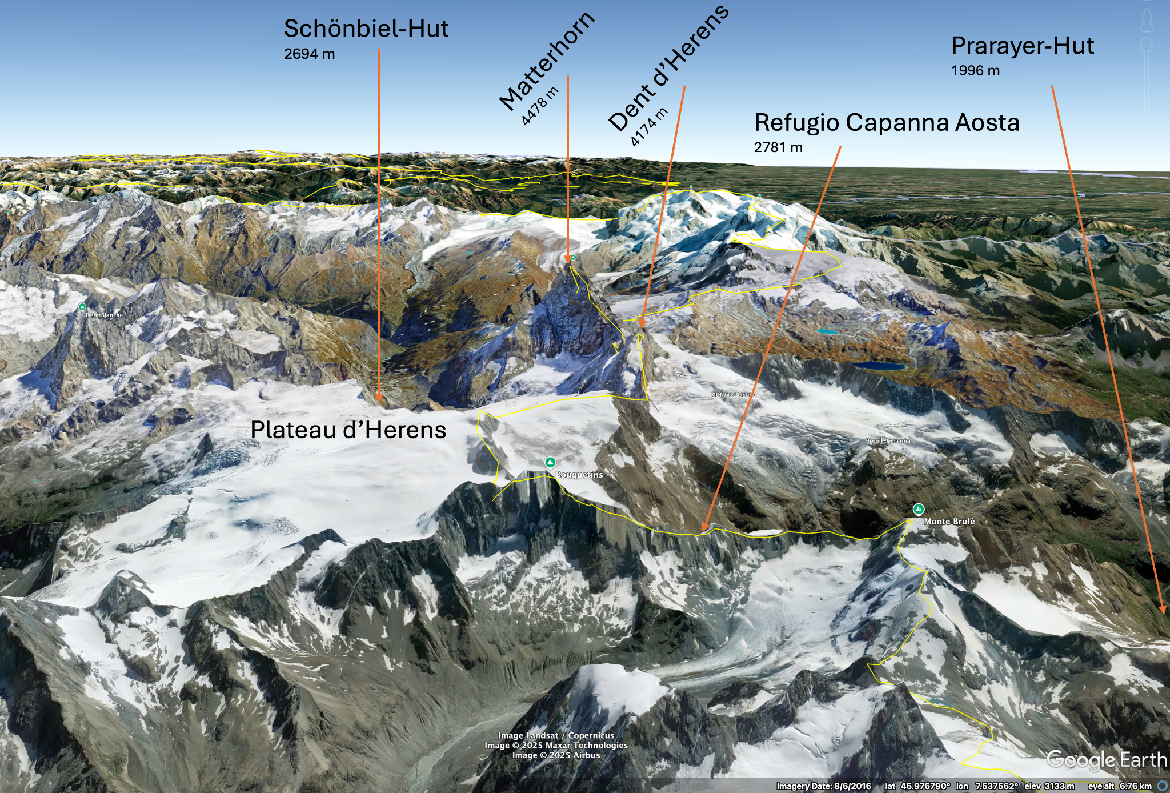
Figure RR2: Simulated view (West to East) from Google Earth.

The final advantage of choosing the Schönbiel location was to have the sounding positioned within the EULAG model grid that was used to simulate the observed cases. This allowed us to iteratively modify the upstream flow boundary condition so that the simulated sonde profile matched the observations. See Thomas et al (2024, under minor revisions in JAS) that was also made available with the review material, for details.
We added the following paragraph to the manuscript to address the difficulty of finding a representative site and the reasons for choosing the Schönbiel location (starting line 172): “Identifying the best-suited site to collect representative flow conditions upwind of the Matterhorn was challenging, as every location in complex terrain suffers from the influence of upstream topography and from local effects (exposure, valley circulations, etc.). We considered sites slightly north of the Matterhorn and slightly to the south, in the Italian Aosta Valley. We deemed the southern candidates less ideal, mainly due to their proximity to the Dent d’Herens, a mountain just 300 m lower than the Matterhorn, and the depth and southerly exposure of the upper Aosta Valley. Additional logistical disadvantages included operating from two different countries, and extended travel times between upwind and downwind locations. Locations to the north of the Matterhorn seemed better suited, as the westerly flow would enter over the relatively flat Plateau d’Herens.”

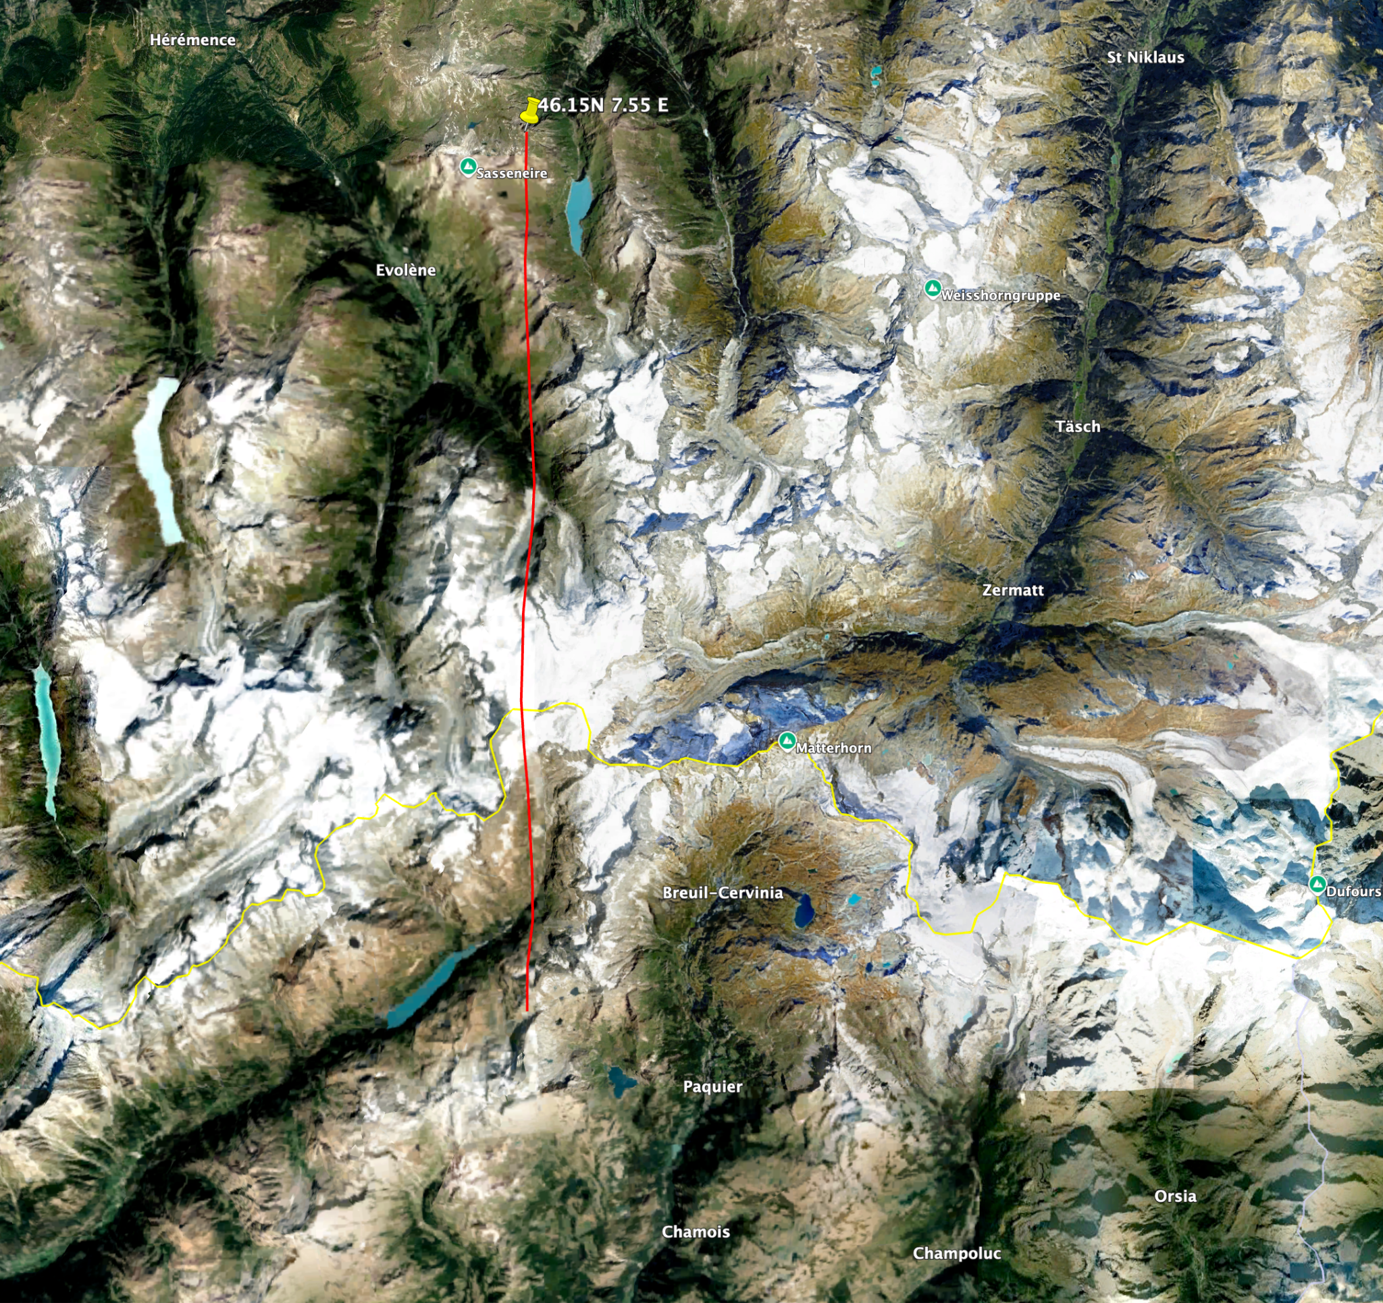
Fig RR3: Google Earth image with red line between the two ERA5 grid points discussed.

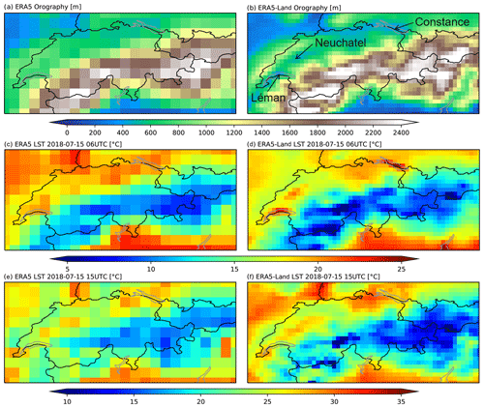
Fig RR4: Fig 4 from Muñoz-Sabater et al. (2021) showing the topography of ERA5 (left).

R1.5: Line 219: With 60 m gate length what is the theoretical maximum range or maybe indicate how far from the instrument you could typically get observations?

A theoretical or technical maximum of our specific instrument would be 11000 m, but to avoid collecting huge amounts of noise at distant range gates, we limited the maximum range to 9 km initially and then to 4200 m by limiting the number of range gates recorded by the lidar. Typical vertical wind profile retrievals at this high altitude are shown in Fig. 6 and reach ~1000 m. Ranges are somewhat larger when elevation angles are lower, with ~1500 m. As noted in the manuscript the effect of aerosols is large and thus it is hard to define a “typical” range.

R1.6: Table 3: As you can tell, I am not a big fan of Tables. This table has a lot of repetitive information that can be easily put into the text or even in Fig. 4 (azimuthal PPI range and RHI azimuths).

We took notice, and think it is fine for a reviewer to highlight personal preferences. We do think that BAMS articles often form the basis of reference for additional publications from field campaigns, and the articles typically contain a good tabular overview over the experimental setup. But based on your comment we have eliminated this table and instead integrated the information into a new Figure 5.

R1.7: Section 3b: I am not sure if that is possible, but it would be great if the observations could be categorized based on Figure 2. Does that case fall into the lee-side separation or post-wave separations - maybe indicate this in the text (lines 272-274 or in the section title). I now see that you have a discussion in section 4, but you could still address it here as teaser and indicate a more detailed discussion in section 4.

As suggested by the reviewer, we added this information (line 295): “In this paper we focus on the 3 October 2023 case, when lee-side flow separation and sufficient moisture levels led to banner cloud formation. This case is well-suited to describe both the observed mean leeside flow structure and selected turbulent characteristics of the flow.”

R1.8: Fig. 7: Indicate in the figure caption that negative means towards the instrument or west winds and positive means away from the instrument or easterly winds. Amazing measurement!

I can’t believe I missed that. Thank you for catching this, as it would have led to confusion for many readers! We added the following to the figure caption: ”Negative values (blue) correspond to flows towards the lidar, positive values (red) indicate flow away the lidar.”

R1.9: Lines 308-309: Could you add streamlines to the figure?

Single lidar observations can only resolve radial velocities and thus do not resolve the 2D or 3D flow field that could be investigated with a dual-Doppler or triple lidar experiment. We thus can’t add streamlines to these figures. However, Thomas et al. (2025) used the radial velocity fields shown here to evaluate the simulated 3D flow features. The model data then can be used to visualize streamlines, as shown in Fig. RR5 below.

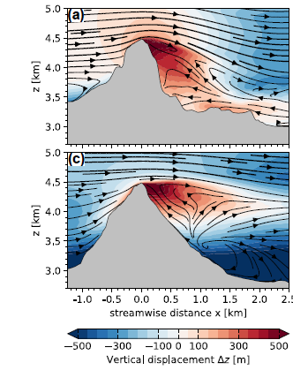
Fig RR5: Streamlines based on model calculations. From Thomas et al. (2025).

R1.10: Lines 316-318. This goes back to my earlier comment. The low stability below mountain top might be a result because the observations are still taken in the valley while the actual westerly flow passes over the higher terrain to the west. This should be mentioned somewhere. Either here or earlier.

We added a short discussion of the selection of the radiosonde site for the observations of upwind profiles, as addressed in the reply to your comment R1.4 above. The dominantly W-NW flow blows across the Plateau d’Herens (~3400-3500 m ASL). The air below that height is affected by the Zmutt Valley airshed. The air that reaches the Matterhorn, however, is ultimately the layered combination of these flows, so we do think that our observations are fairly representative.

R1.11: Figure 8: I like the Ri path. You should mention that you calculated that in section 2.

We’re glad to hear that you agree with our approach. We added the following sentence in Section 2 (line 197): “Stability parameters such as N and the gradient Richardson number R_{i} were derived from these profiles.”

Reviewer #2:
-----------------------------------
Reviewer #2: See attached. Fascinating study.

Review of: The MatterHEX Experiment – Investigating Atmospheric Flow Patterns in Highly
Complex Terrain Related to Banner Cloud Formation
Summary: This paper summarizes a novel field campaign to measure flow separation and
banner cloud formation along the lee slopes of the iconic Matterhorn. The paper presents
the climatological context and experimental design, including the deployment of multiple
lidars, cameras, and radiosondes. A subset of results are presented showing, rather
convincingly, that boundary layer separation occurs along the steep slopes and is linked to
the circulations that generate banner clouds. The authors present some details of the
thermodynamics, as a well as place their findings into a theoretical framework for flow
separation on mountain slopes from Baines.
Review: This paper was fun to read and presented fascinating details of flow and cloud
formation in complex terrain. I find it to be appropriate for BAMS both in scope and style.
The time-averaged lidar observations of flow reversal and upslope flow in the lee of the
Matterhorn are compelling, and fascinating. The use of radiosonde data and topographic
geometry to contextualize the lidar observations is also nice. That said there are a number
of avenues for potential improvement of the manuscript and a handful of issues that
should be addressed before publication. I recommend minor revisions, most of which can
be handled via editorial changes.
Specific Comments:

R2.1: Line 59: What are the challenges in performing these simulations? Sloping model
surfaces? Immersed boundary layers, etc.?

Based on your suggestion, we modified the sentence to (line 60): “One reason may be the challenges in obtaining field observations in highly complex and steep terrain, but there are also challenges in performing highly resolved numerical simulations of flow past steep orography as they require techniques such as immersed boundary conditions (e.g. Lundquist et al. 2012, Connolly et al. 2021).”

R2.2: Line 53-65: Overall this first paragraph is a bit lackluster. I’d encourage the authors to revisit it to arrive at a more compelling introduction.

We are a bit disappointed that the reviewer finds this introduction uninspiring. We have discussed different avenues of introducing this topic, but came to the conclusion that this summary, while a bit “dry”, is necessary to set the stage for the rest of the manuscript.

R2.3: Line 73: “Reveal some of their properties”-> this is a very vague statement, why not share
with the reader what some of those properties are?

We added some more detail as suggested by the reviewer (line 72-75): “Schween et al. (2007) used time-lapse movies for a first systematic study of these clouds forming on Mount Zugspitze, Germany, which were then combined with complementary meteorological observations to reveal some of their properties such as their diurnal cycle, wind direction dependence, and sensitivity to wind speed (Wirth et al. 2012).”

R2.4: Line 84: Again, could you summarize what some of the implications are, not just state that
there are implications?

Based on your suggestion we added more detail (line 85): “They confirmed that banner cloud formation remains primarily driven by dynamically induced upwelling in the lee-side recirculation region, though the detailed flow structure is strongly shaped by terrain complexity.”

R2.5: Line 93: “Lee-side separation” -> it would be useful to explain to the reader what is
separating from what. Some may not be well-versed in what is meant by flow separation.

Your assessment was shared by Reviewer 1, and we modified the sentence to be more descriptive (line 97): Based on whether and where the flow starts to deviate (“separate”) from the shape of the underlying terrain, these regimes are called: “Lee-side separation”, “Post-wave separation”, and “No separation”.

R2.6: Line 94: Might be useful to explicitly state here that large A is linked to steep mountains
(e.g., tall and narrow).

Based on your comment, we added (line 101): “Note that a large 𝒜 represents a steep and tall mountain, …”

R2.7: Line 97: “Turns out to be” -> this seems to informal of a phrase. Consider revising.

We modified the sentence to avoid the informal language (line 105): “The same regime classification was shown to be valid for flow past a three-dimensional mountain (Hunt and Snyder 1980; Baines 1995; Prestel and Wirth 2016).”

R2.8: Line 112: I’d recommend adding two additional avenues of related literature:
(1) While the terrain geometry is very different it would seem important to reference
recent work with lidars characterizing flow separation/recirculation zones during
Perdigao... here is one such example of work (not mine), and I suspect there are
others:
• Menke, R., Vasiljević, N., Mann, J., and Lundquist, J. K.: Characterization of
flow recirculation zones at the Perdigão site using multi-lidar measurements,
Atmos. Chem. Phys., 19, 2713–2723, https://doi.org/10.5194/acp-19-2713-
2019, 2019.

(2) You might also briefly discuss similar flow separation issues related to urban
structures that have been recently observed with lidars (not my work), e.g.
https://www.sciencedirect.com/science/article/pii/S0360132324005353

We thank the reviewer for suggesting these contributions. We were aware of the paper by Menke et al. (2019), but not of the unique new observations in an urban environment. We added these citations.

R2.9: Line 244-245: You’ll probably have to change this link for formal publication.

Yes, indeed. There will likely be a link to an AMS based repository. I will be working with the copy editor of BAMS to make sure the online material will be properly referenced in the article.

R2.10: Line 247-248: While implied by the heading “Campaign Highlights” you might explicitly
state that more detailed analyses are to follow in other work, including the linked 2025
Paper.

We followed the reviewer’s recommendation and added (line 270): “Additional analysis and a comparison of the lidar observations with large eddy simulations can be found in Thomas et al. (2025).”

R2.11: Fig. 6. I find it hard to decipher the colors in this figure. Perhaps try a diderent colormap?
(Authors discretion... not a mandatory change).

I agree with the reviewer that this graphic could be improved. While I didn’t change the color bar, I changed the way the contours were plotted (individual lines and points instead of contour cells), and I think the figure has improved and is more readable.

R2.12: Fig. 7. What a great figure! A few additional thoughts:

• Add a description of in/outbound flow and its shading (blue/red) to the
caption.

I can’t believe I missed that. Thank you for catching this as it would have led to confusion for many readers! We added the following to the figure caption (line 310): “Negative values (blue) correspond to flows towards the lidar, positive values (red) indicate flow away the lidar.”

• Can you find a way to make the color bar more sensitive? As it is there is
not a lot of sensitivity within the blues and reds once you get away from
the zero point.

We very much appreciate your thoughts and input on these details. We did try a lot of different color bars and sensitivities. More sensitive color gradients indeed help to resolve some of the finer detail. However, we specifically decided to keep the main focus of these figures on the main, coarser flow features, and thus opted for a less sensitive color bar.

• Could you add panels showing the variance or fraction of time the wind is
in/outbound? This would get at the variability of the flow discussed in the
text and contained in the supplemental figures.

We appreciate your input here and thank you for sharing this idea. We followed your suggestion and added the figure to the supplements (see also below as Fig. RR6). We modified the text to (line 315): “The individual retrievals are provided in Figures S1-S51 of the supplementary information. Figure S52 further illustrates the data coverage and visualizes the fraction of time the radial velocity is directed toward the lee of the mountain.”

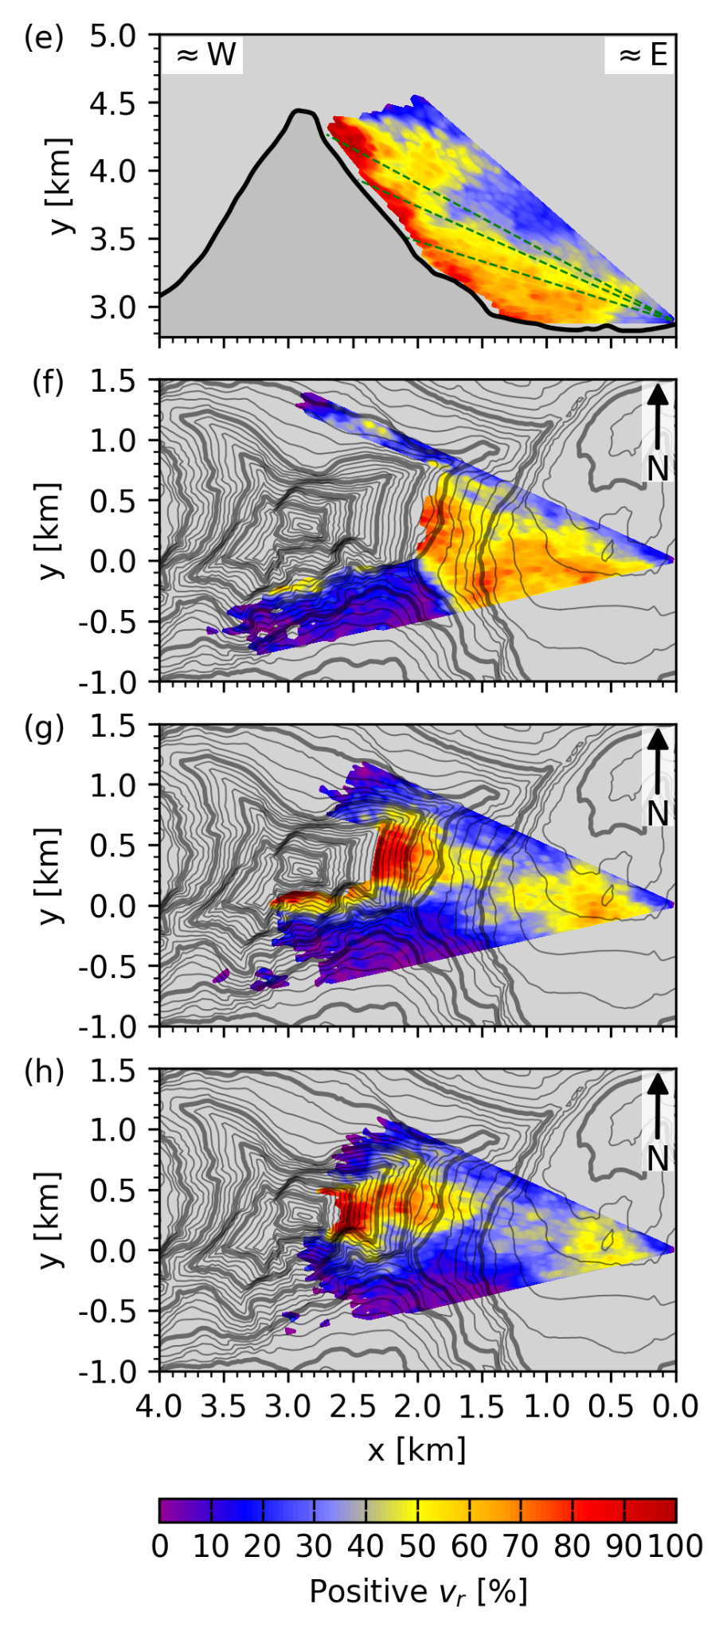
Fig. RR6: Subfigures suggested by the reviewer, now included in revised Fig S52, showing the percentage positive radial velocities.

R2.13: Line 302: Note that you don’t know what path air parcels actually take on the windward side… that said I agree with inference.

You are absolutely right, and a lidar on the windward side would be needed to verify this. But as you agree with our inference, we haven’t made any changes to the text, to keep the reader focused on the main message.

R2.14: Line 304: Might you capture this variation in some way other than the panels in the
supplement? The variance of the wind or the fraction of the time the wind is positive or
negative at a given point in the gridded analysis? [Same comment as above]

See the new figure in the supplements and our reply to your comment R2.12. Again, thank you for sharing this suggestion!

R2.15: Line 310: I find this sentence a bit handwavy/unclear. First I’m not sure I know exactly what is meant by a shear surface? Is this an isosurface for a specific value of azimuthal shear (or horizontal shear)? Is it the zero point where the flow changes direction? Second, the flow
history part... I think I sort of get what you’re saying but this needs to be clarified.

We appreciate the assessment of the reviewer and have rewritten this paragraph to be clearer (line 334): “The mean flow patterns shown in Figure 7b-d illustrate the flow separation on the ridgelines as the main flow passes the mountain. A flow separation eddy forms in the lee, generating drastic changes in flow direction. Shear surfaces can be identified where the flow quickly changes direction over short distances. These surfaces define the basic structure or outline of the banner cloud. Lee-side, easterly and rising air reaches saturation and forms the cloud banner. Entrainment of relatively drier air from the westerly flow at the cloud’s edges subsequently leads to the evaporation of cloud droplets and the downwind thinning of the banner cloud.”

R2.16: Line 316-319: What about the neutral stability (or low stability) favors banner clouds... help the reader here so they don’t have to dig into Prestel and Wirth.

Thank you for this comment. We clarified this paragraph, modifying it to (line 344): “As shown in model simulations by Prestel and Wirth (2016), low atmospheric stability below the mountain summit favors lee-side flow separation and is conducive to banner cloud formation. Hence, the occurrence of a banner cloud in this specific episode is consistent with these earlier predictions based on theory and numerical simulation.”

R2.17: Line 338-339: Try as I might I really don’t see the ascending descending alternation in the lidar data? Also it might be useful here to plot the backscatter maxima at the cloud edges from the lidar. Is the lidar attenuating right at the base of these clouds in this example? Maybe use dark markers to indicate lidar detected cloud base?

Thank you for taking a careful look at this manuscript and hinting at points such as this one to help improve the manuscript. You are correct, that the lidar is attenuated just within the cloud deck. Our illustration with the filled colored circular arrows was probably also not the best to highlight the ascending and descending areas at the cloud edge. We have reworked the figure, shown below as Fig. RR7 (and included in the revised manuscript). We are now just highlighting the undulation of the radial velocities in the RHI scan with transparent arrows, instead of superimposing the color-filled circular arrows. This new figure may be less intuitive for a reader with less practice in looking at doppler velocity fields, but it better highlights the features that we argue are indicative of the velocity field consistent with the observed clouds. Following your suggestions we are also indicating the cloud base.

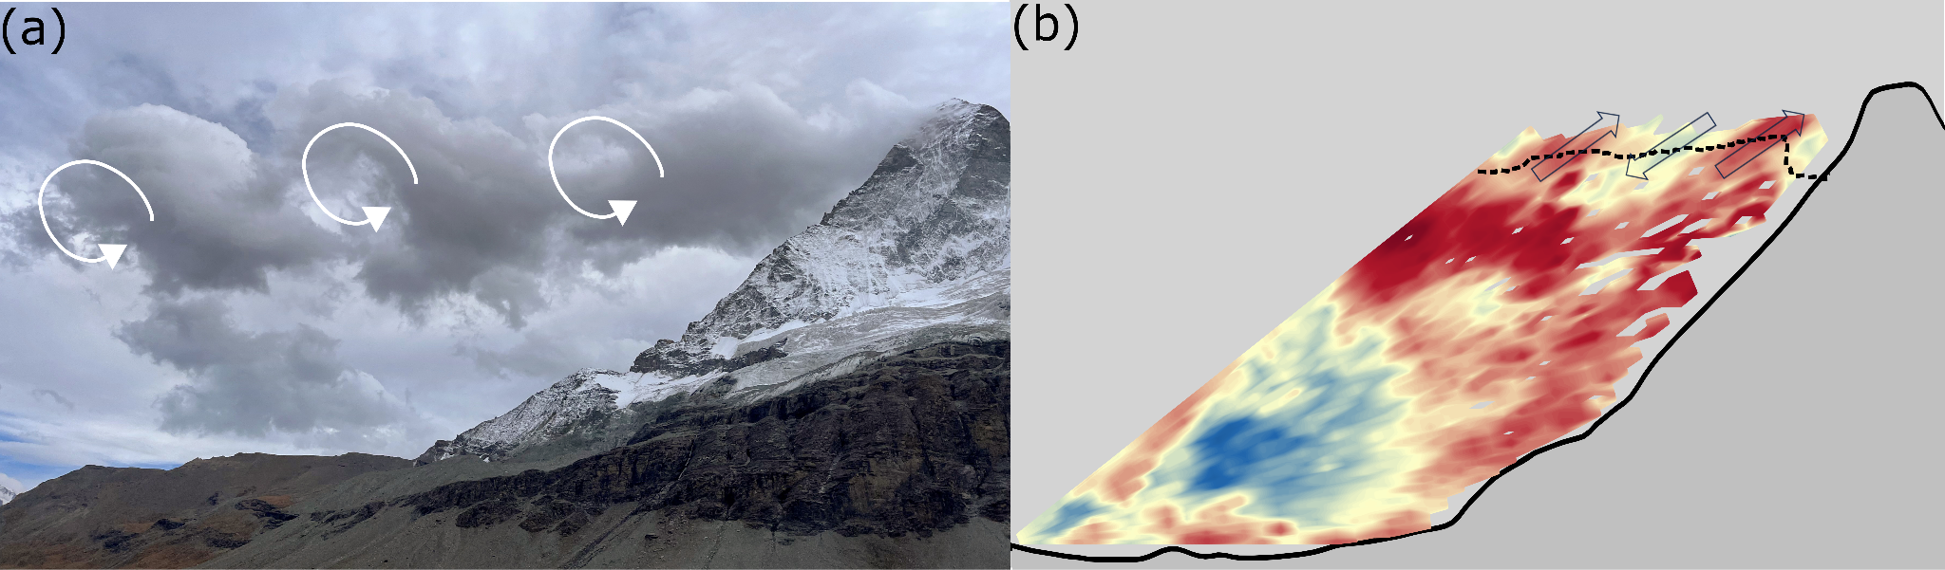
Fig. RR7: Revised Fig. 9: “Analysis of turbulent cloud features at 1506 UTC 3 October 2023: (a) Photograph of a banner cloud pattern resembling Kelvin-Helmholtz billows, and (b) RHI scan through the Matterhorn summit. The dashed line indicates the base of the cloud, and the arrows highlight the fluctuations in radial velocities consistent with the cloud billows.”

R2.18: Figure 10: I’d recommend removing all the white space by plotting the individual vertical stare periods as separate subpanels. There is some rich info in here, but it gets overwhelmed by the data gaps in this presentation.

We redrafted Figure 10 following your recommendations using separate sub-panels.

R2.19: Line 368-379: It took me a number of reads to really understand what you were computing here, I’ve got it now and it all makes sense, but you might be able to be more explicit. As I understand it for each grid point you compute h as the difference in the point’s height from the summit height, and Ad as the horizontal distance from the summit... in effect a “bulk” slope
(rise/run) for each grid point. Is that correct?

Yes, this is correct. Important to note is that A_{d} is the lee-side mountain half width, so when the flow is from the north, it is the characteristic of the southern slope that affects the flow regime.

Also, has anyone conducted a similar analysis in other settings?

Some of us were involved in the study by Gerber et al. (2017) (cited in the manuscript) where a similar approach was used to assess the potential for recirculation effects on snow accumulation.

R2.20: Line 374: Why 2 km? Is the result (e.g., the points falling in the correct regime in panel b)
sensitive to this radius?

We’re lucky to have such an interested and attentive reviewer! We’re more than happy to clarify and discuss this in more detail. Initially we used the 2-km radius, but we can, indeed, calculate the topographic parameters for varying values.

We chose the 2-km value as we felt that it encompasses the entire mountain. Heights of the 2 km radius line are at about 3000 m where it intersects the Hörnligrad, and at 2750 m at the Furgg Glacier. Changing the radius has, as the reviewer expects, an effect on $N_{lim }$as the lee-side slopes are getting steeper toward the summit. We are including a figure below showing the effect of radii of 2 km (black) and 1 km (red). We need to mention here that with a decrease of the radius, we should also consider a change of the height interval over which to calculate the mean flow speed and stability, and we ultimately get into a philosophical discussion on representability of the observations for various, increasingly smaller scales. That discussion could also involve the observed smooth cloud surfaces that often seem to encompass apparent topographies around the true rugged terrain.

As seen in Figure RR8 below, the results still hold when the radius is reduced to 1 km. When limited to 500 m, and still using the mean stability and wind speed values, $〈N_{lim }〉$ encompasses all our observations (not shown).

While we absolutely agree with the reviewer that the effect of the radius chosen and its implications are interesting, we think a discussion here would unnecessarily further complicate the already complex discussion. We thus did not make any specific changes to the manuscript but are aware that these points will allow great discussions in any upcoming seminars on the topic.

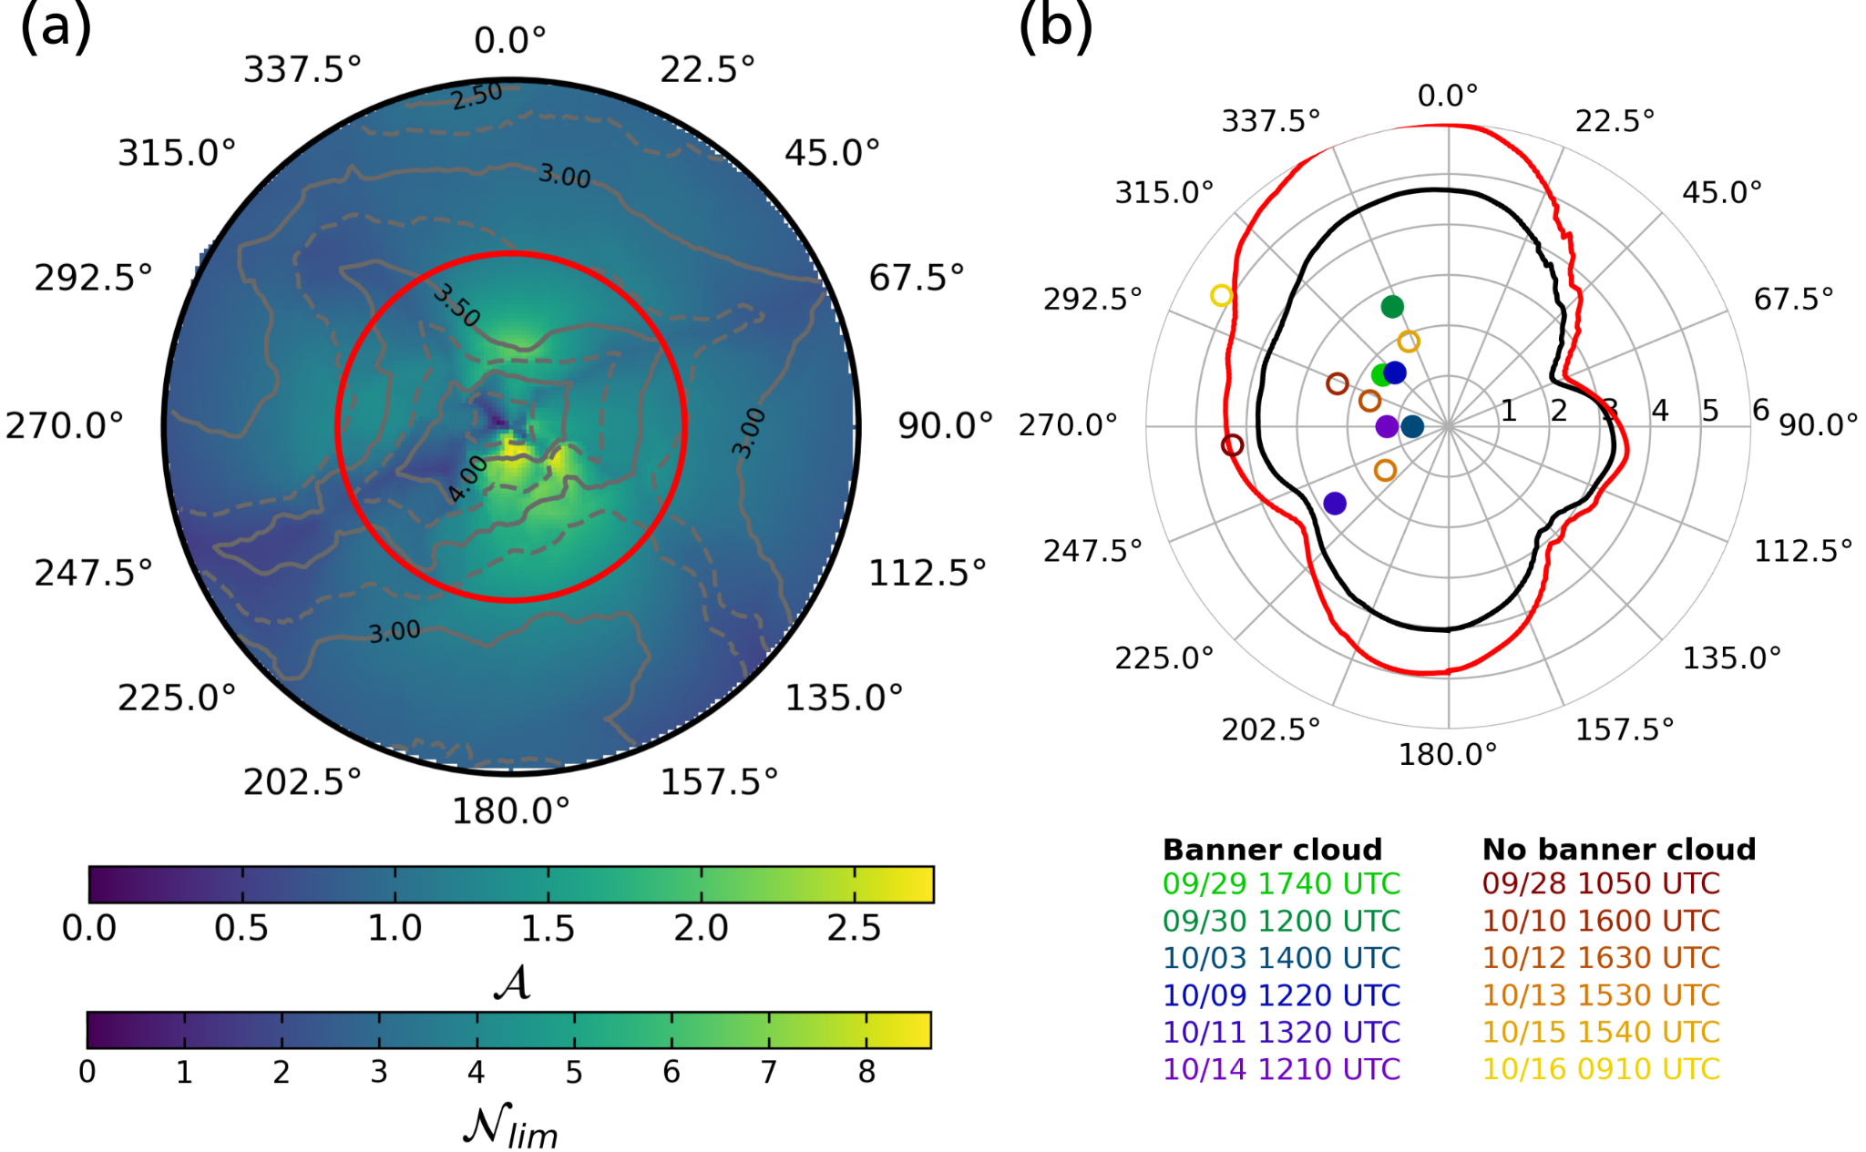
Fig. RR8: As Fig. 11, but showing $〈N_{lim }〉$ contours for both a 2 km (black) and 1 km (red).

R2.21: Figure 11:
In panel a: probably need to make clear that A and Nlim are just scaled version so one another here in the caption... It only makes sense from the text, and isn’t apparent from the caption alone.

As suggested, we added the following to the figure caption (line 426): ”Note that 𝒜 and $N_{lim }$are proportional to each other.”

In panel b: I’m a little confused here... especially by the 2 km radius averaging. Looking at (a)
vs. (b)... in (a) I’d expect northerly flows to be particularly conducive to flow separation on the
upper south facing slopes of the Matterhorn, where Nlim appears to approach values of ~8.
These are the largest Nlim values in your analysis... yet your averaging approach shown in b
suggests more preference for southerly flows with larger Nlim... I’m having a hard time
understanding how the averaging yielded this…

We thank the reviewer once again for the detailed review. We had hoped to avoid this possible misunderstanding but can clearly do better. You are correct, the steeper lee-side terrain of the southern slopes increases $N_{lim }$, but for northerly flow. Thus Fig. 11b shows a larger $〈N_{lim }〉$ (~4.75) at 0/360 degrees (northerly wind direction), and a smaller $〈N_{lim }〉$ (~4.0) for southerly flow (180 degrees). For the smaller averaging radius this difference is enhanced, as seen in Fig. RR8 as the mean slopes become steeper.

We now clarify this by modifications to the main text of the manuscript as well as to the Figure caption. The Figure caption now includes (line 426): ”Panel (b) shows the variation of the spatially averaged $N_{lim }$, $〈N_{lim }〉$ (2-km distance average with 5° directional smoothing) as a function of wind direction.”

We further added a more specific example in the text (line 405): “Analyzing this $〈N_{lim }〉$ we conclude that banner clouds can form under the widest range of $N$ for northerly flows as $〈N_{lim }〉$ is largest (Fig. 11b) due to the steepest lee-side (i.e. southern) terrain; for westerly and easterly flows, $〈N_{lim }〉$ is smaller by comparison, suggesting that for these wind directions banner cloud formation is less likely, and more sensitive to the balance between the wind speed $U$ and the Brunt-Väisälä frequency $N$.

R2.22: Line 411: The lidar data hint at the KH billows, but it doesn’t resolve it.

We agree with the reviewer. This is why we used the term “indicated”.

R2.23: Line 415: Would this result hold for a different averaging radius?

This comment is directly related to the interesting point the reviewer raised in R2.21. Please see the detailed discussion in our reply to that comment. We again would like to thank this reviewer for the time and effort to critically read our manuscript in depth.

Reviewer #3:
-----------------------------------
Reviewer #3: This paper investigates the dynamics of banner clouds in the lee of the iconic Matterhorn in the European Alps, using a small but unique observational dataset. The paper describes the challenges associated with instrument deployment on Alpine terrain.

Major comments
The Matterhorn is a uniquely steep and tall outcropping in the Alps. Banner clouds have long been observed there, as mentioned in many textbooks (e.g., Houze 2014, Cloud Dynamics). As the paper mentions, simulating these clouds is very challenging because of the jagged terrain, but even relatively coarse non-LES models have been able to simulate the essence of the lee circulation leading to banner cloud formation. Other than photographs, very few measurements of environmental conditions (stability, shear) and flow patterns exist, and the rather minimalistic MATTERHEX campaign described in this paper provides just that.

The paper is an interesting read for the broad readership of BAMS. It should be a motivator for early-career scientists to do observational work, showing that a relatively simply but well-designed field experiment can fill a missing gap in our understanding. The Doppler Lidar observations confirm basic insights obtained from modelling studies. The results of this study are simple yet important: it shows that under sufficient ambient humidity, banner clouds are rather common in the lee of the Matterhorn, and a broad range of stabilities. The paper shows that same leeside ascent and turbulence can be present also in clear air - which is no surprise. A statement could be added that such lee ascent and turbulent flow likely are present also in conditions of deep clouds and precipitation, possibly enhancing leeside snowfall, something to be discovered through another field campaign deploying a ground-based or airborne Doppler radar.
The paper is well-written and the illustrations are superb.

We very much appreciate these kind comments of approval.

Following your suggestion, we included the following in the summary (Lines 456-459): “Furthermore, the lee ascent and turbulent flow are likely also present conditions of deep clouds and precipitation. This could possibly enhance leeside snowfall which could be investigated through another field campaign deploying a ground-based or airborne Doppler radar.”

Minor comments

R3.1: The use of the symbol curly N for non-dimensional mountain height is confusing, since one expects units of frequency (1/s). I recommend the use of some sort of letter H (for height), as in is done in other papers and textbooks.

We appreciate the reviewer’s comment and now use the term “inverse Froude number” instead of “non-dimensional mountain height”. One other reason to continue using “curly N” is consistency with previous literature, especially Prestel and Wirth (2016).

R3.2: L429: state "presented in a follow-up paper in preparation" unless Thomas et al. (2025) currently is in review.

The paper is currently under minor revisions, and we hope it will be published around the same time as this manuscript.

