MATERHORN Operations Overview

Summary of MATERHORN Science Objectives

MATERHORN is designed to identify and study the limitations of current state-of-the-science mesoscale models for mountain terrain weather prediction and develop scientific tools to help realize leaps in predictability. It melds four synergistic components working symbiotically, a Modeling Component (MATERHORN-M), a Technology Component (MATERHORN-T), a Parameterization Component (MATERHORN-P) and the Field Experimental Component (MATERHORN-X)

The core scientific objective of MATERHORN-X is a comprehensive study of the interaction of small and large-scale motions in complex terrain at the GMAST (Granite Mountain Atmospheric Science Testbed) at DGP (Dugway Proving Grounds), to support the efforts to improve their predictability via understanding of model errors, error growth and predictability limits. The collected data will facilitate model validation, data assimilation and development of physics-based parameterizations.

To meet this set of objectives, observations are designed to: (i) resolve the variations of surface boundary conditions (e.g., radiation and surface energy budgets, moisture availability, surface and subsurface processes) that drive diurnal mountain winds; (ii) study fundamental near-surface exchange processes (e.g., radiative and sensible heat fluxes, advection); (iii) investigate the spatial and temporal variations of PBL in complex terrain; (iv) understand the interactions of flows of different scales (e.g., synoptic, meso and sub-meso scale flows); and (iv) provide data for model evaluation and improvement. The GMAST terrain ranges between ~1300 m ASL over the flat playas and 2159 m ASL over rugged Granite Peak. The area is characterized by slopes, valleys and playas (Figure 1) that host a full suite of complex-terrain physical processes, allowing studies of broad relevance. The measurements will span from meso-β to Kolmogorov (~1mm dissipation) scales.

Further information on the science objectives of MATERHORN can be found at http://www.nd.edu/~dynamics/materhorn/

MATERHORN field schedule
MATERHORN-X comprises two month-long field campaigns, covering both spring and fall conditions. Based on climatology, the spring is expected to have moist soils and passing synoptic disturbances. Each field campaign will consist of 10 Intensive Observational Periods (IOPs). The field campaigns will take place between:

27-30 August 2012: Dry Run MATERHORN-X-FALL
23 Sept 2012 Fall IOP 0
26 Sept. – 25 Oct. 2012: MATERHORN-X-FALL
22 April – 19 May 2013: MATERHORN-X-SPRING

The 10 IOPs are permitted to take place over weekends, and will be chosen by the MATERHORN Science team as explained below.

A daily planning meeting will be held at the Operations Center, located at the Meteorology Division at Ditto in Dugway. DPG forecasters will present forecasts at 0900 LT to help with the decision making process on IOPs. Need to work out details with DPG for remote participation (e.g. Skype).

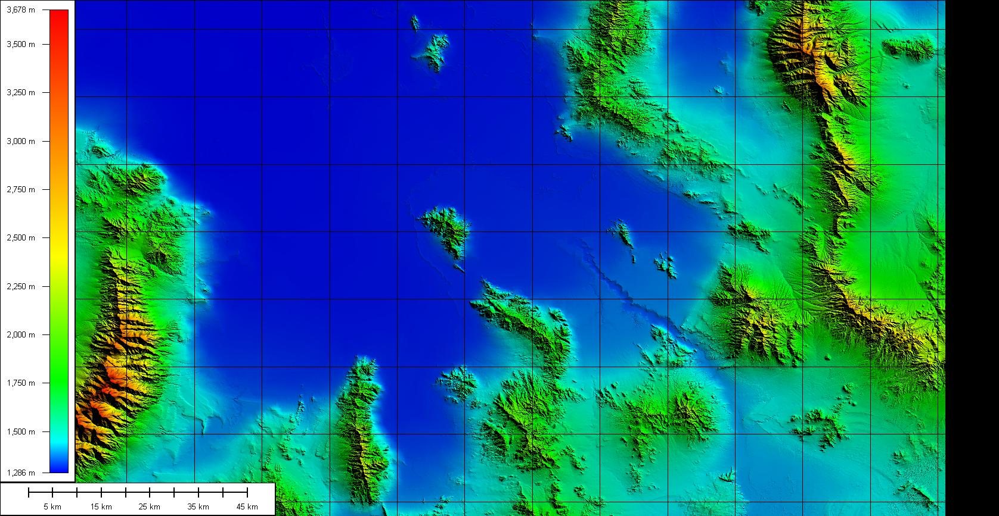
Figure 1 Topographic map of the region centered on Granite Peak, need to add some landmarks.

There will be no back-to-back IOPs. At the daily planning meeting, it will be decided whether an IOP on the following day is “likely” or if there won't be an IOP (“no-IOP”). At the meeting on a day following a “likely” decision, a “Go/No-Go” decision is made. The meeting will be short if a “Go” decision is made, so researchers can rapidly deploy to the field. If a 'No-Go” decision is made, a decision will be made if an IOP is “likely” the following day. More details on the daily planning meting and the decision making process can be found in Section 3.2.

The Science Team will try to cover a range of weather conditions during the IOPs, consistent with proposed research. IOPs will include a number of days with “Quiescent” conditions where thermal circulations dominate, “Moderate” conditions where synoptic effects have increased importance, and “Transition” conditions where large scale events such as frontal passages are present during the IOP. Table 1 summarizes this approach.

There will be two types of IOPs, Daytime Start and Nighttime Start IOPs (see Table 1). This will allow the 24-hour IOP window to cover a full night or a full day, respectively. For example during Fall 2012 there will be three Daytime Start and three Nighttime Start IOPs during Quiescent IOPs.

IOP Type | Definition  700mb wind speed | Number Fall 2012 | Number Spring 2013 | Start – End
Quiescent | < 5 m/s | 3 | 2 | 1400LT -1400LT
 |  | 3 | 2 | 0200 LT -0200LT
Moderate | 5 m/s – 10 m/s | 2 | 2 | 1400LT -1400LT
 |  | 1 | 2 | 0200 LT -0200LT
Transition | Variable, could be >10m/s, front passage | 1 | 2 | Flexible (timed around the event)
Table 1 Ideal distribution of MATERHORN IOP Types and classification.

During the Fall IOP the Sunset/Rise times are ~ 7:21am/7:24pm respectively on September 25.

MATERHORN Instrumentation

The MATERHORN-X comprehensive observing program, which has both substantial ground-based and airborne components, reflects the need to document processes that involve spatial and temporal scales ranging from micro-scale to the scale of the Basin-and-Range topography, and extend from below the ground up to the upper troposphere. A combination of airborne and ground-based measurements is important for documenting the coupling between boundary layer and synoptic scale motions and the dynamical linkages between thermally driven flows and flows aloft.

Airborne Operations: MATERHORN will use several Unmanned Aerial Systems (UAS) and perhaps one research aircraft for documentation the interacting flows. The aircraft is equipped with doppler wind LiDAR capability, the UASs will be used to obtain densely sampled thermodynamic and velocity data for documentation of airflow on both sides of Granite Peak. One UAS will sample turbulence data along its flight path. Table 2 gives the list of MATERHORN aircraft, their deployment periods, research flight hours, and bases of operation.

Research Aircraft | Deployment Period | Research Flight Hours | Base of Operation
Flamingo (UAS) | IOP | NA | Dugway Proving Grounds – DPG Airport
DATAHAWK – University of Colorado (UAS)* | IOP | NA | Anywhere on Grounds
Twin Otter (Proposed w/airborn doppler lidar)* | IOP | ?? | Dugway Proving Grounds Airport
Table 2 List of MATERHORN aircraft / unmanned aerial systems (UAS) with their deployment periods, number of research flight hours, and bases of operation. *The deployment is yet to be confirmed.

Ground-based Operations: MATERHORN ground-based instrument systems will include a wide range of instruments including: lidars (Doppler and aerosol LiDAR), ceilometers, Sodar/Rass, wind profilers, sounding systems, dense networks of automatic weather stations, flux towers, and Combo-probe system. A brief description of the deployment of these instruments follows.

Tethered Balloon (Tethersonde, TS)
Two Tethered Balloon Systems will be deployed to collect thermodynamic profiles of the lower atmospheric boundary layer (up to ~ 500m). Their operation needs a shelter for balloons. UND will operate the tethersonde at the Sage Brush EFS Site, the tethersonde at the Playa EFS site will be operated by UU. Profiles will be sampled every 30 minutes. Data will be collected on the slow upward ascent of the balloon. When the maximum height is reached (depending on meteorological conditions) the balloon will be brought down quickly – the descent data will be discarded. Operations of the tethered balloons will be limited to IOPs with quiescent to moderate wind conditions.

Upper Air Soundings (Radiosondes, RS)
Radiosondes will be flown every 3 hours during IOPs from the EFS Playa (SLTEST) site. Three mobile GRAW GS-H sounding systems (2 from UU, 1 UV) are available to be used in a flexible operation. If resources allow, during selected IOPs, additional flights will be launched from Springs or a location along I-80 northwest of DPG. A decision on these flights will be made on an IOP by IOP basis. These locations are indicated in Figure 2a with a red dot. Coordinates for these sites are given in Table 3 below. Expendables: 8 sondes are available for each 24-hour IOP.

Platform/Instrument/Institution | Deploy-ment Period | Location | Lat/Long location | Elevation  (m)
DPG Network
SAMS | CM | See Appendix
mini-SAMS | CM | See Appendix
PWIDs | CM | See Appendix
Extended Flux Sites (EFS)
EFS-P (UoU) | CM | Playa / former SLTEST | 40.13498 -113.45158 | 1298 ?
EFS-SB (UoU) | CM | Vegetated /"Sagebrush" | 40.12136 -113.12907 | 1317 ?
EFS-ESL2 / ES5 (UoU) | CM | Granite Peak East Slope | 40.09652 -113.25861 | 1378 ?
EFS-ESL1 / ES3 (UND) | CM | Granite Peak East Slope | 40.09567 -113.24405 | 1417 ?
WS2 / EFS-WSL (UND) | CM | Granite Peak West Slope | 40.11179 -113.30230
East Slope Towers
ES1 / DPG32mEast Tower (DPG) | CM |  | 40.0938 -113.2032 | 1314
ES2 / Combo Probe (UND) | CM |  | 40.09588 -113.237544
ES3 / EFS-SL1 (UND) | CM |  | 40.09567 -113.24405
ES4 / DPG32mSlope (DPG) | CM |  | 40.09586 -113.25252
ES5 / EFS-SL2 (UoU) | CM
IR Camera (UND) |  | Granite Peak East Slope – looking upslope from SL2 tower | 40.096365 -113.249540 | 1378
West Slope Towers
WS1 / DPG32mWest Tower (DPG) |  | Granite Peak West Slope
WS2/ EFS-WSL (UND) | CM | Granite Peak West Slope | 40.11179 -113.30230
Other Towers
GAP/ DPG32mGAP Tower (DPG) | CM | Gap: Sapphire Mtn. -Dugway Range | 40.0448 -113.23737 | 1315
SGT1 (Small Gap Tow. 1, UND) | CM | Gap: Sapphire Mtn. - Granite Pk. | 40.06664 -113.26827
SGT2 (Small Gap Tow. 2, UND) | CM | Gap: Sapphire Mtn. - Granite Pk. | 40.06001 -113.24789
Radiosonde Launch Sites
RS Playa | IOP | Playa site (former SLTEST) | 40.134909 -113.45097 | 1298
RS Fish Springs | IOP |  | 39.84617 -113.57443 | 1326
RS I-80 | IOP |  | 40.74007 -113.85222 | 1287
Tethered Balloon Operations
TS-P Tether Balloon-Playa (UoU) | IOP | Playa (former SLTEST) | 40.134909 -113.45097 | 1298
TB-SB Tether Balloon- Sagebrush (UND) | IOP | Sagebrush EFS Site | 40.12136 -113.12907
SoDAR Operations
SoDAR Gap (UoU-ATM)) | CM | Gap between Sapphire Mtn. and Dugway Range | 40.04503 -113.23729
SoDAR North (UoU-ME) | CM | North of Granite Peak | 40.159720 ..-113.241060
SoDAR West (UND) | CM | West of Granite Pk. "Upwind" | 40.10138 -113.33759 | 1347
LiDAR Operations
LiDAR–Halo (UND) | IOP / CM | Slope Experiment | 40.09587 +±/-x -113.23733 +/-±x | 1338
LIDAR–Halo-Slope (UoU) | IOP / CM | Slope Experiment | 40.09587±x -113.23733±x | 1338
UVA ALS300 Aerosol LIDAR | CM | East of Granite Peak | 40.1350 -113.4417 | 1298
ARL Leosphere Windcube 100S |  | Pointing toward Gap | 40.070680 -113.191370 | 1315
Wind Profilers
DPG FM/CW |  | Horizontal Grid | 40.196902 -113.167763 | 1313
DPG Profiler (449 & 924 Mhz) |  | Horizontal Grid | 40.196902 -113.167763 | 1313
Ceilometers
DPG Ceilometer-D | CM | Ditto | 40.182440 -112.926140 | 1324
DPG Ceilometer-TG | CM | Tower Grid | 40.10345 -112.98039 | 1325
DPG Ceilometer-BSP | CM | Baker Strong Point, West gate | 40.092380  -113.69934 | 1316
UND Ceilometer-WS | CM | West Slope of Granite | 40.10138 -113.33759
PWIDS - as requested for MATERHORN
PWID PE West | CM | Pony Express road | 39.921320 -112.96932 | 1382
PWID PE Central | CM | Pony Express road - in Old River Bed | 39.967120 -  112.90195 | 1344
PWID PE East | CM | Pony Express road | 39.999350  -112.84744 | 1385
Table 2 List of MATERHORN ground-based instruments with their deployment periods and locations. *indicates need to verify location. CM – continuous monitoring, IOP – only monitoring during IOPs.

Proposed PWIDS Deployment

We propose the siting of 24 PWIDS (Portable Weather Information Display System) stations at DPG to augment the existing network of weather stations. PWIDS are described in section 5 below. The proposed locations are:

1) 9 PWIDS on Slope Experiment: two across-slope lines.
2) 4 PWIDS between Sapphire Mountain summit and Granite Peak ridge.
3) 3 PWIDS along Pony Express trail, including the "Old Riverbed".
4) 4 PWIDS along the west slope of Granite Peak (proposed by Julian Hunt - CHECK WITH HIM IF SITING OK)
5) 3 PWIDS - deployed with each SoDAR
6) PWIDS at Playa Site (also called the SLTEST site)

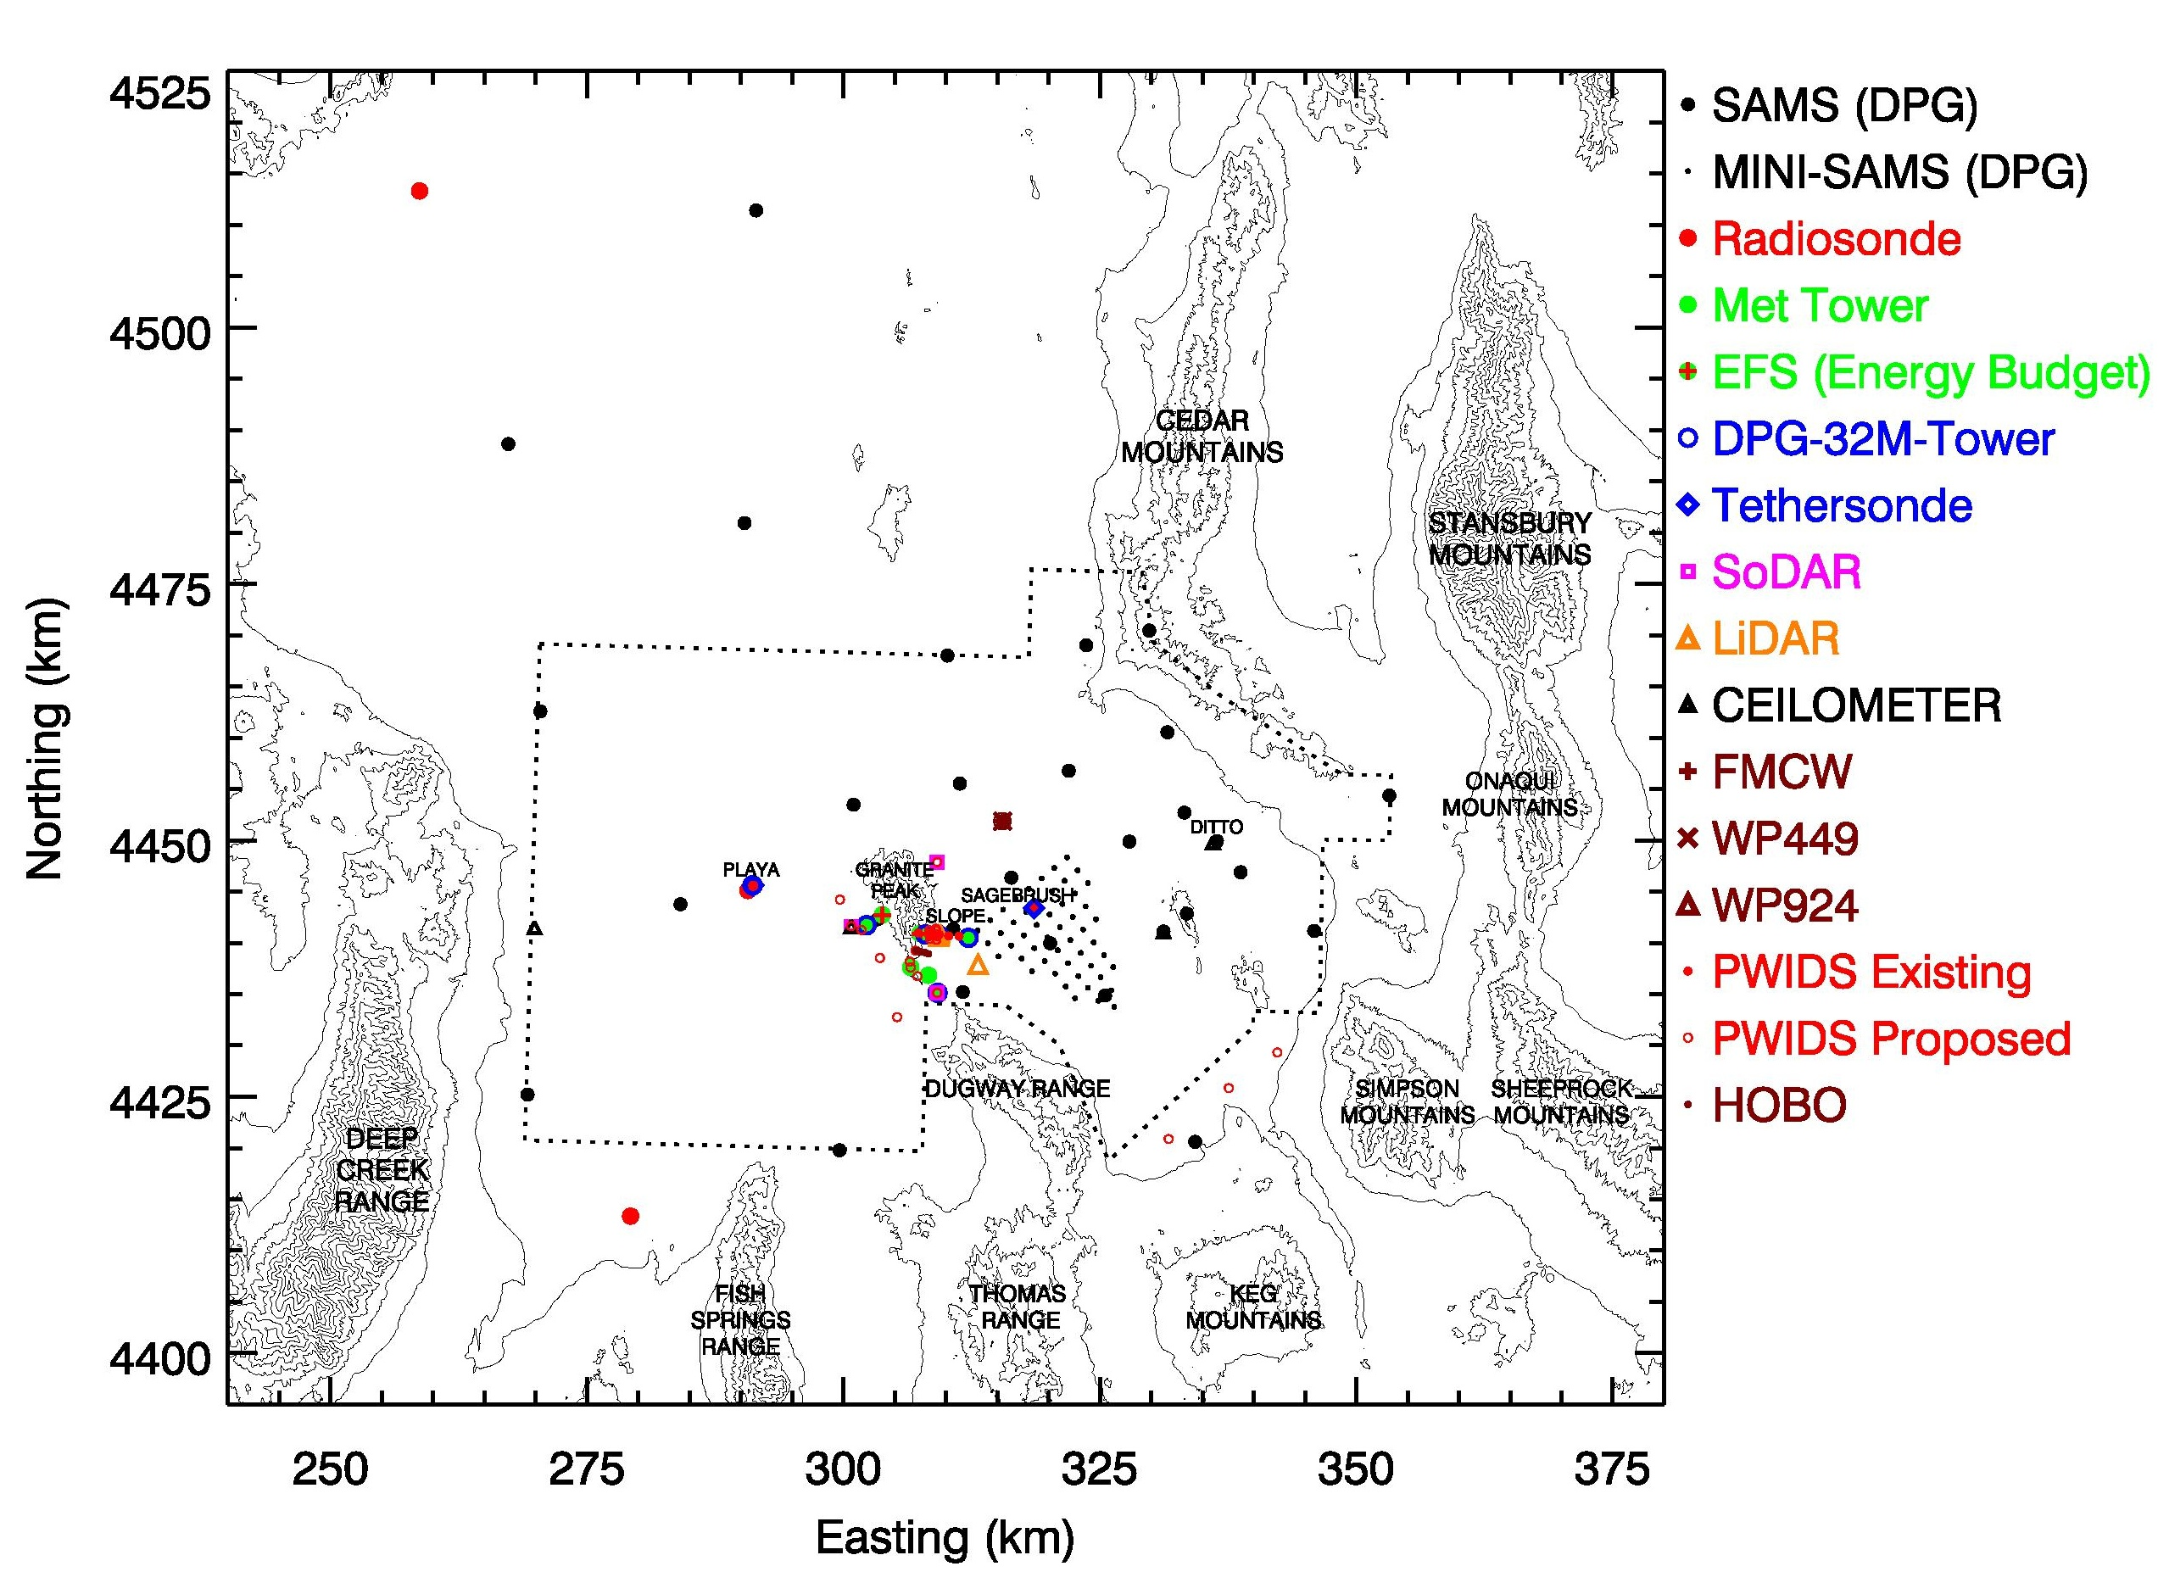
Figure 2a MATERHORN ground-based instrumentation systems and their locations. "Radiosonde" denotes potential radiosonde launch locations for upwind soundings during different large scale flow regimes. Dotted line indicates approximate boundaries of Dugway Proving Grounds. UTM projection, 200 m elevation contours.
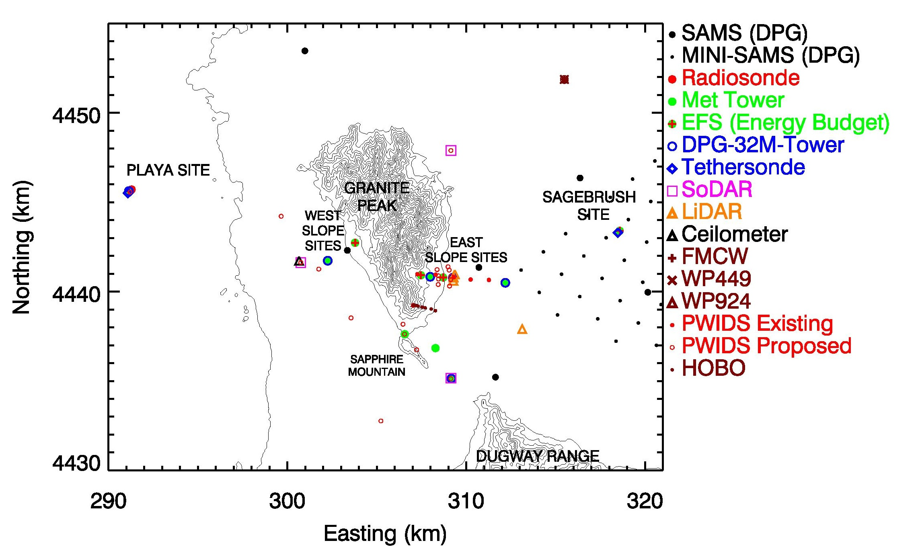
Figure 2b MATERHORN ground-based instrumentation systems and their locations near Granite Peak. UTM projection, 50 m elevation contours.

LiDAR Siting
The two Halo Photonics Streamline Doppler LiDARs (UU and UND) and the Aerosol LiDAR (UVA) will be deployed at the East Slope Experiment site (ES2). The Army Research Laboratory (ARL) scanning wind lidar is a Leosphere Windcube 100S that will be placed ~ 5 km north-east of the main gap between the Dugway Range and Granite Peak.

SoDAR Siting
The three mini-SoDARS (2 UU and 1 UND) will be deployed in 1) the main gap between the Dugway Range and Granite Peak; 2) West side of Granite Peak; 3) the north-east side of Granite Peak.

Ceilometer Siting
Five ceilometers will be deployed during the campaign. Four of the ceilometers are DPG instruments that are standard instruments already in-place and one is owned and operated by UND that will be deployed specifically for the experiment. One DPG Ceilometer will be at Ditto, one at Tower grid, on at Baker Strong Point, the West gate. The UND Ceilometer will be deployed at the Playa (SLTEST) site.

East Slope Experiment - Towers ES1-ES5

The eastern slope of Granite Peak will be heavily instrumented to observe flow interactions between local up-and downslope flows and larger-scale valley winds. Four towers will be erected west of the 2-track road, the existing 32 m tower operated by DPG will continue to operate (as ES1). One of the towers (ES4) is UND's "Combo Probe" tower, two towers (1 UU/ES5, 1 UND/ES3) will observe flows at 5 levels and the entire energy budget. The 4th tower (sonics on 6 levels) will be instrumented by DPG (ES4). Figures 2c and 3a show the present stage (1 May 2012) of planning of the slope experiment (Siting and instrumentation, respectively).

An existing PWIDS line traversing the slope will remain in place. Additionally, two across-slope lines (9 PWIDS total) will be added to determine the effect of local inhomogeneities on the slope flows and to provide a better understanding of the flow as it exits the laterally confined portion of the slope.

Distributed Temperature Sensing (DTS) - 20 km of fiber-optic cable will be deployed by Chad Higgins to observe near surface temperatures at 2 m resolution along the east slope of Granite Peak [ .... ]

West Slope Experiment - Towers WS1 & WS2

To better understand the interactions of synoptic flows with slope flows, as well the contrasting development of thermal circulations on opposing slopes (East vs. West) during transition periods, the western slope of Granite Peak will be instrumented with two towers. These towers will accompany an existing SAMS (#32) station on the West Slope. The West Slope plan is shown in Figure 2d. This plan will include one DPG 32m tower (WS1) equipped with sonic anemometers. In addition, a second tower 20 m further up the slope supplied by UND (WS2) and instrumented by both UND and UU will be deployed. The WS2 tower is an EFS tower that will have full energy budget measurement capabilities.

In addition to the tower based measurements, a remote sensing platform on a berm (rise) that essentially separates the Playa from the sage brush on the west side of Granite Peak will be deployed. The site will include a SODAR/RASS system operated by UND and a supplemental PWIDS station.

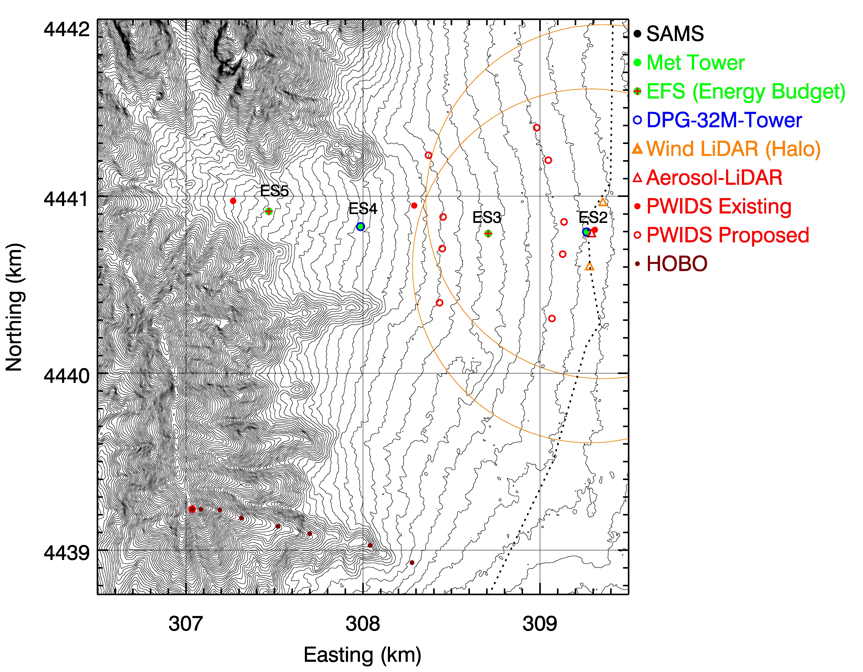

Figure 2c MATERHORN ground-based instrumentation systems and their locations near the east slope of Granite Peak. UTM projection, 5 m elevation contours [MATERHORN-X-SLOPE-EAST]
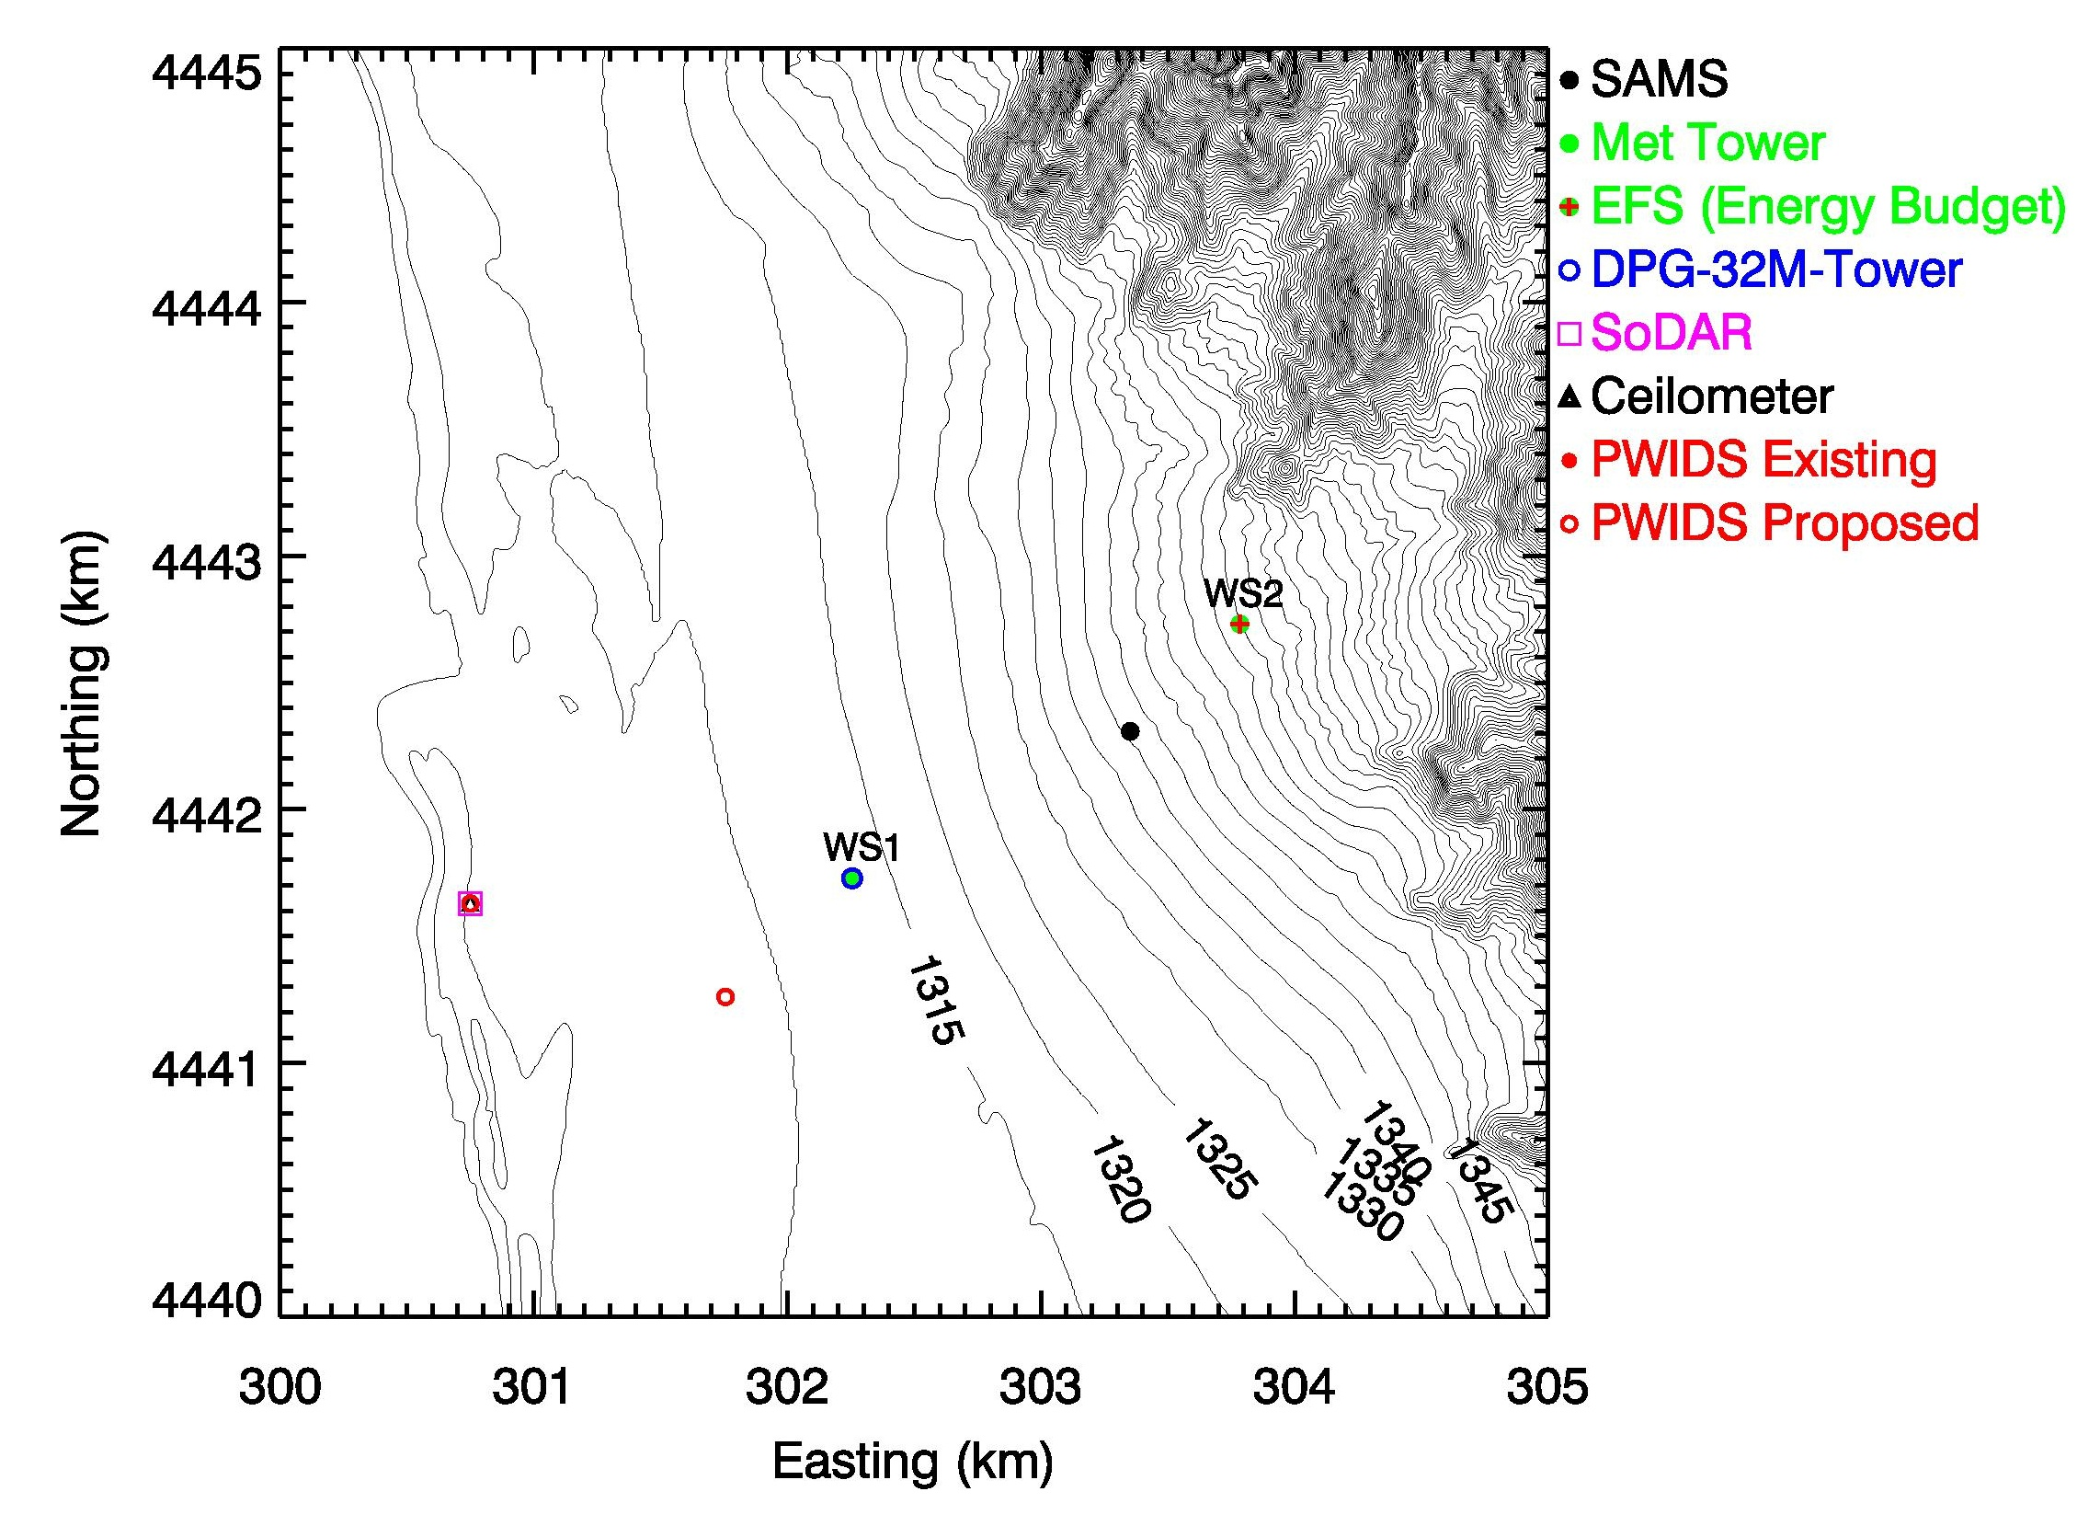
Figure 2d MATERHORN ground-based instrumentation systems and their locations near the west slope of Granite Peak. UTM projection, 5 m elevation contours [MATERHORN-X-SLOPE-WEST]
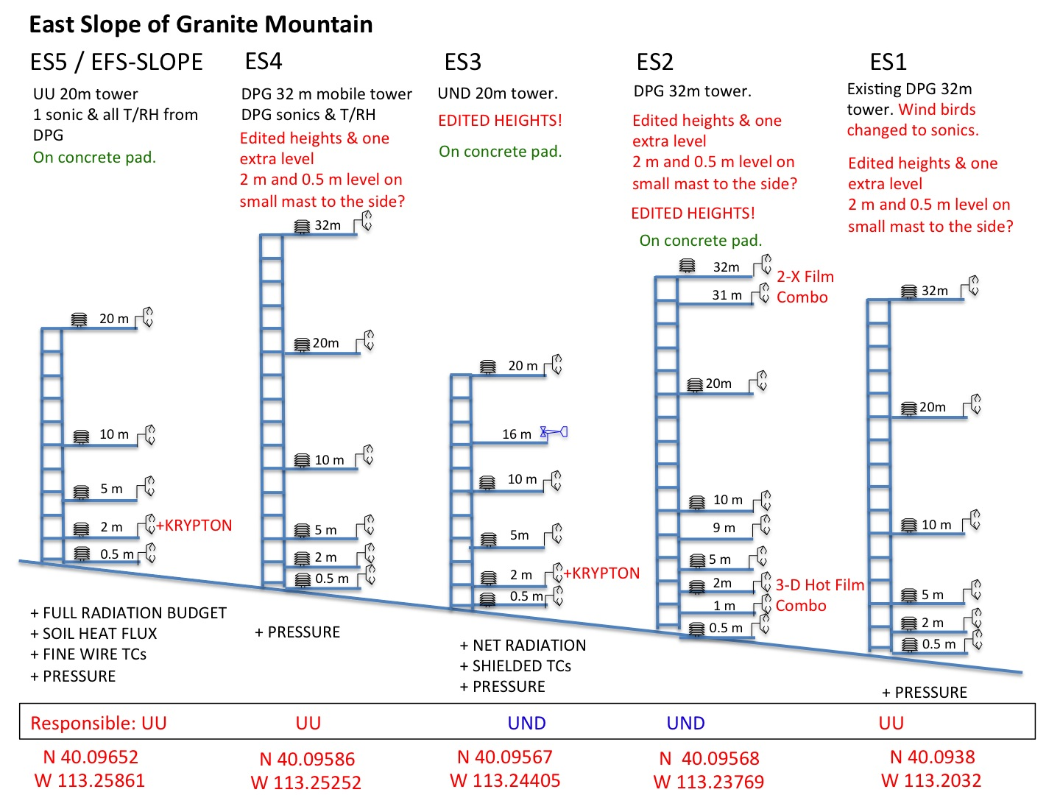
Figure 3a MATERHORN-X-East SLOPE schematic of instrumentation on the east slope of Granite Peak. Note that the towers span approximately 6 kilometers from the top UU tower to the bottom DPG tower. The spacing between the towers is nominally 1.5 km.
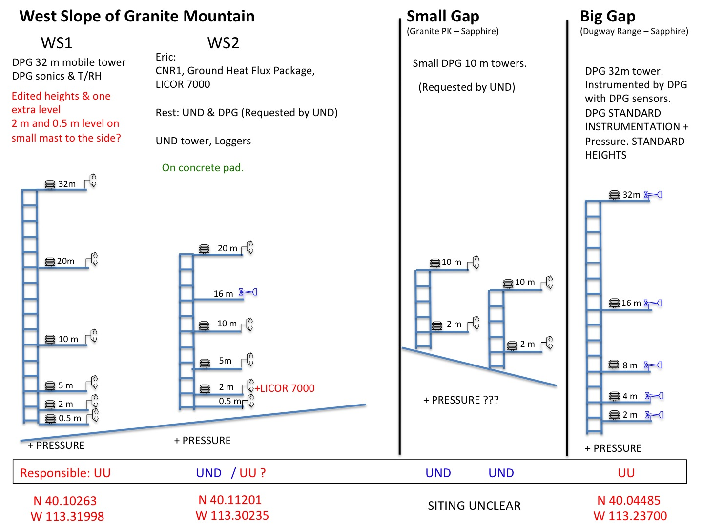
Figure 3b MATERHORN-X-West SLOPE schematic of instrumentation on the west slope of Granite Peak, as well as the instrumentation planned for the gaps between Sapphire Mountain and Granite Peak and Sapphire Mountain and the Dugway Range.

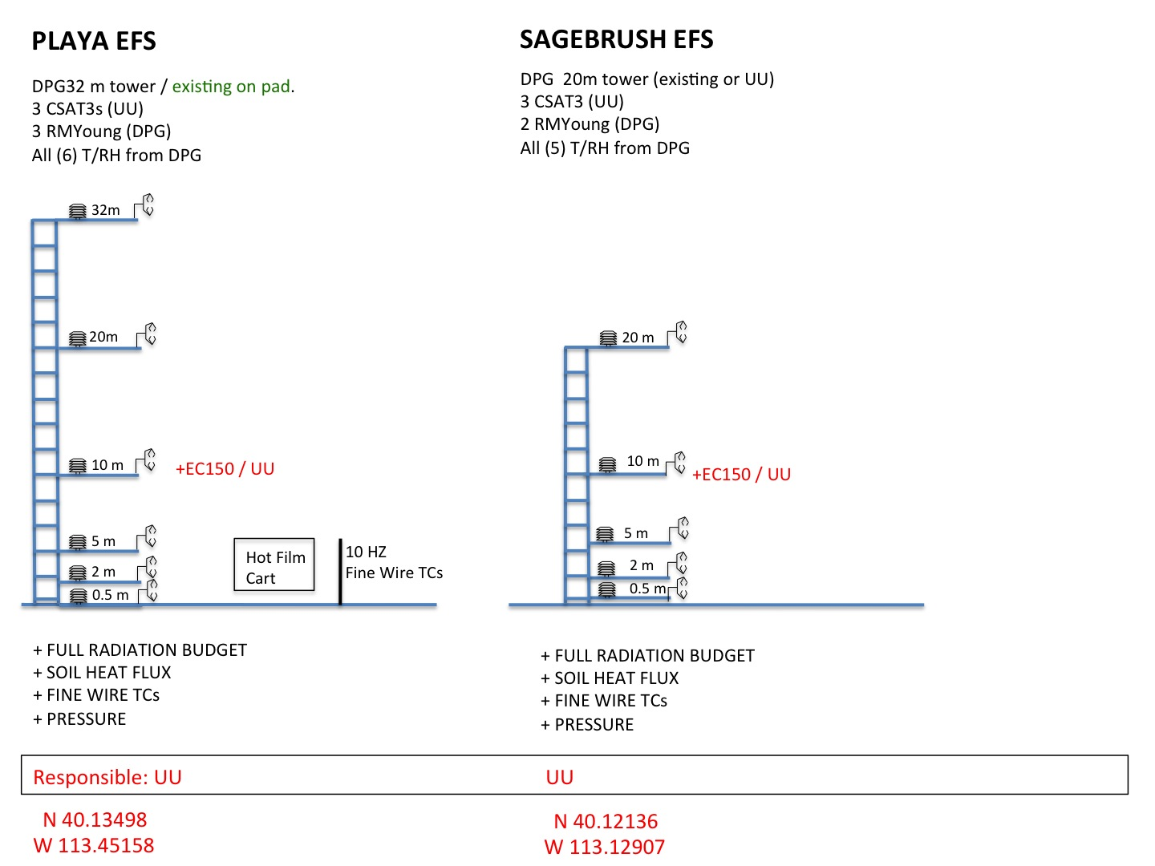
Figure 3c MATERHORN-X- Non-slope EFS sites.

Extended Flux Measurement Sites (EFS)
Five extended flux site experiments will be conducted at the following locations: Playa (SLTEST) Site, Sage Brush Site, East Slope 3 Site, East Slope 5 Site and West Slope 2 Site. The purpose of the sites will be to monitor the complete surface energy balance as well fluxes of momentum, sensible and latent heat and carbon dioxide (3 sites) using the Eddy Covariance technique. The five sites represent very different surface conditions (e.g. albedo, roughness) and will potentially be influenced very differently by local thermal circulations.

Fine Scale Turbulence and Mixing Experiments
Hot-wire/cold wire anemometry experiments will be conducted at the Playa (SLTEST) Site. Experiment will include fast response thermo-couples placed in high vertical resolution very close to the surface to calculate temperature tendencies, to model clear air radiative heating and cooling rates due to radiative flux divergence in the surface layer. Sensible heat flux profiles from a “flux Richardson number probe” will allow us to determine the role of sensible heat flux divergence. Horizontally spaced thermocouples downwind of the flux probes and the vertically spaced thermocouples will further allow us to quantify the roles of the various terms at different heights including: horizontal, vertical advection terms, as well as thermal diffusion.

Distributed LEM stations
To better understand the spatial distribution of near surface met variables, twenty, small local energy monitoring (LEM) stations will measure surface temperature (radiative), solar radiation, air temperature and humidity, soil moisture and soil temperature will be during the campaign. Locations are still to be determined, but stations will likely be deployed around each of the EFS sites.

Preliminary Deployment

The University of Utah will begin preliminary deployment as early as Spring 2012 consisting of Surface Stations, basic Extended Flux Site (EFS) infrastructure. Tower infrastructure will be deployed during the summer 2012.

During the summer of 2012, UofU will test hot-wire system Richardson number probe at the SLTEST site.

Dry Run

MATERHORN-X-FALL: Dry-Run Tests, 25-27 August 2012

The first experimental campaign scheduled in September 25 - October 25 is approaching fast. This is part of MATERHORN-X component coordinated by Prof. Pardyjak from University of Utah (UoU).

At this stage, all teams involved (from UoU, University of Notre Dame (UND) in primis) are engaged in making final instrumentation and technological development checks. The technological aspects involve among others instrumental development for UAV and high-resolution turbulence measurements i.e. “combo’s probes as well as RF systems for soil moisture measurements. This is part of MATERHORN-T component coordinated by UND.

Currently, a great deal of dedication is also been made by teams coordinators and Dugway Proving Grounds (DPG) group coordinated by Mr. John Pace and Dr. D. Zaijc to ensure that all instruments and technical aspects have been fully evaluated and logistic arrangements are set in place.

Dry-Run tests are scheduled for August 25-27 as part of the fall-campaign preparatory phase. They have been designed to test and evaluate the Operational Plan that has been developed during the last months to ensure success of the fall campaign. During the three-days, the full campaign will be simulated starting with the Daily Briefing at the Operations Center, located at the Meteorology Division at Ditto at DPG. Here, DPG forecasters will present meteorological forecasts necessary to aid in making a “Go/No-Go decision” regarding Intensive Observational Periods (IOPs). A simulation of this process is also planned. A detailed log of the time required to deploy personnel to the key sites will be maintained, including reporting of possible problems and difficulties. This will be followed up with an end-of-day report and assessment by the participating teams. The primary on-site participating teams are: UoU, UND, and U of Virginia. Additional participation includes: Prof. Chad Higgins (Oregon State University), Prof. Marcus Hultmark (Princeton University) and Dr. Yansen Wang from the Army Research Laboratory. Not all team members will be available to participate, but should plan to participate in the planning remotely via Skype.

The Dry Run will evaluate both equipment operations as well as team coordination. The coordination strategic plan takes into account the management required:
- to coordinate several sites located in an area of about 25 km x 50 km with all instruments working simultaneously in synchronized mode;
- to coordinate ground-based and aerial operations;
- testing communication between the different parties involved.

To this end, the Dry Run will focus on the simulation of the experiment with as complete a set-up of ground-based instruments as possible deployed in the field, with main personnel in position at the key-sites.

Specifically the main objectives of the Dry-Run are to:
- check full functioning of data-recording systems of ground-based instruments been deployed by UoU, UND and DPG as specified in the Operational Plan regarding continuous measurement (CM) as well as IOPs;
- test the synchronization of the systems and transmittal of data for those systems that adopt this solution;
- evaluate overall time break-down for running IOPs;
- verify personnel coordination and communication strategy during IOPs;
- test data collection strategy, daily data verification and reporting;
- consider all other problems that may arise and make adjustment.

Ground-based Operations:
The key-sites for Ground-based operations during the Dry Run include: standard DPG instruments (SAMs, PWIDS, FM/CW, Profilers, and Ceilometers) sites, the extended flux sites (EFS), lidar, ceilometer and sodar measurement sites. Although most of the instrumentation required during IOPs with the exception of tethered balloon, is not included in the Dry-Run tests, time break-down for running IOPs will also be evaluated. These instruments will be deployed per the Operational Plan. The Dry Run will also include a test radiosonde release from the Playa site.

Aerial Operations:

Unmanned Flamingo operations and manned CIRPAS Twin Otter operatons (if funded) will begin and end at DPG airfield. Unmanned DATAHAWK operations (if funded) can begin and end at any location in the investigation area. During the dry run, a potential flight plan for each of the aircraft will be proposed and discussed with the respective PIs and DGP personnel. Several potential flight plans will be drafted prior to the dry run and a selection of a particular flight plan will be made depending on meteorological conditions and science objectives of the IOP . The flight plan includes the flight paths and start and end time and location of each of the flight paths. Prior to the dry run, DPG personnel will be contacted to inquire about tests and other circumstances that exclude the operation of any aircraft during an IOP.

- Flamingo
- DATAHAWK
- Twin Otter

IOP Timing and Duration:

Two types of IOPs are planned that each last 24 hours.
Type 1 IOP: Starts at 1400
Type 2 IOP: Starts at 0200

A report will be generated at the end of the Dry-Run test and this will be available to all participants.

MATERHORN Operations Domain

The MATERHORN field campaign will take place at the Dugway Proving Grounds in Utah’s West Desert (Figure 1). This area has been selected because it has several key features that make it suitable and interesting for study flow in complex terrain including: mountainous topography (isolated peaks, slopes, gaps, etc.), adjacent plains, variable surface cover (Malek and Bingham 1997).

Aircraft Operation
One major base exists on Dugway Proving Grounds at the Ditto site. Need to find out how UAS will be deployed. DATAHAWK does not need any runway. Flamingo needs runway. Can Stephan update this section?

Playa Site (SLTEST)
MATERHORN Operations will be conducted on the silty-clay playa of The SLTEST (Surface Layer Turbulence and Environmental Science Test) site, which has been operating since the mid 1990s. This site is extremely flat, varying less than a 1 m over an area of ~65 km in the east-west direction and 130 km in the north-south direction surrounding the site (Malek 2003). According to Malek the site can become a shallow lake. Many fundamental studies associated with high Reynolds number boundary layers and dispersion have been conducted there (e.g. (Metzger, Klewicki et al. 2001; Priyadarshana and Klewicki 2004; Metzger, McKeon et al. 2007; Morris, Stolpa et al. 2007)). (Malek and Bingham 1997) describe the microclimate of at this site, and the soil properties are described in (Malek 2003). The soil has very high electrical conductivity.

Slope Site
The lower slope site is covered by sparse high desert vegetation (e.g. Greesewood, grasses) that mostly less than 50 cm tall. The upper slopes also have larger Juniper trees that can be several meters tall.

MATERHORN Funding, Support, and Participation

MATERHORN is a multi-agency, multi-national research project. Major funding for MATERHORN is provided by the Office of Naval Research MURI program. The funding for partners comes from ……(add later). Participants in MATERHORN include investigators from a large number of US universities and agencies, the National Center for Atmospheric Research, and several European universities and research institutes (www.nd.edu/~dynamics/materhorn).

Additional collaborators are considered after consideration of merits (added value) of their participation, on a case by-case-basis. A brief proposal from the prospective collaborators stating their contribution to science and technology development of MATERHORN as well as how they complement existing resources will be required. The funding mechanism for additional activities must be identified. A committee comprised of Stephan De Wekker, Joe Fernando, Joshua Hacker and David Whiteman will determine the suitability of the proposal.

The MATERHORN data will be available to these collaborators during the embargo period provided that the ensuing papers have joint authorship with a MATERHORN PI.

MATERHORN Modes of Operation and Missions

MATERHORN observational activities will be conducted within the following modes of operation:
- Intensive Observing Periods (IOPs),
- Continuous Monitoring (CM), and

Intensive Observing Periods

An Intensive Observing Period (IOP) is a period of comprehensive ground-based and/or airborne observations in the project target area organized and launched to document …( outline these processes and refer to specific hypotheses here)
- Most airborne operations
- Tethered balloon operations

Continuous Monitoring

Continuous Monitoring (CM) involves continuously operating fixed networks of remote and in situ sensors, which will be operated throughout the entire one month period of each MATERHORN campaign …

- PWIDs
- EFS towers

Special Observation Periods
Need to determine if there will be a need for any SOPs.

MATERHORN Mission Planning and Implementation

The planning of a mission involves several steps. These include facility status report, weather forecasting, and proposals of new missions by MATERHORN investigators, leading to the daily planning meeting, during which mission plan is formulated and mission staffing decisions made. The implementation steps include alert sequence and the mission execution itself.

Key Mission Staff

Mission Scientific Team (MST)

- Science Director (SD)
- MATERHORN Director for scientific mission decisions
- Co-chairs MATERHORN Daily Planning Meeting
- Leads daily mission planning discussion
- Decides (with consultation with Mission Planning Panel) the final deployment of all facilities
- Provides Science Progress Reports to Daily Planning Meeting
- Works with Operations Director (OD) and flight scientists to produce flight plans
- Makes go/no go decision for day’s mission
- Leads in-flight coordination during operations
- Prepares Daily Mission Summary Report
- Co-chairs special science meetings

- Flight Scientist(s)
- Scientific director onboard aircraft
- Point of contact for all flight planning and execution (for a given aircraft or balloon)
- Prepares daily aircraft operations support
- Participates in mission debriefing

- Mission Planning Panel
- Composed of one or two MATERHORN PIs at BOC with a broad overview of MATERHORN objectives
- Advises SD as part of the mission planning process to facilitate achievement of MATERHORN science objectives as described in the Science Overview Document
- Membership will be rotated during the field campaign
- BOC members must be present in person at BOC and other two members at their respective OCs and attend all Daily Planning Meetings during their rotation

FUNCTION | PARTICIPANT
Science Director (SD)/Materhorn-X | Eric Pardyjak
Flight Scientist | Stephan DeWekker
Mission Planning Panel | Joe Fernando (Silvana DiSabatino); Dragan Zajic (John Pace); Dave Whiteman (Sebastian Hoch)
Table 3 Staffing table of Mission Scientific Team members. As of 14 January 2012.

Operations Coordination Team (OCT)

- Operations Director (OD)
- Convenes and co-chairs MATERHORN Daily Planning Meeting
- Implements the daily MATERHORN Operations Plan
- Provides Status Report summary to Daily Planning Meeting
- Assigns duties to OCT personnel
- Responsible for form and content of Daily Operations Summary
- Coordinates aircraft flight debriefings

- Aircraft Coordinator (AC)
- Single Point of Contact (POC) for all MATERHORN Aircraft Facility Project Managers
- Coordinates ATC requirements–alerts, advanced notifications, etc.
- Coordinates all communications between Operations Center and research aircraft–flight track changes, data products transmitted to/from aircraft
- Works with SD, OD and flight scientists to update flight tracks as needed

- Surface Observing System Coordinator
- Point of contact for all surface based observing
- Coordinates all communications between BOC and surface observing systems
- Monitors status of all surface observing systems and expendables
- Works with SD and OD to coordinate aircraft overflights of surface observing systems

- DPG Site Coordinator
- Acts as point of contact/project liaison with all operation sites, local arrangements
- Coordinates public relations for MATERHORN activities in Dugway and Salt Lake City

- DPG Communications/Networking Coordinator
- Manages communication at Dugway

- In-Field Data Management/Catalog Coordinator
- Responsible for implementation and updating of the MATERHORN Field Data Catalog
- Assists participants with submitting preliminary data products to the catalog
- Works with DPG
- Monitors supplementary operational real-time data collection for MATERHORN
- Assures ingest and display of MATERHORN specific satellite data and products

- Weather Forecaster Coordinator
- Schedules daily operations support for forecasting and nowcasting including Pre-Flight Briefings
- Trains forecasters and nowcasters on MATERHORN requirements and procedures
- Establishes standard forecast content and products for MATERHORN Field Catalog

FUNCTION | PARTICIPANT
Operations Director (OD) | Eric Pardyjak
Aircraft Coordinator (AC) | Charles Retallack, Stephan DeWekker
Sfs Obs System Coordinator | Sebastian Hoch
Playa Site Coordinator | Sebastian Hoch
Slope Site Coordinator | Matt Jeglum, Derek Jensen, UND pers.
DPG Site Coordinator | Dragan Zajic
DPG Communications Coordinator | Dragan Zajic
Field DM Coordinator | Silvana Di Sabatino
Forecaster | DPG Personnel
U of U Synoptic Meteorologist | Jim Steenburgh, Jeff Massey, Matt Jeglum
Table 4 Staffing table of Operation Coordination Team members. Need to make decisions here.

MATERHORN Daily Planning Process

Daily Planning Meeting

A daily general meeting and weather briefing will be held at the Operations Center, located at the Meteorology Division at Ditto in Dugway Proving Grounds. DPG forecasters will present forecasts at 0900 to help with the decision making process on IOPs. The meeting will be held seven days per week throughout the field campaigns. There will be no back-to-back IOPs. At the meeting, it will be decided whether an IOP on the following day is “likely” or if there won't be an IOP (“no-IOP”). At the meeting on a day following a “likely” decision, a “Go/No-Go” decision is made. The meeting will be short if a “Go” decision is made, so researchers can rapidly deploy to the field. If a 'No-Go” decision is made, a decision will be made if an IOP is “likely” the following day.

The Daily Planning Meeting will be co-chaired by the MATERHORN Science Director and Operations Director. The agenda for the meeting will be consistent each day and include the following items:

- Status of aircraft, mobile facilities and remote observing systems
- Data management and communications status report
- Forecast discussion from 2-36 hours, special products; outlook
- Report on the status of scientific objectives and results of the last mission and/or update on the status of an on-going mission
- Mission Selection, staff assignment, and schedule of operations
- Report on potentially conflicting DPG tests and limitations to MATERHORN operations
- Logistics or administrative matters
- Other announcements

Mission Plan Preparation

When there is a plan for a mission beginning the next day, the Science Director and Operations Director will meet immediately following the Daily Planning Meeting (MPP Meeting) to finalize the Mission Plan for the next 12-36 hours. This meeting may include other PIs or staff crucial to formulate the details of the Mission Plan. The following items will be decided during this meeting and reported in the Daily Operations Summary:

- Description of mission (primary and alternate), including a brief discussion of objectives and strategy and criteria for proceeding to the alternate mission
- Assignment of staffing for mission support for the next 24-36 hours
- Preliminary Aircraft Operations Domain
  - Aircraft pre-flight briefing times
  - Proposed aircraft flight plans
  - Aircraft take-off times
  - Weather forecast support
  - Special observation schedules
- Debriefing schedule

Daily Operations Timeline

Figure X illustrates the planning–implementation sequence of IOP activities, emphasizing the scheduling of aircraft operations. Times are given relative to Local Time (Mountain Daylight Time).

Every Day:
0700–0800 Forecasters supporting MATERHORN operations will evaluate various current weather models
0800–0900 Forecast preparation and submission to MATERHORN Field Catalog.
0800–0900 Status update of all MATERHORN facilities to MATERHORN Field Catalog.
Initialize remote communications links (e.g. Skype)
0900–1000 MATERHORN Daily Planning Meeting (see previous details).
1000–1100 Mission and IOP-type selection (Daytime Start / Nighttime Start IOP) and preparation of Mission Plan (flight plans, scanning strategies, TB operations).
1100–1600 Notifications—facilities, Air Traffic Control Centers, Field Catalog Operations Report.

Operational (IOP) Day: (Approximate times for daylight operations)
0900 Operational update—weather and facility status.
0930 Go/No Go/ decision
1000 Notify all field personnel and DPG personnel of decision and mission plan

a) Daytime Start IOP

1200–1200+24h IOP operations for soundings and other enhanced ground-based operations.
1000–1100 Pre-flight briefings (1.5 hr before takeoff).
0700–2000 Flight operations–vary by aircraft but limited (daytime restrictions?).
1600–2100 Debriefings (1 hr after landing).

b) Nighttime Start IOP

2400–2400+24h IOP operations for soundings and other enhanced ground-based operations.
2000–2200 Pre-flight briefings (1.5 hr before takeoff).
0700–2000 Flight operations–vary by aircraft but limited (daytime restrictions?).
0200–0400 Debriefings (1 hr after landing). [REALLY???]

Daytime Start IOP
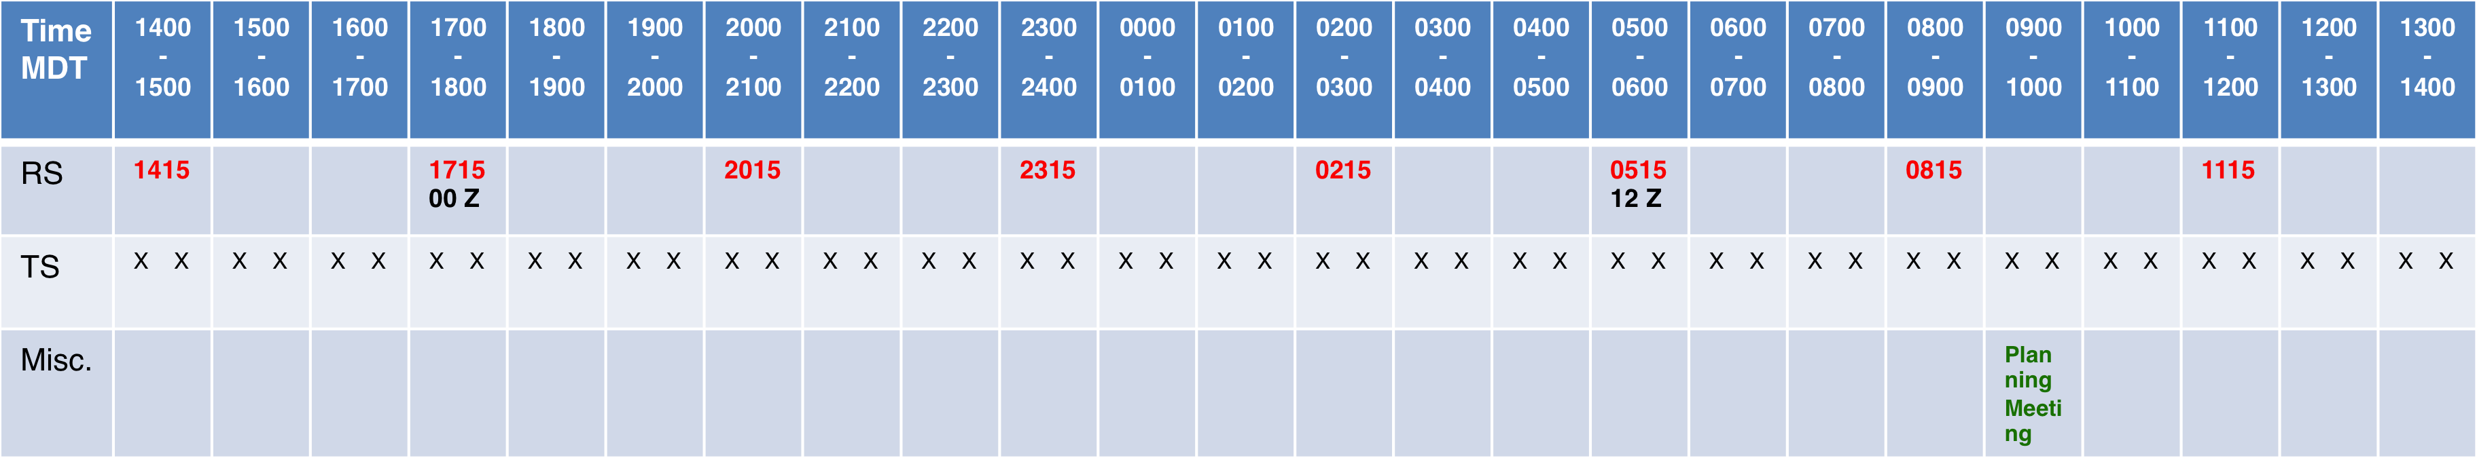

Nighttime Start IOP
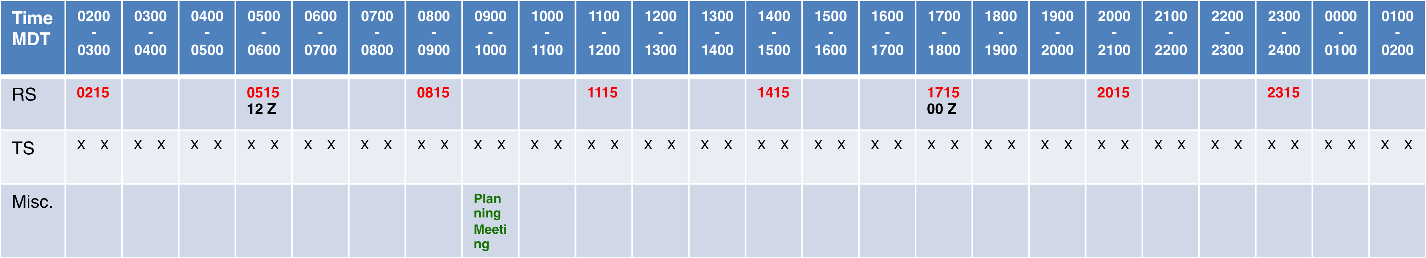

Figure 6 MATERHORN Daily Timeline of Operations..

Operations Implementation

Facility Notification Procedure

Once the facility operating schedules for missions are decided at the Daily Planning Meeting the responsibility for the conduct of operations shifts to the Operations Coordination Team (OCT) under the leadership of the Operations Director. Official notifications to Facility Managers are made by OCT staff. Notification of planned aircraft take-off times will be given by the Operations Director (or Aircraft Coordinator) to the Aircraft Facility Managers and Mission Scientists at least 06 hours in advance. The Aircraft Coordinator will provide advanced notification to the appropriate Federal Aviation Administration (FAA) Air Traffic Control (ATC) Centers (Salt Lake City) and Military Operations Centers. Notification of operations schedules for the lidars and soundings will be made by the Operations Director (or Ground-based Facility Coordinator). The Operations Director prepares the Daily Operations Summary. This summary will be distributed to all participants via the MATERHORN Field Catalog.

Aircraft Operations Coordination

Determination of aircraft flight schedules will follow aircraft operational guidelines. The Aircraft Flight Scientists and Aircraft Coordinator will work with the aircraft pilots in the preparation of detailed flight plans. Aircraft pilots will submit flight plans following normal ATC procedures. Individual pre-flight briefings will be given 2 hours prior to the scheduled take-off and will be prepared to meet individual aircraft facility requirements. Pre-flight briefings will be attended by the Science Director or Operations Director, aircraft coordinator, flight scientists, and pilots.

Debriefing and Reporting

At the completion of a day’s mission, post-flight debriefings will be held for each aircraft mission. The debriefings will be conducted by the Operations Director (or Aircraft Coordinator, or Flight Scientist) at the aircraft operations base as soon as possible after landing so that all onboard scientists and selected crewmembers can participate. Key issues are the perceived success of the mission, and the status of the facility (and crew) for the next day’s operations. Each Aircraft Flight Scientist or Ground System Manager is expected to provide a Facility Operations Report (or Flight Report) of their operations, within 24 hours to the MATERHORN Field Catalog.

Surface System Operations Coordination

Lidar Operations Coordination
Scheduled scan coordination operations, continuous operations
Overflight and intercomparison plans
Sounding Operations Coordination
Scheduled measurement operations
Expendable and Helium supply, staff schedule restrictions
Tethered Balloon Operations Coordination
Scheduled measurement operations
Expendable and Helium supply, staff schedule restrictions

Forecasting for MATERHORN

The MATERHORN forecasting support will be provided by the Meteorology Division of DPG in conjunction with MATERHORN PIs. They will use forecasting products based on an ensemble of mesoscale models. This forecast information will be used to help plan daily IOPs.

Ground-Based Operations

This chapter provides additional information on the MATERHORN ground-based instrument systems listed in Table 2 including deployment locations, system characteristics, and scanning strategies. Each group needs to submit their information here.

UND

1. Flux Tower Measurement Systems (East Slope Granite Peak)
2. Combo probe system (East Slope Granite Peak)
3. UAVs (should be coordinated with Stephan de Wekker too)
4. Ceilometers (West Slope Granite Peak)
5. Lidars
6. SODAR/RASS
7. Soil moisture system (Tom Pratt) – Received.
8. Tethered balloon operations

Utah –
- Tethered Balloon Operations – Playa (Pardyjak)
- Flux Tower Operations (Sebastian)
  - Playa
  - Slope
  - Sage Brush
- LEMS - Local Energy Measurement Stations – (Pardyjak/Derek/Nipun)
- HOBOs (Whiteman)
- Hot-wire anemometry Experiments – Playa (Pardyjak)
- SODAR operations (Hoch/Whiteman)
- Radiosonde operations (Hoch/Whiteman)
- Lidar (Hoch/Whiteman)

Dugway -
- SAMS
- PWIDS
- Lidar
- Ceilometer

Doppler Lidars

UU Doppler Lidar

Summary of Goals
A. Development and structure of up- and downslope flows, especially transient behavior
B. Flow interactions between valley flow system and local slope flows
C. Support boundary-layer studies
D. Acquire data for data assimilation into 4DVAR, dual Doppler (?)

Site Selection
1. Site visit by Hoch Nov 2011. Investigated sites for UU.
2. Location of UU lidar –primary site ....

Equipment Performance and Programming
1. Doppler lidar -- assembled and tested ...

Power
1. Lidar - Tests necessary! Test with mobile Generator.

Personnel

Contact Information

Safety

DPG Doppler Lidar

Instrument
WindTracer rented from Coherent Technologies Inc. (CTI)

Measured Parameter
Line-of-sigh velocity, backscatter intensity

Deployment
??? - ???

Location
??? ºN, ???ºW

Data Availability
???

Staff

Proposed Lidar Scanning Strategies

Aersosol Lidars

RF Remote Soil Moisture Sensor

RF CROSSHAIR

Test Overview
RF CROSSHAIR is a remote soil moisture sensing system that operates in three frequency bands: 470 MHz, 915 Mhz, and 2.437 GHz. The system consists of a transmitter station (which will be deployed on the slope of the mountain) and a receiver station that will be mounted on a 20m mast near the base of the mountain. The system transmits signals in each of these frequency bands from directional antennas that are directed towards the intended target area on the ground between the transmit and receive stations. The forward scatter energy from the ground reflections are sensed by a receiver that collects the signal at programmable intervals (e.g., every 10 minutes). The measured responses are used to interpret changes in moisture content.

Contact information
Tom Pratt: Lead-PI for using RF CROSSHAIR (cell: 770-853-5277)
Neil Dodson: RF Crosshair engineer

Location
At the time of this writing, we intend to install the receiver on a dedicated 20m mast near Granite slope. The transmit unit will be deployed on a shorter mast on the mountain slope at a height approximately equal to that of the receiver.

Setup
The RF CROSSHAIR system will be arriving by cargo van. The transmitter will be manually installed on a tripod/mast system on the mountain slope. The receiver will be installed on a dedicated 20m mast to be installed by DPG. Somebody trained in climbing will be needed to install the receiver system on the 20m mast.

Teardown
RF CROSSHAIR is scheduled to remain in the field for the full duration of the experiment. At the conclusion of the experiment, the equipment will be removed from the mountain slope and from the dedicated 20m mast and packed into the cargo van for transport back to the University of Notre Dame. We will need help unmounting the receiver from the 20m mast.

Staffing
Plans are to have Tom Pratt and Neil Dodson on-site during the first week to ensure proper installation and operation of the equipment. Laura Leo and Silvana Di Sabatino will provide oversight of equipment operation in subsequent weeks. The equipment operates in a relatively autonomous manner, but periodic checking of the system’s operation is recommended to ensure the quality of collected data.

Safety Issues
- RF Transmissions: Avoid standing in front of the transmit antennas at close range.
- Mounting of receiver system on 20m mast will likely require assistance from somebody who is qualified for this task.

System Maintenance
- Generator refueling: The generators at the transmit and receiver sites will have to be refueled on a periodic basis.

- External Hard Disk: The RF CROSSHAIR system records raw data at a rate of approximately 500 Mbyte per hour. For MATERHORN, we have chosen to store raw data on a 2 TB Maxtor hard disks. The disk will fill after about 6 months of continuous operation. Hence the external drive should not need to be replaced during the tests, however, three additional 2 TB disks have been purchased for the experiment just in case we decide to collect data more frequently or to store raw time-domain signals as well.

Unattended Operation
RF CROSSHAIR is designed for automated operation. However, it lacks self-health diagnostics and the ability to report problems if they occur. Therefore, an operator should be present in order to keep an eye on things. Examples of items that should be monitored:
  - Presence of received signals in all three frequency bands
  - Data quality, as indicated by near real-time outputs on host laptop
  - Presence of of data files on the external drive
  - Ensure that the Matlab scripts are still running

Data
RF CROSSHAIR produces the following data products in the field:
- Raw data files are in “.mat” format: This is a binary format native to Matlab.
- Quick-look images: Near real-time figures of the measurements are plotted on the host laptop.
- Video files from a fixed webcamera
- Files from a pressure/humity/temperature sensor

Programs
- Raw data files are generated by custom data acquisition software created for RF CROSSHAIR, which runs under MATLAB on the data acquisition computer. This custom code was written by folks at the University of Notre Dame.
- Quick-look images are created in near real-time on the host computer using Matlab scripts that process the raw data.
- A MATLAB program is also being developed to display raw data in post-analysis.
- Vendor software is used to control video/audio collections from the webcam
- Vendor software is used to control data collection from the temperature probe

Data Communications
No data communications are anticipated. All collected data will be stored locally on an external hard disk.

System Description
The purpose of this section is to provide an overview of the system used for RF-based moisture monitoring and to describe the anticipated deployment topology, the operation of the instrumentation, data collection, and data storage methods.

The RF-based moisture sensing system consists of components for RF transmission and components for signal reception. The system is configured in a manner to enable bistatic collection of clutter returns from the target area to be monitored, as shown in Figure 1 for a single transmitter-to-receiver link.

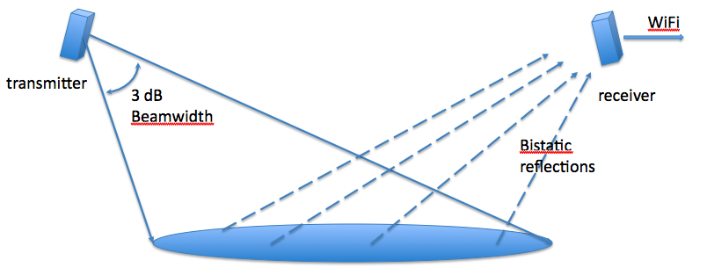
Figure 1. Bistatic Collection Geometry

As indicated in the figure, the clutter returns can be monitored to characterize polarimetric features of the received signal that are modulated by changes in the moisture and temperature of the target area. These changes are monitored using transmitted signals from multiple transmitter sites and multiple frequency bands to help detect and characterize soil moisture changes. In the presence of precipitation, the sensor outputs may enable characterization of hydrometeors.

The specific frequency bands that are being employed are shown in Table 1.

Table 1. Frequency Band Descriptions
Band Designation | Frequency Range
Band 1 | 2.4 GHz to 2.5 GHz
Band 2 | 902 MHz to 928 MHz
Band 3 | 450 MHz to 500 MHz

A block diagram of the sensing system is shown in Figure 2. It indicates three operational frequencies, where transmission is achieved using COTS access points, and where a multi-band system is employed at the receiver. In addition to processing RF signals to generate data products, the system will also employ a pressure/temperature/humidity gauge to track ambient values with time.

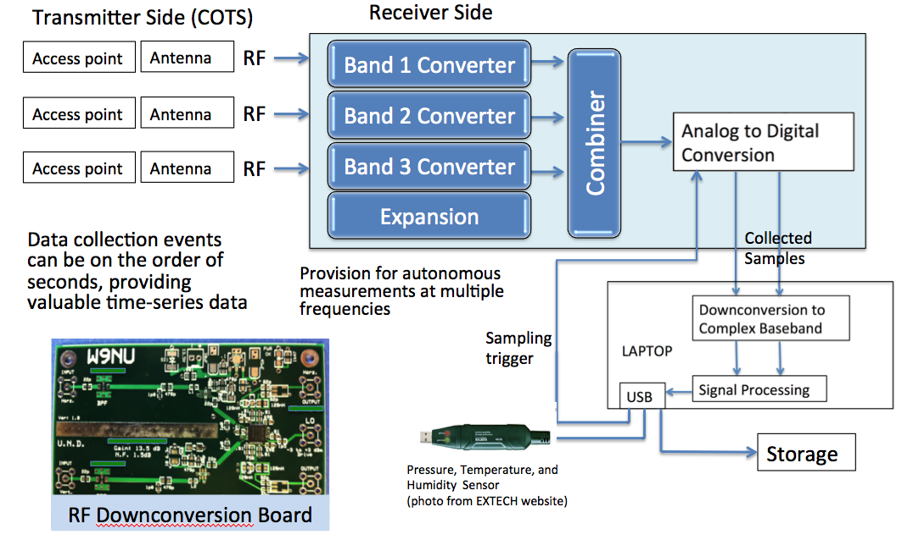
Figure 2. Sensor System Block Diagram

An example of a transmitter system for one of the frequency bands is shown in Figure 3. It consists of an encased weather-protected transmit unit that requires DC power, an Ethernet cable to initialize the transmitter, and cabling to drive an external antenna. In the case of the 2.4 GHz system, a power amplifier may be employed to increase the system range since propagation losses are more severe at 2.4 GHz than at the other transmit frequencies used by the system. These will be mounted on masts that are deployed near the maintain base, roughly 20m above the base. Since three frequencies are to be used, three such systems will be deployed on the mast at each transmit locations.

The receiver system consists of an antenna and RF front-end combination for each frequency subband, a combining circuit, an analog to digital converter subsystem, and digital signal processing of the digitized signals to extract the polarization features from the received signals. Snapshots derived from the receiver are collected periodically, e.g., every 15 minutes and data products are calculated from the received snapshot. A “record” consisting of a time stamp and extracted signal features is then stored on a 2 TByte external drive for post-test processing. Temperature/pressure/humidity (TPH) are also simultaneously collected at periodic intervals using an EXTECH probe, and these data are also stored on the 2 TByte external hard disk. Webcam video images and audio samples will also be collected and stored.

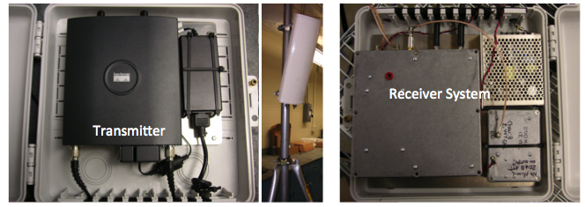
Figure 3. Transmitter and Receiver Subsystems

Anticipated Deployment Topology
The CROSSHAIR system is to be deployed at Dugway Proving Grounds near the Target R Command Post to monitor soil moisture changes and to potentially detect hydrometeors and fog formation. The deployment will include up to three transmitter sites. The sites will each employ an 8’ tripod for mounting transmitter equipment and antennas for three subbands, 2.4 GHz, 900 MHz, and 400 MHz. The tripods will be cemented into the ground and anchored bracing may also be applied to limit vibration due to the wind. We anticipate that a generator (and inverters) will be required at each transmit site due to the power demands of the transmitters and amplifiers.

A single receiver site will be used, where the receiver equipment will be placed on a 20m mast. Near the top of the mast, antenna/RF front-ends for each frequency subband will be installed. Near the base of the tower, a weather-protected console unit will be deployed. This unit contains a laptop, an external drive, a TPH sensor, and I/O and power cabling to the units on the mast. The 20m mast must be secure to the ground in a manner that minimizes motion/vibration that would otherwise degrade the quality of measurements of the sensor system. A generator, or possibly 12V batteries will be needed to power the receiver system.

Figure 4 depicts the anticipated topology. The transmitters will be mounted on the lower slope of the mountain at widely separated angles (as viewed by the receiver) and the receiver will be mounted on a 20m mast. The figure depicts an illustrative topology at a site near Granite Mountain that was originally considered for the tests. However, a new test site location has been selected, one that is farther south on the eastern side of Granite Mountain (e.g., where the other major test equipment is being deployed).

Note that we are requesting that in-situ sensors be deployed by DPG to measure soil moisture at different depths in the target area footprint between each transmitter and the receiver. These will provide data that can be correlated with the RF sensor measurements.

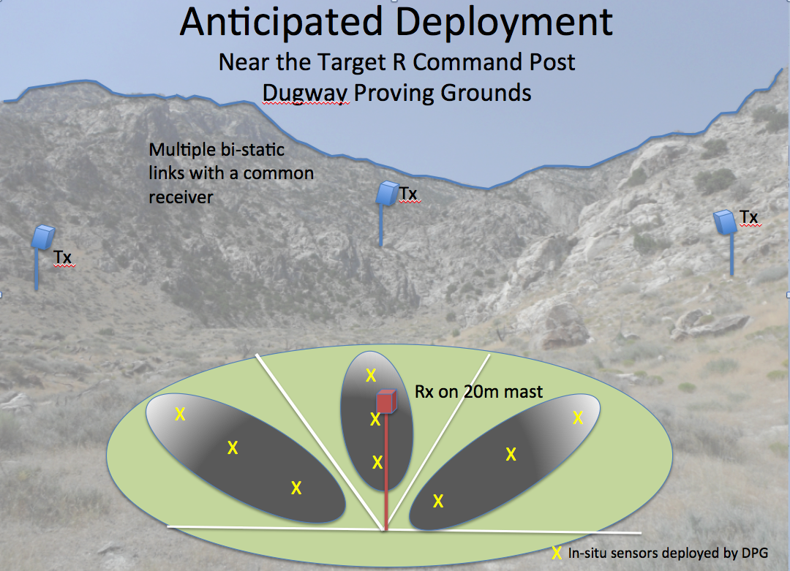
Figure 4. Example of Anticipated Deployment Geometry

Operation of the Instrumentation
Operation of the instrumentation is as follows.

- After deployment and power-up of the transmitter units, the laptop from the receiver console unit is used to program and initiate transmission by each transmit unit. Once the transmitters are initiated, they will transmit continuously throughout the experiments and will function autonomously.

- The laptop is then placed in the console and all I/O lines are connected, including to the external drive, the TPH sensor, and to the RF sensor units.

- Software on the laptop is then used to initiate collection by the TPH sensor. We intend to configure the system to collect data every 15 minutes, although collections at other rates are possible. Once initiated, collections should be autonomous, and no intervention should be required.

- Other software on the laptop is used to initiate collection by the RF sensor. The RF sensor system software will be configured to collect snapshots every 15 minutes, and data products associated with each transmit location and each transmit frequency will be stored to the external hard disk. The software should be able to run autonomously, although periodic checking is recommended to ensure that the system is operational.

- The laptop will display outputs on the screen to provide indications of its status.

The specific outputs that will be stored by the sensor system are listed in the table below. Additional parameters may be added if deemed useful. A snippet of the time-domain received signal may be periodically stored (e.g., once per hour) to assist with signal association in post-test processing.

Table 2. Collected Parameters to be Stored on External Hard Disk
Parameter Number | Description
1 | Date/Time (based on computer clock)
2 | Temperature (from probe deployed near base of tower)
3 | Pressure (from probe deployed near base of tower)
4 | Humidity (from probe deployed near base of tower)
5 | Signal Power Level (for Tx signal 1 through Tx signal 9)
6 | SNR (for Tx signal 1 through Tx signal 9)
7 | Polarization parameters (for Tx signal 1 through Tx signal 9)
8 | Signal Frequency (for Tx signal 1 through Tx signal 9)
9 | Signal Quality Measurements (Tx 1 through Tx 9)
10 | Noise Power Level (Tx 1 through Tx 9)

…
…

PWIDS (Portable Weather Information Display System)

  - The WDTC-developed PWIDS consists of mobile meteorological measurement stations capable of collecting and displaying weather information at a predetermined rate. Each station consists of a tripod-mounted propeller-vane wind monitor, a temperature/humidity sensor mounted in a naturally aspirated radiation shield, a data logger, an optically isolated RS-232 interface, and a spread-spectrum radio/modem. Power is supplied by a solar panel and battery combination.
  - Typically, the measurement height is 2 m AGL, although many other configurations have been fielded that were anything but typical. In most uses, the PWIDS data acquisition rate is 1 Hz, and the data collected are averaged to 10-sec intervals. Accuracies of the R.M. Young 05103 wind monitor are ±0.2 m s-1 and ±3°. The Vaisala HMP-45 temperature/humidity probes are accurate to ±0.4°C for temperatures ranging from -20 to 55 °C and to ±2 percent for relative humidity (RH) ranging from 0 to 90 percent.
  - Pressure is measured with the Vaisala PTB-101B, which has an accuracy rating of ±2 hec- topascal (hPa) over the temperature range of -20 to 45°C. PWIDS data are processed by the Campbell Scientific (Logan, Utah) CR1000 datalogger and forwarded via a FreeWave 902-928 MHz spread spectrum transceiver to the DPG Weather Station via a radio link and then routed to the test site through the DPG computer intranet or through a second radio network. Forty PWIDS will be deployed for FFT-07 with lateral spacing of 150 m and a separation of 150 m between rows.
Note that this description is verbatim from the FFT-07 Test Plan (Storwald, 2007 ) https://www.fft07-slc.org/documents/TestPlan.pdf.

Wind Profiling Radar

The 924 MHz radar wind profiler is a ground-based, phased array pulsed radar designed to provide wind profiles in 100-m range gates from 100 m through several kilometers AGL. The radar emits radio energy along radial beams (vertical and tilted towards north or south and east or west) and then listens for returned signals, which are Doppler shifted in frequency by along- radial wind velocity components and reflected back to the radar antenna by density discontinui- ties in the atmosphere. The time-tagged radial velocity data are then resolved into alongwind, crosswind, and vertical velocity components at each range gate. These velocity components are used to produce vertical profiles of wind speed and direction. The wind profiling radar will be stationed near the CP and will be operated continuously with 15-min averaging during FFT-07.
Note that this description is verbatim from the FFT-07 Test Plan (Storwald, 2007 ) https://www.fft07-slc.org/documents/TestPlan.pdf.

FM-CW Radar

The FM-CW radar uses Bragg scatter from atmospheric refractive index inhomogeneities to observe, in fine detail, the turbulence and wave structure within the planetary boundary layer (PBL). When pointing vertically and operated in a range-only mode, the FM-CW radar produces time-height refractive index profiles that can be used to identify boundary layer growth and col- lapse, daytime convection, and wave structure in the nocturnal residual layer. The FM-CW radar uses a linear, continuous, sinusoidal, waveform in the 3-GHz range (10-cm wavelength) swept over a 200-MHz band. The frequency emitted at one part of this band propagates vertically, with a portion of the energy backscattered to the receiving antenna where it is differenced against the original transmitted frequency. The resulting beat frequency is proportional to the range at which the backscatter occurred, and the signal magnitude is proportional to the strength of the index of refraction variation. FM-CW radar resolution is on the order of 1 m in range and a few seconds in time, providing detailed boundary layer time-height sections. The FM/CW radar is located at Horizontal Grid at DPG, which is approximately 7 miles northwest of the FFT-07 test grid. Note that this description is verbatim from the FFT-07 Test Plan (Storwald, 2007 ) https://www.fft07-slc.org/documents/TestPlan.pdf.

Aircraft Operations

Stephan please fill this in.

- Appendix: FLIGHT PLANS

Flight No: ??? Date:

Scientific Objectives:

Location:

Weather conditions:
Flight Pattern:

Notes:

References:

Malek, E. (2003). "Microclimate of a desert playa: evaluation of annual radiation, energy, and water budgets components." International Journal of Climatology 23(3): 333-345.
Malek, E. and G. Bingham (1997). "Partitioning of radiation and energy balance components in an inhomogeneous …." Journal of Arid Environments.
Metzger, M., B. McKeon, et al. (2007). "The near-neutral atmospheric surface layer: turbulence and non-stationarity." Philosophical Transactions of the Royal Society A: Mathematical, Physical and Engineering Sciences 365(1852): 859-876.
Metzger, M. M., J. C. Klewicki, et al. (2001). "Scaling the near-wall axial turbulent stress in the zero pressure gradient boundary layer." Physics of Fluids 13: 1819.
Morris, S., S. Stolpa, et al. (2007). "Near-surface particle image velocimetry measurements in a transitionally rough-wall atmospheric boundary layer." Journal Of Fluid Mechanics 580: 319-338.
Priyadarshana, P. J. A. and J. C. Klewicki (2004). "Study of the motions contributing to the Reynolds stress in high and low Reynolds number turbulent boundary layers." Physics of Fluids 16: 4586.

