Jordan Narrows Gap Ammonia Transport Study - Meteorological Support and Observations

  - Final Report prepared for the Utah Division of Environmental Quality

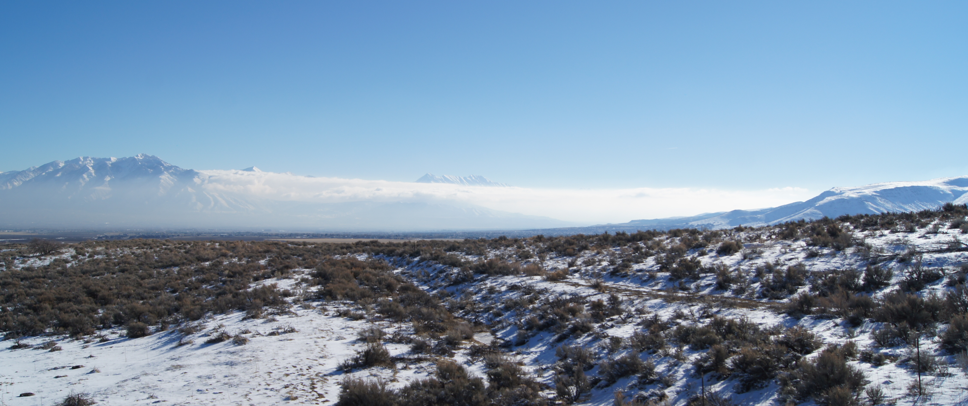
Jordan Narrows, looking south. 20 January 2011. ©Sebastian Hoch

Sebastian W. Hoch and Erik T. Crosman
Department of Atmospheric Sciences
135 S 1460 E, Rm 819
University of Utah
Salt Lake City, UT 84112-0110

1. Background and Introduction

This study is a follow-up study to the January 2017 Utah Winter Fine Particulate Study (UWFPS). UWFPS was a collaborative effort between National Oceanic and Atmospheric Administration (NOAA), United States Environmental Protection Agency (US EPA), Utah Division of Environmental Quality (UDEQ), the University of Utah, and other universities, to investigate meteorological and chemical processes driving the wintertime fine particulate pollution in the Salt Lake, Cache, and Utah Valleys. One of the outcomes of the UWFPS study (Brown et al. 2018, final report) was that a better understanding of ammonia sources and concentrations in the Salt Lake Valley is needed, including improved understanding of the role of air mass exchange and ammonia transport between the Salt Lake Valley and Utah Valley basins.
This study, conducted in early 2019, provides the key meteorological support for the concurrent chemistry observations of the Wasatch Front Ammonia and Chloride Observations (WaFACO) study and developed a methodology to investigate air mass exchange and ammonia transport between the Salt Lake and Utah Valleys.
The study included three tasks, 1) meteorological observations in the Jordan Narrows, 2) analysis of existing and study-specific meteorological datasets, and 3) forecast support for the WaFACO science team.
1. Observations in the vicinity of the Jordan Narrows

The meteorological approach of this study was to instrument a site at Camp Williams near the center of the Jordan Narrows gap on the southern end of the Salt Lake Valley with the University of Utah Doppler wind LiDAR to investigate the air mass exchange between the Utah Valley and Salt Lake Valley basins. These wind profile observations could then be used to estimate transport of the chemical species measured with the collocated equipment of the WaFACO team. In addition to the wind LiDAR, two automatic weather stations (AWS) and two ceilometers measuring the profile of the atmospheric backscatter coefficient were deployed within the topographic gap (Camp Williams) and in Bluffdale, roughly 7.5 km to the NNW of the Jordan Narrows. The AWS were deployed to resolve the flow field at the low point of the Jordan Narrows gap, only a few meters above the Jordan River, and at North Star Academy in Bluffdale in an area just within the Salt Lake Valley basin to the north of the gap. A first ceilometer was collocated with the wind LiDAR, the second was deployed at Bluffdale Elementary. See Figure 1 and Table 1 for a map and site details, respectively.

Additional weather observations discussed in this report include the twice-daily radiosonde ascents by the National Weather Service (NWS) from the Salt Lake International Airport (KSLC), and the UUNET/MesoWest AWS Flight Park South (FPS) located at 1586 m ASL to the NE of the Jordan Narrows topographic gap.

LiDAR, AWS and ceilometers were deployed on 11 January 2019 and removed on 12 March 2019.

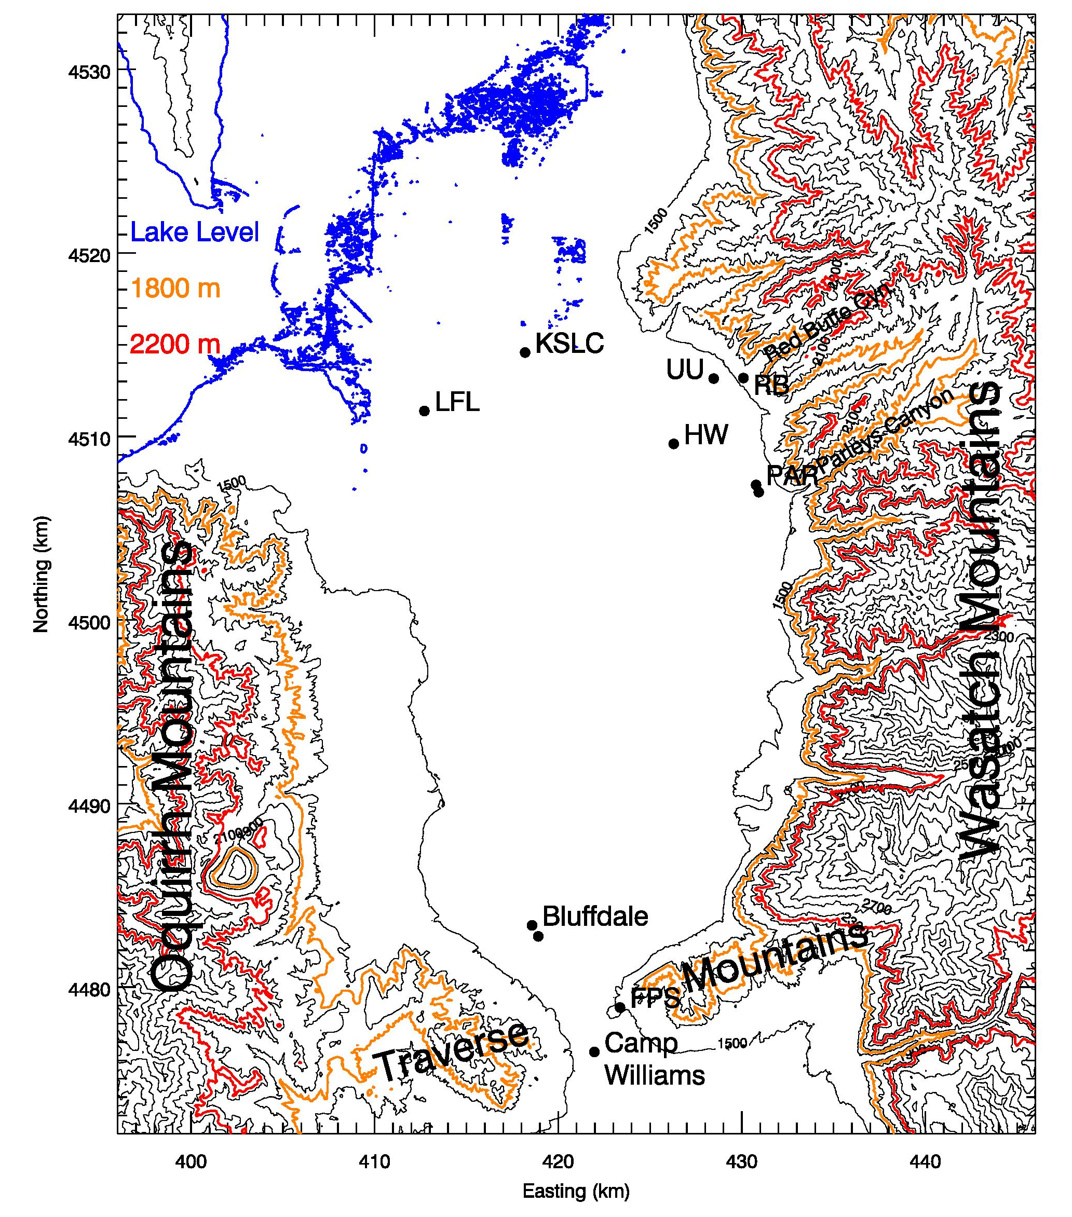
Figure 1: Topographic map (UTM grid) showing the Salt Lake Basin and the Jordan Narrows around Camp Williams, highlighting relevant observational sites from the current study and past field experiments. Lake level (blue), 1800 m (orange) and 2200 m ASL contour lines (red) are highlighted.

2. Analysis of meteorological datasets

The meteorological variables expected to control the direction and strength of the inter-basin air mass exchange between the Salt Lake Valley and Utah Valley basins are the vertical thermal stratification of the atmospheric boundary layer (ABL) and the strength and direction of the synoptically forced wind. The vertical thermal stratification governs the static stability and the forcing of thermally driven circulations between the basins, while the synoptic flow - often channeled between the Wasatch and Oquirrh Mountains - determines the forcing for the inter-basin exchange above or in absence of a thermally-driven flow field.

Data from the University of Utah Doppler wind LiDAR deployed at Camp Williams was analyzed to determine the flow field through the Jordan Narrows topographic gap. Velocity-Azimuth-Display (VAD) retrievals were calculated for the plan-position-indicator scans (PPIs) that were performed every 5 minutes.

Table 1: The main meteorological observational sites in the Salt Lake Valley.
Site Name | Site Abbreviation | Instrumentation | Elevation (m ASL) | Elevation above ground (m) | Latitude (°N) | Longitude (°E)
Camp Williams | CW | Lidar wind profile:  u, d  Ceilometer: aerosol backscatter coefficient β | 1422 m | 0 - 1000 m  (dependent on atmospheric conditions)  10 - 7700 m | 40.4351° | -111.9200°
Camp Williams AWS | CW-AWS | T/RH,u,d | 1387 m | ~2 m | 40.4349° | -111.9151°
Flight Park South | FPS | T/RH,u,d | 1586 m | ~2 m | 40.4569° | -111.9048°
Salt Lake City International Airport | KSLC | Radiosonde profile: T/RH, u, d | 1289 m | 0 - 20 km | 40.772436° | -111.9547°
Bluffdale Elementary | BD | Ceilometer: aerosol backscatter coefficient β | 1377 m | 10- 7700 m | 40.4916° | -111.9569°
Bluffdale, North Star Academy | BD-AWS | T/RH,u,d | 1380 | ~2 m | 40.4969 | -111.9609

2.1 Temperature Profiles and the Valley Heat Deficit
Vertical profiles of the atmospheric temperature are necessary to evaluate static stability of the atmosphere and to help to define the strength of diurnal and persistent cold air pools. A good measure of the stability of a valley atmosphere is the Valley Heat Deficit (VHD, Whiteman et al. 2014). Observations of the temperature structure in the Salt Lake Valley are readily available from the twice-daily radiosonde ascents from KSLC. Radiosondes are launched daily, at approximately 0500 and 1700 MST. Additional observations are based on a pseudo-vertical assumption (Whiteman and Hoch 2014), where temperature observations along an elevation transect are interpreted as a proxy for the vertical variation of temperatures within the valley or basin atmosphere. Information on the static stability in the immediate vicinity of the Jordan Narrows gap was inferred from temperature data recorded at the AWSs at Camp Williams (CW) and Flight Park South (FPS). Locations of the sensors are shown in Figure 1 and given in Table 1.
The Valley Heat Deficit (VHD) is a measurement of the amount of energy that would be needed to bring a valley or basin atmosphere to a neutral stratification. Following Whiteman et al. (1999, 2014) it is calculated for the Salt Lake Valley as
$VHD =c_{p} \int_{1300 m}^{2200 m}{ρ(z) [θ_{h}-θ(z)]} dz,$ [J m⁻²],
where $θ_{h}$is the potential temperature at height h, $ρ(z)$ and $θ(z)$ are the air density and potential temperature from the twice-daily radiosonde sounding, respectively. The specific heat of air at constant pressure is denoted as $c_{p}$, and dz is 10 m. The VHD is the heat required to warm an atmospheric column with a 1-m² base to the potential temperature observed at the top of the basin at height h=2200 m, bringing the underlying atmosphere to a dry adiabatic lapse rate. Calculations were performed using the twice-daily radiosondes launched by the NWS at the KSLC site. For the Salt Lake Valley, the elevation range between 1300 m ASL (valley floor) and the height of 2200 m (red contour line in Fig. 1) are used, corresponding the mean ridge height surrounding the valley. Calculations of VHD reveal the episodes of high atmospheric stability during the passage of high-pressure centers across Northern Utah.
When compared with previous and average winter seasons, the experimental period in early 2019 was characterized by a more active synoptic pattern that did not allow the development of persistent cold-air pools (PCAPs). This is reflected in very modest values on the VHD (Figure 2) and limited the analysis to cases where only moderate near-surface stability dominated the air mass exchange through the Jordan Narrows gap.
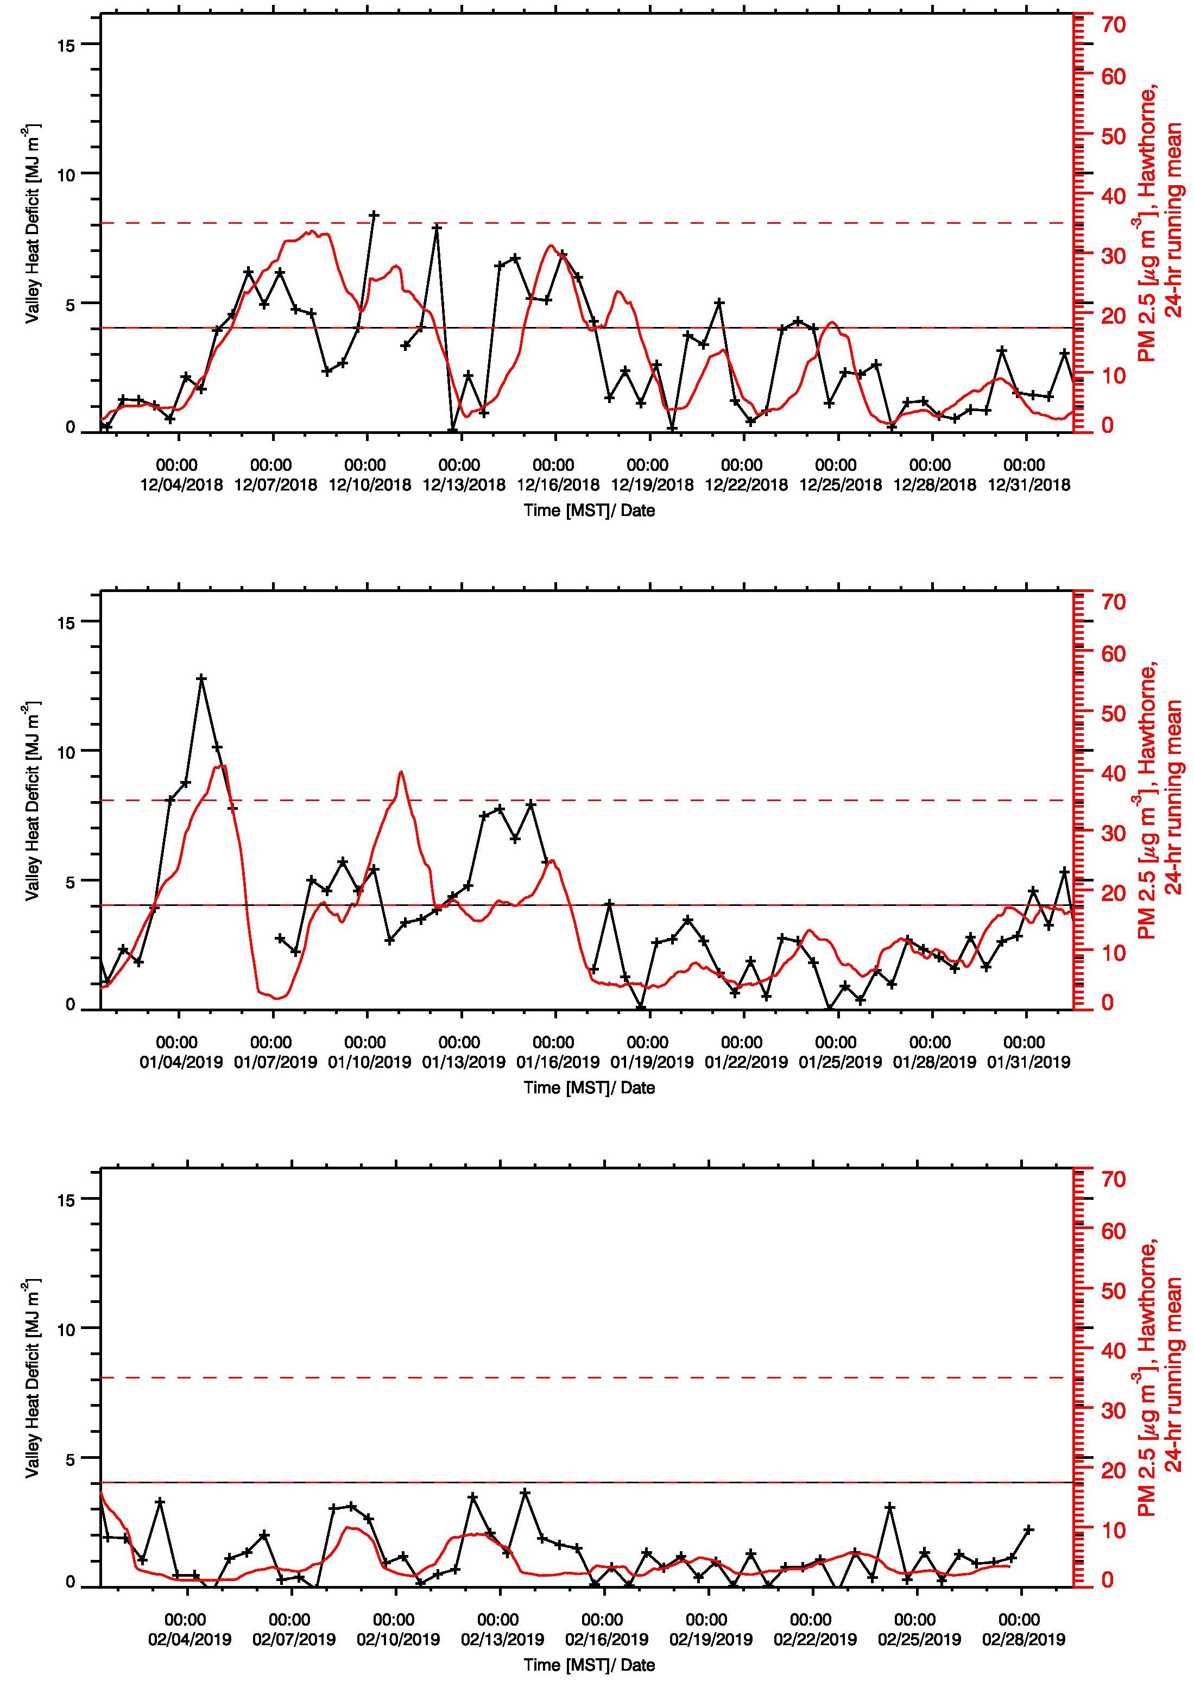
Figure 2: Evolution of the Valley Heat Deficit (VHD) in the Salt Lake Valley for the 2018-2019 winter months (DJF), together with the 24-hr running mean of PM_{2.5} recorded by UDAQ at Hawthorne Elementary.

2.2 Aerosol Backscatter
Aerosol backscatter profiles were recorded by two ceilometers at two locations in the vicinity of the Jordan Narrows to resolve spatial differences in the atmospheric aerosol loading and to resolve temporal changes in the aerosol optical properties at these sites. Ceilometers (Vaisala CL31) were deployed at the Camp Williams (CW) site (collocated with the wind LiDAR) and at Bluffdale Elementary, about 7.5 km to the NNW of the topographic gap of the Jordan Narrows. These observations complement the UDAQ operated observations with Vaisala CL51 ceilometers at Hawthorne (HW) and in Lindon (LN) in the Salt Lake and Utah Valleys. The CL31 instruments recorded a vertical profile (10-m resolution) of the atmospheric aerosol backscatter coefficient β every 16 seconds. The raw data was averaged to 10-min means for further processing. Daily quicklooks (see Figure 3 as an example) are available for the duration of the experiment (January and February 2019) at the following web site: http://www.inscc.utah.edu/~hoch/AIRQUAL_2018-2019/CEILOMETER/ Time-height cross sections of aerosol backscatter illustrate changes in the polluted PCAP atmosphere, and visualize mixing processes, layering, and injection of clean or polluted air with directional changes in the flow field. Further, phases of quickly intensifying backscatter retrievals may indicate periods of PM_{2.5} formation.
Figure 3: Profile of aerosol backscatter coefficient β observed with the CL31 ceilometer at the Camp Williams (CW) site on 26 Jan. 2019. Backscatter indicates the depth of the stable nocturnal and then the daytime convective atmospheric boundary layer. Layering, lifting and appearance of backscatter layers reflects a complex interaction of dynamic processes. Above the basin, some virga (precipitation evaporating before reaching the ground) and a descending but dissolving cloud layer are observed.

2.3 Wind Profiles
Wind profiles were continuously recorded within the Jordan Narrows for the duration of WaFACO using the University of Utah Halo Photonics (UK) Doppler wind LiDAR. The installation required a fixed power source and an unobstructed view of sky. The lidar was programmed to scan a Plan Position Indicator (PPI) scan pattern every 5 minutes. The Vertical Azimuth Display (VAD) analysis was used to retrieve the vertical profile of the three-dimensional wind field. This wind field can be overlaid with the aerosol backscatter coefficient of the LiDAR retrieval or of the co-located ceilometer. Daily quicklooks were produced during the experiment and shared via a web page with the collaborators and interested public (http://www.inscc.utah.edu/~hoch/AIRQUAL_2018-2019/WIND_LIDAR/CAMP_WILLIAMS/)
Figure 4 shows the LiDAR retrieval of the horizontal wind field in the Jordan Narrows, together with the lidar backscatter coefficient β, for 26 Jan. 2019, the same day for which ceilometer data is shown in Fig. 3. The three sub-panels show 8-hourly intervals of the full UTC day (i.e. 1700 MST 25 Jan. 2019 through 1700 MST 26 Jan. 2019). The time-height cross section of the horizontal winds illustrates how inhomogeneous the flow field can be at times, and that frequent reversals of the flow direction through the Jordan Narrows occur. Most importantly, we see that reversals of the flow direction with height can be observed. In the case of the example day shown in Fig. 4, a southerly flow throughout all heights resolved with the wind LiDAR (~ 500 m AGL) dominated until 0100 MST, when a northerly flow began to take over, starting from the surface and reaching 500 m AGL by 0200 MST. The northerly flow aloft strengthened through the rest of the period shown, and dominated the flow in the upper part of the Jordan Narrows. The flow layer below, however, reversed again and three distinct pulses of southerly flow, associated with an increase in backscatter intensity, can be seen at 0400 MST, 0645 MST and 1130 MST. Daytime heating and the growth of a surface-based convective boundary layer coupled the surface with the upper-level flow by ~1300 MST, leading to another flow reversal to northerly directions.
This example shows how difficult flow and transport estimates are, especially under variable conditions with competing contributions of synoptically forced flows and thermally driven winds.

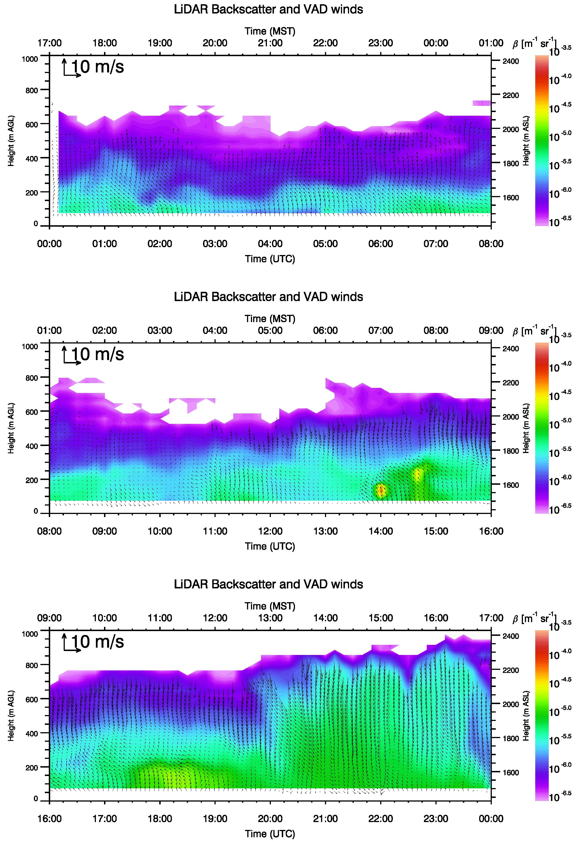
Figure 4: Profile of horizontal winds and lidar backscatter coefficient β observed with the University of Utah Doppler Wind LiDAR at the Camp Williams (CW) site on 26 Jan. 2019. Flow reversals occur with respect to time, but also with respect to height, factors that are crucial to capture when attempting estimates of pollution transport between the Utah Valley and Salt Lake Valley basins.
3. Pollution Transport Estimates
The successful retrieval of the vertical profile of horizontal winds allows a first step towards pollution transport estimates. Under the assumption that the wind profile is representative of the entire cross section of the topographic gap, and a careful analysis of the gap and basin topography (see Figure 5), a total volume flux can be calculated. That calculation was performed for individual 10-m deep layers, and the volume flux can then be integrated over any depth of interest. Our approach as outlined graphically in Fig. 5. was to integrate both northerly and southerly volume flux separately to account for the different flow layers identified by the LiDAR wind retrievals.

Figure 5: Summary of topographic calculations based on a digital elevation model. Top left panel: topography of the Jordan Narrows gap. The red line indicates the mean wind direction through the gap, and the light blue perpendicular lines show the locations of cross-gap contours shown in the bottom left panel. Bottom left panel: Topographic cross section (light blue) through the Jordan Narrows gap at different locations perpendicular to the mean wind direction and their maximum (red) and minimum (blue) values. The cross section of the maximum values is used in this study as the effective topographic cross section through the Jordan Narrows. Horizontal lines show the elevation of the mean basin top at 2200 m ASL of the Salt Lake Valley (red dotted), and the height of the 1800 m ASL contour (orange dotted), which isolates a lower gap from elevations where flow will effectively cross over other low points of the Traverse Mountains. The top right panel shows the width of the Jordan Narrows gap as a function of height, the right middle panel the integrated gap cross section area to height z. The bottom right panel shows the integrated basin volume to height z of the Salt Lake Valley.

3.1 Transport Estimates - 24 January 2019 Case Study
The evaluation of the LiDAR wind field, the gap flow, and finally the volume flux is illustrated in Figure 6 for 24 January 2019. This day was selected as it resolved a deep flow layer and a distinct directional change from near-surface southerly flow to a northerly flow aloft.

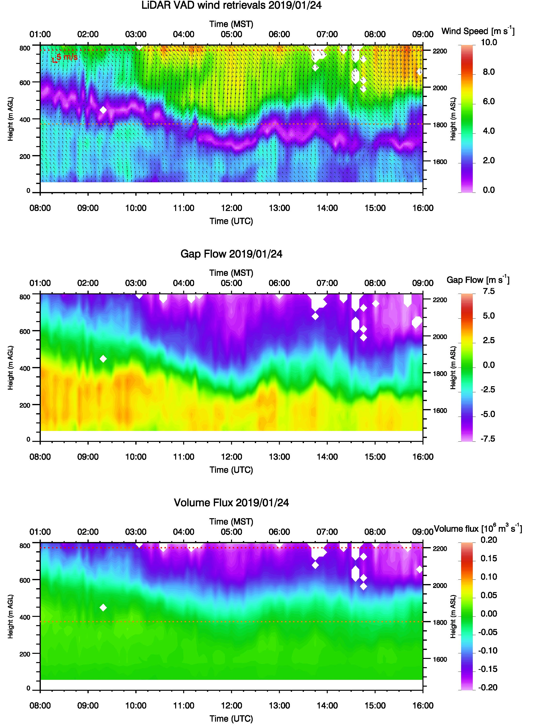
Figure 6: LiDAR wind retrievals for 24 January 2019 (top panel), vertical profile of gap flow (middle panel), and vertical profile of volume flux (bottom panel) through the Jordan Narrows.

The volume flux calculations illustrated in Figure 6, available for each layer, can then be integrated to different depths or filtered for southerly or northerly transport directions. Calculations integrating the volume flux to 2200 m (average depth of the Salt Lake Valley basin) and 1800 m, which is the height to which the Salt Lake Valley basin is sheltered by the Traverse Mountains, and the gap flows is confined to the Jordan Narrows gap.
In the case of 24 January 2019, the overall air mass exchange was dominated by northerly transport (Fig. 7, top panel), while the southerly transport dominated in the lower, more confined part of the Jordan Narrows (Fig. 7, bottom panel).

Figure 7: Volume flux calcu-lations for 24 January 2019 to two heights, 2200 m (top), which is the average depth of the Salt Lake Valley basin, and 1800 m (bottom), which is the height to which the Salt Lake Valley basin is sheltered by the Traverse Mountains, and the gap flows is thus confined to the Jordan Narrows gap.

3.2 Pollution (Mass) Transport - 12 February 2019 Case Study
The developed methodology illustrated in Section 3.1 can be used in a next step to estimate pollution mass transport between the two basins, if representative observations of pollution concentrations are available. WaFACO observations of ammonia at Camp Williams were limited to a two-week period in early February 2019. As seen in the analysis of the Valley Heat Deficit (Fig. 2), the period did not include periods of persistent cold air pools (PCAPs). Nevertheless, shorter periods of stronger static stability associated with nocturnal cooling allowed ammonia to accumulate in the near-surface air when vertical mixing was limited. Figure 8 gives an overview over the observations in the vicinity of the Jordan Narrows for the period of WaFACO (2 Feb. - 16 Feb. 2019).

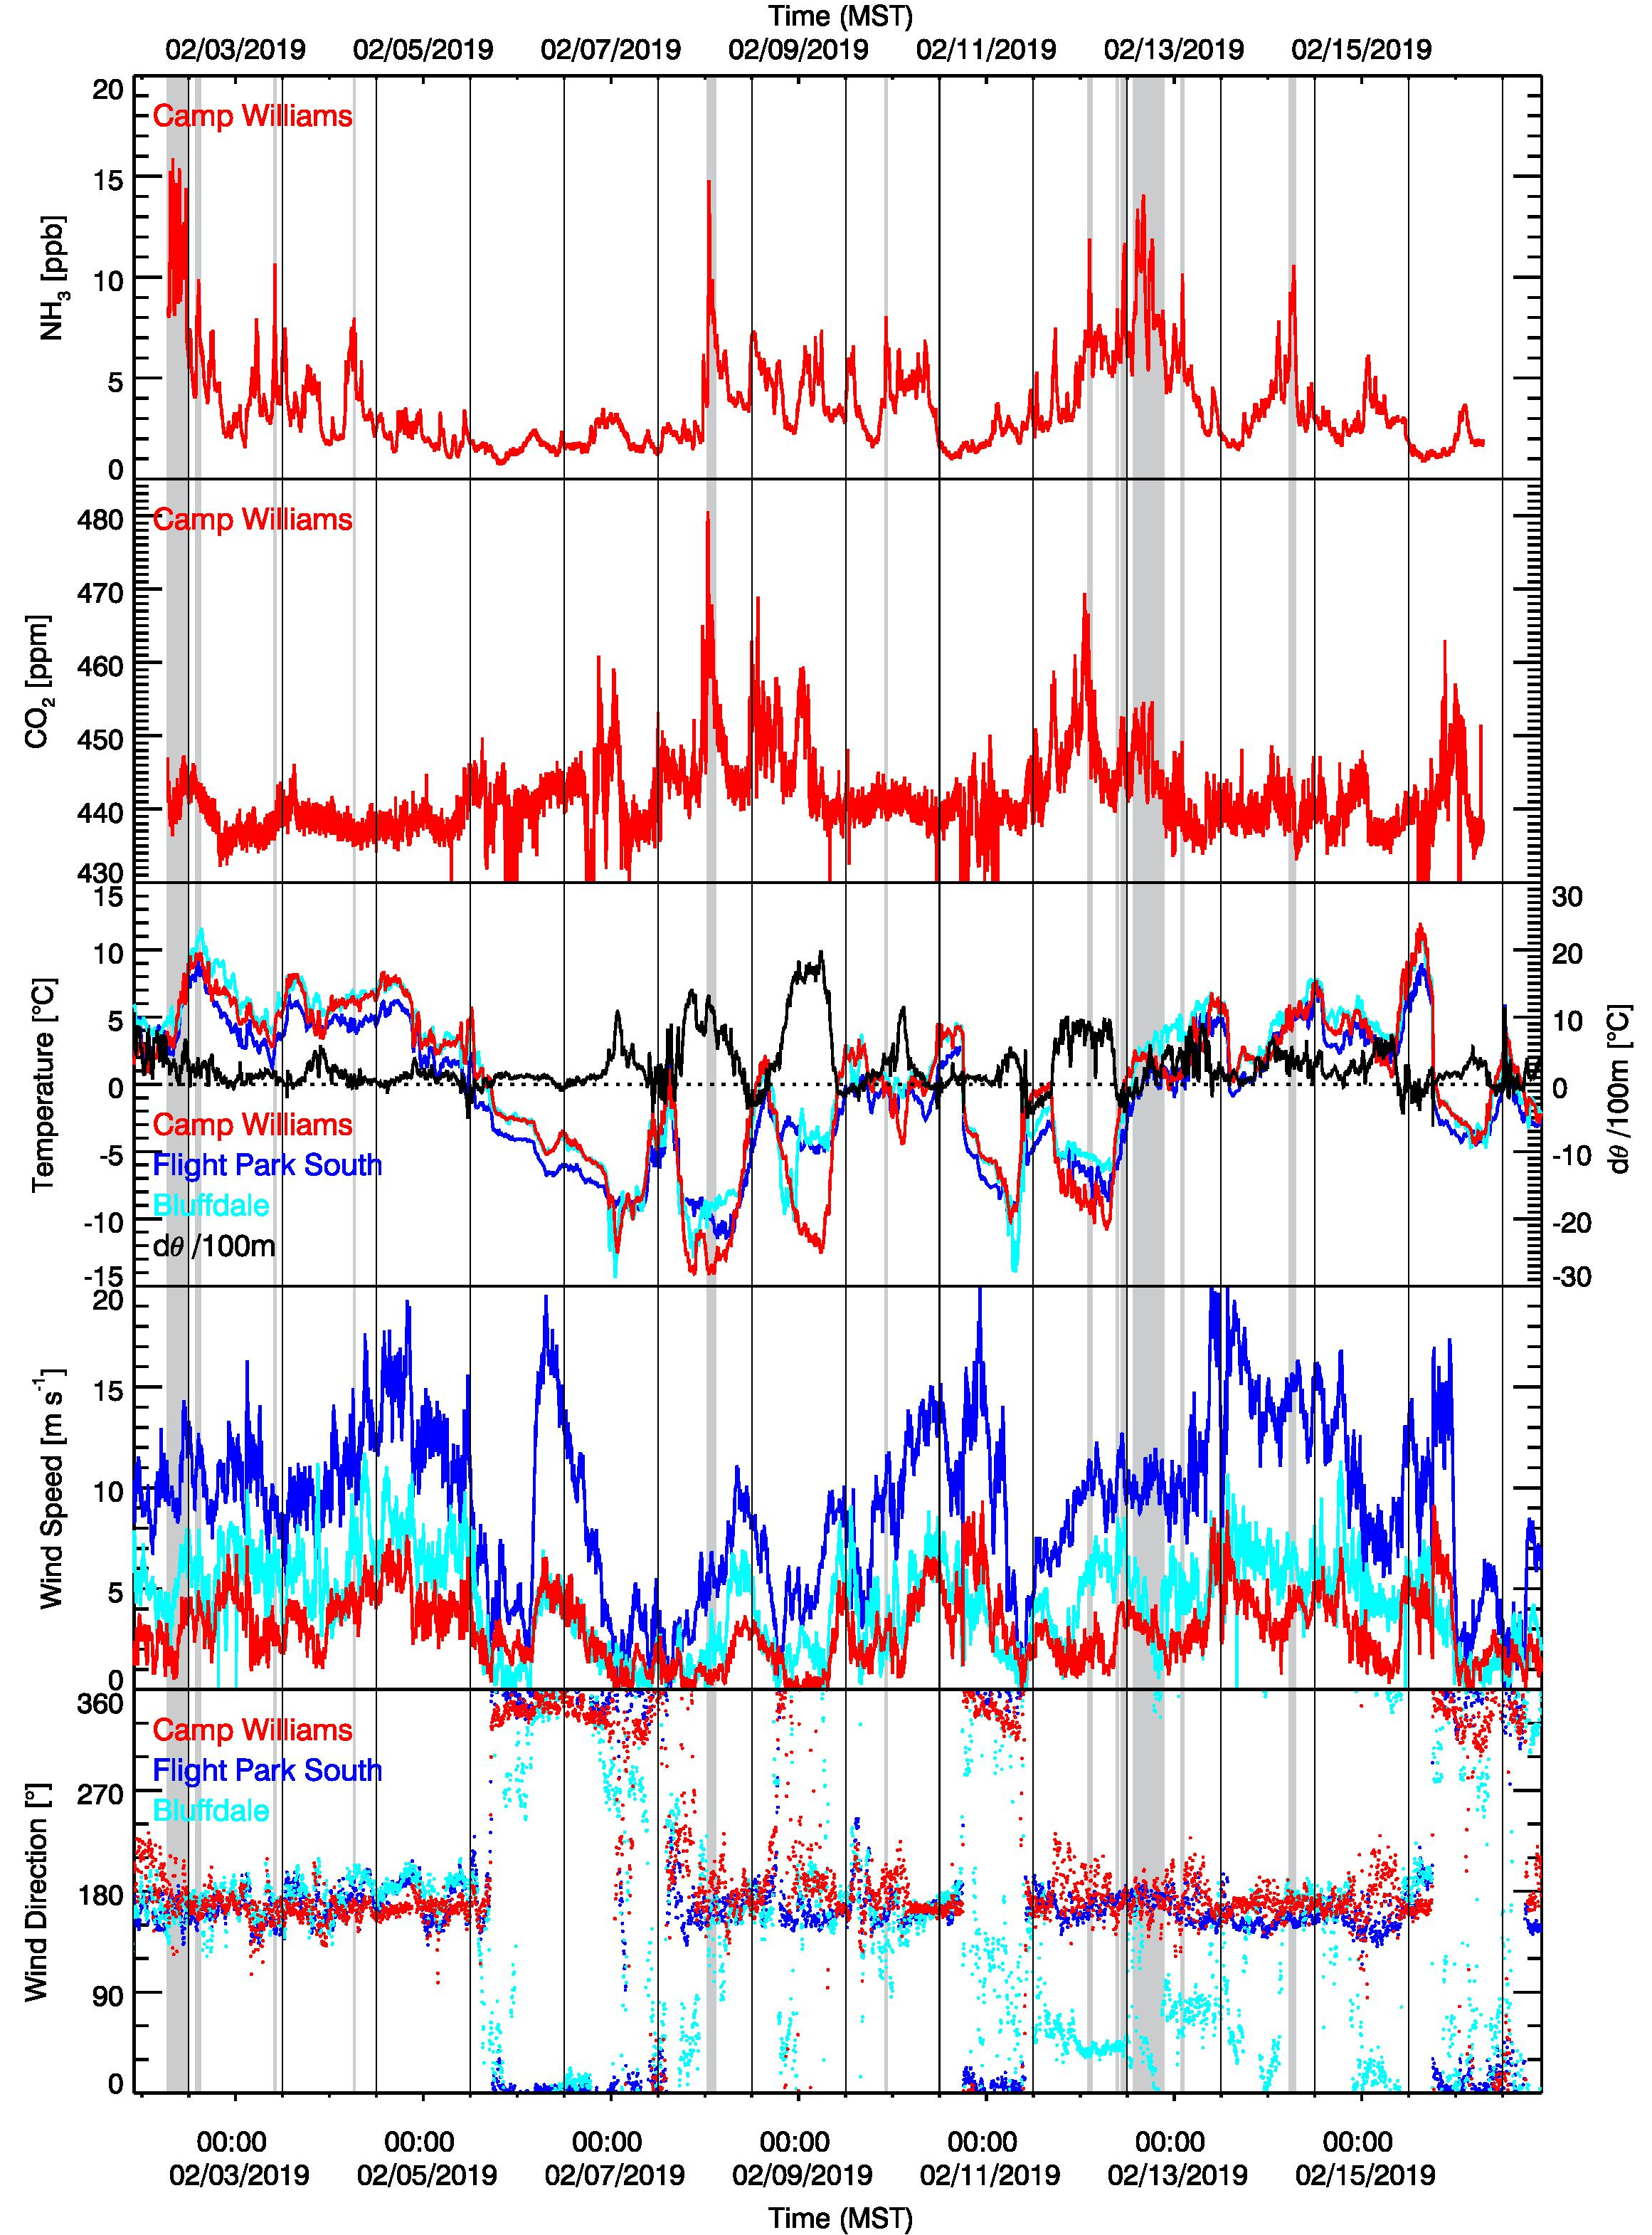
Figure 8: Ammonia and carbon dioxide observations during WaFCO, temperature and stability estimates for the vicinity of the Jordan Narrows, and wind speed and wind direction time series. Ammonia (NH₃) and carbon dioxide (CO₂) concentrations provided courtesy of Randy Martin.

The upper two panels of Fig. 8 show the time series of ammonia (NH₃) and carbon dioxide (CO₂) concentrations (courtesy of WaFACO principal investigator Randy Martin). Temperature time series from the AWS at Camp Williams (CW), Flight Park South (FPS), and Bluffdale (BD) are given together with a potential temperature gradient estimated from the difference between FPS and CW. Positive values of dθ/dz are seen to precede or coincide with elevated concentrations of ammonia. Wind speeds and directions are shown in the bottom two panels. Elevated concentrations of ammonia are generally observed under southerly flow conditions after a period of stagnation and stable atmospheric conditions, indicating to dominating ammonia sources in Utah Valley during this time.
Under the assumption that surface-based ammonia concentrations are representative for the entire flow layer in the gap (an assumption that is very likely not justified) and neglecting mass gain or loss through reactions, the approach developed in this study allows a first estimate of the pollution mass flux between the two basins. By multiplying the integrated volume flux with the pollutant mass concentration, a total mass transport in unit mass per time is obtained. This approach thus successfully results in estimates of pollutant transport across airsheds, which could be used for detailed pollutant budget calculations.
Figs. 9-11 summarize an estimate of ammonia transport through the Jordan Narrows gap between 0900 and 1700 MST 12 February 2019 based on the LiDAR retrieval of the horizontal wind field (Fig. 9) and the derived volume flux (Fig. 10). This day is chosen here as an example despite the limitation of the successful LiDAR returns to below 1800 m ASL, as it featured relatively high ammonia concentrations.

Figure 9: LiDAR retrievals of the horizontal wind field through the Jordan Narrows, 0900 to 1700 MST 12 February 2019. Note that the LiDAR could only resolve the flow in the lowest 300-400 m due to relatively clear conditions.

Figure 10: LiDAR-based estimates of volume flux at different heights through the Jordan Narrows, 0900 to 1700 MST 12 February 2019.

The flow on 12 February 2019 was from the south, and the integrated volume flux below 1800 m ASL reached values of up to 15 km³ per hour (Fig. 11, top panel). This flux would replenish the entire air Salt Lake Valley airshed (below 1800 m ASL) in a little more than one day (~29 hours).
By multiplying this integrated volume flux with the observed ammonia concentrations (Fig. 11, middle panel) we derive an estimate of the mass transport of ammonia through the Jordan Narrows, reaching values above 100 kg hr⁻¹ (Fig. 11, bottom panel). This estimate is based on the assumption that the observed concentrations are representative for the entire flow layer. These values would add up to a daily ammonia transport on the order of 2.0 metric tons.
A comparison with daily emission rates of ammonia for a typical 2017 winter week-day of 4.74 and 10.52 metric tons for Salt Lake and Utah counties, respectively (UDAQ, personal conversation), shows that the inter-basin transport of ammonia can be significant. In the example case for 12 February 2019, Utah County exports about 20% of its daily emission through the Jordan Narrows to Salt Lake County, which receives an additional 50% of its own ammonia emission by means of this inter-basin airmass exchange.

3.3 Future Refinements
The current study developed a methodology to estimate pollution mass transport between to adjacent basins, the Salt Lake Valley and Utah Valley basins. This method is based on Doppler Wind LiDAR observations (wind profile), geographic calculations based on a digital elevation model, and surface observations of a pollutant (in this case ammonia).
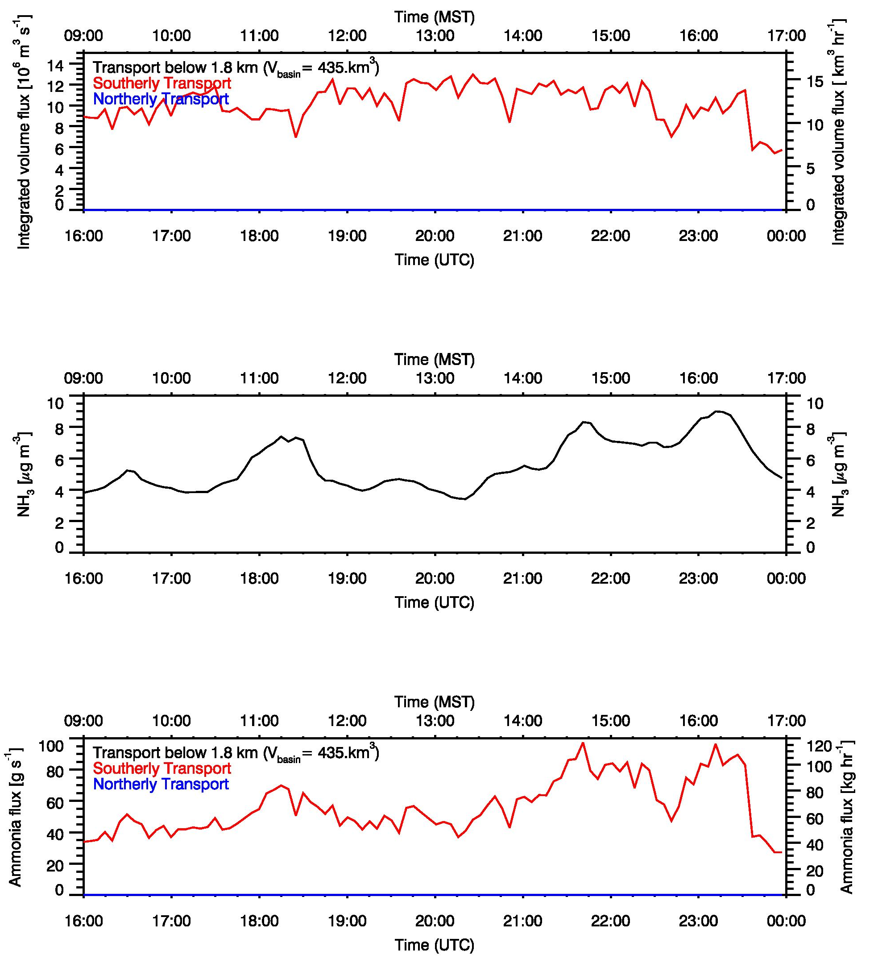
Figure 11: LiDAR-based estimate of volume flux through the Jordan Narrows below 1800 m ASL, 0900 to 1700 MST 12 February 2019 (top panel). Ammonia concentrations observed at Camp Williams, courtesy Randy Martin, USU (middle panel), and the derived ammonia transport estimates.
Several assumptions were made to allow for the estimates. These include that the observed wind field is representative for the entire cross section of the Jordan Narrows, and that the surface concentrations are representative for the concentration in the entire flow layer. These hypothesis could be tested in future investigations, by adding wind observations in other locations using SoDAR or LiDAR, and by operating additional ammonia measurements at different heights along the Jordan Narrows cross sections.
Further small refinements may include the development of a better representation of the lowest flow layer (below the first layer resolved with the wind lidar) that has been neglected in the present study.
3. Forecast support

Weather forecasts were provided every few days during the Jordan Narrows Gap Ammonia study to support field operations of the WaFACO study. A variety of global numerical models were used in providing the forecasts, including the National Center for Environmental Prediction Global Forecasting System (GFS) and the North American Model (NAM). Satellite data, particularly snow cover, as well as surface weather data from MesoWest was used to supplement the model data. A forecast funnel approach was used, focusing in the long-term and zooming into the shorter term.
The forecasts provided under http://uwfps.blogspot.com/ are listed in the Appendix.
4. Summary

The Jordan Narrows Gap Ammonia Transport Study was conducted in Jan-Feb 2019 to provide the key meteorological support for the concurrent chemistry observations of the Wasatch Front Ammonia and Chloride Observations (WaFACO) study. It further developed a methodology to investigate inter-basin air mass exchange and ammonia transport between the Salt Lake Valley and Utah Valley basins.

Despite the fact that the 2018-2019 cold season was dominated by a progressive synoptic pattern that prevented persistent cold air pools from forming during the course of the study, we were successful in developing and demonstrating the use of a methodology to estimate ammonia transport between the Utah and Salt Lake Basins. Depending on the meteorological conditions, ammonia can be transported in both directions. In the example of 12 February 2019 highlighted in this report, ammonia transport through the Jordan Narrows was shown to amount to significant portions (20% and 50%) of the daily typical winter week-day ammonia emissions of the two (Utah and Salt Lake) counties.
Acknowledgements

We thank George Summit from Camp Williams / Utah National Guard to help us identify an ideal location for our observations at the Camp Williams and for facilitating our access to the site. We thank North Star Academy and Bluffdale Elementary schools for housing one of the automatic weather stations or ceilometer, respectively, during the study. We also thank UDEQ for providing us with additional ceilometer data and ammonia emission estimates, and WaFACO PI Randy Martin for sharing ammonia concentration measurements.

Appendix A: Forecasts in Support of the Wasatch Front Ammonia and Chloride Observations (WaFACO) study

Tuesday, January 8, 2019
Poor air quality is expected through next weekend as a weak inversion strengthens. More detailed forecasts will start with the beginning of the UDEQ Jordan Narrows Transport Study on 15 January 2019. Inversion for Friday January 11th is shown in Fig. A1.
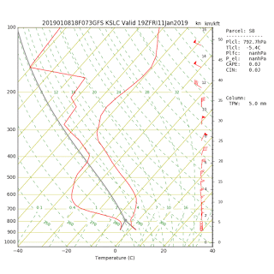 | Fig. A1: Forecast sounding showing inversion on Friday 11 January.

Thursday, January 10, 2019
High pressure aloft will strengthen to the west of Utah Friday, then shift east into the northern Great Basin for the weekend. This will result in a prolonged period of inversion conditions through at least Monday in the valleys of northern Utah. Pollution levels are currently around 30 µg m⁻³. Expect particulate pollution to increase by 5 µg m⁻³ per day on average in the Salt Lake Valley (SLV) through Monday. This means several days exceeding the National Ambient Air Quality Standard are likely Friday - Monday. Fog and clouds within the cold-air pool will become increasingly likely as the inversion strengthens this weekend.

Saturday, January 12, 2019
High pressure aloft centered over the northern Rockies will remain the dominant weather feature early next week, resulting in a strengthening cold-air pool through Tuesday. A series of weather disturbances will finally return to the area toward the middle of the week and scour out the Valley pollution.

The PM_{2.5} levels across the SLV have remained nearly constant the last few days (30 µg m⁻³) as rain, fog, and low clouds have increase vertical mixing and diluted the pollution trapped in the Valleys of Northern Utah. A strengthening inversion with and marginal to poor air quality will remain the norm through Monday. Tuesday through Wednesday the inversions will likely mix out and air quality will dramatically improve.
More detailed forecasts to follow starting 15 January.

Tuesday, January 15, 2019
This will be updated every other day unless conditions warrant. Summary: A weak storm system will clean out the remaining pollution Wednesday. A windy and wet pattern will ensue through Thursday night with several feet of snow in area mountains as a strong Pacific storm system traverses the Western US. An inch or two of snow is possible in the Valleys Thursday night into Friday morning. A short 60-hr cold-air pool episode is forecast Friday afternoon through Sunday night followed by a cold front and mix-out to clean conditions late Sunday night or Monday morning. PM_{2.5} pollution levels will stay below the National Ambient Air Quality Standards (NAAQS) on Saturday and Sunday. Cool, clean northwest flow will follow into Monday and Tuesday.

Wednesday January 16th, 2019
Remaining pollution from last episode will be mixing out by mid-afternoon. 70% chance of rain and snow mix. Winds 5-10 kts from south. High 40°F Low Wednesday night 37°F

Detailed forecast:
Thursday 17 January: Clean air in Utah Valleys. Rain likely (90% chance), heavy at times. Too warm for Valley snow accumulation in the Salt Lake Valley until late Thursday night with 1 inches possible toward dawn Friday. Winds 5-10 kts from south. High 46°F Low Thursday night 33°F
Friday 18 January: Clean air in Utah Valleys. Snow showers likely (70% chance). 1-2 inches possible. High 37°F Low Friday night 30°F.
Saturday 19 January: Weak pollution episode begins with cold-air pool conditions being established. High 37°F Low Saturday night 26°F. Forecast model inversion sounding late morning Saturday showing descending mountaintop subsidence inversion associated with progressive short-wave trough (Fig. A2).
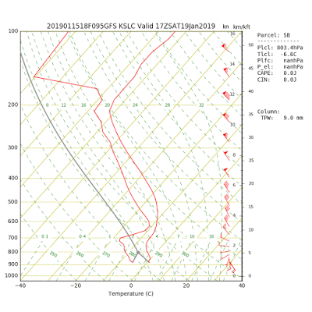 | Fig. A2: Forecast sounding showing inversion on Friday 19 January.

Sunday 20 January: Weak pollution episode continues through Sunday night. PM_{2.5} levels likely to remain below NAAQS. High 40°F Low Sunday night 29°F. Forecast model inversion sounding in the morning Sunday showing the mountaintop subsidence inversion has descended and the low-level inversion has strengthened (Fig. A3).

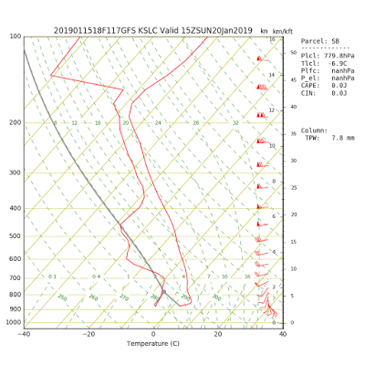 | Fig. A3: Forecast sounding showing inversion on Saturday 20th January.

Monday 21 January: At this time (weather models could change) another cold front will end the short weekend episode with a chance of snow. Stay tuned. High 38°F Low Monday night 25°F.

Friday, January 18th, 2019
Summary: A major storm system brought heavy rain and snow to Utah is winding down on Friday. Weak high pressure will result in brief cloud-topped cold-air pool/inversion through the weekend, with only minor impacts to Valley air quality. A major snowstorm is looking more likely for Monday. This could set the stage for a large high pressure system over the Western US with snow on the ground in northern Utah Valleys, potentially leading to a major persistent cold-air pool episode beginning around Saturday 26 January if current model forecasts hold. Stay tuned.

Detailed forecasts:
Saturday 20th January: Mostly cloudy with sprinkles or flurries possible in the morning. Weak cold-air pool in place in the cloud-topped inversion. PM_{2.5} concentrations between 5-10 µg m⁻³. High 42°F Low 33°F. NAM model sounding showing the deep cloudy inversion layer between the surface and mountaintop (700 mb) (Fig. A4).

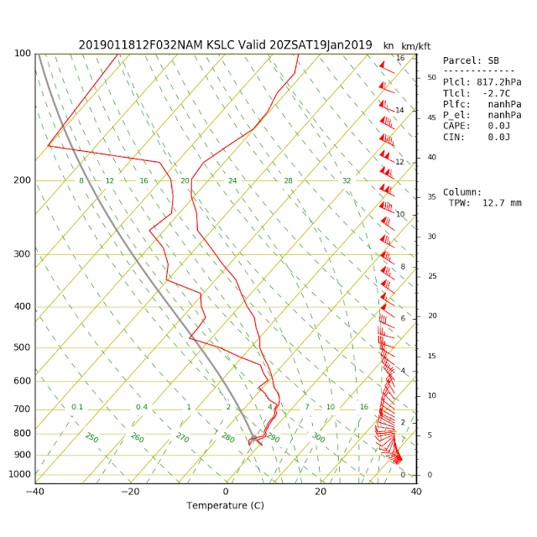 | Fig. A4: Forecast sounding showing inversion on Saturday 19th January.

Sunday 21st January: partly cloudy. Weak cold-air pool in place. PM_{2.5} concentrations between 8-14 µg m⁻³. High 45°F Low 33°F.
Monday 22 January: Cloudy, 70% chance of snow. Significant accumulations possible.
High 35°F Low 21°F.
Tuesday 23 January: Mostly cloudy, cold. High 30°F Low Saturday night 24°F.
Wednesday 24 January: Mostly cloudy chance of light snow. High 37°F Low Sunday night 25°F.
Thursday 25 January: Mostly cloudy chance of light snow. High 38°F Low Monday night 24°F.

Tuesday, January 22nd, 2019
Weather Synopsis: A major storm system brought widespread snow accumulations to Utah Valley ranging from 4-16 inches. Thus, a significant snowpack is in place to support intense inversions.
To view snowfall accumulations see:
https://www.cocorahs.org/Maps/ViewMap.aspx?state=usa
However, a series of weak weather systems progressing around a high pressure system off the West US coast will keep temperatures aloft from warming much through Saturday. Thereafter, cold-air pool conditions may become established starting Sunday but it is too far out to have much confidence in the forecasts. The 3-5 day forecast is also unusually uncertain. If the high pressure over the west coast shifts east more than currently forecast, a persistent cold-air pool could form later this week. Stay tuned for updates.

Wednesday January 23rd, 2019:
Short term forecast: Stormy conditions will be replaced by a building ridge of high pressure late in the weekend. However at this point the ridge looks to be short-lived.

Wednesday 23rd January: Mostly cloudy flurries possible. High 36°F Low 22°F
Thursday 24th January: Mostly cloudy. Chance of snow Wednesday night into Thurs morning. High 37°F Low 27°F. GSF model shows light snow and short-wave trough impacting Northern Utah Thursday morning (Fig. A5).

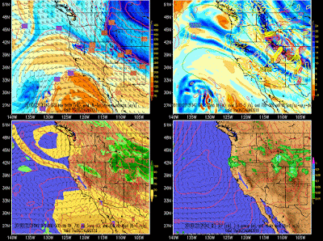 | Fig. A5: GFS Forecast Model for Thursday 25th January.

Friday 25th January: Mostly cloudy slight chance of snow. High 36°F Low 24°F. GFS Forecast Model showing light snow and short-wave trough impacting Northern Utah Friday night (Fig. A6).

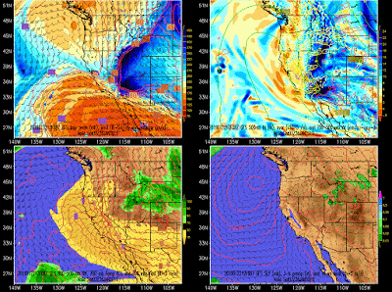 | Fig. A6: GFS Forecast Model for Friday 26th January.
Saturday 26th January: Mostly sunny, cool. High 37°F Low 24°F.
Sunday 27th January: GFS Forecast Model showing high pressure ridge building over Utah on Sunday (Fig. A7). Mostly sunny, cool. High 37°F Low 25°F.

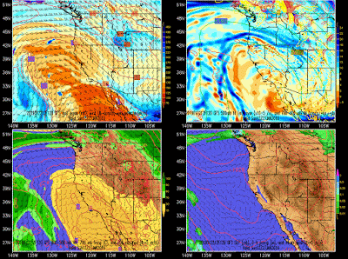 | Fig. A7: GFS Forecast Model for Friday 26th January.
Monday 28 January: Mostly cloudy chance of light snow. High 36°F Low Monday night 20°F.

Sunday, January 27, 2019:
Summary: Weather models have backed away from any major PCAPS for the next 10 days. A weak cold-air pool this weekend will end Monday with a dry cold system coming from the north. Another weak 3.5 day duration cold-air pool will extend from Tuesday evening - Friday. Pollution levels may slowly increase to 15 µg m⁻³ by Friday, but this is not expected to be a very significant inversion episode. A series of storm systems are now forecast to bring rain and snow to Utah from next Saturday - Tuesday (February 2 nd-5 th).
Monday 28th January: Mostly cloudy, High 38°F Low 25°F.
Tuesday 29th January: Mostly sunny. High 35°F Low 24°F.
Wednesday 30th January: Sunny. High 36°F Low 23°F. GFS Forecast Model showing weak inversion in place on Wednesday morning (Fig A8).

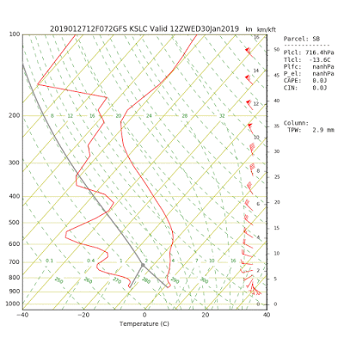 | Fig. A8: Forecast sounding showing inversion on Wednesday 30th January.

Thursday 31 January: Mostly sunny. High 39°F Low 27°F.GFS Forecast Model showing weak inversion continuing Thursday morning.
Friday 1 February: Mostly sunny. High 41°F Low 25 °F. Saturday 2 February. A chance of rain and snow. High 40°F Low 32°F

Wednesday, January 30th, 2019:
Summary: A weak persistent cold-air pool (high pressure and associated capping inversion is not that pronounced, meaning the pollution builds into a deeper layer, and also surface snow cover is partially gone) will continue through Friday, with PM_{2.5} concentrations increasing 5 µg m⁻³ each day. A series of weather systems will clean the air starting Saturday and bring Valley Rain this weekend, followed by Valley snow early next week.
Thursday 31st January: Partly cloudy, increasing haze within cold-air pool. High 37°F Low 27°F.
Friday 1 February: Partly cloudy, increasing haze within cold-air pool. High 42°F Low 25°F. NAM Forecast Model showing temperature inversion in place on Friday morning showing a surface inversion and inversion aloft (Fig. A9).

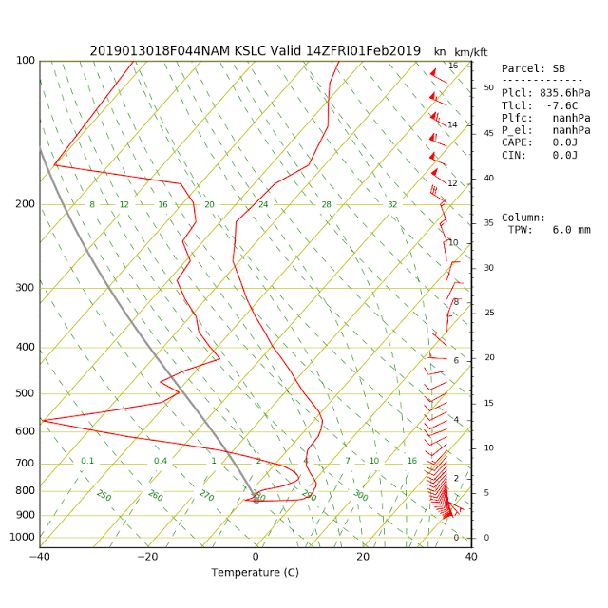 | Fig. A9: Forecast sounding showing inversion on Friday 1st February.
Saturday 2 February: A chance of showers in the afternoon. High 45°F Low 32°F.
Sunday 3 February: Rain showers likely, changing to snow showers Sunday night. High 40°F Low 30°F.
Monday 4 February: A chance of snow. High 39°F Low 23°F.
Tuesday 5 February: A chance of snow. High 32°F Low 21°F.

Saturday, February 2nd, 2019:
Summary: A complex series of storms will traverse the western US through the next week. Rain will predominantly fall in the Valleys this weekend, melting the remaining snow. A chance of snow if forecast with colder systems by the middle of next week No persistent cold-air pools are forecast for the next week at least.

Sunday 3 February: Rain. High 48°F Low 41°F.
Monday 4 February: Rain. High 49°F Low 42°F.
Tuesday 5 February: Rain with possible snow mix. High 43°F Low 29°F.
Wednesday 6 February: Chance of snow. High 36°F Low 25°F.
Thursday 7 February: Partly cloudy. High 32°F Low 24°F.
Friday 8 February: Partly cloudy. High 35°F Low 23°F.

Wednesday, February 6th, 2019:
Summary: A major storm system generally brought between 9 and 14 inches of snow to Utah Valleys Wednesday with more lake effect possible into Thursday morning. See https://www.cocorahs.org/ for a map of snowfall totals.
A large trough over the western US will keep air quality good through next weekend with breezy conditions and moderating temperatures. Snow possible Monday. Yet additional storms may affect the region going into the middle of Feb.
Daily forecast info will be provided once a persistent cold air pool period has been identified in weather guidance models.

Friday, February 8th, 2019:
Summary: A storm system will approach Utah Sunday afternoon, increasing southerly winds and keeping the deep snow cover and cold temperatures from generating much pollution build-up. Another snowstorm is possible Sunday night into Monday morning. Unsettled conditions with another cold storm possible Wed-Thursday next week. No persistent cold-air pools are forecast for the next 7 days at this point.
Daily forecast info will be provided once a persistent cold air pool period has been identified in weather guidance models.

Monday, February 11th, 2019:
Summary: Another storm system will approach Utah Wednesday afternoon through Thursday, increasing southerly winds and keeping the air clean. The storm looks to be primarily a rain/snow mix in the Valley locations. Yet another cold front and snowstorm is possible Saturday, with cold and unsettled conditions with light snow lingering into early next week.
No persistent cold-air pools are forecast for the next 7 days at this point, and with the climatological end of "inversion season" in mid-February, it is looking increasingly likely that the winter pollution season is over. Daily forecast info will be provided once a persistent cold air pool period has been identified in weather guidance models.

Saturday, February 16th, 2019:
Summary: Cool temperatures and scattered snow showers will impact Utah through the weekend. A broad trough will keep unseasonably cool temperatures and well-mixed conditions through next week. A stronger storm is possible later next week.
No persistent cold-air pools are forecast for the next 7 days at this point, and with the climatological end of "inversion season" in mid-February, it is looking almost certain that the winter pollution season is over.

