The MatterHEX Experiment – Investigating Atmospheric Flow Patterns in Highly Complex Terrain Related to Banner Cloud Formation

Sebastian W. Hoch ^{(1),(2)}, Marius L. Thomas⁽³⁾, Hendrik Huwald⁽⁴⁾, Michael Lehning⁽⁴⁾, Brandon J. A. van Schaik⁽⁴⁾, Paul Imbert⁽⁴⁾, Dominique S. Rentel⁽³⁾, and Volkmar Wirth⁽³⁾

⁽¹⁾ Atmospheric Sciences Department, University of Utah, Salt Lake City, UT
⁽²⁾Earth Observing Laboratory, National Center for Atmospheric Research, Boulder, CO
⁽³⁾Johannes Gutenberg University Mainz, Mainz, Germany
⁽⁴⁾EPFL Valais/Wallis, Sion, Valais, Switzerland

Abstract
Orographic clouds are typically formed on the windward side of a topographic barrier when approaching air is cooled as it is lifted, and moisture condenses into cloud droplets. Sometimes however, special clouds can be observed. Attached to lee-side mountain slopes below the summit, like a flag or banner to a mast, these clouds, often seen on steep singular mountains, are known as “banner clouds”. Their formation indicates that vertical displacement in the lee dominates over the lifting occurring upwind. Past investigations of this phenomenon have mostly relied on numerical simulations due to considerable challenges associated with observations in the often extremely complex mountainous terrain.
To study this flow phenomenon observationally and numerically, our international team proposed the Matterhorn Experiment, MatterHEX. The experiment, centered on the iconic Matterhorn in the European Alps, where banner clouds are frequently observed, was designed to collect the minimum data necessary to constrain the phenomenon from the best possible locations still accessible by foot, and further making use of remotely sensed winds.
This article summarizes the design, execution, and initial findings of the field experiment conducted in Fall 2023 and highlights how geographic and logistical challenges were navigated to make successful observations of upwind flow and stability conditions as well as the relevant leeward flow patterns using radiosonde launches, Doppler wind lidar, and webcams, at this high-altitude tourist destination.
Time-averaged lidar scans highlight lee-side ascent driving banner cloud formation, while individual scans resolve the turbulent features associated with lee-side flow separation. Our analysis shows that flow conditions around the Matterhorn are frequently conducive for banner cloud formation, but that a lack of moisture can prevent their formation.

Introduction

Flow past orography is a classical topic in mountain meteorology (Whiteman 2000). In the recent decades, associated processes such as gravity waves (Smith 1979, Durran 2003), orographic drag (Fritts et al. 2016), and orographic precipitation (Roe 2005) have been in the focus of research and of field campaigns. The majority of these studies have dealt with meso- or larger-scale flow over large mountains or mountain ranges rather than single mountains. One reason may be the difficulties in field observations in highly complex and steep terrain, but also the difficulties in modeling on the scales necessary to simulate complex flow interactions without overcoming numerical difficulties (i.e. by using immersed boundary methods), or using computationally-expensive Large-Eddy Simulations (LES) (Lundquist et al. 2012, Connolly et al. 2021) .

One smaller-scale phenomenon, however, has received some attention: orographic banner clouds. These clouds form — somewhat counter-intuitively and often under otherwise cloud-free conditions — in the lee of steep mountains (Glickman 2000). They are closely attached to the lee slopes, and the combination of strong flow past the mountain's summit ridgelines and the associated wind shear let them appear like a banner flying in the wind (Fig. 1). Schween et al. (2007) used time-lapse movies for a first systematic study of these clouds forming on Mount Zugspitze, which were then combined with additional meteorological observations to reveal their properties (Wirth et al. 2012). The first Large-Eddy Simulations of banner clouds were conducted by Reinert and Wirth (2009) followed by Voigt and Wirth (2013), whose simulations using idealized topography resolved a bow-shaped vortex in the lee of the mountain and highlighted the role of the extensive lee-side vertical uplift for banner cloud formation. Trajectory calculations by Schappert and Wirth (2015) illustrated that the majority of air parcels in the banner cloud traveled around the mountain before ascending on the lee-side. Prestel and Wirth (2016) systematically examined the conditions most conducive for banner cloud formation, stressing the role of weakly stratified flow. More recently, Thomas and Wirth (2023) investigated the effect of the real topography of the Matterhorn on the previous findings that were based on idealized terrain.

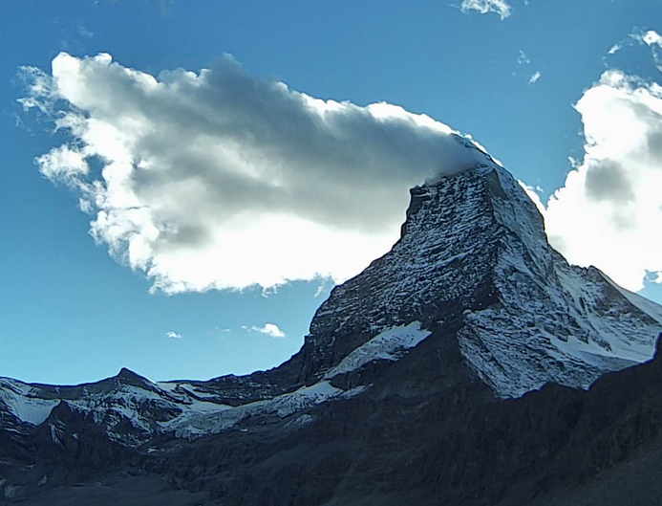
Fig. 1: Banner cloud on the Matterhorn, 1540 UTC 29 September 2023.

The flow response to a topographic obstacle depends on the momentum of the flow, the height and width of the obstacle, and the ambient static stability (resistance to lift) (Whiteman 2000). Based on laboratory experiments with two-dimensional flow over singular mountains, Baines (1995) defined regimes of characteristic flow responses to terrain as a function of two non-dimensional parameters describing the upwind flow properties and the geometry of the obstacle. As shown in Figure 2, “Lee-side separation”, “Post-wave separation”, and “No separation” occurs depending on the obstacle aspect ratio $A=h_{0 }/A_{d }$, and on the non-dimensional mountain height (inverse Froude number) $N=Nh_{0}/U$. Here, $h_{0}$​ is the obstacle height, $A_{d }$​ the lee-side mountain half-width, $N$ the Brunt-Väisälä frequency, and $U$ the wind speed. The same regime classification turns out to also be valid for flow past a three-dimensional mountain (Hunt and Snyder 1980; Baines 1995; Prestel and Wirth 2016). Banner clouds only occur in the “Lee-side separation” regime because extended lift on the leeward face of the mountain, all the way up to its summit, is a prerequisite of banner cloud formation (Voigt and Wirth 2013).

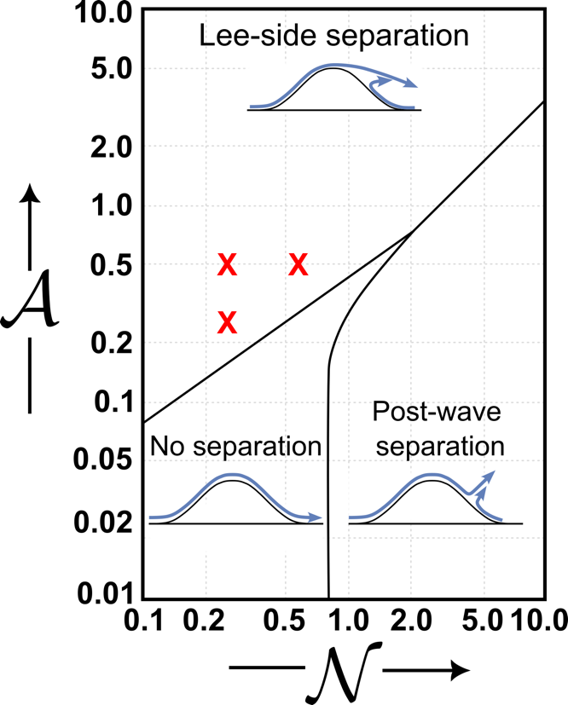 | Figure 2: Diagram of lee-side separation properties as a function of the inverse Froude number $N$ and mountain aspect ratio $A$, adapted from Fig. 5.8 of Baines (1995). Conditions shown to be conducive for banner cloud formation in idealized simulations using a three-dimensional obstacle (Prestel and Wirth 2016) are shown in red.

While theoretical and model studies are consistent, there has been - so far - a lack of direct observations of the banner cloud phenomenon. Fortunately, the development of smaller and more mobile Doppler wind lidars in the past decade has facilitated the deployment of such equipment in complex terrain and allowed advances in applications such as mountain meteorology, wind energy, and fire weather (Gerber et al. 2017; Lareau et al. 2017; Whiteman et al. 2018; Kristianti et al. 2023; van Schaik et al. 2024).

Based on these developments, we explored the possibility of an observational campaign. Banner clouds frequently form on the eastern and southeastern side of the summit pyramid of the Matterhorn near Zermatt, Switzerland, one of the most iconic peaks in Europe and worldwide. Despite being one of the highest peaks in the Swiss Alps, the Matterhorn is rather well accessible due to the infrastructure catering to skiers, hikers, and mountaineers visiting Zermatt.

After exploratory measurements during a sabbatical in 2018 showed the fundamental feasibility of direct observation of the flow within a banner cloud edge in the lee of the Matterhorn, we received funding from the German Research Council (Deutsche Forschungsgemeinschaft, DFG) to conduct a small and focussed field campaign, the MatterHorn EXperiment (MatterHEX). The key objectives of the low cost, low profile, observational campaign were to observe the mean lee-side flow features resulting from the interaction of a well-characterized background flow with the topography of the Matterhorn. A further motivation was to collect a dataset that would be uniquely suited to validate Large-Eddy Simulations in extreme complex topography.

The global COVID-19 pandemic delayed international field campaigns, and we thus had to wait until the fall of 2023 to conduct the experiment. We were further constrained by having to avoid the main tourist season while minimizing a risk of being shut down due to an early onset of winter. Upper-air soundings had to be coordinated with the busy helicopter traffic related to tourism, mountain rescues, and infrastructure maintenance.

Experimental Design and Observations
We received permission for the three-week MatterHEX field campaign between 25 September and 15 October 2023, preceded by a one-week setup, and followed by a one-week take-down period. Logistical issues delayed the helicopter lifts to the field sites, and routine observations did not start until 29 September.

Based on the wind climatology for the fall months September and October (Fig. 3), and the supporting infrastructure available on the eastern side of the Matterhorn, we designed the experiment for a westerly flow regime. The challenge was to find an upwind location suitable to support a radiosonde operation, as well as accessible terrain in the lee of the mountain save enough to deploy remote wind sensing equipment with a limited range.

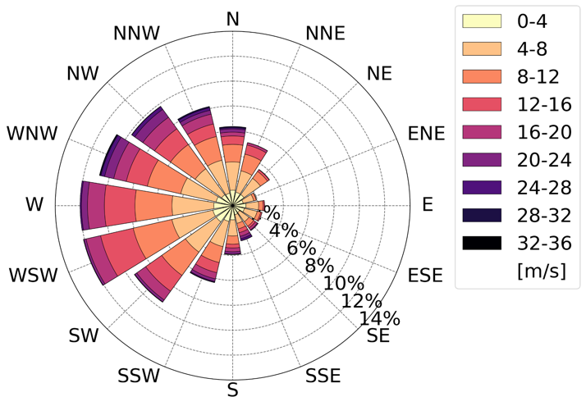 | Figure 3: ERA5 reanalysis 600 hPa wind climatology at lat=45.9° lon=7.55° for 15 September though 15 October in the period 1993-2023.

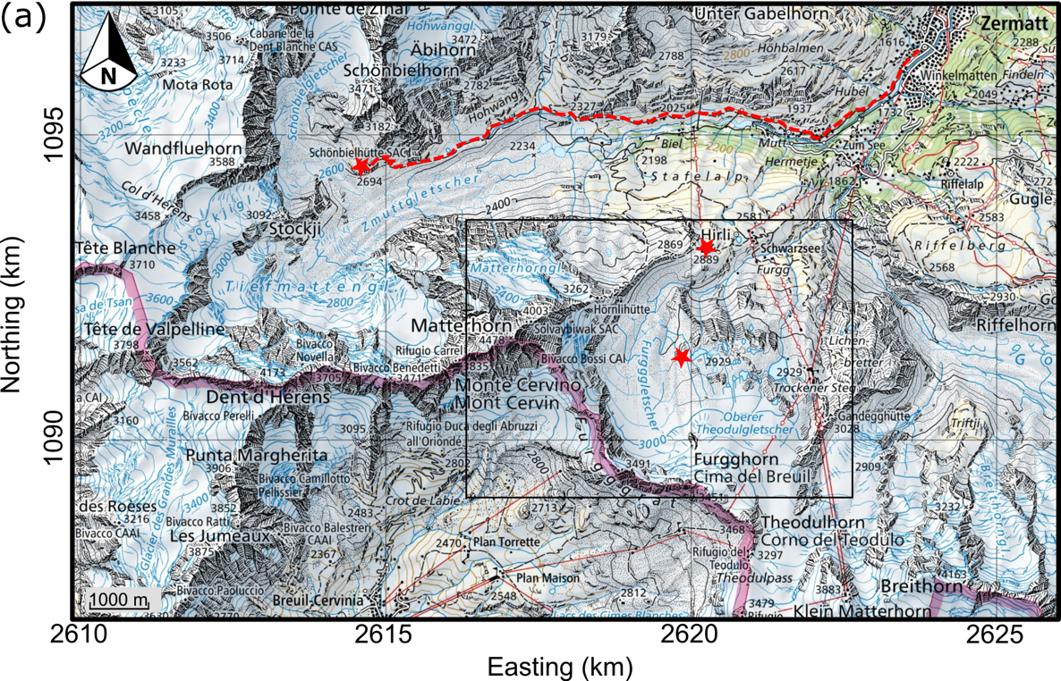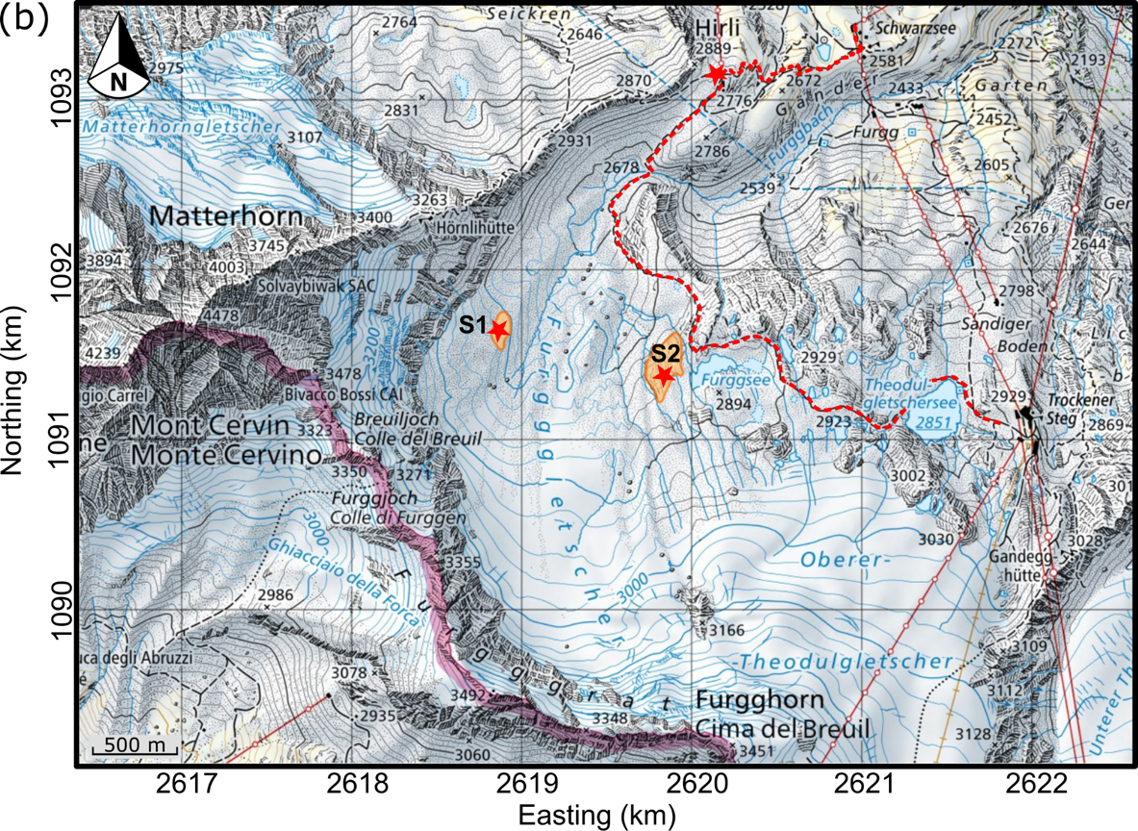

Figure 4: Maps showing (a) the Matterhorn region and the distribution of both up- and downwind observational assets, and (b) the terrain on the lee of the Matterhorn and location of the instrumentation used to monitor the lee-side circulation. Based on CH1903+ / LV95 maps from the Swiss Federal Office of Topography, swisstopo.

Upwind Observations
To meet the key objectives of the project while keeping costs low, we decided to observe the relevant upwind conditions by launching radiosondes from the Schönbielhütte (Fig. 4), a mountain hut of the Swiss Alpine Club, which is reached in a 4.5 hour hike from Zermatt. The Schönbielhütte is located at 2694 m ASL on the northern slope of the east-west oriented Zmutt valley northwest of the Matterhorn. By the start date of the campaign the hut was already closed for the season, but we were allowed to use the winter emergency quarters. Provisions as well as cooking fuel were flown in by helicopter, together with the scientific equipment, a small generator, and the helium cylinders needed for our radiosonde operation. Water was available from a natural well near the hut. We had two of our group stay at the hut for 2-6 days, and would then switch up with another team of two.

To evaluate the upwind conditions, we launched radiosondes (GRAW DFM-09) that measured temperature, relative humidity, wind speed and direction as a function of height. Radiosondes were launched when favorable westerly flow was forecast, as well as when banner clouds were observed under various flow conditions.

Initially we had discussed alternative upwind locations for the radiosonde operation, including sites in Italy and the Arolla Valley. Each of these locations had their own topographic characteristics, and ultimately the logistical benefits of the Schönbielhütte dictated our decision.

Downwind Observations

The flow response in the lee of the Matterhorn was remotely sensed using Doppler wind lidar techniques. The principal instrument in use was the University of Utah’s Halo Photonics Streamline XR scanning Doppler wind lidar. There were several constraints that limited the choice of an optimal observational site. While smaller lidar units can be powered using portable generators which gives significant flexibility, we were limited to stable terrain safe from rockfall, with easy access, and well-hidden from the numerous tourists. During an exploratory visit in summer 2023 we noticed that vast areas of the Furgg glacier on the eastern slopes of the Matterhorn had melted, exposing very loose and unstable debris unsuitable for instrument deployment. However, we identified two potential locations on solid bedrock. While the site closest to the summit pyramid (location S1 in Fig. 4) offered the best vantage point for observing the underside of a banner cloud, access required crossing over meltwater streams with large diurnal variations in runoff and travel over debris-covered ice. We therefore opted for the second-best location. This location, on the western side of the Furggsee (marked S2 in Fig. 4), is easily accessible from a popular hiking path which winds down between the Trockener Steg and Schwarzsee lift stations. This guaranteed safe access even under adverse weather conditions, and no major stream crossings were necessary. The local topography, with sharp drop-offs to the west, allowed for a deployment that was well-hidden from the trail despite its proximity. At a highpoint near this site, near-surface wind and turbulence were measured with an 3D ultra-sonic anemometer (Campbell Scientific CSAT3). The near-surface wind profile was monitored using a 5-beam prism-based lidar retrieval with a Vaisala Windcube WLS21. All instruments, hardware, generators, fuel, provisions, and camping gear were flown in by helicopter.

A second scanning Doppler wind lidar (Lumibird Streamline XR) was deployed for part of the experiment at a roof of the Trockener Steg cable car station — the same location where the explorational measurements were taken in 2018. This site, while at a large distance from the summit pyramid of the Matterhorn, offered hard power and easy access under any weather conditions. Observations from this location were seen as a backup, in case of a failure of the system installed at the Furggsee location.

Lidar Scanning Strategy

The Halo Photonics Doppler wind lidar at the Furggsee site was programmed with a repeating scan pattern which consisted of three range-height indicator (RHI) and four plan-position indicator (PPI) scans, and a short period of vertical stare (see Table 3). This scan pattern was repeated every 7 minutes. In addition, a 6-point PPI scan every 15 minutes was used for a velocity azimuth display (VAD) wind retrieval.

The extent of the RHI and PPI scans is illustrated in Figure 5. These scans were designed to capture the key features of the flow field around the Matterhorn’s summit pyramid. The three RHI scans were centered on, as well as to the south and north of, the summit. The PPI scans were positioned to capture potential flow asymmetries at different elevations, and to gauge the anticipated flow reversal in the lee of the mountain.

The lidar’s range gate length was set to 60 m. While the Streamline XR allows range gates as small as 18 m, we chose 60 m to enhance the returns in the high-altitude and low-aerosol environment. Lidar data was collected using the continuous scanning mode, and scan speeds and acquisition time were chosen to resolve the radial wind velocities at the distance of the Matterhorn summit with a spatial resolution of approximately 30 m. Noise was filtered using a threshold filter but limited by applying the Density-Based Spatial Clustering of Applications with Noise (DBSCAN) algorithm (Ester et al. 1996; Alcayaga 2020; Duscha et al. 2023). More details on the data processing can be found in Thomas et al. (2025).

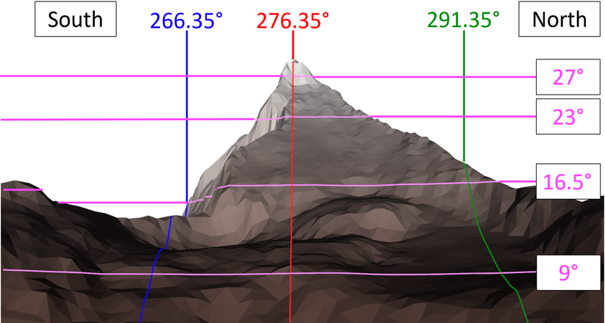
Figure 5: RHI and PPI scans and their simulated terrain intersections.

Table 3: Lidar scans of scan sequence repeated every 7 minutes.
Scan | Gate length | Azimuthal Range | Elevation Range | Angular Resolution
RHI 1 | 60 m | 266.35° | 0°-52.5° | 0.55°
RHI 2 | 60 m | 276.35° | 0°-52.5° | 0.55°
RHI 3 | 60 m | 291.35° | 0°-52.5° | 0.55°
PPI 1 | 60 m | 256.35°-296.35° | 9° | 0.55°
PPI 2 | 60 m | 256.35°-296.35° | 16.5° | 0.55°
PPI 3 | 60 m | 256.35°-296.35° | 23° | 0.55°
PPI 4 | 60 m | 256.35°-296.35° | 27° | 0.55°
Vertical Stare | 60 m | 0°-0° | 90°-90° | 0.55°

The additional profiling wind lidar (WindCube WLS21) recorded the wind profile above the Furggsee site to a height of 300 m above ground in 20 levels. The back-up lidar at Trockener Steg scanned a repeating grid pattern across the summit pyramid using a 60 m gate length, as well as a 6-point PPI for a VAD retrieval of the vertical wind profile.

Webcams
Time-lapse photography was used to monitor and document the banner cloud formation and evolution during the field campaign. One camera was co-located with the lidar at the Furggsee site, a second was deployed at the upper Hirli cable car station (Fig. 4), where hard power was available. The combined perspectives from these two vantage points helped to distinguish banner clouds from other low- or mid-level cloud formations. Both cameras captured time-stamped images every minute, which were transmitted in real time. This allowed the team to assess current conditions remotely, whether in Zermatt or at the Schönbielhütte. The images were later animated into time lapse videos to better visualize the temporal and spatial evolution of the banner clouds. An example video is available as an online supplement.

Table 1: MatterHEX sites, their coordinates, and elevations.
Observation Site | Latitude | Longitude | Elevation
Schönbielhütte | 46.002°N | 7.629°E | 2694 m
Furggsee | 45.974°N | 7.695°E | 2887 m
Trockener Steg | 45.971°N | 7.722°E | 2939 m
Hirli | 45.989°N | 7.699°E | 2765 m

Table 2: Observational components, targeted processes, instrumentation, and measured variables.
Observational component | Targeted Process | Instrument | Location | Variables | Manufacturer | Model
Upwind flow conditions | Wind profile,  stratification | Radiosonde | Schönbielhütte | P, T, RH, u,v | Graw | DFM-09
Lee-side flow response | Lee-side flow field, wind profile | Doppler wind lidar | Furggsee, Trockener Steg | Radial velocity, aerosol backscatter, VAD wind retrieval | Halo Photonics | Streamline XR
 | Lee-side wind profile | Doppler wind lidar | Furggsee | VAD wind retrieval | Vaisala | Windcube WLS21
 | Banner cloud formation | Webcam | Furggsee, Hirli | Pictures | Microseven | M7B5MP-PSAA
 | Near-surface turbulence | Sonic Anemometer | Furggsee | u, v, w, T | Campbell Scientific | CSAT3

Initial Results
In this overview paper we will focus on highlighting the key results from the observational part of the research project, i.e. the key findings based on the wind lidar retrievals during the occurrence of banner clouds. A more detailed discussion of a comparison of observations with LES model simulations can be found in Thomas et al. (2025).

Banner Cloud Occurrence
Banner cloud formation was observed on 8 days of the 17 days of the MatterHEX campaign, and banner clouds can be identified during 45 hours of webcam imagery. Not all banner clouds are as well defined as the one pictured in Fig. 1. There were cases when the banner clouds were very faint, almost sub-visible, and other cases when lower clouds were concealing a banner-shaped cloud attached to the mountain. Even transitions from cap clouds to banner clouds were observed. Further, banner clouds were observed under different prevailing upstream wind directions. Table 4 summarizes the banner cloud observations, lists the prevailing wind direction, and the launch times of the upwind radiosondes flown during the event.

Table 4: Overview of banner cloud episodes observed during MatterHEX.
Date | Banner cloud characteristics | Duration (hours) | Prevailing wind | Radiosonde lauch time (UTC)
29-Sep | Well defined | 3 (1500-1800 UTC) | NNW / NW | 1200, 1740, 2000
30-Sep | Faint | 4 (1100-1500 UTC) | N / NNW | 1200, 1810
3-Oct | Well defined | 6 (1200-1800 UTC) | W | 1200, 1400
4-Oct | Faint | 5 (1200-1700 UTC) | NW / NNW | 1815
7-Oct | Cap cloud to banner cloud transition | 1 (1130-1230 UTC) | NW / NNW | -
8-Oct | Good | 5 (1300-1800 UTC) | NNW/N | -
11-Oct | Very Faint | 10 (0500-1500 UTC) | SW | 1000, 1320
14-Oct | Good / Obscured | 11 (0500-1600 UTC) | W / WSW | 0530, 0900, 1210

To give an overview over the experiment, a time-height cross sections of the vertical wind profile of wind direction above the Furggsee site is shown in Figure 6. Note that the vertical extent of the VAD retrieval is constrained by aerosol availability in this high-altitude environment. A successful VAD retrieval of a flow field above the Furggsee site at the height of the Matterhorn summit may not be possible despite a successful retrieval of the radial flow field within and near a banner cloud edge. This is due to the enhanced reflectivity of the cloud droplets allowing for successful retrievals of radial wind velocities.

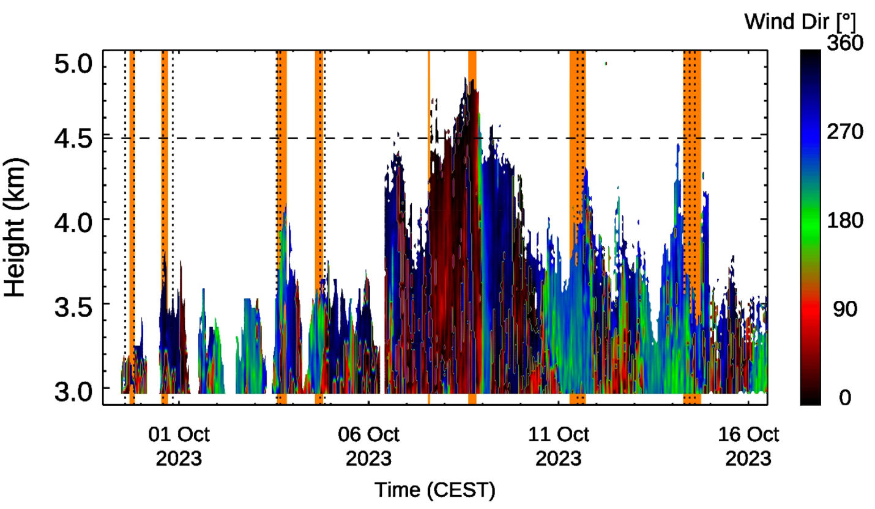
Figure 6: Time-height cross section of wind direction east of the Matterhorn from Doppler wind lidar at the Furggsee site. Episodes with banner cloud observations are highlighted in orange, radiosonde ascents as vertical dotted lines.

Two days of our campaign had well-defined banner cloud cases. One of these cases - 3 October 2023 - is highlighted in this article to describe the observed mean lee-side flow structure, as well as to illustrate selected turbulent characteristics of the flow.

Lee-side Mean Flow Structure
Our lidar scans were successful in resolving the key flow features associated with banner cloud formation as predicted by previous model studies. These are, firstly, the flow reversal in the lee of the mountain - a distinct motion towards the lee-side mountain face is resolved - and secondly, the rising motion in the vicinity of the lee-side mountain face. Both of these features are necessary consequences of boundary layer separation on the summit and ridgelines as illustrated in the regime diagram (Fig. 2).

The mean flow structure can be visualized by combining multiple individual lidar retrievals. This has been done for the scans between 1200 and 1800 UTC 3 October 2023, and the composite scans are shown in Figure 7. Details on the averaging procedure can be found in Thomas et al. (2025). The individual retrievals, and information on the data density of the averages, are shown in Figures S1-S51 and S52 of the supplementary information, respectively.
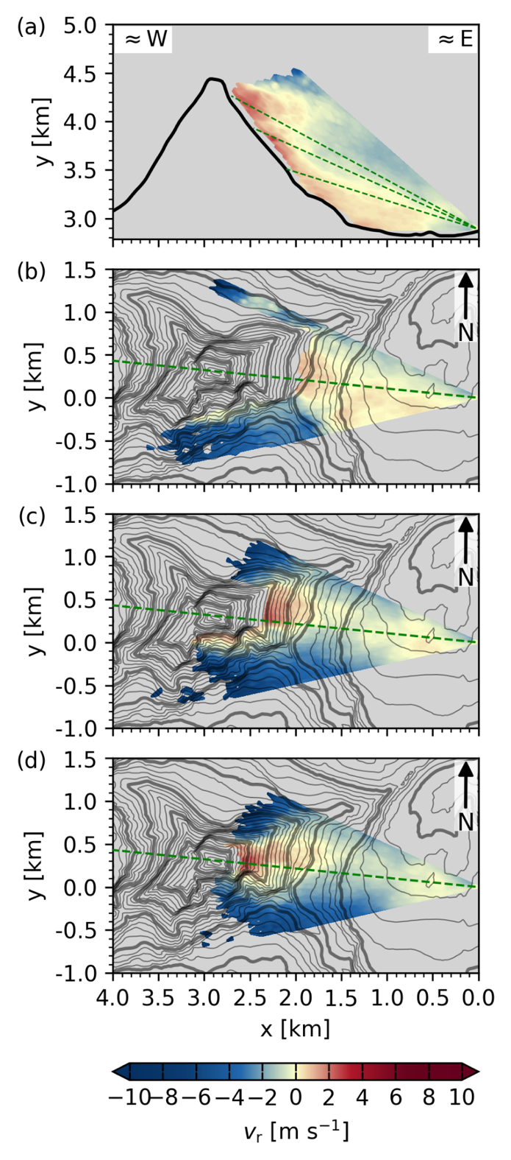
Figure 7: Mean lee-side radial velocities resolved by (a) the range-height indicator scan (RHI) through the summit pyramid, and plan-position indicator scans at (b) 16.5°, (c) 23°, and (d) 27° elevation for the scan cycle between 1200 and 1800 UTC, when data at each interpolated grid point is at least available for 25% of the scans. These composites indicate the flow pattern in the lee of the Matterhorn’s summit pyramid: Strong directional shear near the mountain edges, lee-side rising motion and flow toward the mountain’s lee slope. Coordinate x describes the line of sight distance from the lidar in (a), E-W distance in (b)-(d).
Due to the fact that the wind lidar is limited to resolving radial velocities, these retrievals can be difficult to interpret. For example, the radial velocities away from the lidar (towards the mountain’s lee-side) could be explained by either one of the following two extremes: due to either a strong upward motion, and no horizontal flow component, or by strong horizontal motion towards the mountain and no vertical flow component. As the radial velocities remain significant in the direct vicinity of the mountains’ east face, and radial velocities in the PPI scans change signs very quickly at mountain edges, however, we conclude that a combination of both flow towards, and flow upwards along the lee slopes is reflected in the radial retrievals.

The extent of the consistent flow towards and upwards along the lee slope of the summit pyramid allows the air parcels to ascend over larger vertical distances than at the windward side. This ultimately results in the greatest adiabatic cooling of lee-side air parcels, leading to saturation and the formation of the banner cloud. The continuous shear around the mountain edges confines the cloud to its banner-like shape. Additionally, entrainment of drier air at the cloud’s edges subsequently leads to the evaporation of cloud droplets and the thinning of the cloud banner downwind.

As seen from the visualizations of the individual scans (Fig. S1-S51), the spatial extent and shape of the zone of uplift varies greatly with time. The individual scans reveal the turbulent structures in the flow regime that in its mean allows the formation of a banner cloud.

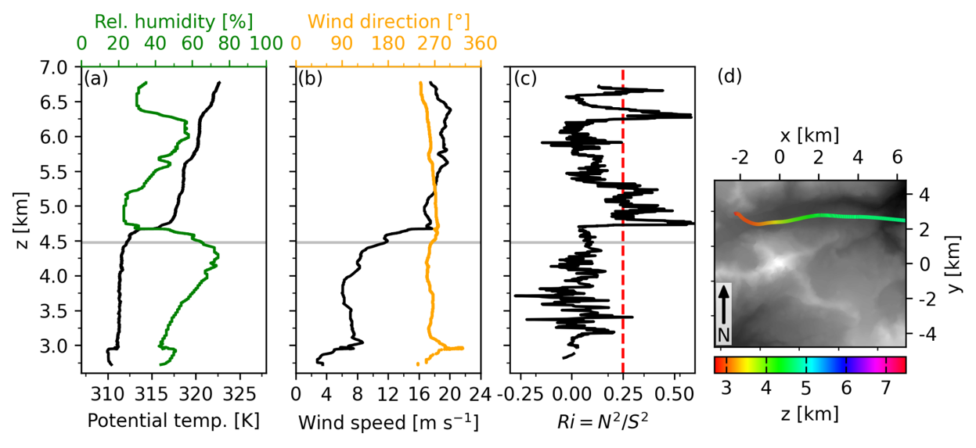
Figure 8: Upwind vertical profiles at 1358 UTC 3 October 2023 of (a) potential temperature and relative humidity, (b) wind speed and direction, and (c) gradient Richardson number. Subplot (d) shows the ascent path of the radiosonde. The gradient Richardson number is calculated using a centered rolling mean with a moving window size of 20 measurement points ($≈$100 m). Horizontal gray lines indicate the summit height of the Matterhorn.

The upwind atmospheric profile from the radiosonde launched at 1358 UTC 3 October 2023 shows a near neutral boundary layer capped by a strong increase in potential temperature and wind speed above the height of the Matterhorn summit (Fig. 8). As argued in Prestel and Wirth (2016) these are ideal conditions for banner cloud formation.

Lee-side Turbulent Features
While the key goal of the observations was to validate the mean circulation patterns in the lee of the mountain, we also aimed to capture key turbulent patterns related to the strong shear in the flow field.

On 3 October, one of our team members took the photo shown in Figure 9 during the hike back to Zermatt. It shows how parts of the banner cloud are sheared off, and how strong overturning leads to a cloud train with tops resembling Kelvin-Helmholtz waves. The atmospheric conditions on this day were conducive for Kelvin-Helmholtz Instability (KHI), as indicated by the statically-stable shear layer where the gradient Richardson number dropped below the critical threshold of Ri_{c}=0.25 (Fig. 8c). Furthermore, KHI likely intensified in the lee of the Matterhorn. At the time of these observations, the RHI scan (Fig. 9b) reveals a substantial area of upwelling reaching the summit, likely amplifying directional wind shear. This created favorable conditions for this unique banner cloud display, resembling Kelvin-Helmholtz Waves. The RHI scan also shows the characteristic ascending and descending portions of the wave at the cloud base.

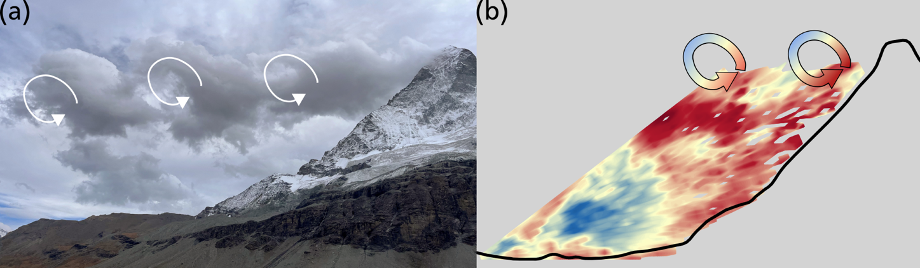
Figure 9: (a) Photograph of a banner cloud pattern resembling Kelvin-Helmholtz Wave patterns at 1506 UTC 3 October 2023 and (b) RHI scan through the Matterhorn summit at 1506 UTC 3 October 2023.

Strong overturning motion can also be detected directly above the Furggsee lidar site. Vertical velocities from stare scans, shown in Fig. 8c, highlight the strong vertical speed oscillations associated with the passing of overturning eddies. Vertical velocities on the order of >5 m/s are observed, indicating the vigorous mixing.
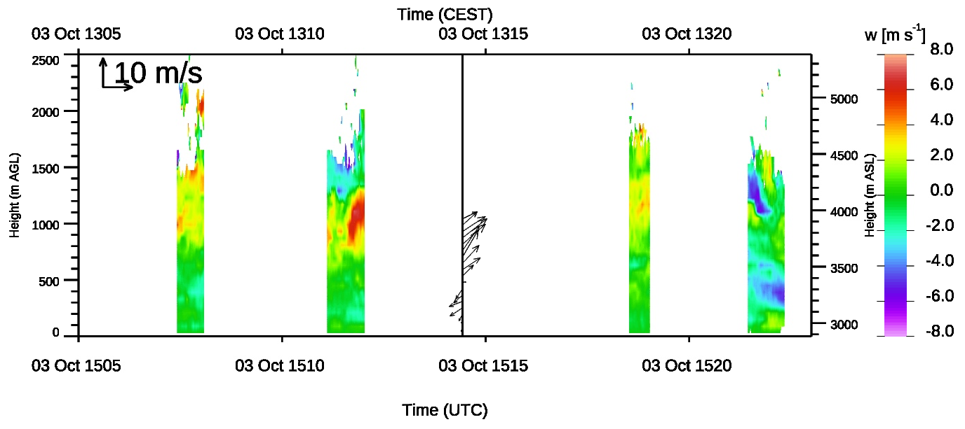
Figure 10: Vertical velocities from stares, and vertical profile of horizontal winds from VAD retrieval above the Furgsee lidar site between 1505 and 1525 UTC 3 October 2023.

As the lidar scans only resolve radial velocities, interpreting the full three-dimensional flow pattern can be challenging, especially as turbulent structures evolve within and between individual scans. Figure 11 illustrates this complexity: the RHI scan centered on the summit (Fig. 11a) reveals a strong cellular pattern, with generally enhanced flow directed toward and along the lee slope. The subsequent PPI scan (Fig. 11b) shows a pattern that could be interpreted as arising from two counterrotating, vertical-axis vortices, with the upper spinning counter-clockwise, the lower spinning clockwise. This configuration would trigger vertical mixing, enhancing lee-side lift to the south, but lee-side sinking motion more to the north of the N-S axis through the summit topography. A slight tilt of the plain separating these two horizontal-axis vortices, as illustrated in Figure 11d, can explain the vertical motion observed in the stare scan above the Furggsee lidar site (Fig. 11d) with descent in the lowest $≈$ 400 m and strong ascent above, as well as the horizontal motion in the VAD retrieval (Fig. 11d, showing NE flow in the lowest $≈$ 400 m, SW flow above). We want to stress here that this description represents only one interpretation of the turbulent pattern in the lee of the mountain, associated with conditions conducive to banner cloud formation. This highlights how valuable additional lidar observations (dual, or triple-Doppler approaches) would be to capture a more complete view of these complex flows. Similarly, visualizations of observation-validated Large-Eddy Simulations add to the understanding of the complex flow pattern (Thomas et al. 2025).

Our observations show that individual retrievals of the lee-side circulations, featuring large turbulent eddies, make it virtually impossible to detect the mean lee-side lift (Fig. 7) that allows banner clouds to form. This again stresses the importance of continuous and repetitive observations when studying complex turbulent flows in the environment, to successfully resolve the key flow structures on larger spatiotemporal scales through temporal averaging.

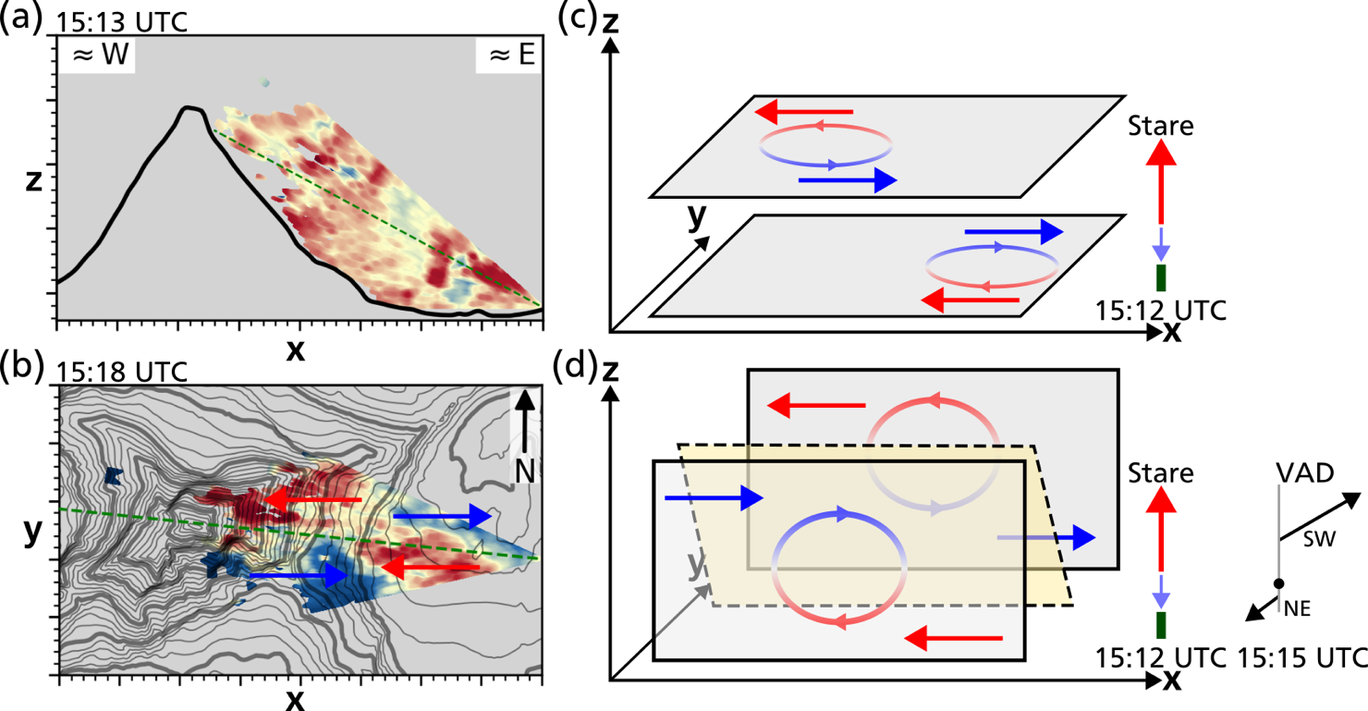
Figure 11: Exemplary turbulent flow realization shown in the (a) RHI scan through the Matterhorn summit at 1513 UTC 3 October 2023 and the (b) PPI scan at 27° elevation at 1518 UTC 3 October 2023. Panel (c) and (d) present a schematic interpretation of the lee-side turbulent flow, based on the available observational data

Discussion
The regime diagram (Fig. 2) illustrates why steep mountains like the Matterhorn (i.e. large $A$), are more likely to exhibit a banner cloud in their lee: Lee-side flow separation occurs under a much wider range of stratification for a given wind speed $U$ (i.e. allowing larger $N$). Going a step further, we can now explore whether certain wind directions favor banner cloud formation on a specific mountain. Figure 12a illustrates how the detailed topography of the Matterhorn controls the height and width scales ($h_{0 }$and $A_{d }$), and thus $A$ as a function of wind direction and distance from the summit. Similarly, the directional variation in lee-side topography dictates the threshold value of $N$ which may not be exceeded in order for the flow to remain within the “lee-side separation” regime (Fig. 12a). Note that $N$ and $A$ are proportional to each other for a given $U$.
Baines (1995) emphasizes varying regime boundaries depending on the exact obstacle shape. In order to account for these, we calculate a directionally-smoothed mean $N$ for a 2-km radius around the Matterhorn summit. Analyzing this mean $N$, we conclude that banner clouds can form under a wider range of $N$ conditions for northerly or southerly flows (Fig. 12b). For westerly and easterly flows, on the other hand, the range of sufficient $N$ conditions is slightly narrower, suggesting that banner cloud formation is more sensitive to the balance between the wind speed $U$ and the Brunt-Väisälä frequency $N$ for these wind directions.

We can now use all of the upwind observations to evaluate whether the flow conditions fall into the lee-side separation regime, and thus, if conditions are conducive for banner cloud formation. Figure 12b shows that only two of our upwind profiles result in $N$ values exceeding the threshold level, suggesting that banner clouds cannot develop. All other profiles fall into the banner cloud-permitting lee-side separation regime, including four cases during which no banner clouds were visually observed. On these four days, upwind relative humidity levels tended to be lower (not exceeding 40% relative humidity in the 750 m below the summit) than on days when banner clouds were observed (Fig. S53-S65). On 11 October, the banner cloud was very faint, and humidity levels peaked at just 45%. These observations indicate that the circulation pattern responsible for banner cloud formation likely occurs more frequently than their formation might suggest.

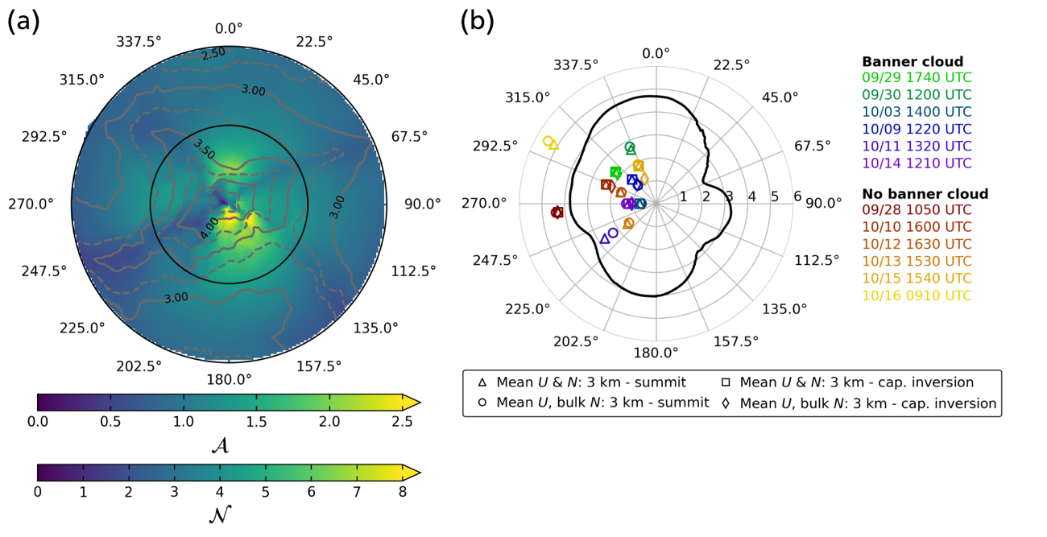
Figure 12: Directional dependencies of (a) mountain aspect ratio 𝒜 and the upper threshold value of 𝒩 for lee-side flow separation allowing banner cloud formation, within a 2-km radius around the summit, and (b) the threshold value of $N$ for upwind conditions, averaged over a 2-km distance and smoothed with a 5°-wide moving average. Symbols indicate values of $N$ based on radiosondes from our observational periods with and without visual banner cloud formation. Symbol shapes denote varying estimates of $N$, using a mean $U$ and either a mean $N$ or bulk $N$, and determining these for either a layer between 3000 m and the Matterhorn summit (4478 m), or between 3000 m and the upper edge of an identifiable capping inversion above the mountain top.

Summary and Conclusions
We summarized the design and execution of a high-risk, high-reward field experiment addressing the frequent formation of banner clouds on the iconic Matterhorn of the Swiss Alps.

Commercially available Doppler wind lidar systems have become available in the last decades to observe the complex circulation patterns in extremely complex terrain, even at elevations with reduced aerosol loading.

Under favorable upwind conditions conducive for banner cloud formation, our observations confirm previous model results by resolving mean radial velocity patterns matching a strong flow reversal and extensive upward motion in the lee of the Matterhorn.

Our observed banner cloud cases can be categorized using the regime diagram by Baines (1995). As shown in Fig. 12b, all banner cloud cases fit well within the regime of lee-side flow separation. We further show why the Matterhorn (and other steep pyramidal peaks) are more likely to exhibit these unique clouds, and what wind directions for the Matterhorn are more likely to trigger these clouds under given upwind conditions. Due to their aspect ratio, these peaks (or the peak shape interaction with the flow) can exhibit lee-side flow separation under more stable conditions compared to mountains with a lower aspect ratio.

Our observations further suggest that the flow regime conducive for the generation of banner clouds occurs more frequently than observations of banner clouds may suggest. This is due to the fact that moisture levels can be insufficient for condensation to occur despite the large lee-side vertical displacement. These findings emphasize the prevalence of extensive lee-side rising motion even in the absence of banner clouds.

The mean lift in the lee is the residual of strong turbulent eddies and overturning, involving fast changes of vertical velocity exceeding 5 m/s over short distances. This emphasizes the danger to lee-side air travel, even when clouds may not be visible.

The data collected is uniquely suited to validate Large-Eddy Simulations in steep complex terrain. Such comparisons are presented in our follow-up paper by Thomas et al. (2025).

We hope to have demonstrated that we could make, with rather simple means, meaningful observations in highly complex terrain that were inconceivable just a few years ago. Given the continuous advances and miniaturization of observational platforms, this bodes well for a bright future in observational mountain meteorology.

Acknowledgements
MatterHEX was funded by grant 432130757 of the Deutsche Forschungsgemeinschaft (DFG, German Research Foundation). We thank Bernhard Arnold and Romy Biner-Hauser (Gemeinde Zermatt), Air Zermatt, Fredy and Yolanda Biner-Perren (Schönbielhütte SAC), and Reinhard Lauber (Zermatt Bergbahnen AG) for logistical support. We could not have realized these observations without their support.

Availability Statement

All data is available upon request.

References
Alcayaga, L., 2020: Filtering of pulsed lidar data using spatial information and a clustering
algorithm. Atmospheric Measurement Techniques, 13 (11), 6237–6254, https://doi.org/10.5194/50amt-13-6237-2020.
Baines, P., 1995: Topographic Effects in Stratified Flows. Cambridge University Press.

Connolly, A., F. K. Chow, and S. W. Hoch, 2021: Nested large-eddy simulations of the displacement of a cold-air pool by lee vortices. Boundary-Layer Meteorology, 178 (1), 91–118, https://doi.org/10.1007/s10546-020-00561-6.

Durran, D., 2003: Lee waves and mountain waves. Encyclopedia of Atmospheric Sciences, J. R. Holton, Ed., Academic Press, Oxford, 1161–1169, https://doi.org/https://doi.org/10.1016/B0-12-227090-8/00202-5.

Duscha, C., J. P´alenik, T. Spengler, and J. Reuder, 2023: Observing atmospheric convection with dual-scanning lidars. Atmospheric Measurement Techniques, 16 (21), 5103–5123, https://doi.org/10.5194/amt-16-5103-2023.

Ester, M., H.-P. Kriegel, J. Sander, and X. Xu, 1996: A density-based algorithm for discovering clusters in large spatial databases with noise. Proceedings of the Second International Conference on Knowledge Discovery and Data Mining, AAAI Press, 226–231, KDD’96.

Fritts, D. C., and Coauthors, 2016: The Deep Propagating Gravity Wave Experiment (DEEPWAVE): An Airborne and Ground-Based Exploration of Gravity Wave Propagation and Effects from Their Sources throughout the Lower and Middle Atmosphere. Bull. Amer. Meteor. Soc., 97, 425–453, https://doi.org/10.1175/BAMS-D-14-00269.1.

Gerber, F., M. Lehning, S. W. Hoch, and R. Mott, 2017: A close-ridge small-scale atmospheric flow field and its influence on snow accumulation. Journal of Geophysical Research: Atmospheres, 122 (15), 7737–7754, https://doi.org/https://doi.org/10.1002/2016JD026258.

Glickman, T. S., Ed., 2000: Glossary of Meteorology. 2nd ed., American Meteorological Society, 855 pp., Boston, Massachusetts, U.S.A.

Hunt, J. C. R., and W. H. Snyder, 1980: Experiments on stably and neutrally stratified flow over a model three-dimensional hill. Journal of Fluid Mechanics, 96, 671 – 704.

Kristianti, F., J. Dujardin, F. Gerber, H. Huwald, S. W. Hoch, and M. Lehning, 2023: Combining weather station data and short-term lidar deployment to estimate wind energy potential with machine learning: A case study from the swiss alps. Boundary-Layer Meteorology, 188 (1), 185–208, https://doi.org/10.1007/s10546-023-00808-y.

Lareau, N. P., and C. B. Clements, 2017: The Mean and Turbulent Properties of a Wildfire Convective Plume. J. Appl. Meteor. Climatol., 56, 2289–2299, https://doi.org/10.1175/JAMC-D-16-0384.1.

Lundquist, K. A., F. K. Chow, and J. K. Lundquist, 2012: An immersed boundary method enabling large-eddy simulations of flow over complex terrain in the wrf model. Monthly Weather Review, 140 (12), 3936 – 3955, https://doi.org/10.1175/MWR-D-11-00311.1.

Prestel, I., and V. Wirth, 2016: What flow conditions are conducive to banner cloud formation? Journal of the Atmospheric Sciences, 73 (6), 2385 – 2402, https://doi.org/10.1175/JAS-D-15-0319.1.

Reinert, D., and V. Wirth, 2009: A new large-eddy simulation model for simulating air flow and warm clouds above highly complex terrain. part ii: The moist model and its application to banner clouds. Boundary-Layer Meteorology, 133 (1), 113–136, https://doi.org/10.1007/s10546-009-9419-x.

Roe, G. H., 2005: Orographic precipitation. Annual Review of Earth and Planetary Sciences, 33, 645–671, https://doi.org/10.1146/annurev.earth.33.092203.122541.

van Schaik et al. 2024

Schappert, S., and V. Wirth, 2015: Origin and flow history of air parcels in orographic banner clouds. Journal of the Atmospheric Sciences, 72 (9), 3389 – 3403, https://doi.org/10.1175/JAS-D-14-0300.1.

Schween, J. H., J. Kuettner, D. Reinert, J. Reuder, and V. Wirth, 2007: Definition of ”banner clouds” based on time lapse movies. Atmospheric Chemistry and Physics, 7 (8), 2047–2055, https://doi.org/10.5194/acp-7-2047-2007.

Smith, R. B., 1979: The influence of mountains on the atmosphere. Advances in Geophysics, Vol. 21, Elsevier, 87–230, https://doi.org/10.1016/S0065-2687(08)60262-9.

Thomas, M. L., and V. Wirth, 2023: Sensitivity of banner cloud formation to orography and the ambient atmosphere: Transition from idealized to more realistic scenarios. Journal of the Atmospheric Sciences, 80 (11), 2653 – 2668, https://doi.org/10.1175/JAS-D-23-0106.1.

Voigt, M., and V. Wirth, 2013: Mechanisms of banner cloud formation. Journal of the Atmospheric Sciences, 70 (11), 3631 – 3640, https://doi.org/10.1175/JAS-D-12-0353.1.

Whiteman, C. D., 2000: Mountain Meteorology: Fundamentals and Applications. Oxford University Press, https://doi.org/10.1093/oso/9780195132717.001.0001.

Whiteman, C. D., M. Lehner, S. W. Hoch, B. Adler, N. Kalthoff, and T. Haiden, 2018: Katabatically Driven Cold Air Intrusions into a Basin Atmosphere. J. Appl. Meteor. Climatol., 57, 435–455, https://doi.org/10.1175/JAMC-D-17-0131.1.

Wirth, V., P. Bubel, J. Eichhorn, E. Schömer, T. Kremer, R. Erbes, S. Schappert, and I. Prestel, 2020: The role of wind speed and wind shear for banner cloud formation. Journal of the Atmospheric Sciences, 77 (4), 1199 – 1212, https://doi.org/10.1175/JAS-D-18-0354.1.

Wirth, V., M. Kristen, M. Leschner, J. Reuder, and J. H. Schween, 2012: Banner clouds observed at mount zugspitze. Atmospheric Chemistry and Physics, 12 (8), 3611–3625, https://doi.org/ 10.5194/acp-12-3611-2012.

