Online Supplement for: The MatterHEX Experiment – Investigating Atmospheric Flow Patterns in Highly Complex Terrain Related to Banner Cloud Formation
Sebastian W. Hoch,^{a,b} Marius L. Thomas,^{c} Hendrik Huwald,^{d,e} Michael Lehning,^{d,e} Brandon J. A. van Schaik,^{d} Paul Imbert,^{d} Dominique S. Rentel,^{c} and Volkmar Wirth,^{c}

ª Earth Observing Laboratory, National Center for Atmospheric Research, Boulder, CO
^{b} Atmospheric Sciences Department, University of Utah, Salt Lake City, UT
^{c} Institute for Atmospheric Physics, Johannes Gutenberg University Mainz, Mainz, Germany
^{d} Laboratory of Cryospheric Sciences, Ecole Polytechnique Fédérale de Lausanne (EPFL), Sion, Switzerland
^{e} WSL Institute for Snow and Avalanche Research, SLF Davos, Switzerland

Corresponding author: Sebastian Hoch, hoch@ucar.edu

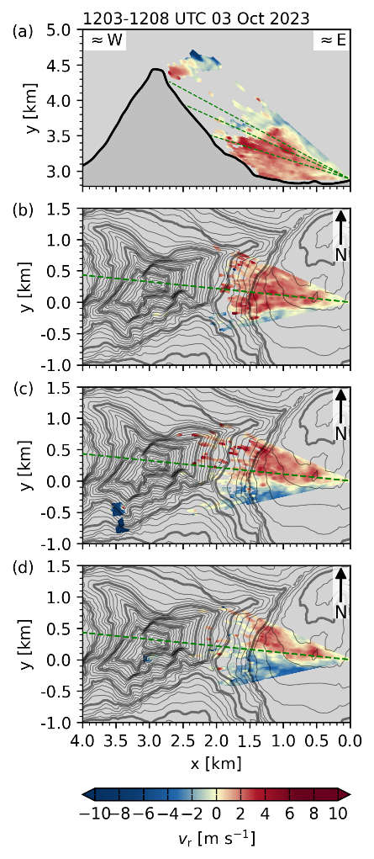  Fig. S1: Lee-side radial velocities resolved by (a) the range-height indicator scan (RHI) through the summit pyramid, and plan-position indicator scans (PPI) at (b) 16.5°, (c) 23°, and (d) 27° elevation for the scan cycle between 1203 and 1207 UTC, 3 October 2023. | 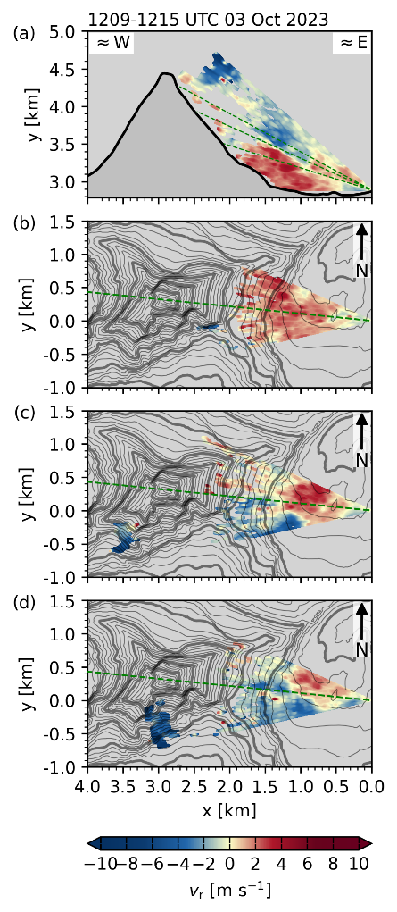  Fig. S2: As Fig. S1, but for scan cycle between 1209 and 1215 UTC, 3 October 2023. | 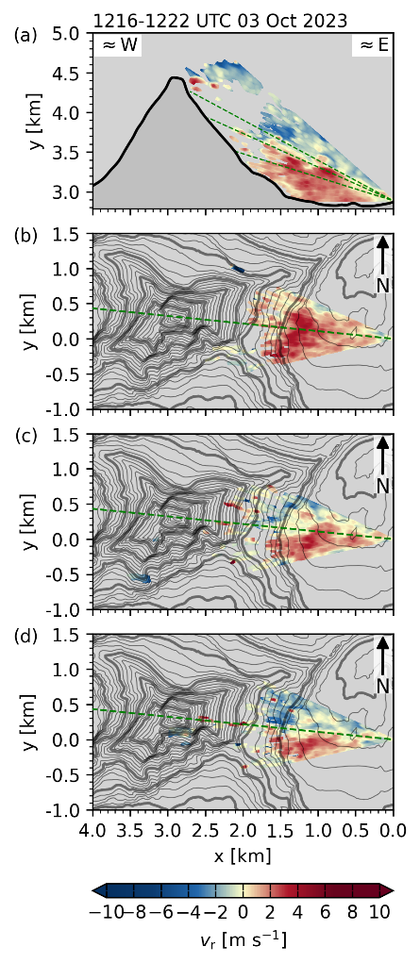  Fig. S3: As Fig. S1, but for scan cycle between 1216 and 1222 UTC, 3 October 2023.
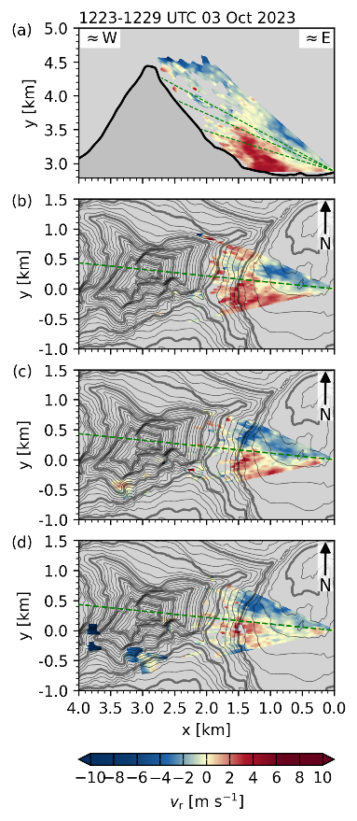  Fig. S4: As Fig. S1, but for scan cycle between 1223 and 1229 UTC, 3 October 2023. | 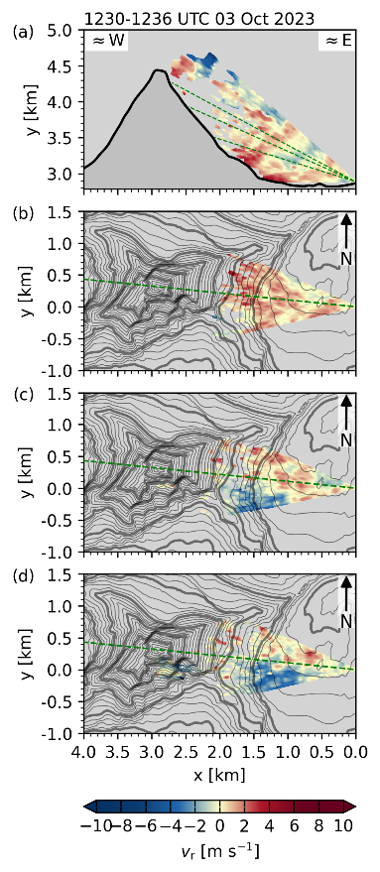  Fig. S5: As Fig. S1, but for scan cycle between 1230 and 1236 UTC, 3 October 2023. | 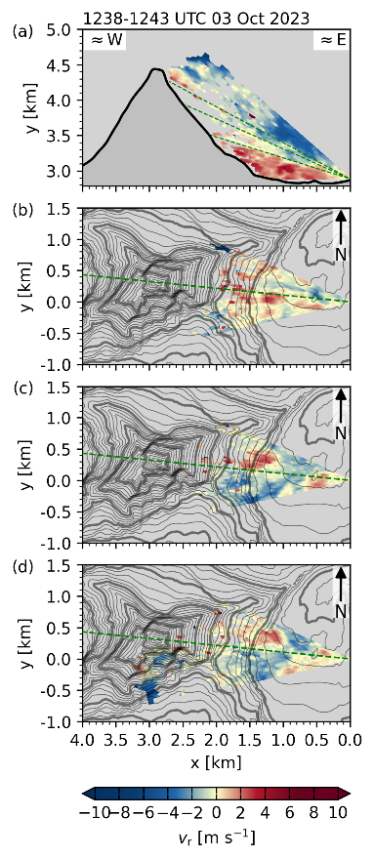  Fig. S6: As Fig. S1, but for scan cycle between 1238 and 1243 UTC, 3 October 2023.
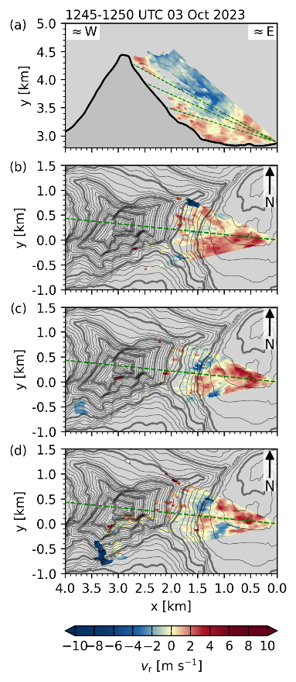  Fig. S7: As Fig. S1, but for scan cycle between 1245 and 1250 UTC, 3 October 2023. | 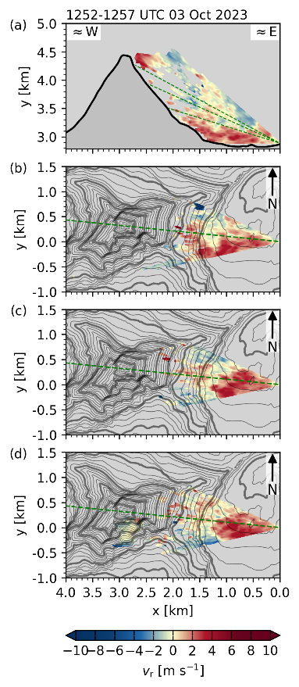  Fig. S8: As Fig. S1, but for scan cycle between 1252 and 1257 UTC, 3 October 2023. | 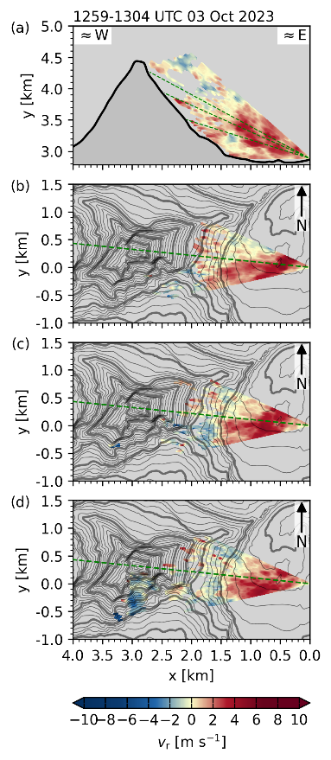  Fig. S9: As Fig. S1, but for scan cycle between 1259 and 1304 UTC, 3 October 2023.
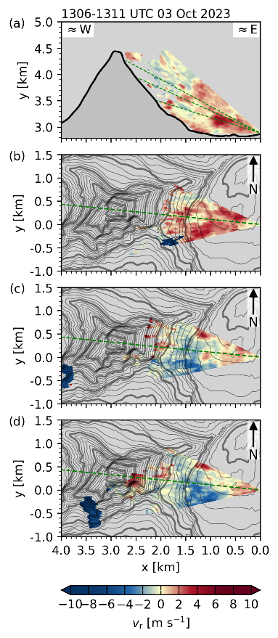  Fig. S10: As Fig. S1, but for scan cycle between 1306 and 1311 UTC, 3 October 2023. | 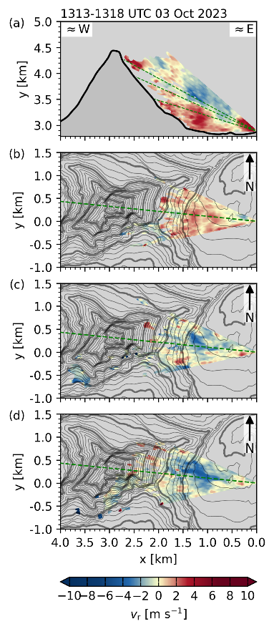  Fig. S11: As Fig. S1, but for scan cycle between 1313 and 1318 UTC, 3 October 2023. | 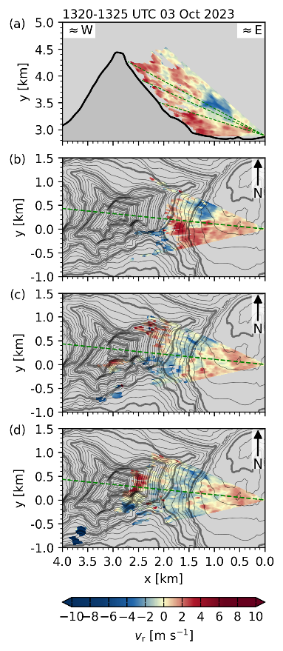  Fig. S12: As Fig. S1, but for scan cycle between 1320 and 1325 UTC, 3 October 2023.
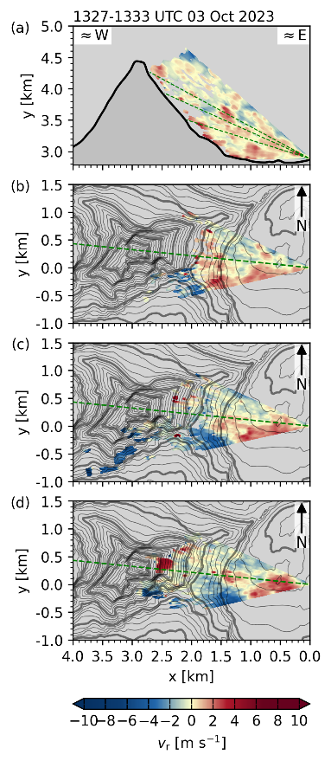  Fig. S13: As Fig. S1, but for scan cycle between 1327 and 1333 UTC, 3 October 2023. | 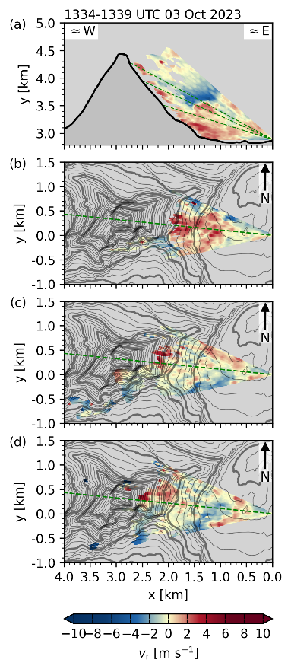  Fig. S14: As Fig. S1, but for scan cycle between 1334 and 1339 UTC, 3 October 2023. | 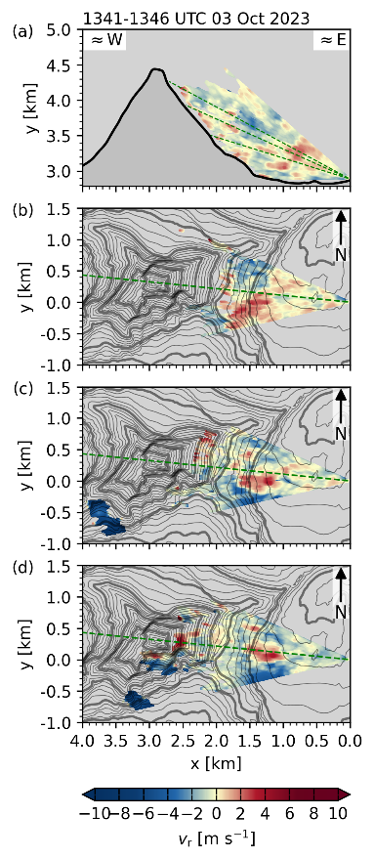  Fig. S15: As Fig. S1, but for scan cycle between 1341 and 1346 UTC, 3 October 2023.
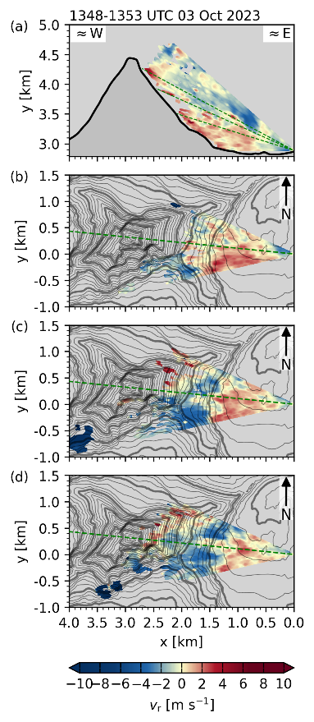  Fig. S16: As Fig. S1, but for scan cycle between 1348 and 1353 UTC, 3 October 2023. | 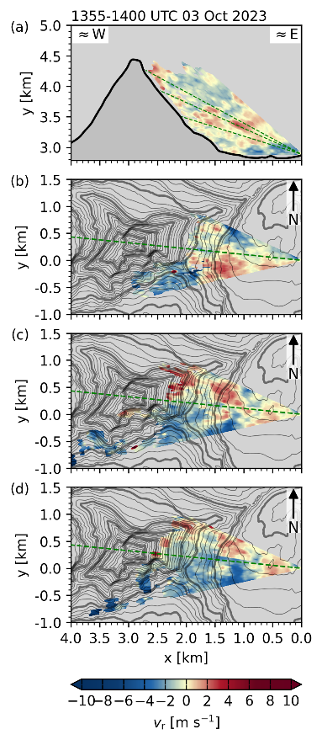  Fig. S17: As Fig. S1, but for scan cycle between 1355 and 1400 UTC, 3 October 2023. | 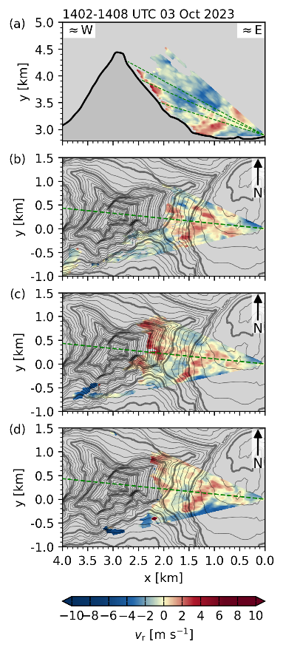  Fig. S18: As Fig. S1, but for scan cycle between 1402 and 1408 UTC, 3 October 2023.
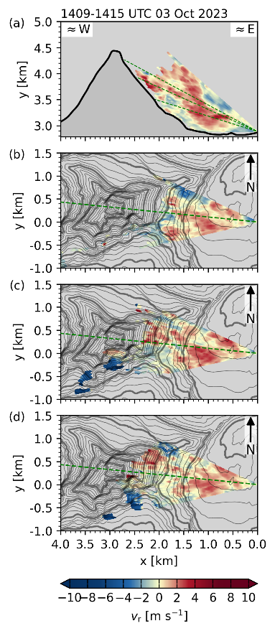  Fig. S19: As Fig. S1, but for scan cycle between 1409 and 1415 UTC, 3 October 2023. | 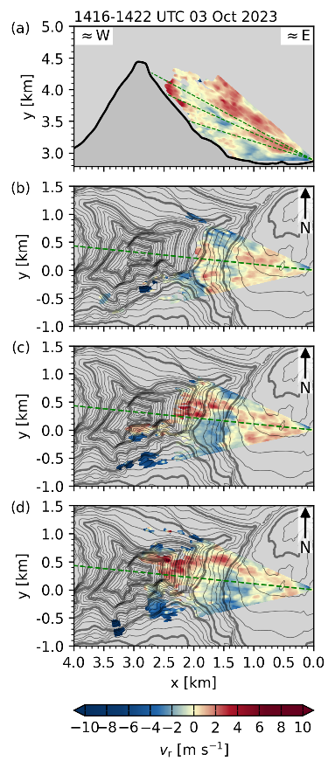  Fig. S20: As Fig. S1, but for scan cycle between 1416 and 1422 UTC, 3 October 2023. | 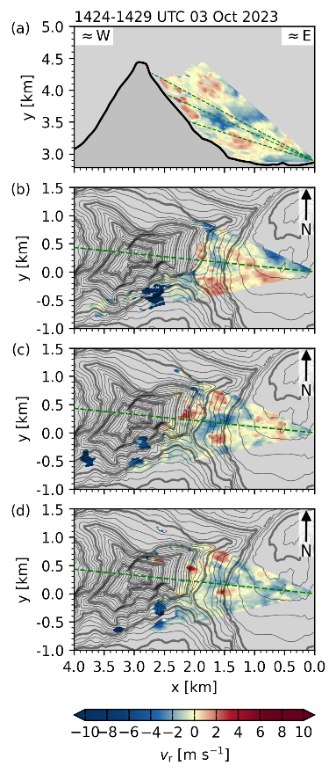  Fig. S21: As Fig. S1, but for scan cycle between 1424 and 1429 UTC, 3 October 2023.
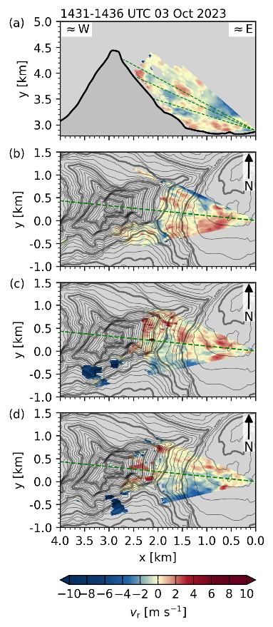  Fig. S22: As Fig. S1, but for scan cycle between 1431 and 1436 UTC, 3 October 2023. | 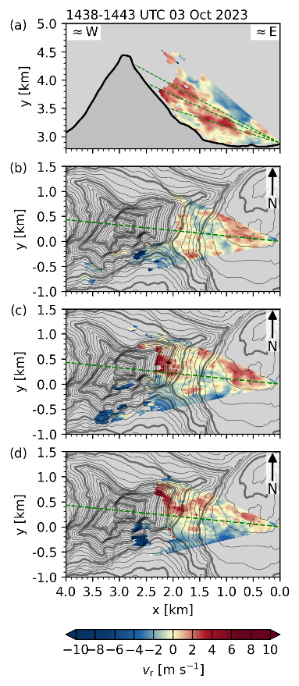  Fig. S23: As Fig. S1, but for scan cycle between 1438 and 1443 UTC, 3 October 2023. | 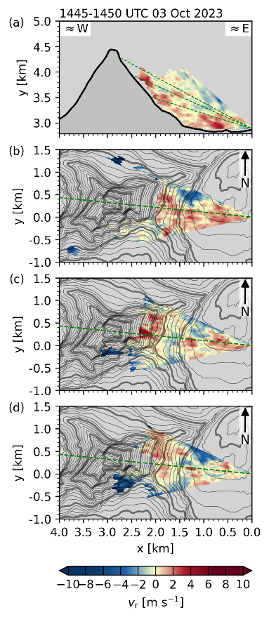  Fig. S24: As Fig. S1, but for scan cycle between 1445 and 1450 UTC, 3 October 2023.
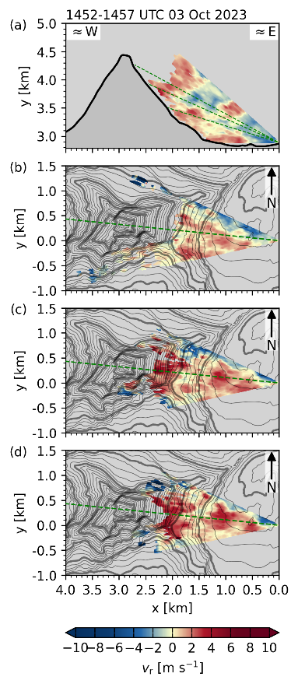  Fig. S25: As Fig. S1, but for scan cycle between 1452 and 1457 UTC, 3 October 2023. | 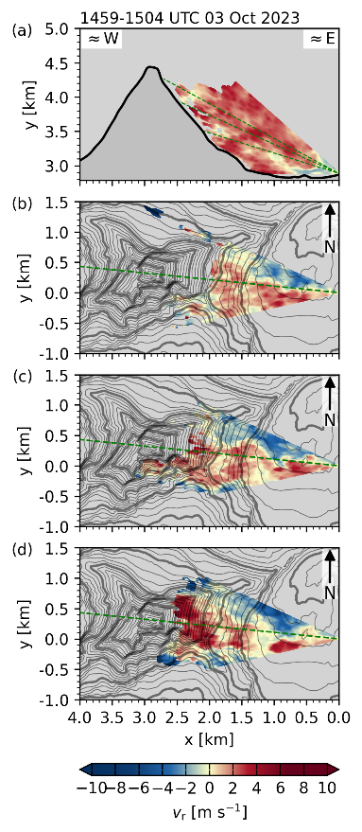  Fig. S26: As Fig. S1, but for scan cycle between 1459 and 1504 UTC, 3 October 2023. | 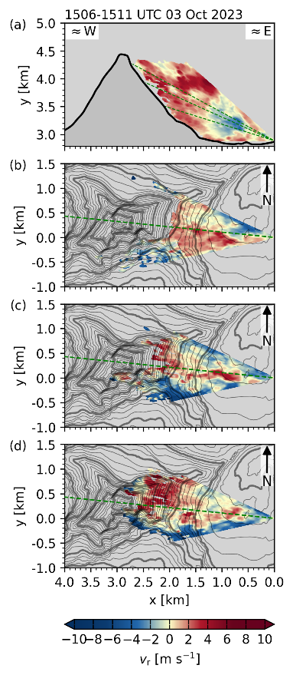  Fig. S27: As Fig. S1, but for scan cycle between 1506 and 1511 UTC, 3 October 2023.
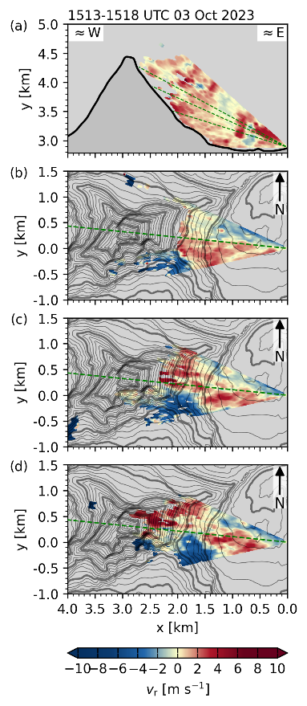  Fig. S28: As Fig. S1, but for scan cycle between 1513 and 1518 UTC, 3 October 2023. | 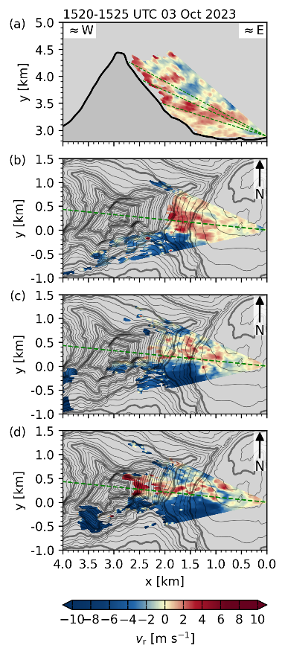  Fig. S29: As Fig. S1, but for scan cycle between 1520 and 1525 UTC, 3 October 2023. | 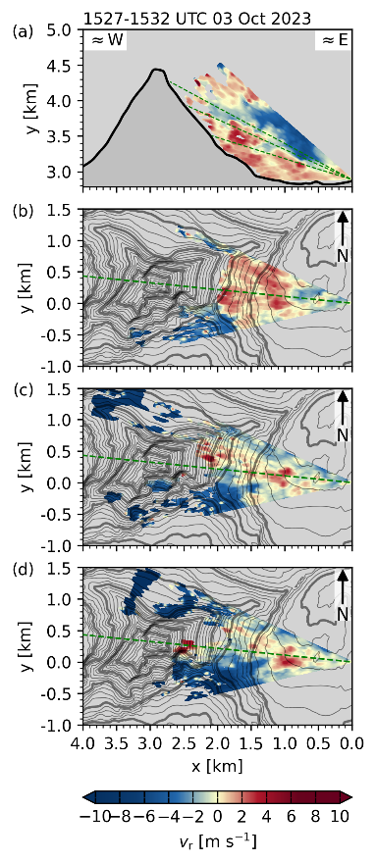  Fig. S30: As Fig. S1, but for scan cycle between 1527 and 1532 UTC, 3 October 2023.
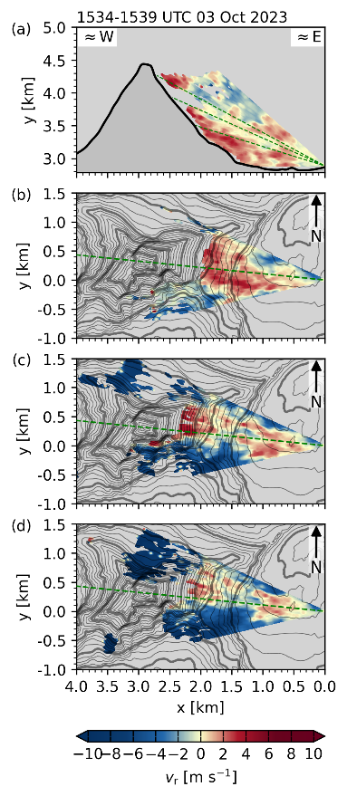  Fig. S31: As Fig. S1, but for scan cycle between 1534 and 1539 UTC, 3 October 2023. | 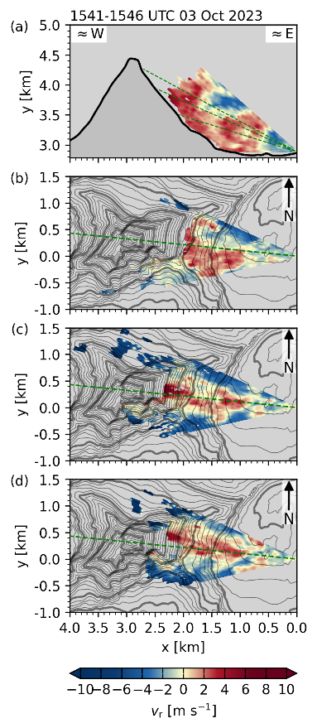  Fig. S32: As Fig. S1, but for scan cycle between 1541 and 1546 UTC, 3 October 2023. | 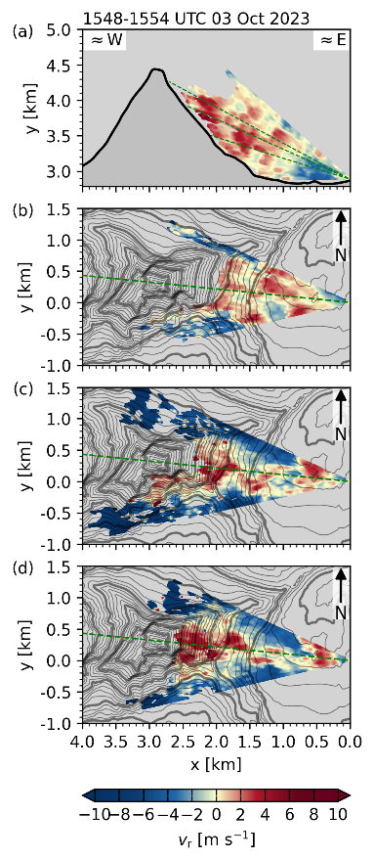  Fig. S33: As Fig. S1, but for scan cycle between 1548 and 1554 UTC, 3 October 2023.
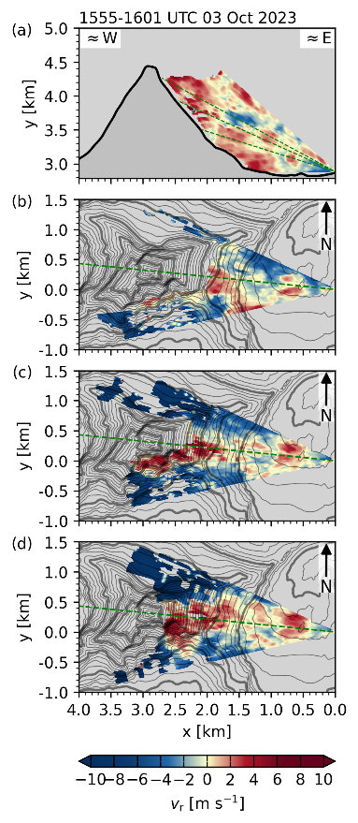  Fig. S34: As Fig. S1, but for scan cycle between 1555 and 1601 UTC, 3 October 2023. | 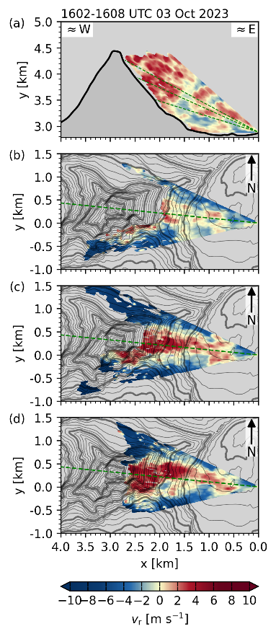  Fig. S35: As Fig. S1, but for scan cycle between 1602 and 1608 UTC, 3 October 2023. | 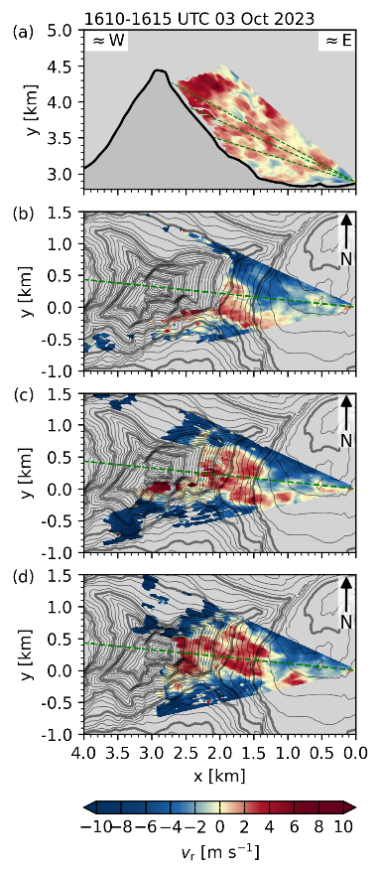  Fig. S36: As Fig. S1, but for scan cycle between 1610 and 1615 UTC, 3 October 2023.
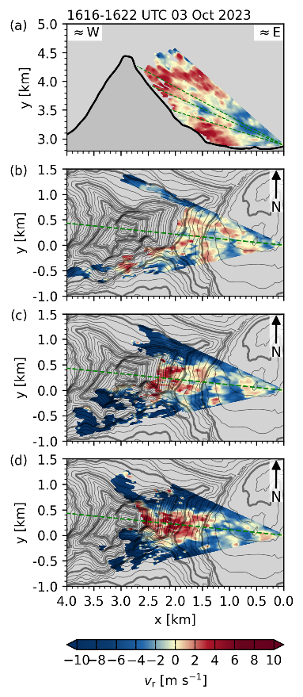  Fig. S37: As Fig. S1, but for scan cycle between 1616 and 1622 UTC, 3 October 2023. | 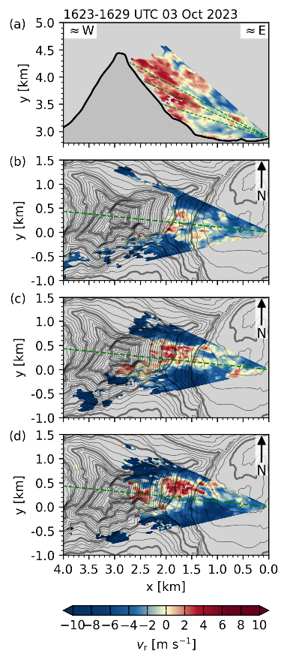  Fig. S38: As Fig. S1, but for scan cycle between 1623 and 1629 UTC, 3 October 2023. | 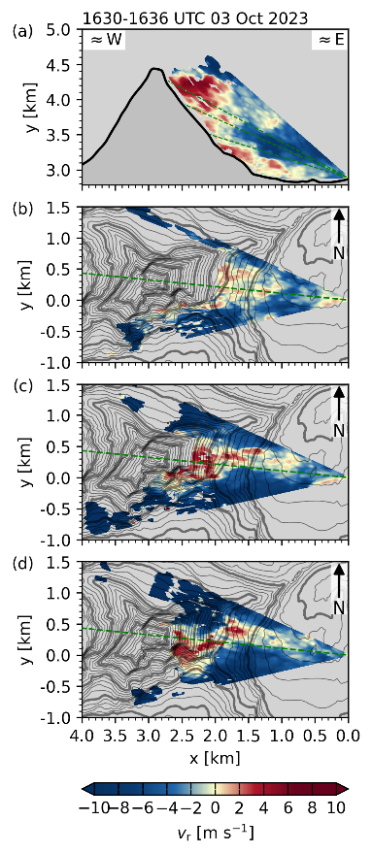  Fig. S39: As Fig. S1, but for scan cycle between 1630 and 1636 UTC, 3 October 2023.
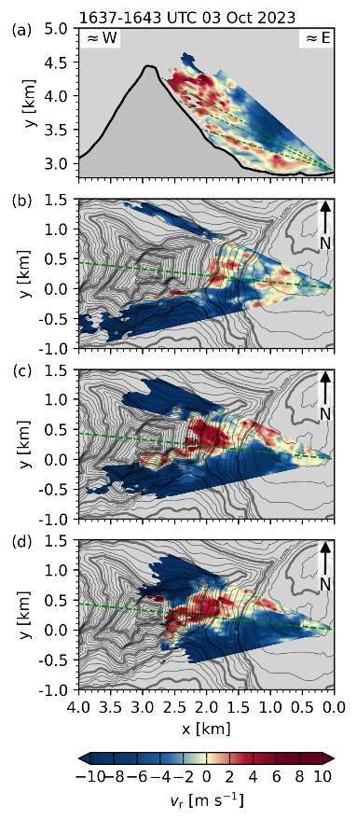  Fig. S40: As Fig. S1, but for scan cycle between 1637 and 1643 UTC, 3 October 2023. | 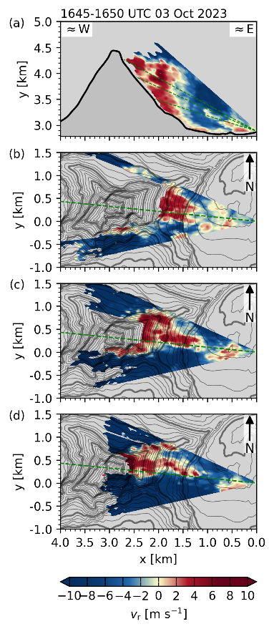  Fig. S41: As Fig. S1, but for scan cycle between 1645 and 1650 UTC, 3 October 2023. | 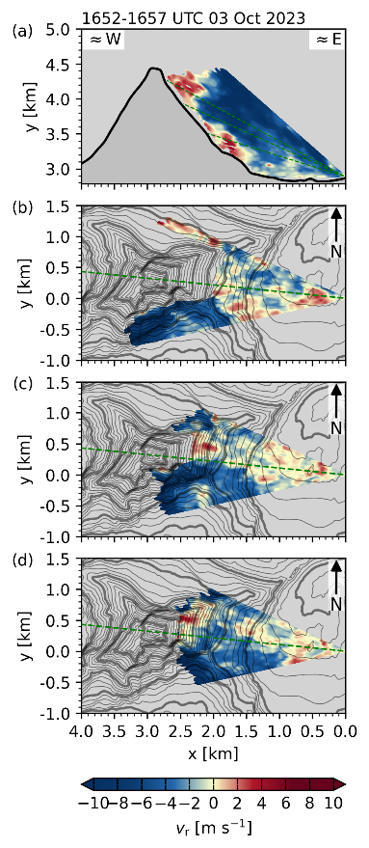  Fig. S42: As Fig. S1, but for scan cycle between 1652 and 1657 UTC, 3 October 2023.
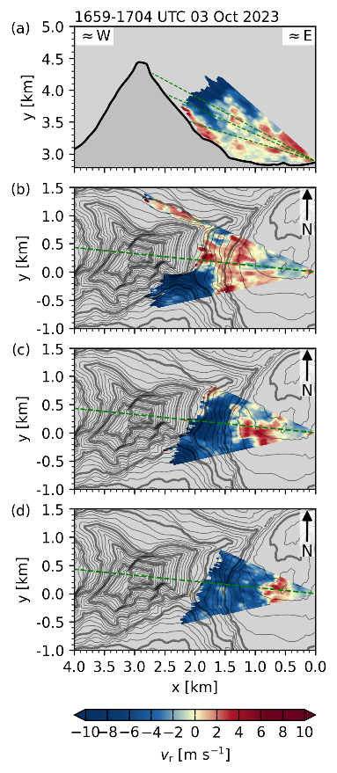  Fig. S43: As Fig. S1, but for scan cycle between 1659 and 1704 UTC, 3 October 2023. | 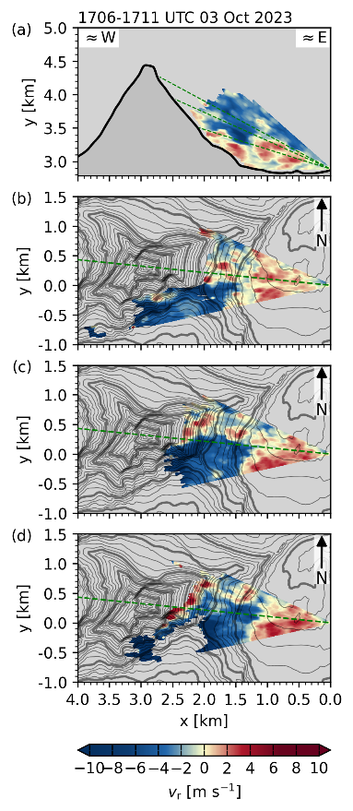  Fig. S44: As Fig. S1, but for scan cycle between 1706 and 1711 UTC, 3 October 2023. | 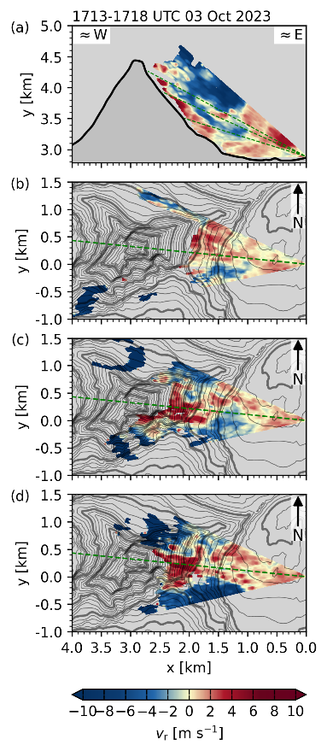  Fig. S45: As Fig. S1, but for scan cycle between 1713 and 1718 UTC, 3 October 2023.
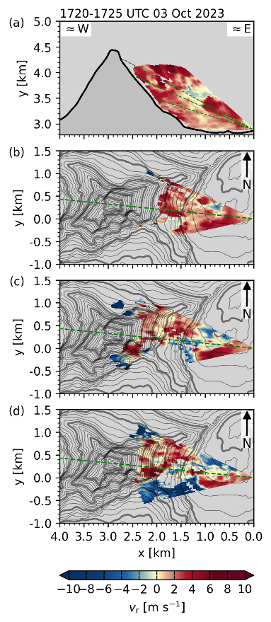  Fig. S46: As Fig. S1, but for scan cycle between 1720 and 1725 UTC, 3 October 2023. | 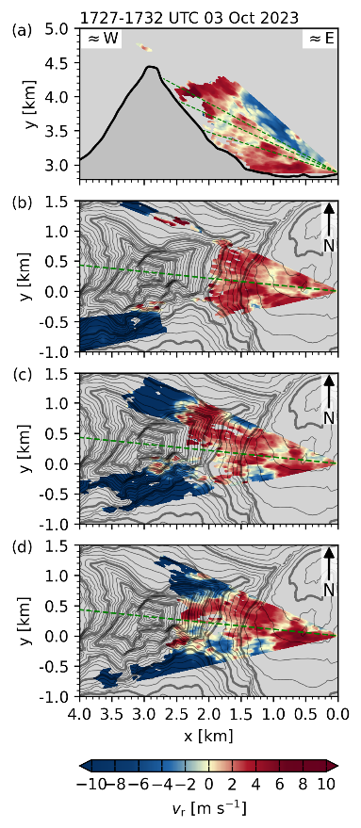  Fig. S47: As Fig. S1, but for scan cycle between 1727 and 1732 UTC, 3 October 2023. | 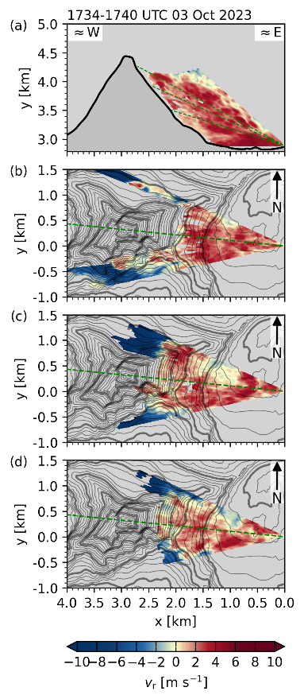  Fig. S48: As Fig. S1, but for scan cycle between 1734 and 1740 UTC, 3 October 2023.
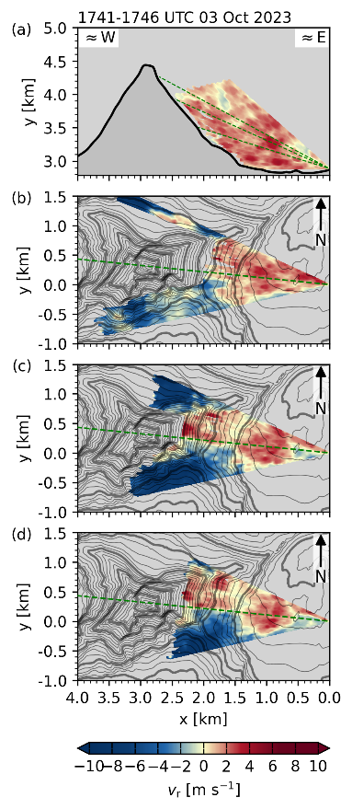  Fig. S49: As Fig. S1, but for scan cycle between 1741 and 1746 UTC, 3 October 2023. | 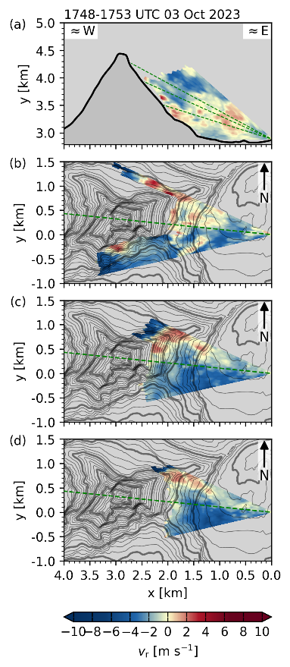  Fig. S50: As Fig. S1, but for scan cycle between 1748 and 1753 UTC, 3 October 2023. | 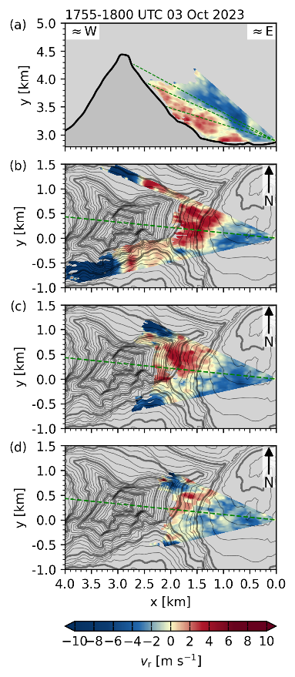  Fig. S51: As Fig. S1, but for scan cycle between 1755 and 1800 UTC, 3 October 2023.

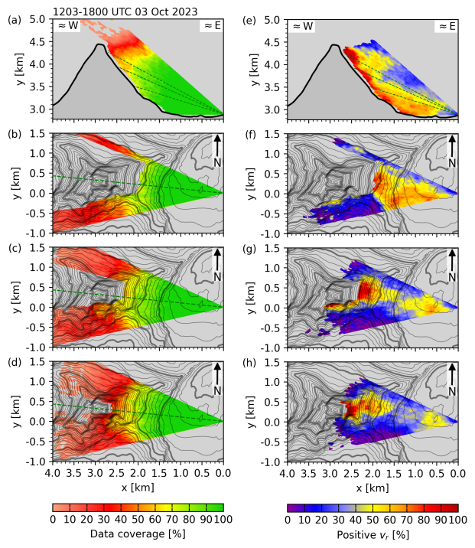
Fig. S52: Percentage in data coverage available for composing the average radial velocities shown in Fig 7, for (a) the range-height indicator scan (RHI) through the summit pyramid, and plan-position indicator scans (PPI) at (b) 16.5°, (c) 23°, and (d) 27° elevation for all cycles between 1200 and 1800 UTC, 3 October 2023.

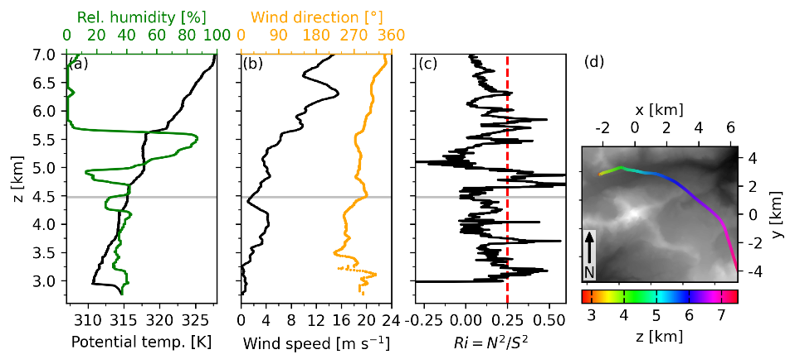
Fig. S53: Upwind vertical profiles at 1050 UTC 28 September 2023 of (a) potential temperature and relative humidity, (b) wind speed and direction, and (c) gradient Richardson number, calculated using a 20-point rolling mean ($≈$100 m). Horizontal gray lines indicate the summit height of the Matterhorn, and the red dashed line in (c) depicts the critical Richardson number Ri_{c} of 0.25. Panel (d) shows the ascent path of the radiosonde, with coordinates centered at the Matterhorn summit and grey shading indicating topography.

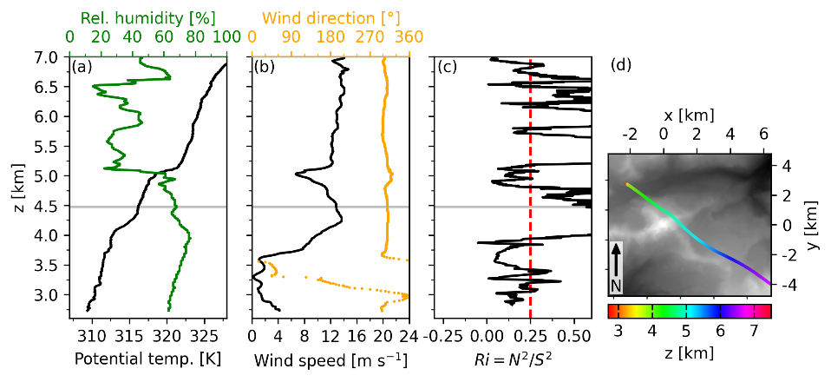
Fig. S54: As Fig. S53, but for radiosonde data from 1740 UTC 29 September 2023.

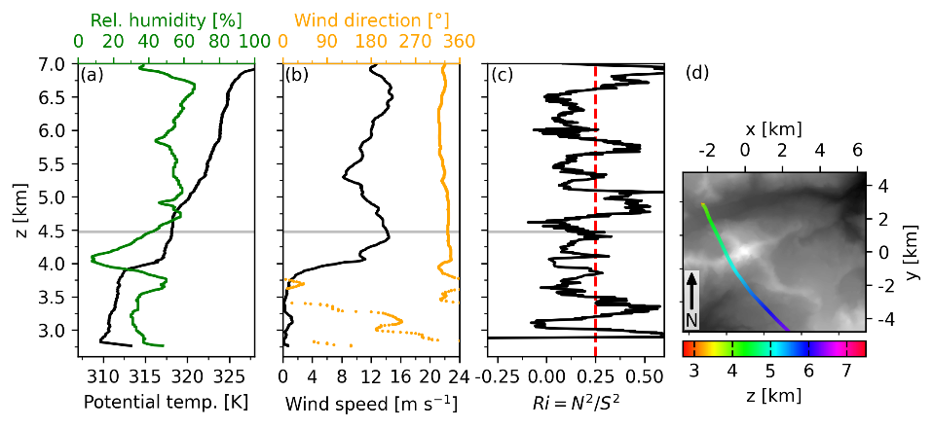
Fig. S55: As Fig. S53, but for radiosonde data from 1200 UTC 30 September 2023.

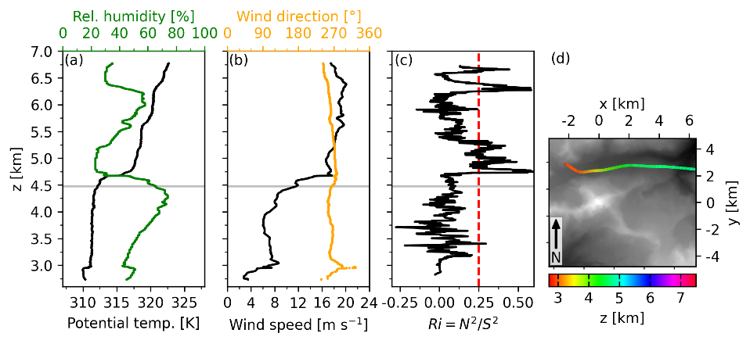
Fig. S56: As Fig. S53, but for radiosonde data from 1400 UTC 3 October 2023.

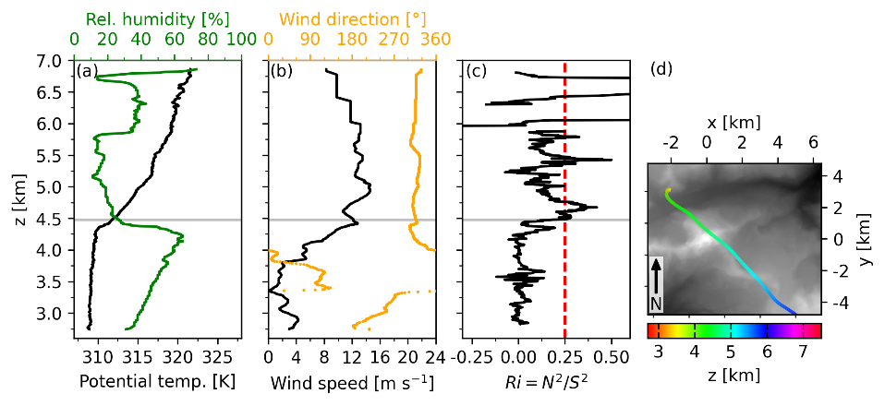
Fig. S57: As Fig. S53, but for radiosonde data from 1220 UTC 9 October 2023.

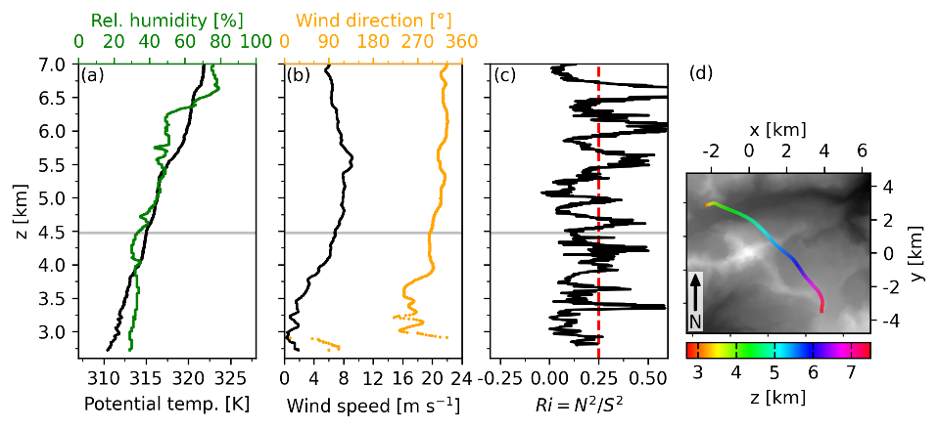
Fig. S58: As Fig. S53, but for radiosonde data from 1600 UTC 10 October 2023.

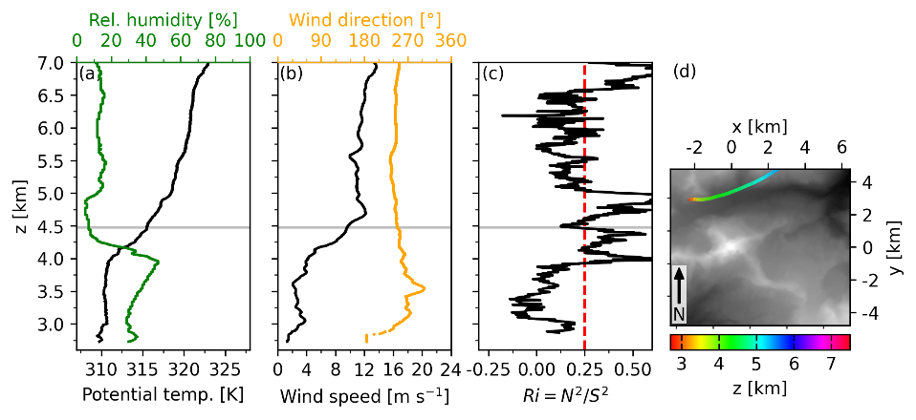
Fig. S59: As Fig. S53, but for radiosonde data from 1320 UTC 11 October 2023.

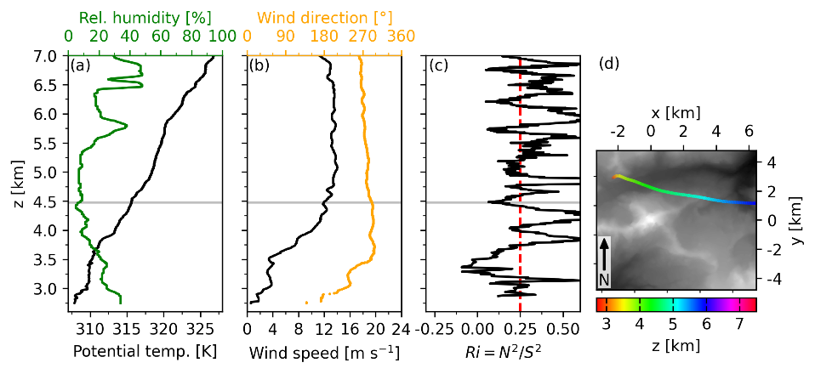
Fig. S60: As Fig. S53, but for radiosonde data from 1630 UTC 12 October 2023.

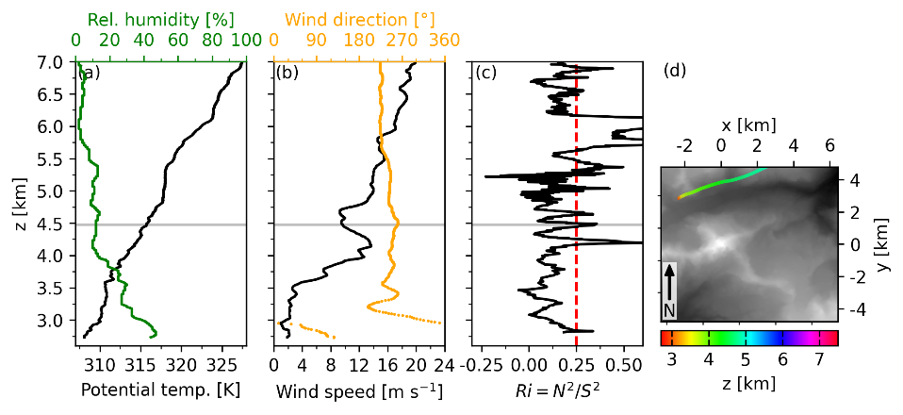
Fig. S61: As Fig. S53, but for radiosonde data from 1530 UTC 13 October 2023.

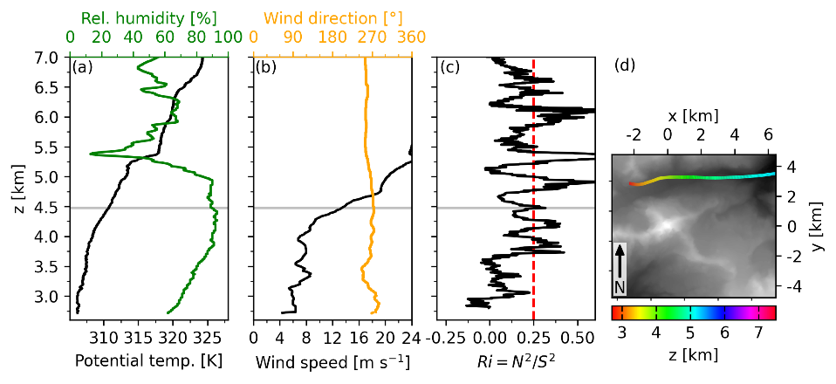
Fig. S62: As Fig. S53, but for radiosonde data from 1210 UTC 14 October 2023.

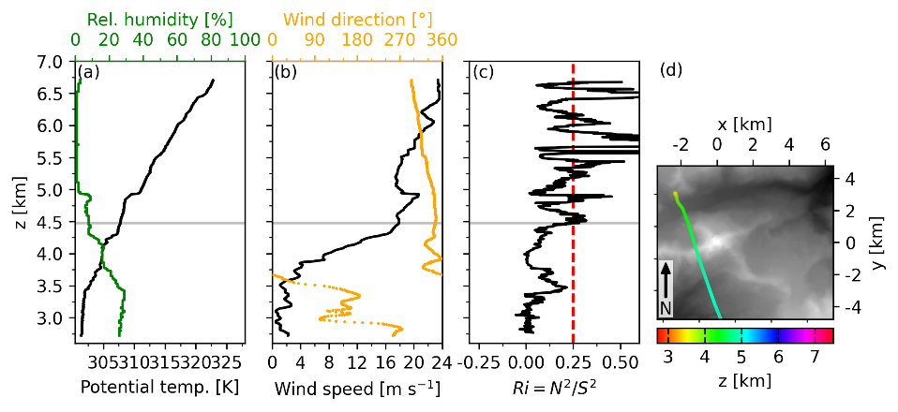
Fig. S63: As Fig. S53, but for radiosonde data from 1540 UTC 15 October 2023.

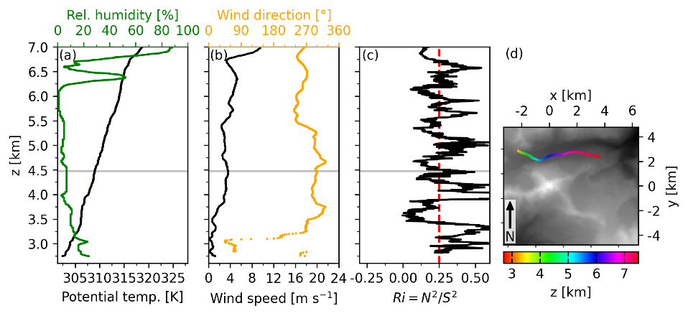
Fig. S64: As Fig. S53, but for radiosonde data from 0910 UTC 16 October 2023.

