+ **The MATERHORN – Unraveling the Intricacies of Mountain Weather**

Through woods and mountain passes  
the winds, like anthems, roll.  
 ~Henry Wadsworth Longfellow

prediction capabilities.

Mountain Terrain Atmospheric Modeling and Observations (MATERHORN) Program was designed to investigate complex terrain flow phenomena over a wide swath of scales, topographic features and driving mechanisms by drawing expertise from multiple disciplines and employing complimentary research methodologies with the aim of improving weather prediction in mountain terrain.

H.J.S. Fernando, E.R. Pardyjak, S. Di Sabatino, S. DeWekker, F. Chow, J. Hacker, Yansen Wang, D. Zajic (lead PI, field managers, other PIs, Dugway principal scientist)

**Please suggest:**

Alphabetical order authors?

Notre Dame: P. Conry, R.S. Coppersmith, R. Dimitrova, A., P. Dunn, Grachev, C. Hocut, E. Kit, L.S. Leo, T. Pratt, D., Liberzon, Z. Silver, M. Thomson, K. McEnerney, Tams

Utah: N. Gunawardena, C. Hang, S.W. Hoch, M.E. Jeglum, D. Jensen, V. Kulandaivelu, M. Lehner, J. Massey, E.R. Pardyjak, Z. Pu, J. Steenburgh, C.D. Whiteman, H. Zhang

Berkeley:

Virginia:

Simpson Weather Associates: Dave Emmitt

ARL:

Oregon State: Chad Higgins

Colorado: Ben Balsley, Dale Lawrence

DPG: John Pace

Polytechnique Montréal: D. Nadeau

1. **Introduction:**

For centuries, humans have been both fascinated and awed by mountain weather. The tranquility of a clear and sunny morning on a mountainous slope can quickly turn into tempestuous storms and gale force winds in a few hours, all the while a nearby valley remaining calm. A multitude of known and yet unknown physical processes of different space and time scales and interactions thereof drives this sharp variability, and these manifestations need to be understood, parameterized and modeled if improvements are sought for mountain weather prediction. While isolated mountains are sparse, about 20% of the earth’s land surface is covered by mountains (Louis 1975) that coexist with terrain features such as slopes, valleys, escarpments, gulleys, buttes and hills. Distinguishing mountains from other terrain features, therefore, is important but this division remains ambiguous at best. Various definitions have been proposed, for example, based on height, landscape and microclimate, but it is common to identify mountains as those with height > 600 m (Barry 1982). This is about 5% of the atmospheric scale height, beyond which the use of Boussinesq approximation is questionable. A mosaic of topographic inhomogeneities form complex terrain, which occupies about 70% of earth’s land surface (Strobach 1991), and mountain meteorology is a subclass of complex terrain flow studies where mountains plays a dynamical role.

Figure 1 illustrates a valley located between long (normal to the paper) mountains that disturb the synoptic flow in the free atmosphere. When the approach flow is stably stratified at night (in blue), the wake of the leading mountain consists of lee waves, rotors and separated vortices penetrating in to the valley, whilst under weak synoptic conditions a downslope (katabatic) flow characterizes a shallow *mountain atmosphere*. Convergence of downslope flows in the valley forms a stably stratified cold pool, signifying the *valley atmosphere*, which in this case encompass the *stable boundary layer (SBL)* near the ground. The combined influence of mountain wakes and valley spreads to the *mountain-valley* atmosphere, which transitions to free air though a layer signified by perturbed synoptic flow by mountains. The disturbed layer collectively by the mountains and valley defines the *complex terrain atmospheric boundary layer* (CTABL). Depending on the terrain and land cover, different microclimates are possible within CTABL. Conversely, during daytime convection (in red), the convective boundary layer (CBL) develops deep and the upslope flow, possibly its separation and formation of cumulus clouds are typical features under weak synoptic conditions. Separation of synoptic flow at the mountain top may shed vortices into mountain-valley atmosphere. The CTABL is much more energetic under convective conditions. For reviews of these phenomena, see Blumen (1991), Whiteman (2000), Fernando (2010) and Chow et al. (2011).

A remarkable feature of CTABL is the pervasive range of scales (Figure 1) from mesoscale perturbations of synoptic flows down to Kolmogorov scales of turbulence that interact with each other via numerous instability mechanisms. An example is the breakdown of katabatic (length scale $L_{M}^{γ}$) flow to Kolmogorov eddies ($L_{K}$) via several routes: by flow oscillations at critical internal wave frequency (Princevac et al. 2008), Kelvin-Helmholtz instabilities at various levels (Monti et al. 2002) and colliding with downvalley ($L_{M}^{β}$) flows, as identified in this paper. In each case, stratified turbulence is generated at the scale of instabilities, which breaks down through the inertial subrange ($L_{I}$) to $L_{K}.$ Aside from turbulent boundary layers near solid surfaces, generation of turbulence is the major energy sink. Some of the mountain terrain weather phenomena include lightning, wind gusts, Venturi wind effects between ridges, stagnation, cold air pooling, travelling and stationary waves, up/down drafts, snow/ice and convective clouds.

This article describes a major effort dubbed MATERHORN toward understanding and improved predictions of mountain flows through an integrated inter-university research program contributed by a multidisciplinary group of researchers. It is a five-year Multi University Research Initiative (MURI) funded by the Department of Defense, and has four major thrust areas: Modeling, Experiments, Parameterizations and Technology developments. The goal of the experiments was to measure flows from Macro-β to Kolmogorov scales using an array of either existing or newly designed instruments. While principal motivation for MATERHORN was safe aviation and visibility predictions for battlefield, there are many other civilian applications, including air pollution dispersion, human comfort, weather and snow forecasting, emergency response following accidental spills, freeway acoustics, agricultural and energy production. Mountain (or Alpine) Warfare is one of the most dangerous types of combat that often involves extreme weather, steep terrain, incomplete environmental information, intricate logistics, large uncertainties and high risks.

|  |
| --- |
|  |
| **Figure 1:** Atmosphere in complex terrain. ($L_{Ma}^{α}, V_{G}$) – macro- (>104 km), global; ) - macro- (2-10)x103 km synoptic;) - meso- - (2-20)x102 km regional downvalley; $(L_{M}^{β}, V_{dv}$) - meso- $β$ (2-20)x10km, local down valley; $(L_{M}^{γ}, V_{ds}$) - meso- $γ$ (2-20)km, local downslope or locally distorted regional (R)/canopy (C) flow; $(L_{mi}^{α}, V_{dv}$) - micro- $α$ (0.2-2) km, local flow interactions and collisions; $(L_{Mi}^{β}, V_{dv}$) - micro- $β$ (20-200) m, instabilities; $(L_{Mi}^{γ}, V_{T}$) - micro- $γ$ (<20 m), turbulence and eddies down to Kolmogorov scales $L_{K}$. MC - microclimate  [maybe adjust the aspect ratio of the figure to reduce the steepness of the mountains?] |

1. **Critical Scientific Needs and Approach:**

Preceding MATERHORN, a workshop entitled “Weather in Mountainous Terrain (Overcoming Scientific Barriers to Weather Support)” was held in Tempe, Arizona during February 1-2, 2010 (A detailed report is available from the corresponding author). Twenty-six invited experts representing academia and stakeholders brainstormed to identify a long list of research needs and barriers for improved predictions. Considering resources limitations, only a subset of these issues were included in MATERHORN, namely: (i) The predictability of near-surface atmospheric wind and temperature in complex terrain remains poor, in part due to lack of understanding of land-air and near surface processes; (ii) soil moisture and soil properties sensitively determine the surface layer predictions, especially in arid environments, yet key model related parameters are not accurately and simultaneously measured in field studies; (iii) While previous observations have delved into one or a few physical processes, observations over a range of scales may elicit new phenomena of consequence and their possible origin; (iv) A revisit of turbulence closure models and boundary layer parameterizations is needed, focusing on processes intrinsic to complex terrain processes; (v) There is a potential for high-fidelity ultra-high-resolution (50 m horizontal or finer) simulations for complex terrain, but issues remain on best numerical methods (e.g., terrain following versus immersed boundary layer), model physics and structure. These issues undergirded the design of the project, which melded four cross-fertilizing components.

1. The modeling component (MATEHRORN–M) investigates predictability at mesoscale, in particular, sensitivity (error growth) to initial conditions at various lead times, dependence on boundary conditions and input background properties as merits of different data assimilation techniques. It develops meaningful measures of skill relative to appropriate conditional climatologies.
2. The field experimental component (MATEHRORN–X) conducts measurements at unprecedented spatio-temporal detail, deploying an array of high-end instrumentation to support modeling efforts and process studies.
3. The technology component (MATERHORN–T) develops innovative technologies to enable some needed, yet currently untenable, meteorological measurements. These included an instrumented UAV, and remote sensors and samplers for moisture measurements.
4. The parameterization component (MATEHRORN–P) for high-resolution simulations with novel modeling and terrain-representation methodologies as well as idealized laboratory studies to educe and quantify processes intermingled (and hidden) in field observations and help develop sub-grid parameterizations with improved physics.

Overall, the project design was centered on two MATERHORN-X field studies conducted at the US Army Dugway Proving Grounds (DPG), where observations on multi-scale flow and model-related parameters were conducted, accompanied by rigorous modeling efforts for experimental planning and go/no-go decision making for Intensive Operational Periods (IOP).

1. **MATERHORN EXPERIMENTS**

The project is highlighted by two extensive field campaigns, the Fall campaign (September 25 to October 31, 2012; MATERHORN-XF) focusing on quiescent, dry, fair weather (wind speeds < 5 m/s) wherein diurnal heating/cooling provided the main forcing and the Spring campaign (May 1 to May 31, 2013; MATERHORN-XS) dealing with synoptically dominated winds. A dry run was conducted during August 25-August 30 to fine tune instrument placement and logistics. The site, DPG, is located 137 km southwest of Salt Lake City, UT, consisting of 3700 km2 of encroachment-free terrain. It is a secured facility, with controlled roads and air space by the Department of Defense (DOD), and a special cooperative agreement permitted access to DPG. Within DPG, unique topography is present in the form of an isolated, Granite Mountain GM with length 11.8 km, largest width 6.1 km and peak elevation 0.84 km (above valley elevation of 1.3 km). Farther from Granite Mountain, approaching the DPG boundaries, the peaks climb to upwards of 2200 m above the valley on three sides while to the North, salt flats extend for 145 km. Besides terrain heterogeneities, DPG also has variable land cover and use. To the West of Granite Mountain, the terrain is extremely smooth with salt flats (playa) while the terrain to the East is sagebrush covered, leading to differential cooling and roughness variation. The location can be classified as semi-arid terrain, resembling to complex terrain airsheds such as Phoenix and Los Angeles (noted for their ar quality problems) and some remote areas of interest to DOD. The weather is modulated by land-surface contrasts, topographic complexity, inhomogeneities of terrain and land use and intrinsic synoptic variability. The DPG, and the Granite Mountain area in particular, observes much of the flow phenomena of interest including thermal circulation flows, terrain-forced flows and turbulence, frontal cyclones, convective systems and dust storms (Rife et al. 2002; Schultz et al. 2002; Schultz & Trapp 2003; Shafer & Steenburgh; 2008; West & Steenburgh 2010; Jeglum et al. 2010).

The surroundings of Granite Mountain is suitably instrumented to support numerous meteorological testing, training and operational assessments of chemical and biological weapon systems, forming the Granite Mountain Atmospheric Sciences Testbed (GMAST) facility. The core instrumentation infrastructure consisted of 31 Surface Atmospheric Measurement Systems (SAMS), 51 - mini-SAMS and 51 - Portable Weather Information Display Systems (PWIDS). SAMS and mini-SAMS are 10 m towers with anemometers located at 2 and 10 m to measure wind speed/direction and a temperature/relative humidity probe located at 2 m. The difference between the two is their anemometers; the SAMS feature 3D sonics while the mini-SAMS have Wind Monitors. PWIDS are 2 m masts sitting atop tripods for portability and have a Wind Monitor and temperature/relative humidity probe located at 2 m. All data from SAMS/mini-SAMS/PWIDS is transmitted wirelessly to the DPG Meteorology Division dubbed Ditto via a spread spectrum radio. These instrumentation are included in Figures 1 and 2.

Built upon this core infrastructure was the MATERHORN instrumentation that was concentrated on five Intense Operating Locations (IOL, Figure 1).

* **IOL-Playa,** located on the salt playa west of Granite Mountain, and characterized by a high albedo, low roughness length and large seasonal variations in albedo and moisture. This site was dedicated for studies on surface energy budget, internal waves, fine-scale turbulence in Stable Boundary Layer (SBL) and Convective Boundary Layer (CBL) and contrasting features such as albedo, roughness, moisture availability and slope angle.
* **IOL-Sagebrush** was located east of the Granite Mountain. Covered by sparse sagebrush-type vegetation, it is highly representative of the land cover found at DPG. This site was influenced by the nocturnal DPG basin-scale mesoscale drainage flow.
* **IOL- East Slope (ES)** was located on the eastern slope of Granite Mountain. Local slope flows played an important role at this site.
* **IOL-Gap** is the flow exchange area between west and east basins on either side of the Granite Mountain, and it consists of a small and big gap areas
* **IOL-Obverse** is the footprint where northwesterly synoptic approach flow impinges on the granite mountain, wrapping around it while shedding vortices and, under stable conditions, exhibiting a dividing streamline above which the flow goes above the mountain and below it flowing around the mountain.

An array complementary instrumentation was also distributed in the domain to capture broad flow patterns of interest, which included sites in west slope, periphery of GM and remote sites for background flow. Figure 2 shows the entire site map and Figure 3 the photographs of salient instrumentation at DPG.

All IOLs consisted of instrumented towers, at least one 20 m in height, along with a suite of other sensors based on research questions to be addressed. The tower measured a combination of the following: relative humidity, velocities, temperatures, momentum and sensible heat fluxes (using 3D Sonics operating at 20Hz; at 2, 5, 10, and 20 m), fine wire thermocouples (at 2, 5, 10, and 20 m, CO2 and water vapor concentrations (infrared gas analyzers for latent heat and CO2 fluxes), fine-structure temperature profiles ($\sim$ 25 thermocouples up to 10 m, with enhanced vertical resolution near the ground), full radiation budget at 2 m (LW in- and outgoing, SW in- and outgoing), and IR surface temperature, soil heat flux, soil moisture and subsurface temperature probes. Sonics were also placed 0.5 m above surface to investigate the *skin flows*, a phenomenon adumbrated by previous observations but unresolved by both LES and mesoscale models and previous observations (Manins & Sawford 1979a, Thompson 1986; Manins 1992; Mahrt et al. 2001; Soler et al. 2002; Clements et al. 2003).

ES had five heavily instrumented towers (ES-1 to ES-5), with a total of 30 Sonics, 17 Local Energy-balance Measurements Stations (LEMS), Doppler Light Detection and Ranging(LiDAR) instruments with hemispherical scanners. A fiber optic Distributed Temperature Sensing (DTS) system was used to measure the temperature variation along a 2 km track of the slope at 1 m AGL. In-house developed hot-film combo probes measured turbulence down to Kolmogorov scales (Kit et al. 2010), and a FLIR® IR camera, facing uphill measured spatial and temporal response of surface temperatures important for model validation, an observation impracticable with point sensors. A line of 17 HOBO® automatic temperature dataloggers was deployed along a East-West cross section over the southern profile of Granite Mountain.

The Playa site featured unique instrumentation for finest scales of turbulence, employing a near surface flux Richardson number hot-wire probe, thus complementing the ES-2 combo probe that measured similar quantities at 6 m. The ground-based measurements were supplemented by frequent tethered balloon soundings at the Playa and Sagebrush sites, a microwave radiometer profiler (MWRP) for vertical profiles of temperature and humidity up to 10 km, infrared gas analyzers (fluxes) and Krypton Hygrometers (water vapor fluctuations).

The Gap site encompassed small and large gaps southeast of Granite Mountain, the East Slope canyonsof Granite Mountain, West Slope of Granite Mountain, top of the Sapphire Mountain and multiple locations in the proximity, and was densely instrumented. It was also the site for two newly developed RF Polarimetric crosshairs (Pratt et al. 2014) for surface moisture measurments at ~ 1 km (meso grid-resolution) scale. Smoke released illuminated by a powerful laser as well as natural light provided qualitative information on the structure of the katabatic and canyon flows.

Obverse site provided approach flow information for the synoptically dominated experiments, based on a 32 m tall tower (located ? Km northwest) with 3D sonics at 2, 4, 6, 8, 16, and 28*m* with concurrent temperature measurements using Campbell HMP45 probes. Co-located were a MWRP, a Ceilometer, a mini-SoDARs and a Frequency-Modulated Continuous-Wave Radar (FM-CW) RADAR for profiling background thermodynamic structure. PWIDs recorded the local flow at the leading edge. A suitably placed scanning LiDAR and four towers along the southeast foothill captured the separated flow. At least 8 radiosonde launches per IOP at an upwind location provided further information that helped model data assimilation studies. Elaborate multiple smoke releases visualized the flow around Granite Mountain and provided information on the dividing streamlines, streak lines and separation associated with mountain flow physics.

To round out MATERHORN-X instrumentation, aerial measurements were performed by the manned NPS Twin Otter Wind LiDAR (TODWL) and unmanned aerial vehicles (UAV) consisting of DataHawk and Flamingo. TODWL flights crisscrossed the basin at 2400 m AGL, transecting the Granite ridge, conically scanning the terrain with onboard Doppler LiDAR to probe for various flow phenomena including the deluge of mountain generated flows. Unmanned DataHawk flights flew circular Auto-Helix patterns, spiraling from the ground level to a height of 700 m AGL and then back down traversing the EFS-Slope tower line, able to characterize the flow the towers could not reach.

## **Intense Operational Periods (IOPS)**

Each campaign included ten Intensive Observational Periods (IOPs) where all instruments operated simultaneously and in coordination. The wind speed classification used for IOPs is presented in Table 1. IOP days were selected based on guidance via weather briefings provided by DPG featuring DPG’s high-resolution weather modeling system using WRF and data assimilation, cycling 8 times a day at 1.1 km resolution and an ensemble of numerical modeling including the North American Mesoscale (NAM) and Global Forecast System (GFS) models as well as satellite products. During the campaign, weather briefings were held by the DPG forecasters, called-in meteorologists from the MATERHORN group and the participants, and the go/no-go decision for the following day was made after careful deliberation of the data needs, equipment functionality and resource availability for that day. Table 2 contains the details of the fall IOPs including the run date, times and IOP type.

TABLE 1  
INTENSE OPERATIONAL PERIODS (IOPS) WIND SPEED CLASSIFICATION

|  |  |
| --- | --- |
|  |  |
| **IOP Classification** | **Definition** |
| **700 mb wind speed** |
| Quiescent | < 5m/s |
|
| Moderate | 5 m/s - 10 m/s |
|
| Transitional | Variable, could be > 10m/s |
| associated w/front Passage |

Table 2A  
Fall, MATERHORN-X-1 IOPs

|  |  |  |
| --- | --- | --- |
|  |  |  |
| **IOP** | **Run Date and Times (MDT)** | **Type** |
| 0 | 9/25/2012 14:00 - 9/26/2012 14:00 | Quiescent |
| 1 | 9/28/2012 14:00 - 9/29/2012 14:00 | Quiescent |
| 2 | 10/1/2012 14:00 - 10/2/2012 14:00 | Quiescent |
| 3 | 10/3/2012 2:00 - 10/4/2012 2:00 | Transitional |
| 4 | 10/6/2012 14:00 - 10/7/2012 14:00 | Moderate |
| 5 | 10/9/2012 14:00 - 10/10/2012 14:00 | Transitional (Quiescent- Moderate) |
| 6 | 10/14/2012 2:00 - 10/15/2012 2:00 | Quiescent |
| 7 | 10/17/2012 12:00 - 10/17/2012 20:00 | Transitional (Quiescent -Moderate) |
| 8 | 10/18/2012 5:00 - 10/19/2012 12:00 | Quiescent |
| 9 | 10/20/2012 14:00 - 10/21/2012 14:00 | Moderate |

Table 2b  
Spring, MATERHORN-X-2 IOPs

|  |  |  |
| --- | --- | --- |
|  |  |  |
| **IOP** | **Run Date and Times (MDT)** | **Type** |
| 1 | 5/1/2013 14:00 - 5/2/2013 14:00 | Transitional (Moderate-Quiescent) |
| 2 | 5/4/2013 14:00 - 5/5/2013 14:00 | Moderate |
| 3 | 5/7/2013 5:00 - 5/7/2013 17:00 | Moderate |
| 4 | 5/11/2013 14:00- 5/12/2013 14:00 | Quiescent |
| 5 | 5/13/2013 12:00 - 5/14/2013 12:00 | Transitional (Moderate-Quiescent) |
| 6 | 5/16/2013 12:00 - 5/17/2013 12:00 | Transitional (Moderate-Quiescent) |
| 7 | 5/20/2013 17:15 - 5/21/2013 14:00 | Quiescent |
| 8 | 5/22/2013 14:00 - 5/23/2013 14:00 | Moderate |
| 9 | 5/25/2013 10:00 - 5/26/2013 10:00 | Moderate |
| 10 | 5/30/2013 14:00 - 5/31/2013 10:00 | Moderate |

1. **Preliminary Results**

Experimental Findings: Here we will have about 2 pages (~ 3000 words max) of new findings. Each figure counts as 400 words.

**5.1.** Key Surface Energy Balance / Soil Property differences

To fully understand the physical processes driving the thermally driven mountain circulations, the individual components of the radiation and surface energy budget as well as supporting observations (soil properties) were measured at three representative locations (IOL-Sage, IOL-Playa and IOL-Slope), using the best available equipment. Surprisingly small albedo differences were observed between the three sites, limiting the differences in shortwave net radiation at the different surfaces. On the other hand, our measurements revealed the importance of soil property differences across the complex terrain. The differences in thermal conductivity between the soils of the playa and the vegetated areas (0.9 and 0.65 W m-1K-1 at EFS-Playa and EFS-Sage, respectively; Table x) lead to a difference in the importance of the Ground Heat Flux. The Ground Heat Flux at EFS-Playa is a larger energy sink during the day than the Sensible Heat Flux, and the heat is released during the night leads to higher surface temperatures and higher longwave emission. A correct representation of the soil thermal conductivity was shown to be crucial to accurately predict nighttime temperatures over the various soil types using today's forecasting models (Massey at al. 2014).

**5.2. Boundary layer evolution**

The spatial differences in the Surface Energy Balance are reflected in the evolution of both the stable nighttime and convective daytime boundary layers. Tethered balloons were flown during IOPs at both IOL-Sage and IOL-Playa. Figure XY shows the Temperature and wind profiles for the two locations at XX and XX UTC ...

**5.3. Flow transitions on the East Slope of Granite Mountain**

**5.4. Interactions between Slope and Valley Flows**

Even during synoptically quiescent nights, the flow fields in the basins around Granite Peak are very complex. While valley circulations develop on either side of Granite Mountain, these flows are likely enhanced by the differential cooling due to the land surface contrast between sparsely vegetated areas to the SE and the playa to the NW (playa breeze). Inter-basin air exchange across the Sapphire Mountain gaps seem to be largely controlled by the channeling of larger-scale flows, but thermal contrasts can lead to air exchanges as well.

During the night of IOP-2, a southeasterly down-valley flow establishes in the Dugway Basin, and merges with a southwesterly flow across the Granite Mountain - Dugway Range Gap (Big Gap). Vorticity develops acting to deflect the cold air of the valley flow towards the warmer eastern slope of Granite Mountain. The cold air advected by the valley circulation and the downslope flow on the East Slope of Granite Mountain collide as shown in Figure 1. The collision generates an intriguing set of small-scale processes that contribute vigorously to sub-grid scale heat and momentum transfer. These include the collision of gravity currents, formation of intense turbulent regions, intrusions and instabilities. The impact of the collision sends pressure waves, flushing the basin, allowing the cold air that had been pushed up the slope to drain back out into the basin, which is then met by a re-established valley flow. This collision cycle is repeated numerous times during the quiescent evenings. WRF and other mesoscale models do not account for such sub-grid processes, and hence their incorporation through conditional parameterization is crucial in modeling mountain terrain winds.

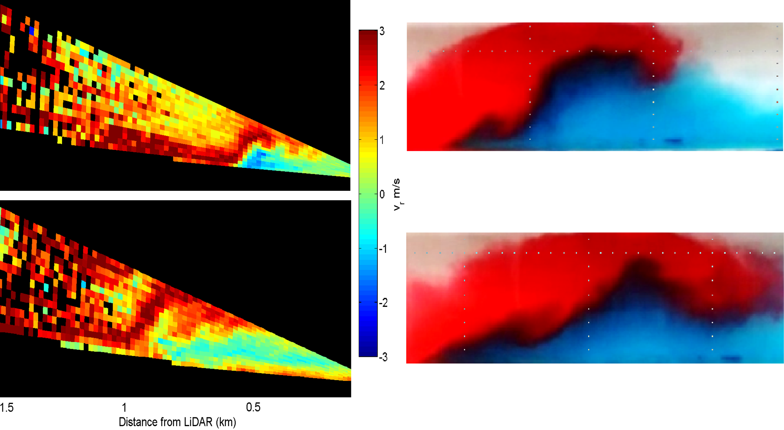

**ts = 22:56 MDT**

**ts = 23:11 MDT**

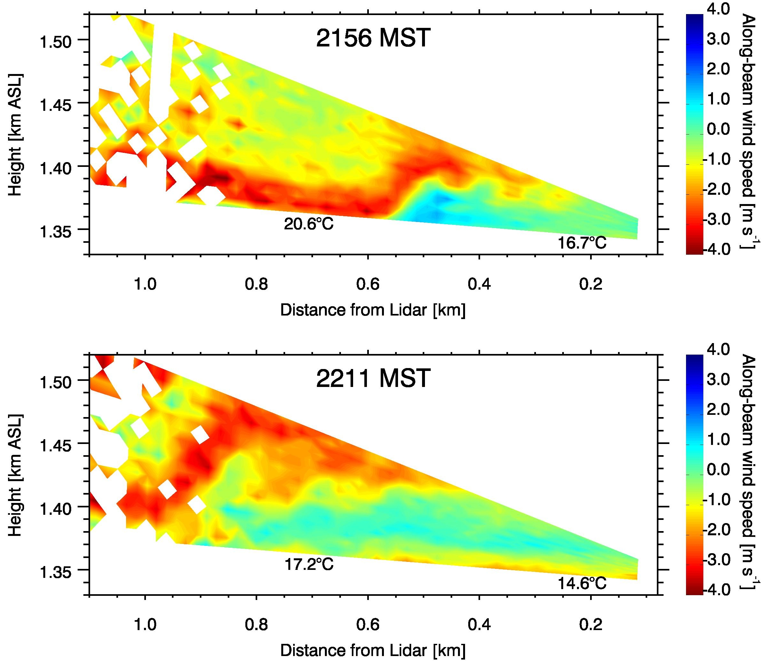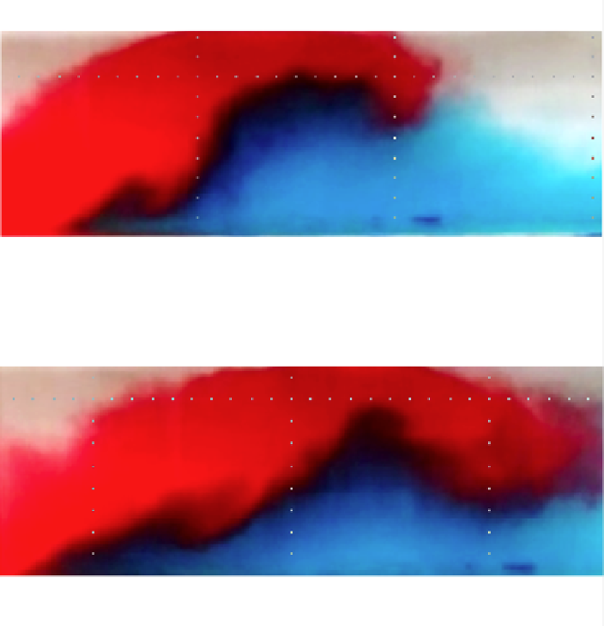

I propose using this edited figure. Here, y-axis is labeled and temperatures from PWIDs on slope are added. Data is noise filtered as well.

Figure 1: Down-slope and valley flow collision during IOP 2 (10/02/2012). Left panel: U. Utah Lidar (S. W. Hoch) located near ES-2. Scans capture the collision between the downslope (red) and colder air advected to the slope by the valley flow (blue). Right panel: Collision of gravity currents at the U. Notre Dame laboratory. In both cases, the denser valley flow undercuts the downslope flow and then pushes up the slope. Intense small-scale processes and instabilities can be observed at the interface of the two currents in the laboratory study.

5.4. Breakdown of Monin-Obukhov similarity

**Joe Fernando – will describe the impacts of flows**

**De Wekker – most significant**

Numerical Modeling:

**Josh, Zhaoxia, Jim – please send us 1500 words (including figures – each figure is 400 words) of a few developments......related to Materhorn experiments.**

**Tina – please send me one figure and major outcome related to Materhorn experiments**

**Synthesis:**

**Fernando will do this**

**Figures:**

|  |
| --- |
|  |
| Figure 1: MATERHORN-X Instrument placement, IOLs and distributed instrumentation (Silvana will provide a new figure) Label Dugway Basin (referred to in text) |

|  |  |
| --- | --- |
| ditto_aerial.jpg |  |
| GMAST, with Granite mountain in the background | PWIDs |

|  |  |  |  |  |  |  |  |  |  |
| --- | --- | --- | --- | --- | --- | --- | --- | --- | --- |
| |  |  | | --- | --- | |  | D:\From Workstation\MATERHORN\DPG photos\Photo_DPG\Fall2012\Photos_2012_10a\IMG_5412.JPG | | E:\Photos\Photos_7\DSC_9775.JPG | D:\From Workstation\MATERHORN\DPG photos\Photo_DPG\Fall2012\Photos_2012_10a\IMG_5413.JPG | | I:\Photos\Photos_8\101ND70S\DSC_0077.JPG | I:\Photos\Photos_8\101ND70S\DSC_0124.JPG |  |  |  |
| SAMS/miniSams; 3D sonic; vane anemometer; MP45 temperature/relative humidity probe in radiation shield. | ES 5;  3 level sonics; | ES 4 | ES 3 | ES 2; | ES 1 |

|  |  |  |  |
| --- | --- | --- | --- |
| E:\Photos\Photos_8\101ND70S\DSC_0080.JPG | E:\Photos\Photos_8\101ND70S\DSC_0177.JPG | E:\Photos\Photos_2\DSC_7403.JPG | E:\Photos\Photos_10\100ND70S\DSC_1397.JPG |
| Fine wire thermocouples coupled with 3D sonic anemometers | Infrared gas analyzers | Krypton Hygrometer | Net radiometer as the tower mounted component of the energy budget |

|  |  |  |  |  |
| --- | --- | --- | --- | --- |
|  | IMG_5453.JPG | D:\From Workstation\MATERHORN\DPG photos\Photo_DPG\Fall2012\Photos_2012_10a\IMG_5376.JPG | D:\From Workstation\MATERHORN\DPG photos\Photo_DPG\Fall2012\Photos_2012_10a\IMG_5477.JPG |  |
| 3D hot-film combo probe | Distributed Temperature Sensing System (DTS) | Array of fine wire thermocouples, enhanced resolution near the ground | FLIR® IR camera | LEMS weather stations |

|  |  |  |  |  |
| --- | --- | --- | --- | --- |
|  |  |  | E:\Photos\Photos_8\101ND70S\DSC_0497.JPG | E:\School\ND\Thesis\Chapters\Chapter 3 Pics\Hot-Wire.jpg |
| Tethered balloon soundings | radiosondes | Microwave Radiometer Profilers | Ceilometers | Flux Richardson number hot-wire probe |

|  |  |  |  |
| --- | --- | --- | --- |
| D:\From Workstation\corsair\Materhorn practicum\IMG_5566.JPG |  | I:\Photos\Photos_1\DSC_7276.JPG | |
| Scanning Lidar | Mini-SoDARs | | SoDAR/RASS |

|  |  |  |
| --- | --- | --- |
|  |  |  |
| Frequency-Modulated Continuous-Wave Radar (FM-CW) RADAR | Dividing streamline smoke release located on the northwest side of Granite Mountain | RF Polarimetric crosshairs surface moisture probes |

|  |  |  |
| --- | --- | --- |
|  |  |  |
| DataHawk UAV | Flamingo UAV | Twin Otter with wind LiDAR (TOWDL) |

Table   
physical parameters for the main land use types of gmast and surroundings

|  |  |  |  |
| --- | --- | --- | --- |
|  |  |  |  |
| **Site** | **Roughness Height (z0) (m)** | **Average Albedo**  Oct / May | **Soil Thermal Conductivity(W m-1K-1)** |
| Oct / May |
| EFS - Playa | 5.7 x 10-4 | 0.31 / 0.34 | 0.98 / 0.79 |
| EFS - Sagebrush | 0.24 | 0.27 / 0.24 | 0.59 / 0.73 |
| EFS - Slope | 0.10 | 0.23 / 0.19 | 0.44 / 0.54 |

instrument details

|  |  |  |  |
| --- | --- | --- | --- |
|  |  |  |  |
| **Instrument** | **Qty Measured** | **Rangex** | **Accuracy** |
| Midrange-SoDAR | $$U, WD$$ | 50 to 400 m | 0.5 ms-1, ± 2° |
| SoDAR/RASS |  | 30 m to 1 km | < 0.3 ms-1, < 0.1 ms-1, ± 1.5°, 0.2°C |
| Ceilometer | Cloud height detection | 0 to 7.6 km | ± 5 m |
| Radiosonde | $$T, RH, P, U$$ | Up to 30 km | 0.5°C, 5%, 1hPa, 0.2 ms-1 |
| FM-CW RADAR | $$C_{n}^{2}$$ | Usually set to 4 km |  |
| Wind Profiler 449 | $$U, WD$$ | 0.075 - 16 km | ±1 ms-1, ± 10° |
| Wind Profiler 924 |  | 0.075 - 5 km | < 1 ms-1, < 10° |
| Microwave Radiometer Profiler\* | $T$, $H_{2}O$ vapor $ρ$  profile, Liquid $H_{2}O$ profile, derived $RH$ | 0 - 10 km | $\sim$ 2° C, 0.5 gm-3, 0.1 gm-3, 20 % |
| 3D Sonic Anemometer |  | NA | ±0.05 ms-1,  ± 2°C |
| Wind Monitor Anemometer |  | NA | ±0.3 ms-1, ± 3° |
| HMP45 Probe | $$T, RH$$ | NA | ± 0.6°C, ± 3% |
| Fine Wire Thermocouple | $$T$$ | NA |  |
| Tethersonde | $$T, RH, P, U, WD$$ | 0 to 500 m | 0.5°C, 5%, 1.5 hPa, 0.1 ms-1, 1° |
| RF Polarimetric Crosshair | Soil Moisture | 1 km grid scale |  |
| Krypton Hygrometer | $H_{2}O$ vapor fluctuations | NA |  |
| Infrared Gas Analyzer | ${CO}_{2}$ and $H_{2}O$ density | NA | 1%, 2% |
| Streamline Doppler LiDAR | $U_{r}$, $SNR$ | up to 10 km | < 0.5 ms-1 |

table 2.3 (Continued)

|  |  |  |  |
| --- | --- | --- | --- |
|  |  |  |  |
| **Instrument** | **Qty Measured** | **Rangex** | **Accuracy** |
| 100S Doppler LiDAR | $U_{r}$, $SNR$ | up to 12 km | < 0.5 m/s |
| HOBO® U23 Pro | $$T, RH$$ | NA | ± 0.21° C, ± 3.5% |
| PWIDS |  |  |  |
| SAMS |  |  |  |
| LEMS | *P, T, RH, TS, VWCsoil, , Tsoil, SWi* | NA | +/- 0.035 kPa,  +/- 0.3 C, +/- 2 %,  +/- 2%, +/- 0.03 m3m-3, +/- 1 C, +/- 3% |
| DTS system+ |  | 2 km | ± 0.1°C |
| Heat Flux Plates | Soil $Q$ | NA | -15% to +5% |
| Net Radiometer (CNR1) | ${SW}_{i}$, ${SW}_{o}$, ${LW}_{i}$, ${LW}_{o}$ | NA | ± 10% |
| Pyranometer (CMP21) | , |  | ± 5 W m-2 |
| Pyrgeometer (CGR4) | , |  | ± 10 W m-2 |
| Hot-Film Combo Probe | $$u', v', w', ε$$ | NA | 4% for 30% TI |
| Hot-wire Flux Richardson Probe | $\overline{u'w'}$ and $\overline{w'T'}$ | NA |  |
| FLIR® IR camera | s | Max FOV = 63.2° x 52.4° | ± 2°C or ± 2% |
| Gravimetric Soil Observations\* | VWC | surface, 5cm, 25cm below surface |  |
| Levelogger Gold®\* | Water Table Depth | 0 to 1m below the surface |  |
| Other ground measurements  TP01 Soil Property Probe | thermal conductivity λ | ±5% |  |
| Twin Otter Wind LiDAR (TODWL)+ |  | 0.3 - 21 km | < 0.1 ms-1 |
| DataHawk UAV+ |  | to 3km AGL | 0.1 m/s, 0.3 °C 1.0e-6, 0.01 %, 1.0 Pa, 1.0e-6 |
| Flamingo UAV+ |  | 12.8 km | 4% for 30% TI |

+ = Only present during the Fall campaign.

\* = Only present during the Spring campaign.

x = Represents the maximum possible range. Results depend on atmospheric conditions.

t.

Here a few photos that may be suitable to substitute / include

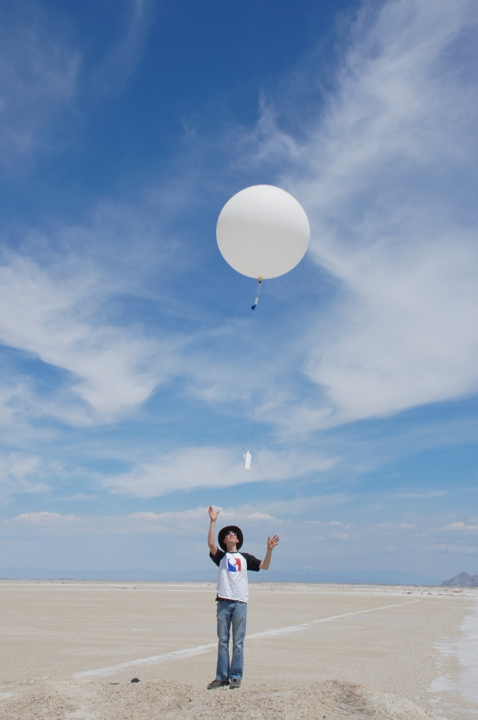

Radiosonde release at EFS-Playa

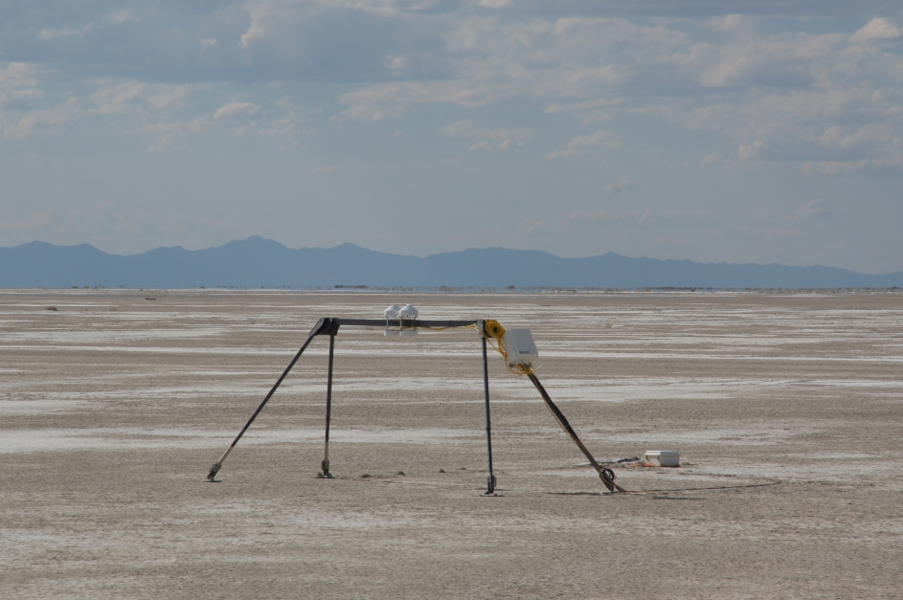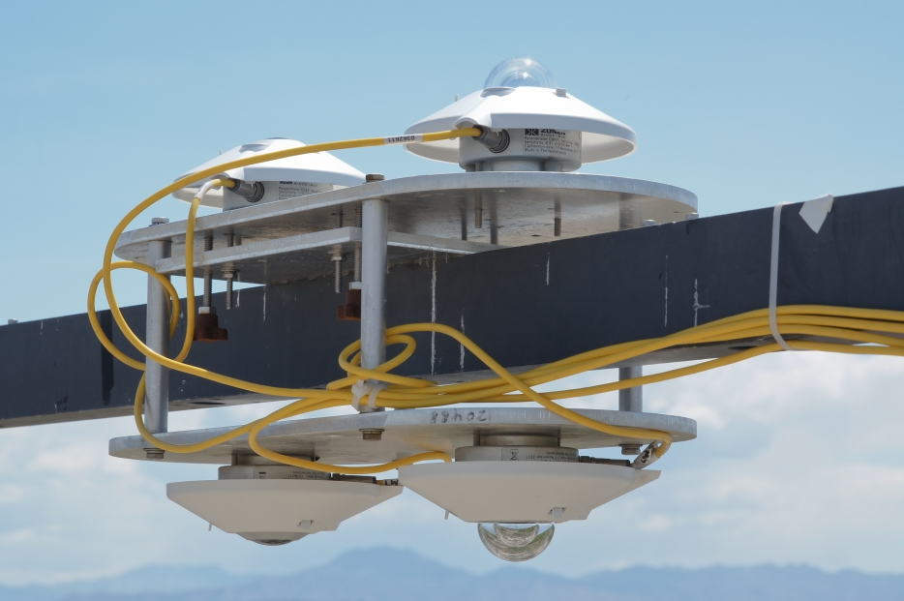

Radiation balance observations at EFS-Playa (left) and EFS-Sagebrush (right)

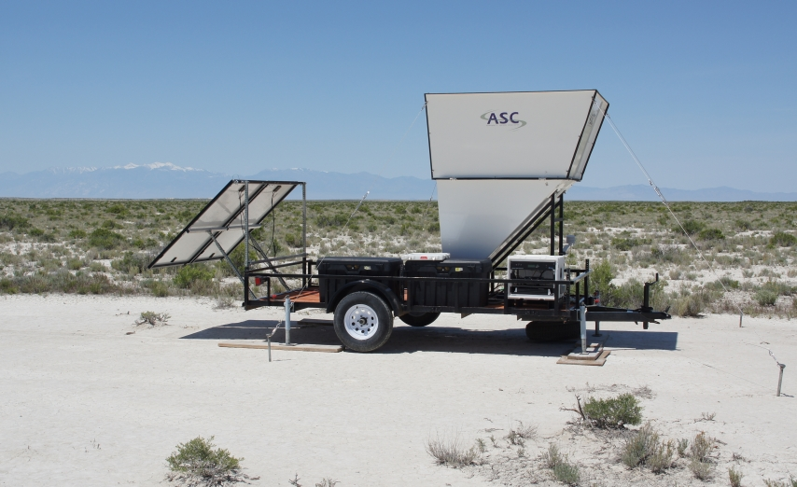

mini-SoDAR at "Big Gap" site

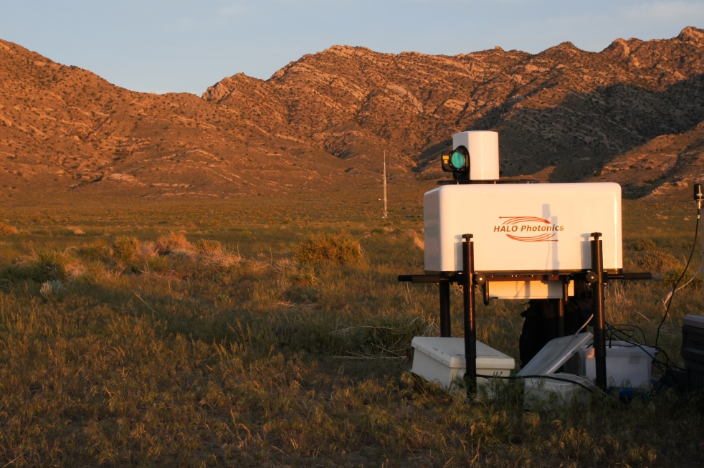

University of Utah Scanning Doppler LiDAR on East Slope near ES-2 (ES-3 can be seen in background)

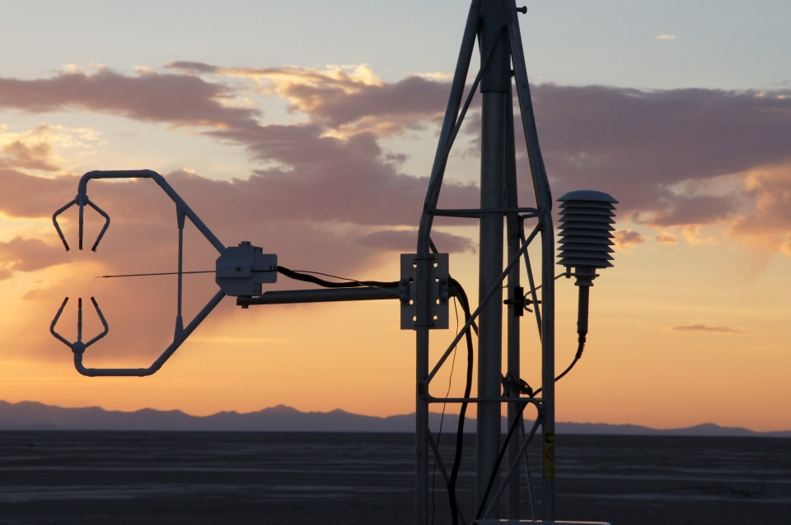

Sonic anemometers / fine wire thermocouple combination at EFS-Playa

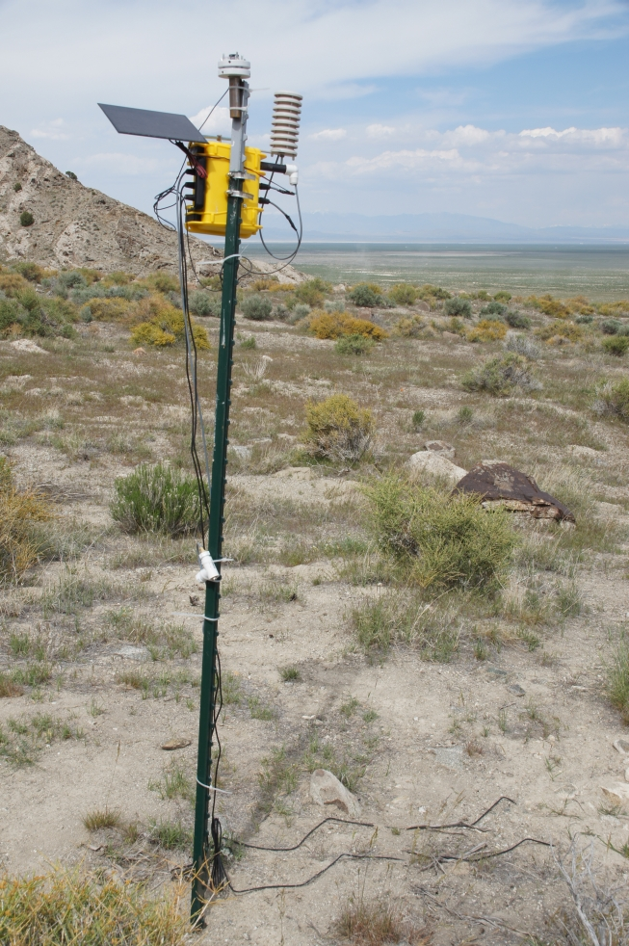

LEMS on East Slope of Granite Mountain

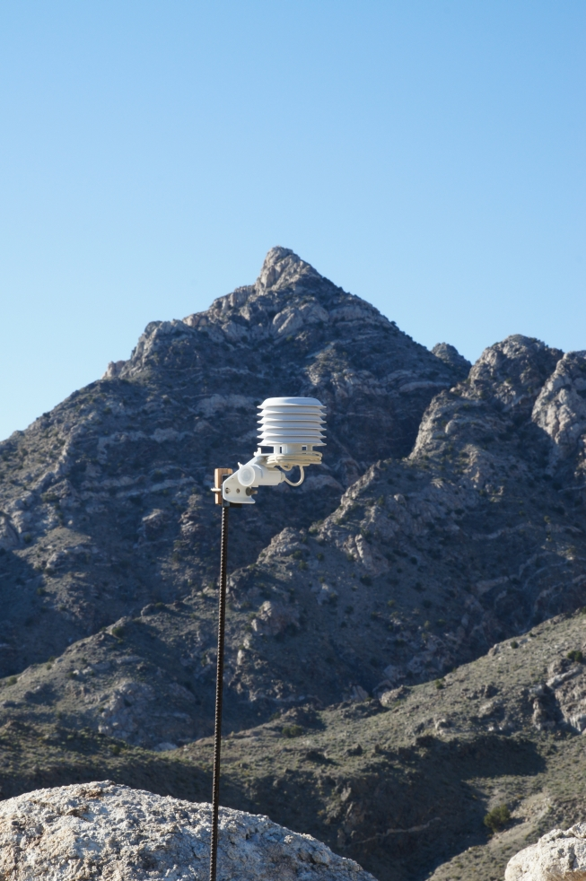 Hobo temperature datalogger near Granite Mountain ridgeline

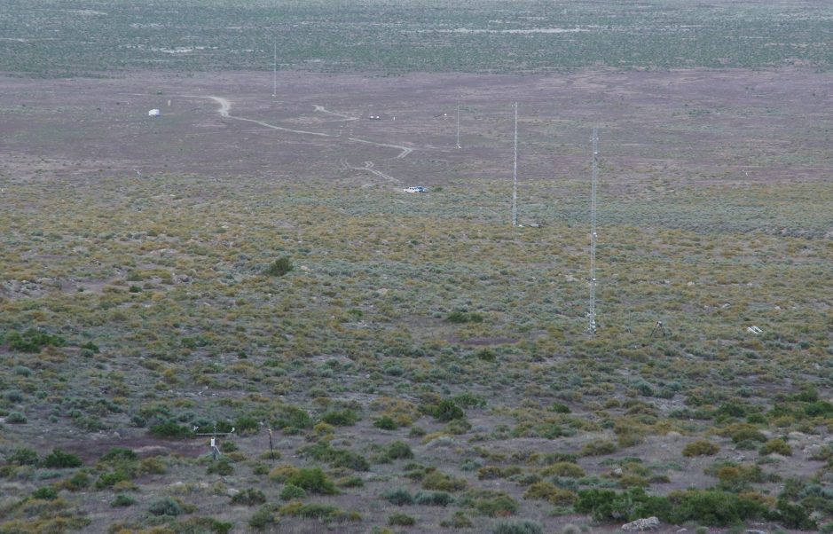

Upper 4 towers (ES-5-ES-2) on East Slope of Granite Mountain, looking East (down the slope).

References:

Chow, F., Snyder, B. and de Wekker, S., (eds), Mountain Weather Research and Forecasting, Springer Atmospheric Sciences Series, ISBN 978-94-007-4098-3.

Louis, H., Neugefasstes Hohendiagramme der Erde, Bayer. Akad. Wiss., (Math Naturwiss. Klasse), 305-326.

Strobach, K. 1991. *Unser Planet Erde- Ursprung und Dynamik,* Gebr. Bornträger, Berlin.

Supplementary Material:

Acknowledgments: , Materhorn workshop was sponsored by the Army Research Office and Office of Naval Research