+ The MATERHORN – Unraveling the Intricacies of Mountain Weather

Through woods and mountain passes
the winds, like anthems, roll.
~Henry Wadsworth Longfellow

prediction capabilities.
The Mountain Terrain Atmospheric Modeling and Observations (MATERHORN) Program was designed to investigate complex terrain flow phenomena over a wide swath of scales, topographic features and driving mechanisms by drawing expertise from multiple disciplines and employing complimentary research methodologies with the aim of improving weather prediction in mountain terrain.

H.J.S. Fernando, E.R. Pardyjak, S. Di Sabatino, S. DeWekker, F. Chow, J. Hacker, Yansen Wang, D. Zajic (lead PI, field managers, other PIs, Dugway principal scientist)

Please suggest:
Alphabetical order authors?

Notre Dame: P. Conry, R.S. Coppersmith, R. Dimitrova, A., P. Dunn, Grachev, C. Hocut, E. Kit, L.S. Leo, T. Pratt, D., Liberzon, Z. Silver, M. Thomson, K. McEnerney, Tams

Utah: N. Gunawardena, C. Hang, S.W. Hoch, M.E. Jeglum, D. Jensen, V. Kulandaivelu, M. Lehner, J. Massey, E.R. Pardyjak, Z. Pu, J. Steenburgh, C.D. Whiteman, H. Zhang

Berkeley:
Virginia:
Simpson Weather Associates: Dave Emmitt
ARL:
Oregon State: Chad Higgins
Colorado: Ben Balsley, Dale Lawrence
DPG: John Pace
Polytechnique Montréal: D. Nadeau

- Introduction:

For centuries, humans have been both fascinated and awed by mountain weather. The tranquility of a clear and sunny morning on a mountainous slope can quickly turn into tempestuous storms and gale force winds in a few hours, all the while a nearby valley remaining calm. A multitude of known and yet unknown physical processes of different space and time scales and interactions thereof drive this sharp variability, and these manifestations need to be understood, parameterized and modeled if improvements are sought for mountain weather prediction. While isolated mountains are sparse, about 20% of the earth’s land surface is covered by mountains (Louis 1975) that coexist with terrain features such as slopes, valleys, escarpments, gulleys, buttes and hills. Distinguishing mountains from other terrain features, therefore, is important but this division remains ambiguous at best. Various definitions have been proposed, for example, based on height, landscape and microclimate, but it is common to identify mountains as those with height > 600 m (Barry 1982). This is about 5% of the atmospheric scale height, beyond which the use of Boussinesq approximation is questionable. A mosaic of topographic inhomogeneities form complex terrain, which occupies about 70% of earth’s land surface (Strobach 1991), and mountain meteorology is a subclass of complex terrain flow studies where mountains plays a dynamical role.

Figure 1 illustrates a valley located between long (normal to the paper) mountains that disturb the synoptic flow in the free atmosphere. When the approach flow is stably stratified at night (in blue), the wake of the leading mountain consists of lee waves, rotors and separated vortices penetrating in to the valley, whilst under weak synoptic conditions a downslope (katabatic) flow characterizes a shallow mountain atmosphere. Convergence of downslope flows in the valley forms a stably stratified cold pool, signifying the valley atmosphere, which in this case encompass the stable boundary layer (SBL) near the ground. The combined influence of mountain wakes and valley spreads to the mountain-valley atmosphere, which transitions to free air though a layer signified by perturbed synoptic flow by mountains. The disturbed layer collectively by the mountains and valley defines the complex terrain atmospheric boundary layer (CTABL). Depending on the terrain and land cover, different microclimates are possible within CTABL. Conversely, during daytime convection (in red), the convective boundary layer (CBL) develops deep and the upslope flow, possibly its separation and formation of cumulus clouds are typical features under weak synoptic conditions. Separation of synoptic flow at the mountain top may shed vortices into mountain-valley atmosphere. The CTABL is much more energetic under convective conditions. For reviews of these phenomena, see Blumen (1991), Whiteman (2000), Fernando (2010) and Chow et al. (2011).

A remarkable feature of CTABL is the pervasive range of scales (Figure 1) from mesoscale perturbations of synoptic flows down to Kolmogorov scales of turbulence that interact with each other via numerous instability mechanisms. An example is the breakdown of katabatic (length scale $L_{M}^{γ}$) flow to Kolmogorov eddies ($L_{K}$) via several routes: by flow oscillations at critical internal wave frequency (Princevac et al. 2008), Kelvin-Helmholtz instabilities at various levels (Monti et al. 2002) and colliding with downvalley ($L_{M}^{β}$) flows, as identified in this paper. In each case, stratified turbulence is generated at the scale of instabilities, which breaks down through the inertial subrange ($L_{I}$) to $L_{K}.$ Aside from turbulent boundary layers near solid surfaces, generation of turbulence is the major energy sink. Some of the mountain terrain weather phenomena include lightning, wind gusts, Venturi wind effects between ridges, stagnation, cold air pooling, travelling and stationary waves, up/down drafts, snow/ice and convective clouds.

This article describes a major effort dubbed MATERHORN toward understanding and improved predictions of mountain flows through an integrated inter-university research program contributed by a multidisciplinary group of researchers. It is a five-year Multi University Research Initiative (MURI) funded by the Department of Defense, and has four major thrust areas: Modeling, Experiments, Parameterizations and Technology developments. The goal of the experiments was to measure flows from Macro-β to Kolmogorov scales using an array of either existing or newly designed instruments. While the principal motivation for MATERHORN was safe aviation and visibility predictions for battlefield operations, there are many other civilian applications, including air pollution dispersion, human comfort, weather and snow forecasting, emergency response following accidental spills, freeway acoustics, agricultural and energy production. Mountain (or Alpine) Warfare is one of the most dangerous types of combat that often involves extreme weather, steep terrain, incomplete environmental information, intricate logistics, large uncertainties and high risks.

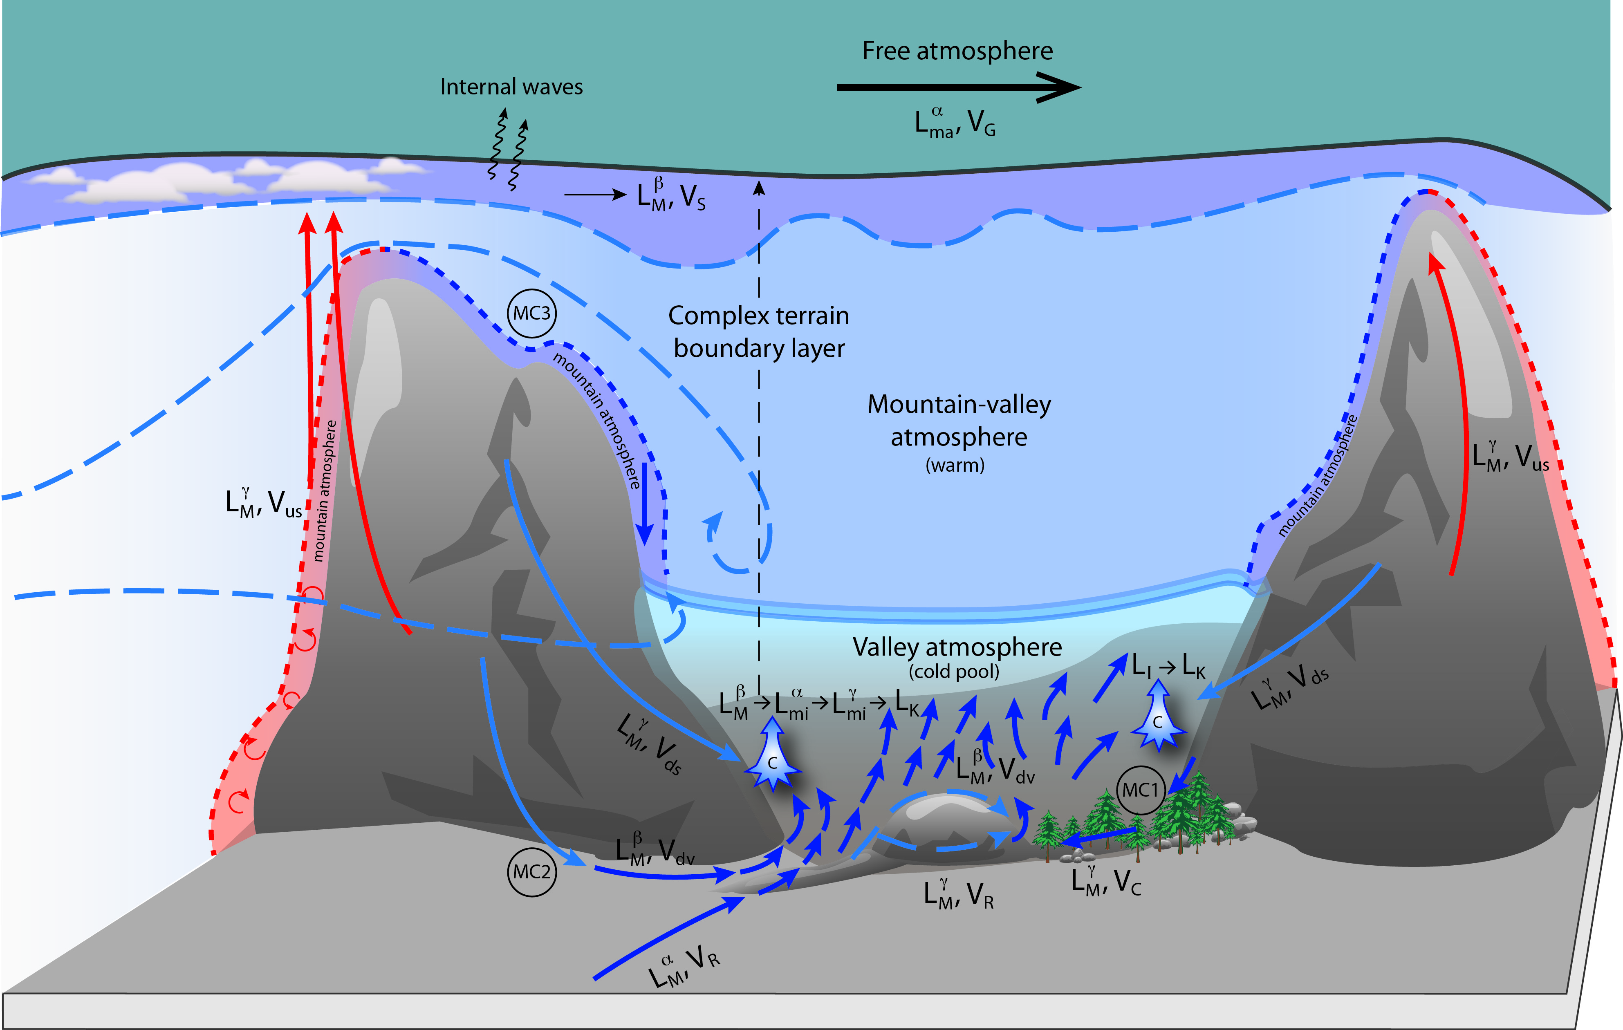
Figure 1: Atmosphere in complex terrain. ($L_{Ma}^{α}, V_{G}$) – macro-$α$ (>10⁴ km), global; $(L_{M}^{β}, V_{S}$) - macro-$β$ (2-10)x10³ km synoptic;$(L_{M}^{α}, V_{dv}$) - meso-$α$ - (2-20)x10² km regional downvalley;$(L_{M}^{β}, V_{dv}$) - meso-$β$ (2-20)x10 km, local down valley; $(L_{M}^{γ}, V_{ds}$) - meso-$γ$ (2-20) km, local downslope or locally distorted regional (R)/canopy (C) flow; $(L_{mi}^{α}, V_{dv}$) - micro-$α$ (0.2-2) km, local flow interactions and collisions; $(L_{Mi}^{β}, V_{dv}$) - micro-$β$ (20-200) m, instabilities; $(L_{Mi}^{γ}, V_{T}$) - micro-$γ$ (<20 m), turbulence and eddies down to Kolmogorov scales $L_{K}$. MC - microclimate

- Critical Scientific Needs and Approach:
Preceding MATERHORN, a workshop entitled “Weather in Mountainous Terrain (Overcoming Scientific Barriers to Weather Support)” was held in Tempe, Arizona during February 1-2, 2010 (A detailed report is available from the corresponding author). Twenty-six invited experts representing academia and stakeholders brainstormed to identify a long list of research needs and barriers for improved predictions. Considering resources limitations, only a subset of these issues were included in MATERHORN, namely: (i) The predictability of near-surface atmospheric wind and temperature in complex terrain remains poor, in part due to lack of understanding of land-air and near surface processes; (ii) soil moisture and soil properties sensitively determine the surface layer predictions, especially in arid environments, yet key model related parameters are not accurately and simultaneously measured in field studies; (iii) While previous observations have delved into one or a few physical processes, observations over a range of scales may elicit new phenomena of consequence and their possible origin; (iv) A revisit of turbulence closure models and boundary layer parameterizations is needed, focusing on processes intrinsic to complex terrain processes; (v) There is a potential for high-fidelity ultra-high-resolution (50 m horizontal or finer) simulations for complex terrain, but issues remain on best numerical methods (e.g., terrain following versus immersed boundary layer), model physics and structure. These issues undergirded the design of the project, which melded four cross-fertilizing components.
- The modeling component (MATERHORN–M) investigates predictability at mesoscale, in particular, sensitivity (error growth) to initial conditions at various lead times, dependence on boundary conditions and input background properties as merits of different data assimilation techniques. It develops meaningful measures of skill relative to appropriate conditional climatologies.
- The field experimental component (MATERHORN–X) conducts measurements at unprecedented spatio-temporal detail, deploying an array of high-end instrumentation to support modeling efforts and process studies.
- The technology component (MATERHORN–T) develops innovative technologies to enable some needed, yet currently untenable, meteorological measurements. These included an instrumented UAV, and remote sensors and samplers for moisture measurements.
- The parameterization component (MATERHORN–P) for high-resolution simulations with novel modeling and terrain-representation methodologies as well as idealized laboratory studies to educe and quantify processes intermingled (and hidden) in field observations and help develop sub-grid parameterizations with improved physics.
Overall, the project design was centered on two MATERHORN-X field studies conducted at the US Army Dugway Proving Ground (DPG), where observations on multi-scale flow and model-related parameters were conducted, accompanied by rigorous modeling efforts for experimental planning and go/no-go decision making for Intensive Operational Periods (IOP).

- MATERHORN EXPERIMENTS

The project is highlighted by two extensive field campaigns, the Fall campaign (September 25 to October 31, 2012; MATERHORN-XF) focusing on quiescent, dry, fair weather (wind speeds < 5 m/s) wherein diurnal heating/cooling provided the main forcing and the Spring campaign (May 1 to May 31, 2013; MATERHORN-XS) dealing with synoptically dominated winds. A dry run was conducted during August 25-August 30 to fine tune instrument placement and logistics. The site, DPG, is located 137 km southwest of Salt Lake City, UT, consisting of 3700 km² of encroachment-free terrain. It is a secured facility, with controlled roads and air space by the Department of Defense (DOD), and a special cooperative agreement permitted access to DPG. Within DPG, unique topography is present in the form of an isolated mountain, Granite Mountain (GM) with length 11.8 km, largest width 6.1 km and peak elevation 0.84 km (above valley elevation of 1.3 km). Farther from Granite Mountain, approaching the DPG boundaries, the peaks climb to upwards of 2200 m above the valley on three sides while to the North, salt flats extend for 145 km. Besides terrain heterogeneities, DPG also has variable land cover and use. To the West of Granite Mountain, the terrain is extremely smooth with salt flats (playa) while the terrain to the East is desert shrub covered (referred to as sagebrush throughout the document), leading to differential cooling and roughness variation. The location can be classified as semi-arid terrain, resembling to complex terrain airsheds such as Phoenix and Los Angeles (noted for their air quality problems) and some remote areas of interest to DOD. The weather is modulated by land-surface contrasts, topographic complexity, inhomogeneities of terrain and land use and intrinsic synoptic variability. DPG, and the Granite Mountain area in particular, observes much of the flow phenomena of interest including thermally driven circulations, terrain-forced flows and turbulence, frontal cyclones, convective systems and dust storms (Rife et al. 2002; Schultz et al. 2002; Schultz & Trapp 2003; Shafer & Steenburgh 2008; West & Steenburgh 2010; Jeglum et al. 2010).

The surroundings of Granite Mountain are suitably instrumented to support numerous meteorological testing, training and operational assessments of chemical and biological weapon systems, forming the Granite Mountain Atmospheric Sciences Testbed (GMAST) facility. The core instrumentation infrastructure consisted of 31 Surface Atmospheric Measurement Systems (SAMS), 51 mini-SAMS and 22 (37 in Spring) Portable Weather Information Display Systems (PWIDS). SAMS and mini-SAMS are 10 m towers with anemometers located at 2 and 10 m to measure wind speed/direction, a temperature/relative humidity probe and a pressure sensor located at 2 m. The difference between the two is that the SAMS feature an additional temperature/relative humidity sensor at 10 m, as well as a rain gauge. PWIDS are 2 m masts sitting atop tripods for portability and have a Wind Monitor, a temperature/relative humidity and a pressure probe located at 2 m. All data from SAMS/mini-SAMS/PWIDS is transmitted wirelessly to the DPG Meteorology Division dubbed Ditto via a spread spectrum radio. This instrumentation is included in Figures 1 and 2.

Built upon this core infrastructure was the MATERHORN instrumentation that was concentrated on five Intense Operating Locations (IOL, Figure 2).
- IOL-Playa, located on the salt playa west of Granite Mountain, and characterized by a higher albedo, low roughness length and large seasonal variations in albedo and moisture. This site was dedicated for studies on surface energy budget (SEB), internal waves, fine-scale turbulence in Stable Boundary Layer (SBL) and Convective Boundary Layer (CBL) and contrasting features such as albedo, roughness, moisture availability and slope angle.
- IOL-Sagebrush was located east of the Granite Mountain. Covered by sparse sagebrush-type vegetation, it is highly representative of the land cover found at DPG. This site was influenced by the nocturnal DPG basin-scale mesoscale drainage flow.
- IOL- East Slope (ES) was located on the eastern slope of Granite Mountain and comprises five 20 m meteorological towers (ES-1 through ES-5). Local slope flows played an important role at this site.
- IOL-Gap instruments the low point between Granite Peak and the Dugway Range where air can be exchanges between the west and east basins. The gap consists of a small and big gap separated by relatively low topography of Sapphire Mountain.
- IOL-Obverse covers the footprint area where a northwesterly synoptic approach flow impinges on Granite Mountain, wrapping around it while shedding vortices and, under stable conditions, exhibiting a dividing streamline above which the flow goes above the mountain and below it flowing around the mountain.

An array of complementary instrumentation was also distributed in the domain to capture broad flow patterns of interest, which included sites on the west slope of Granite Peak, on the periphery of GM and remote sites for background flow. Figure 2 shows a map of the entire site and Figure 3 shows photographs of salient instrumentation at DPG.
All IOLs consisted of instrumented towers, at least one 20 m in height, along with a suite of other sensors based on the research questions to be addressed. The tower was instrumented to measure a combination of the following variables: temperature and relative humidity, wind velocities, momentum and sensible heat fluxes (using 3D Sonics operating at 20Hz; at 2, 5, 10, and 20 m), fine wire thermocouples (at 2, 5, 10, and 20 m), CO₂ and water vapor concentrations (infrared gas analyzers for latent heat and CO₂ fluxes), fine-structure temperature profiles ($\sim$25 thermocouples up to 3.2 m, with enhanced vertical resolution near the ground), full radiation budget at 2 m (LW in- and outgoing, SW in- and outgoing), and IR surface temperature, soil heat flux, soil moisture and subsurface temperature probes. Sonics were also placed 0.5 m above surface to investigate the skin flows, a phenomenon adumbrated by previous observations but unresolved by both LES and mesoscale models and previous observations (Manins & Sawford 1979a, Thompson 1986; Manins 1992; Mahrt et al. 2001; Soler et al. 2002; Clements et al. 2003).

IOL-ES had five heavily instrumented towers (ES-1 to ES-5), with a total of 30 Sonics, 17 Local Energy-balance Measurements Stations (LEMS), Doppler Light Detection and Ranging (LiDAR) instruments with hemispherical scanners. A fiber optic Distributed Temperature Sensing (DTS) system was used to measure the temperature variation along a 2 km track of the slope at 1 m AGL. In-house developed hot-film combo probes measured turbulence down to Kolmogorov scales (Kit et al. 2010), and a FLIR® IR camera, facing uphill measured spatial and temporal response of surface temperatures important for model validation, an observation impracticable with point sensors. A line of 17 HOBO® automatic temperature dataloggers was deployed along a East-West cross section over the southern profile of Granite Mountain.

The Playa site featured unique instrumentation for finest scales of turbulence, employing a near surface flux Richardson number hot/cold-wire probes, thus complementing the ES-2 combo probe that measured similar quantities at 6 m. The ground-based measurements were supplemented by frequent tethered balloon soundings at the Playa and Sagebrush sites, a microwave radiometer profiler (MWRP) for vertical profiles of temperature and humidity up to 10 km, infrared gas analyzers (fluxes) and Krypton Hygrometers (water vapor fluctuations).

The Gap site encompassed small and large gaps southeast of Granite Mountain, the East Slope canyons of Granite Mountain, West Slope of Granite Mountain, top of the Sapphire Mountain and multiple locations in the proximity, and was densely instrumented. It was also the site for two newly developed RF Polarimetric crosshairs (Pratt et al. 2014) for surface moisture measurments at ~ 1 km (meso grid-resolution) scale. Smoke released illuminated by a powerful laser as well as natural light provided qualitative information on the structure of the katabatic and canyon flows.

The Obverse site provided approach flow information for the synoptically dominated experiments, based on a 32 m tall tower (located ~5 km northwest) with 3D sonics at 2, 4, 6, 8, 16, and 28m with concurrent temperature measurements using Campbell HMP45 probes. Co-located were a MWRP, a Ceilometer, a mini-SoDARs and a Frequency-Modulated Continuous-Wave Radar (FM-CW) RADAR for profiling background thermodynamic structure. PWIDs recorded the local flow at the leading edge. A suitably placed scanning LiDAR and four towers along the southeast foothill captured the separated flow. At least 8 radiosonde launches per IOP at an upwind location provided further information that helped model data assimilation studies. Elaborate multiple smoke releases visualized the flow around Granite Mountain and provided information on the dividing streamlines, streak lines and separation associated with mountain flow physics.

To round out MATERHORN-X instrumentation, aerial measurements were performed by the manned NPS Twin Otter Wind LiDAR (TODWL) and unmanned aerial vehicles (UAV) consisting of DataHawk and Flamingo. TODWL flights crisscrossed the basin at 2400 m AGL, transecting the Granite ridge, conically scanning the terrain with onboard Doppler LiDAR to probe for various flow phenomena including the deluge of mountain-generated flows. Unmanned DataHawk flights flew circular Auto-Helix patterns, spiraling from the ground level to a height of 700 m AGL and then back down traversing the East Slope tower line, able to characterize the flow the towers could not reach.

Intense Operational Periods (IOPS)
Each campaign included ten Intensive Observational Periods (IOPs) where all instruments operated simultaneously and in coordination. The wind speed classification used for IOPs is presented in Table 1. IOP days were selected based on guidance via weather briefings provided by DPG featuring DPG’s high-resolution weather modeling system using WRF and data assimilation, cycling 8 times a day at 1.1 km resolution and an ensemble of numerical modeling including the North American Mesoscale (NAM) and Global Forecast System (GFS) models as well as satellite products. During the campaign, weather briefings were held by the DPG forecasters, called-in meteorologists from the MATERHORN group and the participants, and the go/no-go decision for the following day was made after careful deliberation of the data needs, equipment functionality and resource availability for that day. Table 2 contains the details of the fall IOPs including the run date, times and IOP type.

TABLE 1
INTENSIVE OPERATIONAL PERIODS (IOPS) WIND SPEED CLASSIFICATION
IOP Classification | Definition
 | 700 mb wind speed
Quiescent | < 5m/s
Moderate | 5 m/s - 10 m/s
Transitional | Variable, could be > 10m/s
 | associated w/front Passage

Table 2A
Fall, MATERHORN-X-1 IOPs
IOP | Run Date and Times (MDT) | Type
0 | 9/25/2012 14:00 - 9/26/2012 14:00 | Quiescent
1 | 9/28/2012 14:00 - 9/29/2012 14:00 | Quiescent
2 | 10/1/2012 14:00 - 10/2/2012 14:00 | Quiescent
3 | 10/3/2012 2:00 - 10/4/2012 2:00 | Transitional
4 | 10/6/2012 14:00 - 10/7/2012 14:00 | Moderate
5 | 10/9/2012 14:00 - 10/10/2012 14:00 | Transitional (Quiescent- Moderate)
6 | 10/14/2012 2:00 - 10/15/2012 2:00 | Quiescent
7 | 10/17/2012 12:00 - 10/17/2012 20:00 | Transitional (Quiescent -Moderate)
8 | 10/18/2012 5:00 - 10/19/2012 12:00 | Quiescent
9 | 10/20/2012 14:00 - 10/21/2012 14:00 | Moderate

Table 2b
Spring, MATERHORN-X-2 IOPs
IOP | Run Date and Times (MDT) | Type
1 | 5/1/2013 14:00 - 5/2/2013 14:00 | Transitional (Moderate-Quiescent)
2 | 5/4/2013 14:00 - 5/5/2013 14:00 | Moderate
3 | 5/7/2013 5:00 - 5/7/2013 17:00 | Moderate
4 | 5/11/2013 14:00- 5/12/2013 14:00 | Quiescent
5 | 5/13/2013 12:00 - 5/14/2013 12:00 | Transitional (Moderate-Quiescent)
6 | 5/16/2013 12:00 - 5/17/2013 12:00 | Transitional (Moderate-Quiescent)
7 | 5/20/2013 17:15 - 5/21/2013 14:00 | Quiescent
8 | 5/22/2013 14:00 - 5/23/2013 14:00 | Moderate
9 | 5/25/2013 10:00 - 5/26/2013 10:00 | Moderate
10 | 5/30/2013 14:00 - 5/31/2013 10:00 | Moderate

- Preliminary Results

Experimental Findings: Here we will have about 2 pages (~ 3000 words max) of new findings. Each figure counts as 400 words.

5.1. Key Surface Energy Balance and Soil Property Differences
To fully understand the physical processes governing thermally driven mountain circulations, the individual components of the radiation and SEB as well as supporting variables (soil properties) were measured at three representative locations (IOL-Sage, IOL-Playa and IOL-Slope-ES5), using the best available equipment. Surprisingly small albedo differences were observed between the three sites (see Table X), limiting the differences in shortwave net radiation at the different surfaces. On the other hand, our measurements revealed the importance of soil thermal property differences across the complex terrain. The differences in thermal conductivity between the soils of the playa and the sparsely vegetated areas (0.9 and 0.65 W m⁻¹K⁻¹ at IOL-Playa and IOL-Sagebrush, respectively; Table X) led to a difference in the importance of the ground heat flux. This is consistent with the soil moisture content observations, which varied dramatically between sites. Mean soil moisture content and spatial variability was much higher at IOL-Playa than the other two sites (with a water table that was ~80cm from the surface during the spring). As a result of this large moisture reservoir, the ground heat flux at Playa is a larger energy sink during the day than the sensible heat flux. This stored heat is released during the night, leading to higher surface temperatures and higher longwave emission. A correct representation of the soil thermal conductivity was recently shown to be crucial to accurately predict nighttime temperatures over the various soil types using today's forecasting models (Massey at al. 2014).
5.2. Investigating surface layer similarity theory

Issues associated with Monin-Obukhov similarity theory (MOST) have received significant attention (e.g., Foken 2006), yet during transition periods, little is described in the literature. Blay-Carreras et al. (2014) recently observed near surface counter-gradient behavior of sensible heat fluxes during the BLLAST (Boundary Layer Late Afternoon and Sunset Turbulence) campaign in France. Similar to the results of Smedman et al. (2007), they found stability functions that deviated greatly from idealized profiles typically used for weather prediction during conditions of near neutral stability. A similar behavior has been observed during the MATERHORN campaign at all of the flux sites. However, a surprising result from MATERHORN has been the nature of the transition over surfaces with very different thermal characteristics. At the vegetated IOL-Sagebrush site, the local temperature gradient changes sign after the flux changes sign. While at the Playa site, the gradient leads the flux. Both counter-gradient situations lead to similar deviations from theory, but at different times due to the large thermal storage of the Playa.

5.3. Evening transitions on the East Slope of Granite Mountain

The evening transition period on sloping terrain presents extremely interesting physics that play an important role in the development of the local nocturnal boundary layer as well as the interactions with the valley circulation. At the onset of the project, it was hypothesized that a shadow front similar to that observed by Nadeau et al. (2013) in the Swiss Alps would dominate the flow dynamics and transitional behavior from daytime upslope flow to nocturnal downslope flow. Our analysis, however, indicates that the flow is not dominated by the shadow front, and that the two flow transition types (front and cooling slab) previously discussed by Fernando et al. (2013) are present. Front transitions appear to originate upslope of the observation towers and move downslope, changing the observed wind direction at each tower roughly in sequence. During slab transitions, winds change on all towers at approximately the same time as a result of local cooling. Both transition mechanisms exist on the ES in approximately equal distribution during quiescent IOPs. The formation mechanisms leading to the two different flow types is still uncertain and topic of current study.

5.4. Mesoscale nocturnal flows in the basins
The spatial differences in the SEB are reflected in the evolution of both the stable nighttime and convective daytime boundary layers. Tethered balloons were flown during IOPs at both IOL-Sage and IOL-Playa to capture these differences, which are clearly illustrated in the downvalley flows on either side of Granite Mountain during quiescent IOPs. Southeasterly flows originate from Dugway Valley and the slopes of the Simpson and Sheeprock Mountains, while southerly flows that travel on the west side of Granite Mountain (over the Playa) originate from the Snake Valley and Fish Springs Flat. Figure ?? shows the fully established downvalley flows with a jet structure in both of these sub-basins from tethersonde observations. The Sagebrush region exhibits much cooler surface temperatures and a strong low-level elevated capping temperature inversion that acts to prevent the near surface jet flow from mixing vertically. The larger ground heat flux at IOL-Playa leads to much warmer nighttime surface temperatures than at IOL-Sagebrush, allowing the nocturnal jet to mix much deeper into the atmosphere aloft.
Figure ?? – Comparison of the wind and temperature structure of the nocturnal boundary layer at IOL-Playa and IOL-Sagebrush during the quiescent IOP 1 just after 0200 MST 29 September 2012.

5.5. Interactions between Slope and Valley Flows

As described above, on synoptically quiescent nights, the flow fields in the basins around Granite Peak are complex. While valley circulations develop on either side of Granite Mountain, these flows are likely enhanced by the differential cooling due to the land surface contrast between sparsely vegetated areas to the SE and the playa to the NW (playa breeze). Inter-basin air exchange across the Sapphire Mountain gaps seem to be largely controlled by the channeling of larger-scale flows, but thermal contrasts can lead to air exchanges as well.
During the night of IOP-2, a southeasterly down-valley flow establishes in the Dugway Basin, and merges with a southwesterly flow across the Granite Mountain - Dugway Range Gap (Big Gap). Vorticity develops acting to deflect the cold air of the valley flow towards the warmer eastern slope of Granite Mountain. The cold air advected by the valley circulation and the downslope flow coming off of the East Slope of Granite Mountain collide as shown in Figure 1. The collision generates an intriguing set of small-scale processes that contribute vigorously to sub-grid scale heat and momentum transfer. These include the collision of gravity currents, formation of intense turbulent regions, intrusions and instabilities. The impact of the collision sends pressure waves, flushing the basin, allowing the cold air that had been pushed up the slope to drain back out into the basin, which is then met by a re-established valley flow. This collision cycle is repeated numerous times during the quiescent evenings. WRF and other mesoscale models do not account for such sub-grid processes, and hence their incorporation through conditional parameterization is crucial in modeling mountain terrain winds.

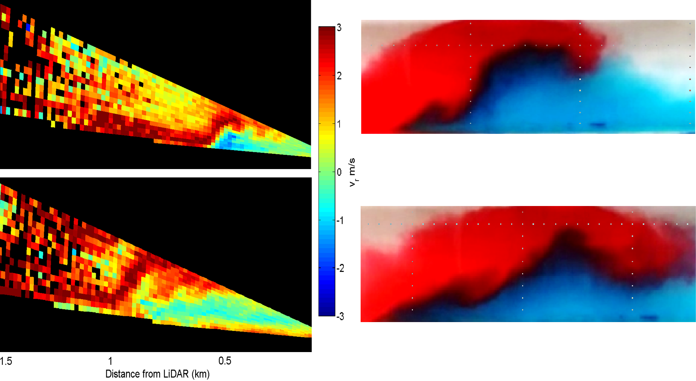
t_{s} = 22:56 MDT
t_{s} = 23:11 MDT
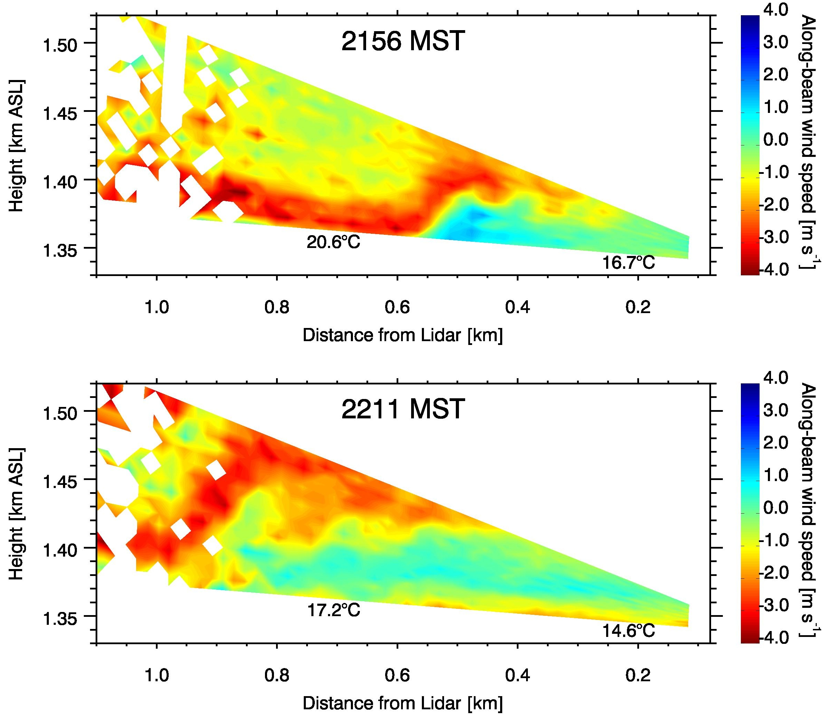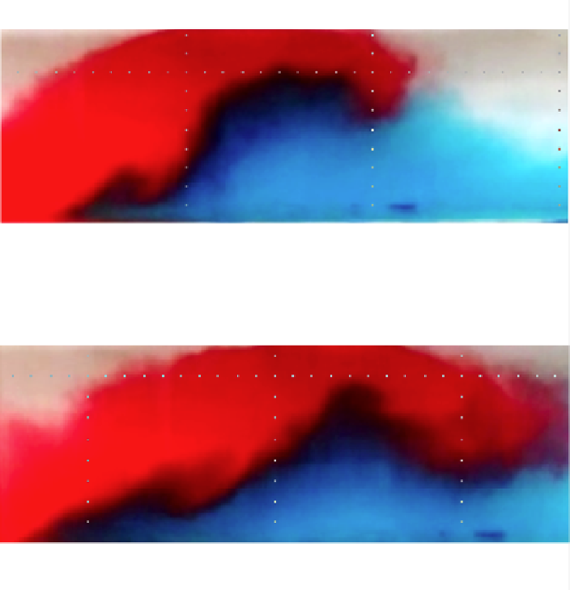
Figure 1: Down-slope and valley flow collision during IOP 2 (10/02/2012). Left panel: U. Utah Lidar (S. W. Hoch) located near ES-2. Scans capture the collision between the downslope (red) and colder air advected to the slope by the valley flow (blue). Right panel: Collision of gravity currents at the U. Notre Dame laboratory. In both cases, the denser valley flow undercuts the downslope flow and then pushes up the slope. Intense small-scale processes and instabilities can be observed at the interface of the two currents in the laboratory study.

Joe Fernando – will describe the impacts of flows

De Wekker – most significant

Numerical Modeling:

Josh, Zhaoxia, Jim – please send us 1500 words (including figures – each figure is 400 words) of a few developments......related to Materhorn experiments.

Tina – please send me one figure and major outcome related to Materhorn experiments

Synthesis:

Fernando will do this

Figures:

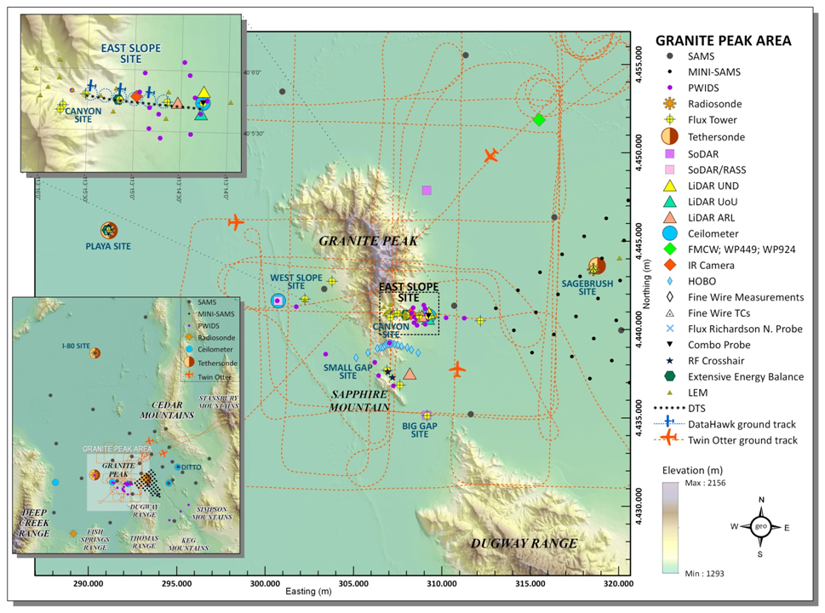
Figure 1: MATERHORN-X Instrument placement, IOLs and distributed instrumentation (Silvana will provide a new figure)

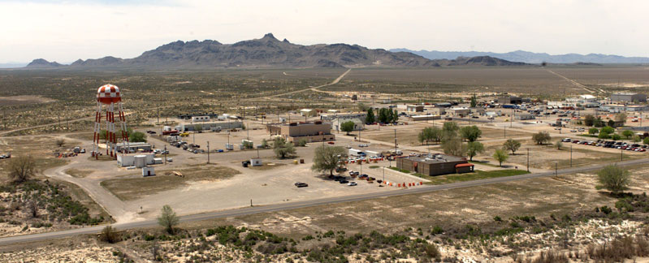 | 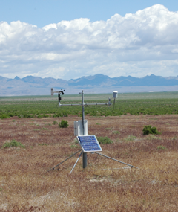
GMAST, with is Camelback Mountain in the background | PWIDs

 | 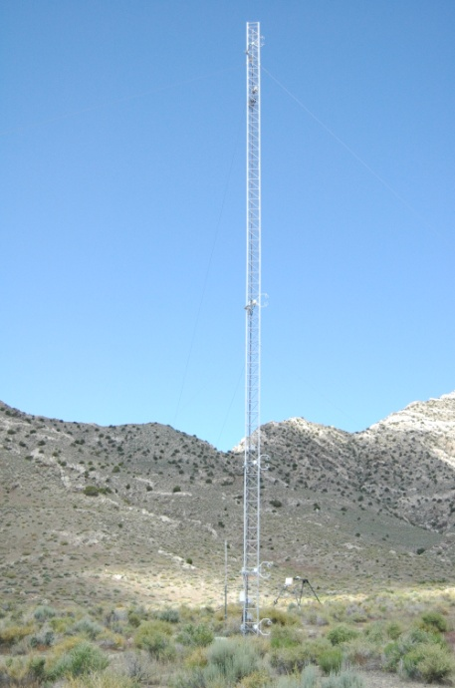 | 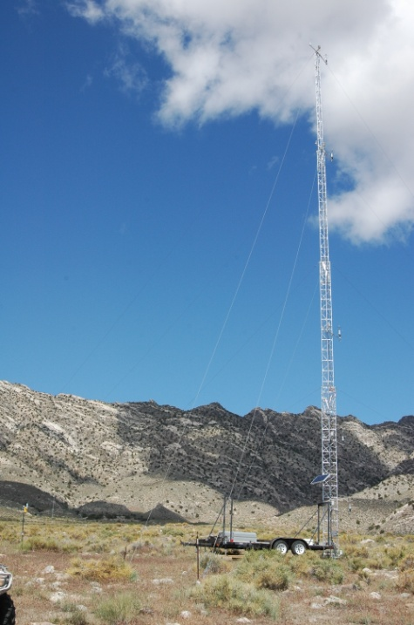 | 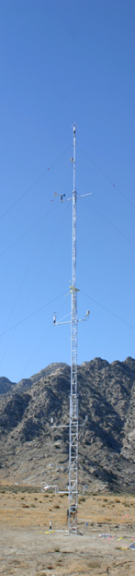 | 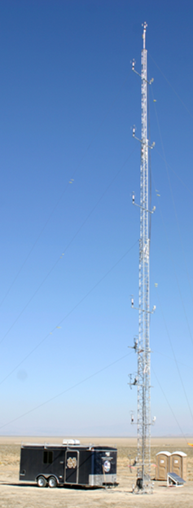 | 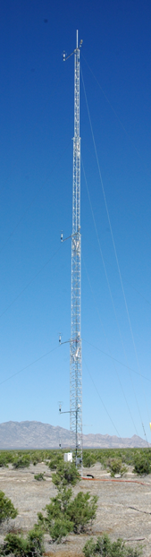
SAMS/miniSams; 3D sonic; vane anemometer; MP45 temperature/relative humidity probe in radiation shield. | ES 5;  3 level sonics; | ES 4 | ES 3 | ES 2 | ES 1

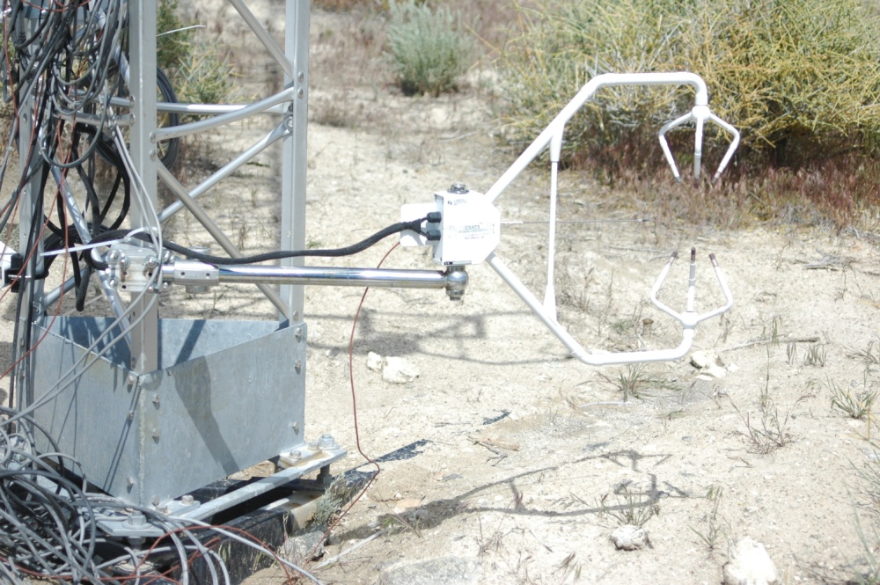 | 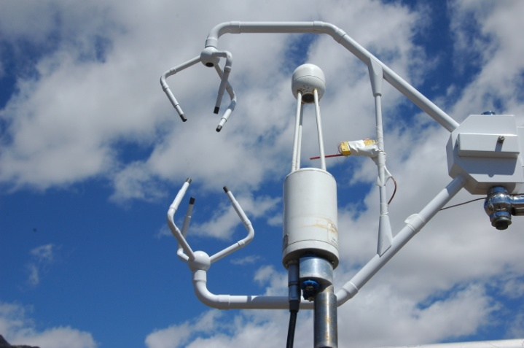 | 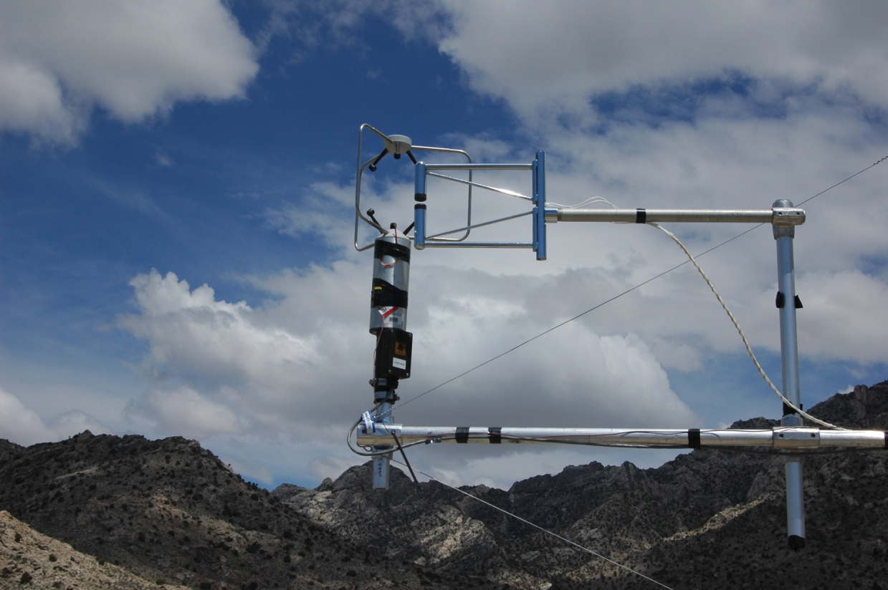 | 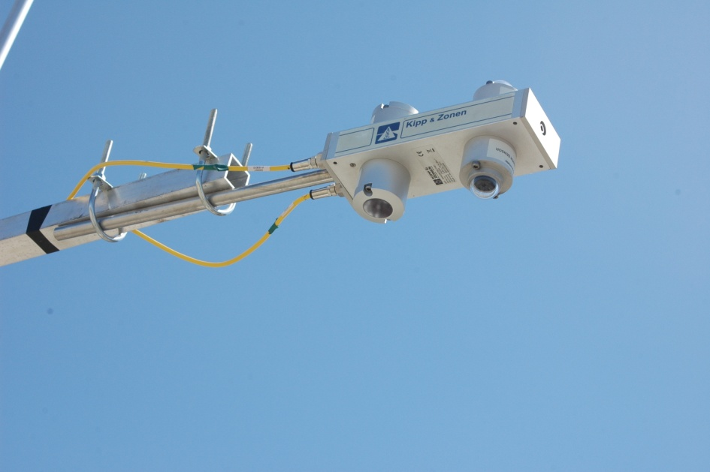
Fine wire thermocouples coupled with 3D sonic anemometers | Infrared gas analyzers | Krypton Hygrometer | Net radiometer as the tower mounted component of the energy budget

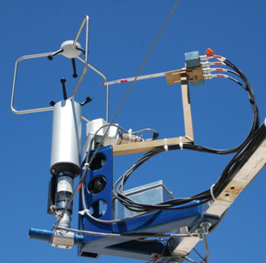 | 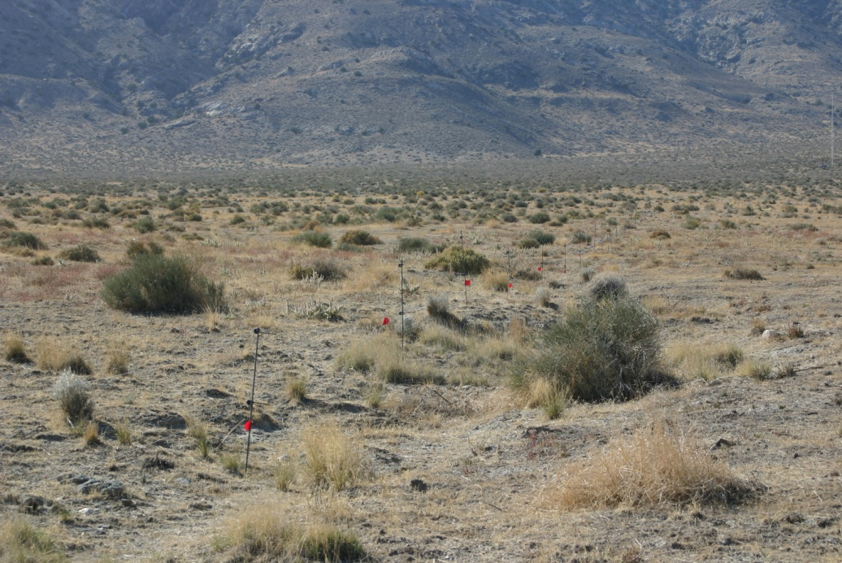 | 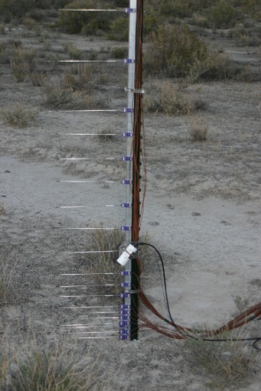 | 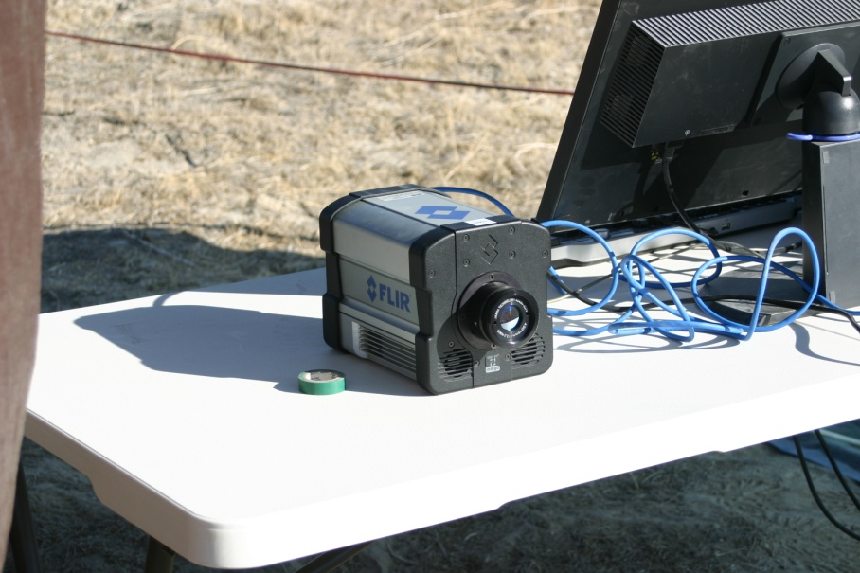 | 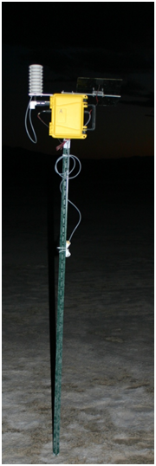
3D hot-film combo probe | Distributed Temperature Sensing System (DTS) | Array of fine wire thermocouples, enhanced resolution near the ground | FLIR® IR camera | LEMS weather stations

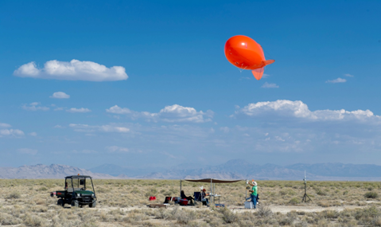 | 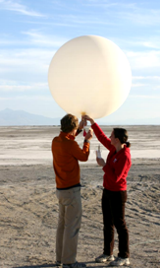 | 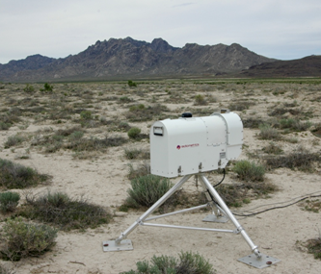 | 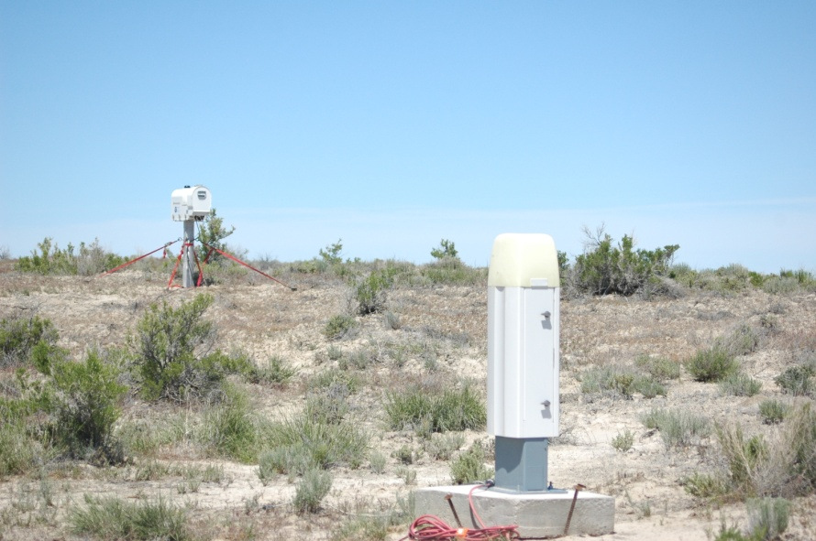 | 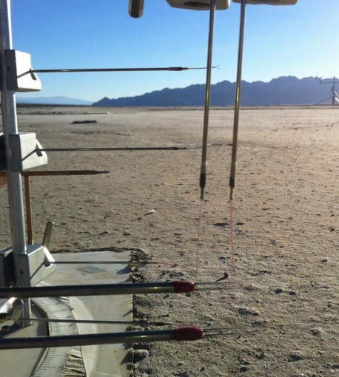
Tethered balloon soundings | radiosondes | Microwave Radiometer Profilers | Ceilometers | Flux Richardson number hot-wire probe

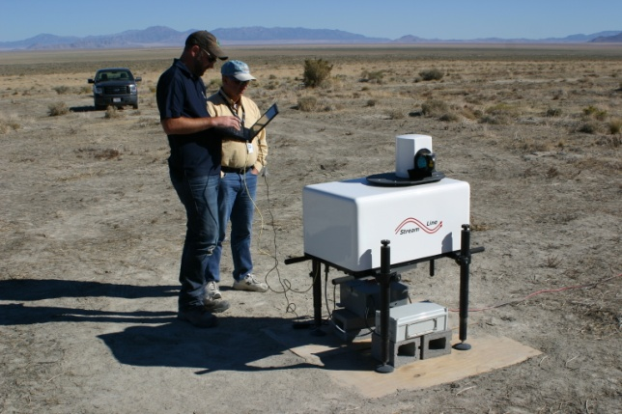 | 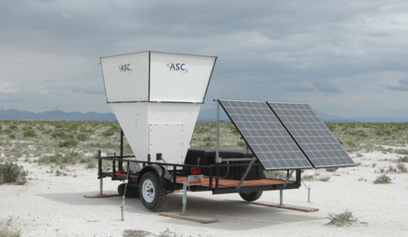 | 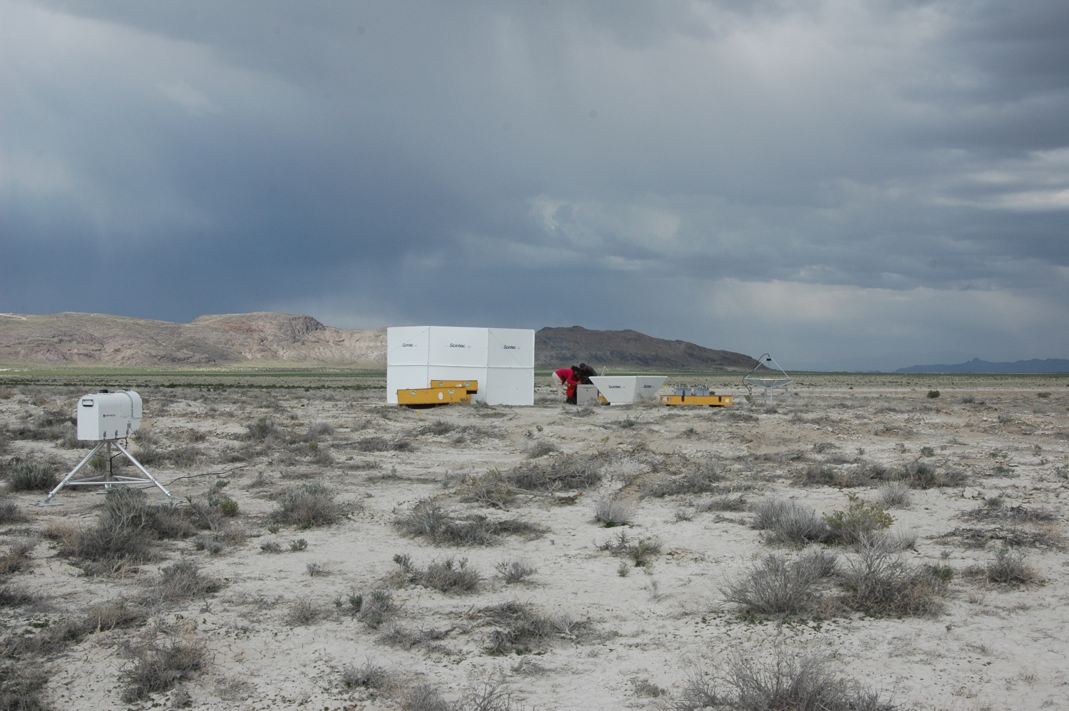
Scanning Lidar | Mini-SoDARs |  | SoDAR/RASS

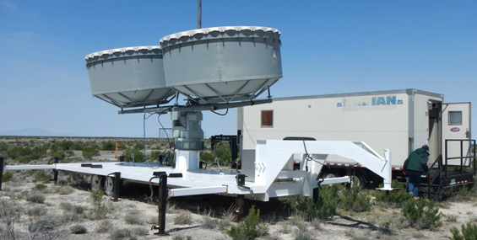 | 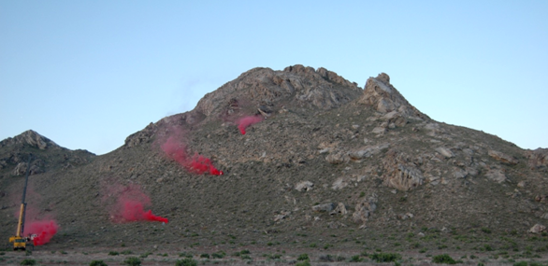 | 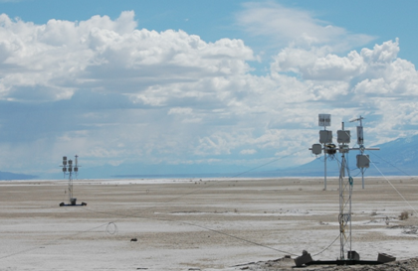
Frequency-Modulated Continuous-Wave Radar (FM-CW) RADAR | Dividing streamline smoke release located on the northwest side of Granite Mountain | RF Polarimetric crosshairs surface moisture probes

 | 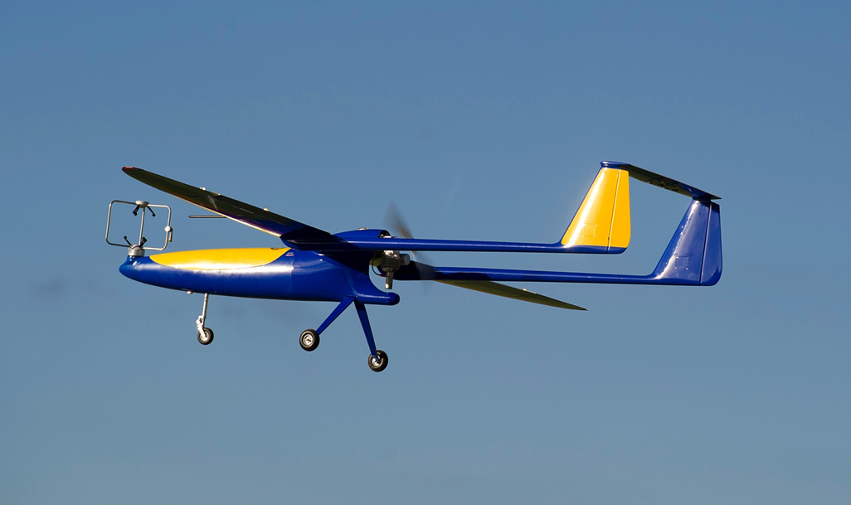 | 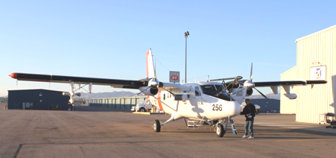
DataHawk UAV | Flamingo UAV | Twin Otter with wind LiDAR (TOWDL)

Table
physical parameters for the main land use types of gmast and surroundings
Site | Roughness Height (z₀) (m) | Average Albedo  Oct / May | Soil Thermal Conductivity (W m⁻¹K⁻¹)
 |  |  | Oct / May
Playa | 5.7 x 10⁻⁴ | 0.31 / 0.34 | 0.98 / 0.79
Sagebrush | 0.24 | 0.27 / 0.24 | 0.59 / 0.73
Slope | 0.10 | 0.23 / 0.19 | 0.44 / 0.54

instrument details
Instrument | Qty Measured | Range^{x} | Accuracy
Midrange-SoDAR | $$U, WD$$ | 50 to 400 m | 0.5 ms⁻¹, ± 2°
SoDAR/RASS | $$U,W, WD, T$$ | 30 m to 1 km | < 0.3 ms⁻¹, < 0.1 ms⁻¹, ± 1.5°, 0.2°C
Ceilometer | Cloud height detection | 0 to 7.6 km | ± 5 m
Radiosonde | $$T, RH, P, U$$ | Up to 30 km | 0.5°C, 5%, 1hPa, 0.2 ms⁻¹
FM-CW RADAR | $$C_{n}^{2}$$ | Usually set to 4 km
Wind Profiler 449 | $$U, WD$$ | 0.075 - 16 km | ±1 ms⁻¹, ± 10°
Wind Profiler 924 | $$U, WD$$ | 0.075 - 5 km | < 1 ms⁻¹, < 10°
Microwave Radiometer Profiler* | $T$, $H_{2}O$ vapor $ρ$ profile, Liquid $H_{2}O$ profile, derived $RH$ | 0 - 10 km | $\sim$ 2° C, $\sim$ 0.5 gm⁻³, 0.1 gm⁻³, 20 %
3D Sonic Anemometer | $$U, V, W, T$$ | NA | ±0.05 ms⁻¹,  ± 2°C
Wind Monitor Anemometer | $$U, WD$$ | NA | ±0.3 ms⁻¹, ± 3°
HMP45 Probe | $$T, RH$$ | NA | ± 0.6°C, ± 3%
Fine Wire Thermocouple | $$T$$ | NA
Tethersonde | $$T, RH, P, U, WD$$ | 0 to 500 m | 0.5°C, 5%, 1.5 hPa, 0.1 ms⁻¹, 1°
RF Polarimetric Crosshair | Soil Moisture | 1 km grid scale
Krypton Hygrometer | $H_{2}O$ vapor fluctuations | NA
Infrared Gas Analyzer | ${CO}_{2}$ and $H_{2}O$ density | NA | 1%, 2%
Streamline Doppler LiDAR | $U_{r}$, $SNR$ | up to 10 km | < 0.5 ms⁻¹
table 2.3 (Continued)
Instrument | Qty Measured | Range^{x} | Accuracy
100S Doppler LiDAR | $U_{r}$, $SNR$ | up to 12 km | < 0.5 m/s
HOBO® U23 Pro | $$T, RH$$ | NA | ± 0.21° C, ± 3.5%
LEMS | P, T, RH, T_{S,} VWC_{soil}, , T_{soil}, SW_{i} | NA | +/- 0.035 kPa,  +/- 0.3 C, +/- 2 %,  +/- 2%, +/- 0.03 m³m⁻³, +/- 1 C, +/- 3%
DTS system⁺ | $$T$$ | 2 km | ± 0.1°C
Heat Flux Plates | Soil $Q$ | NA | -15% to +5%
Net Radiometer (CNR1) | ${SW}_{i}$, ${SW}_{o}$, ${LW}_{i}$, ${LW}_{o}$ | NA | ± 10%
Pyranometer (CMP21) | ${SW}_{i}$, ${SW}_{o}$ |  | ± 5 W m⁻²
Pyrgeometer (CGR4) | ${LW}_{i}$, ${LW}_{o}$ |  | ± 10 W m⁻²
Hot-Film Combo Probe | $$u', v', w', ε$$ | NA | 4% for 30% TI
Hot-wire Flux Richardson Probe | $\overline{u'w'}$ and $\overline{w'T'}$ | NA
FLIR® IR camera | $T$_{s} | Max FOV = 63.2° x 52.4° | ± 2°C or ± 2%
Gravimetric Soil Observations* | VWC | surface, 5cm, 25cm below surface | 1-3%
Levelogger Gold®* | Water Table Depth | 0 to 1m below the surface | 0.05% F.S.
TP01 Soil Property Probe | thermal conductivity λ | 0.3-4 Wm⁻¹K⁻¹ | ±5%
Twin Otter Wind LiDAR (TODWL)⁺ | $$U, V, W, SNR, T$$ | 0.3 - 21 km | < 0.1 ms⁻¹
DataHawk UAV⁺ | $$U, V, W, {T,CT}^{2}, RH,$$  $$P, ε$$ | to 3km AGL | 0.1 m/s, 0.3 °C 1.0e-6, 0.01 %, 1.0 Pa, 1.0e-6
Flamingo UAV⁺ | $$u', v', w', ε, T, RH$$ | 12.8 km | 4% for 30% TI
⁺ = Only present during the Fall campaign.
* = Only present during the Spring campaign.
^{x} = Represents the maximum possible range. Results depend on atmospheric conditions.

Here a few photos that may be suitable to substitute / include

Radiosonde release at IOL-Playa

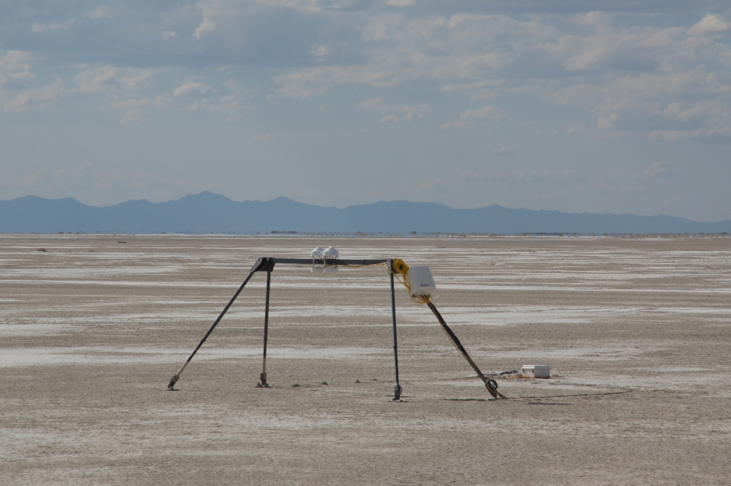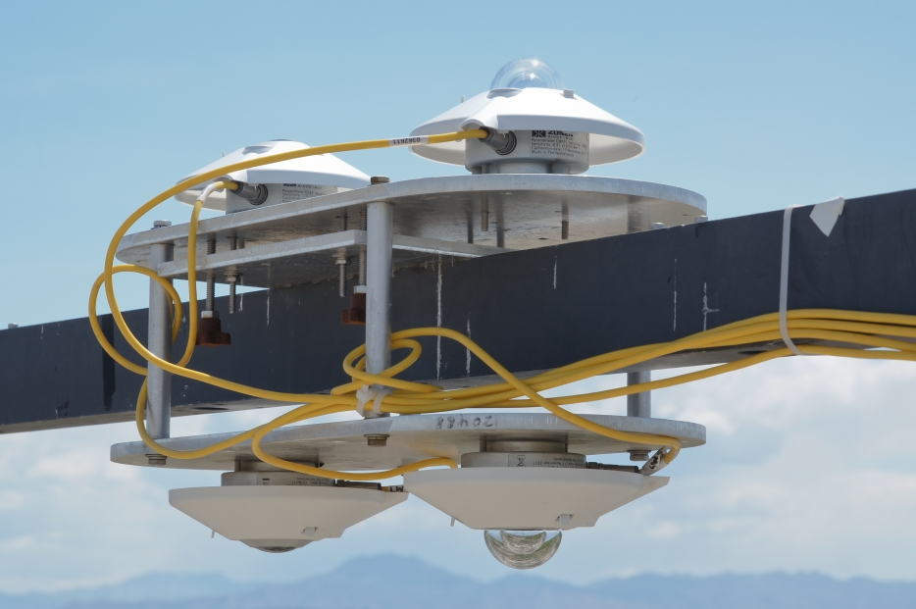
Radiation balance observations at IOL-Playa (left) and IOL-Sagebrush (right)

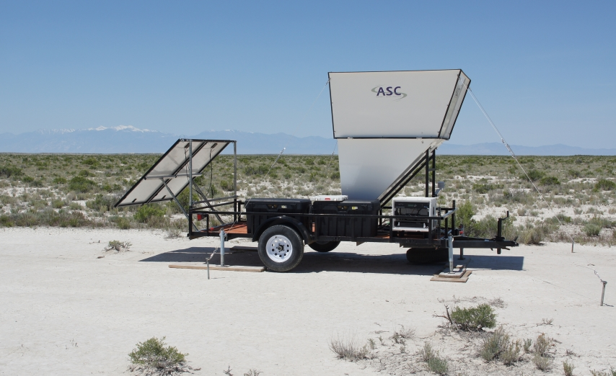
mini-SoDAR at "Big Gap" site
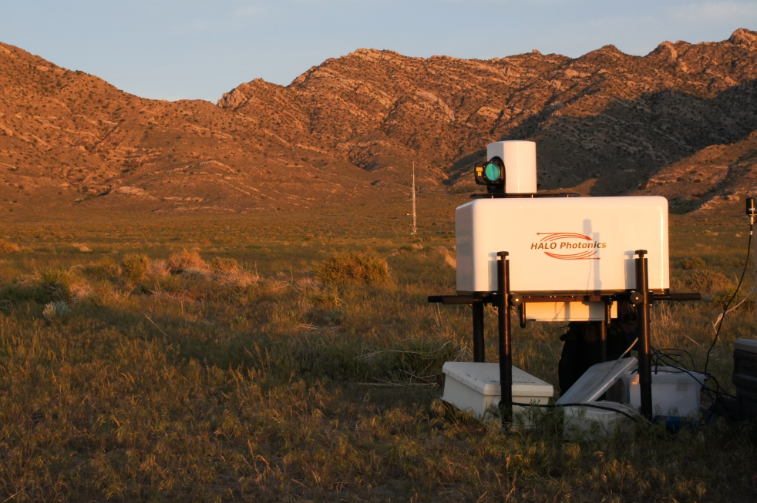
University of Utah Scanning Doppler LiDAR on East Slope near ES-2 (ES-3 can be seen in background)
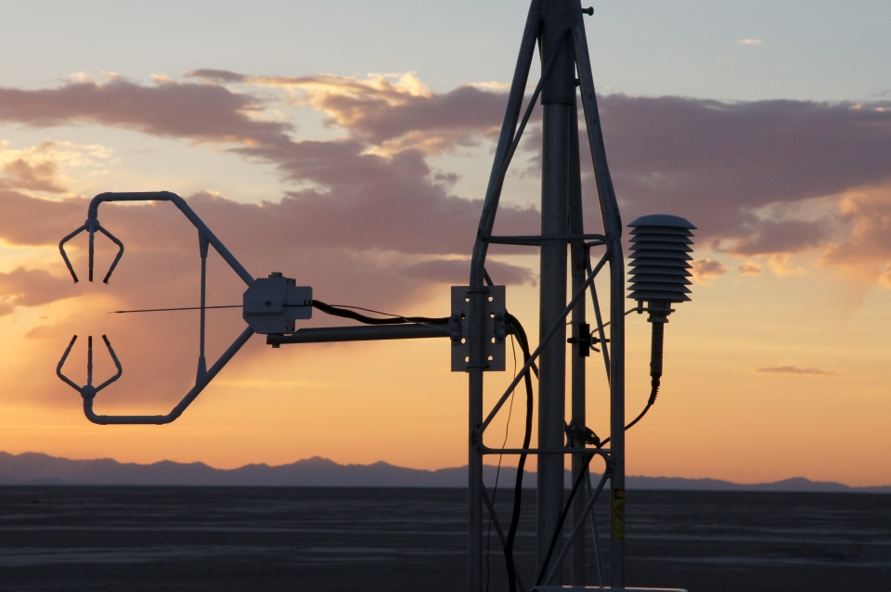
Sonic anemometer / fine wire thermocouple combination at IOL-Playa
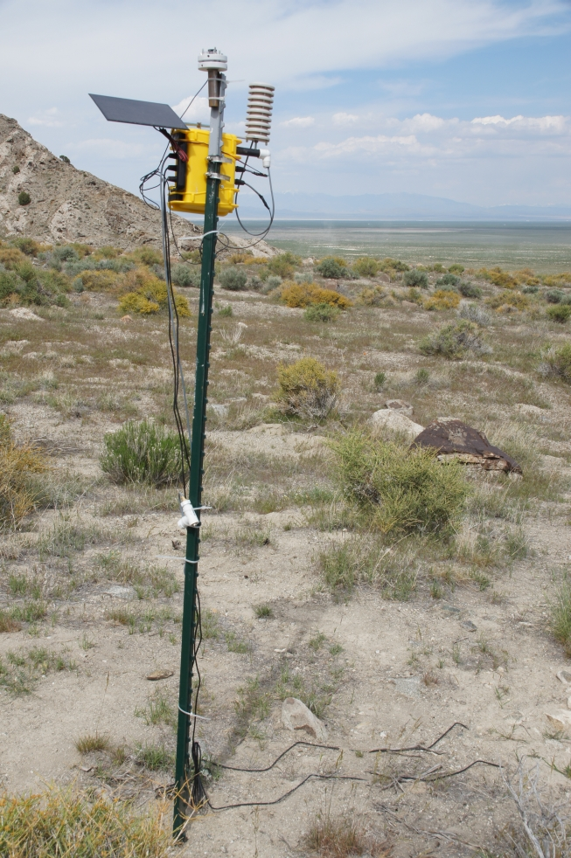
LEMS on East Slope of Granite Mountain
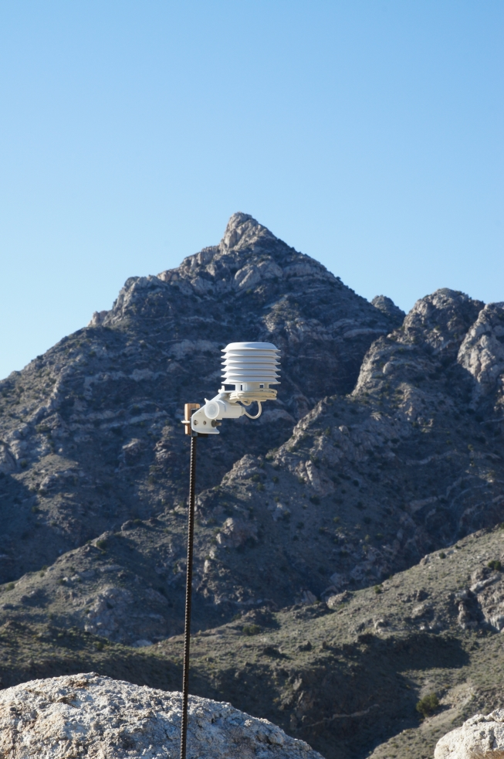
Hobo temperature datalogger near Granite Mountain ridgeline

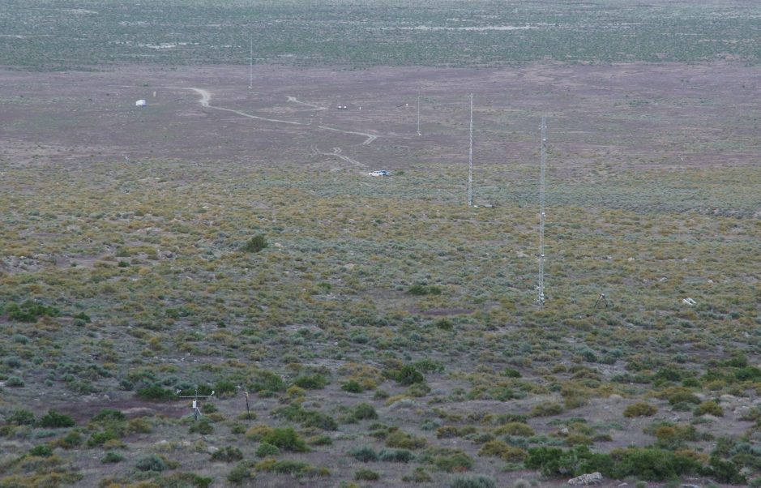
Upper four towers (ES-5 though ES-2) of IOL-East Slope on Granite Mountain, looking East (down the slope).

References:

Chow, F., Snyder, B. and de Wekker, S., (eds), Mountain Weather Research and Forecasting, Springer Atmospheric Sciences Series, ISBN 978-94-007-4098-3.

Louis, H., Neugefasstes Hohendiagramme der Erde, Bayer. Akad. Wiss., (Math Naturwiss. Klasse), 305-326.

Strobach, K. 1991. Unser Planet Erde- Ursprung und Dynamik, Gebr. Bornträger, Berlin.

Supplementary Material:

Acknowledgments: , Materhorn workshop was sponsored by the Army Research Office and Office of Naval Research

